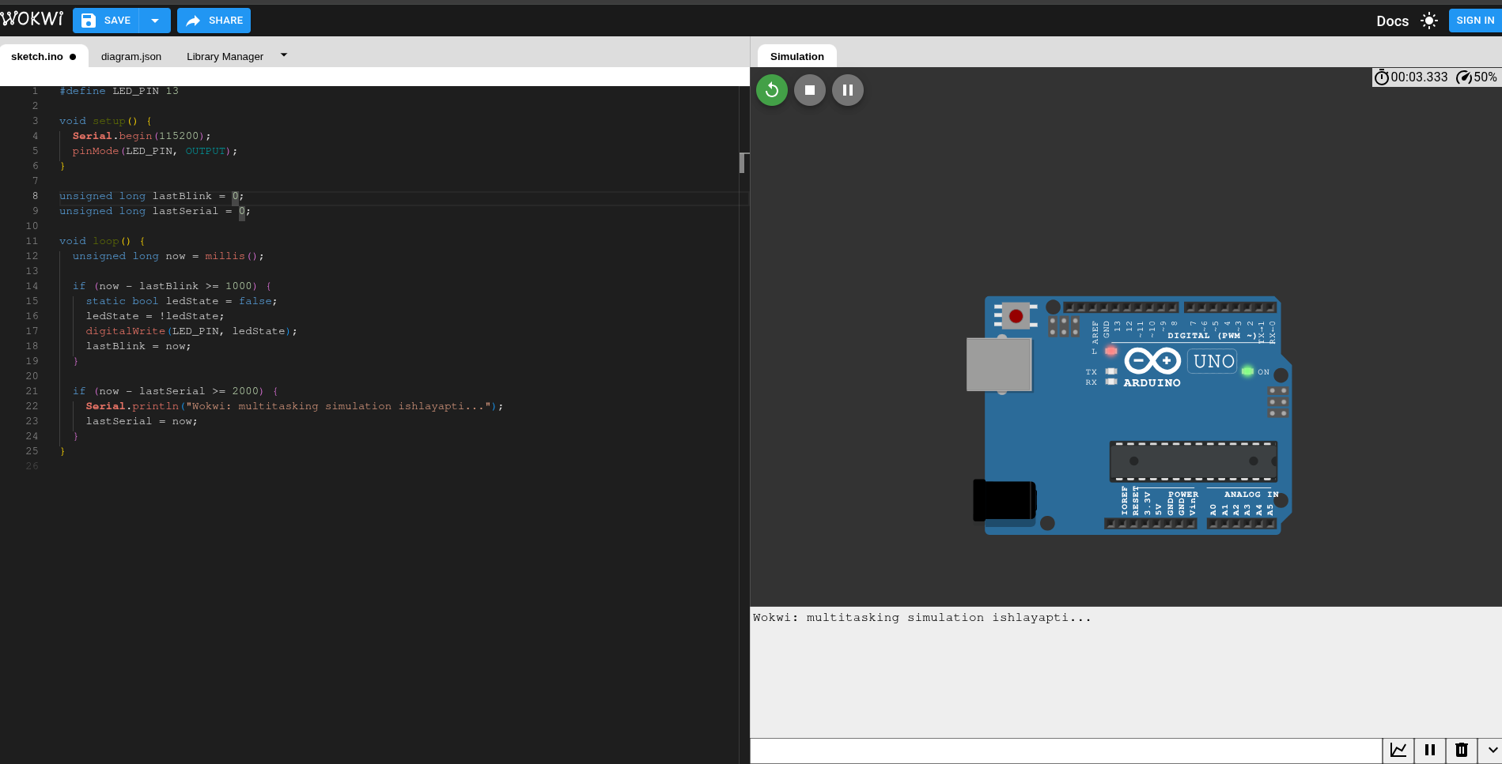

#define LED_PIN 13

void setup() {
Serial.begin(115200);
pinMode(LED_PIN, OUTPUT);
}

unsigned long lastBlink = 0;
unsigned long lastSerial = 0;

void loop() {
unsigned long now = millis();

if (now - lastBlink >= 1000) {
static bool ledState = false;
ledState = !ledState;
digitalWrite(LED_PIN, ledState);
lastBlink = now;
}

if (now - lastSerial >= 2000) {
Serial.println("Wokwi: multitasking simulation ishlayapti...");
lastSerial = now;
}
}

