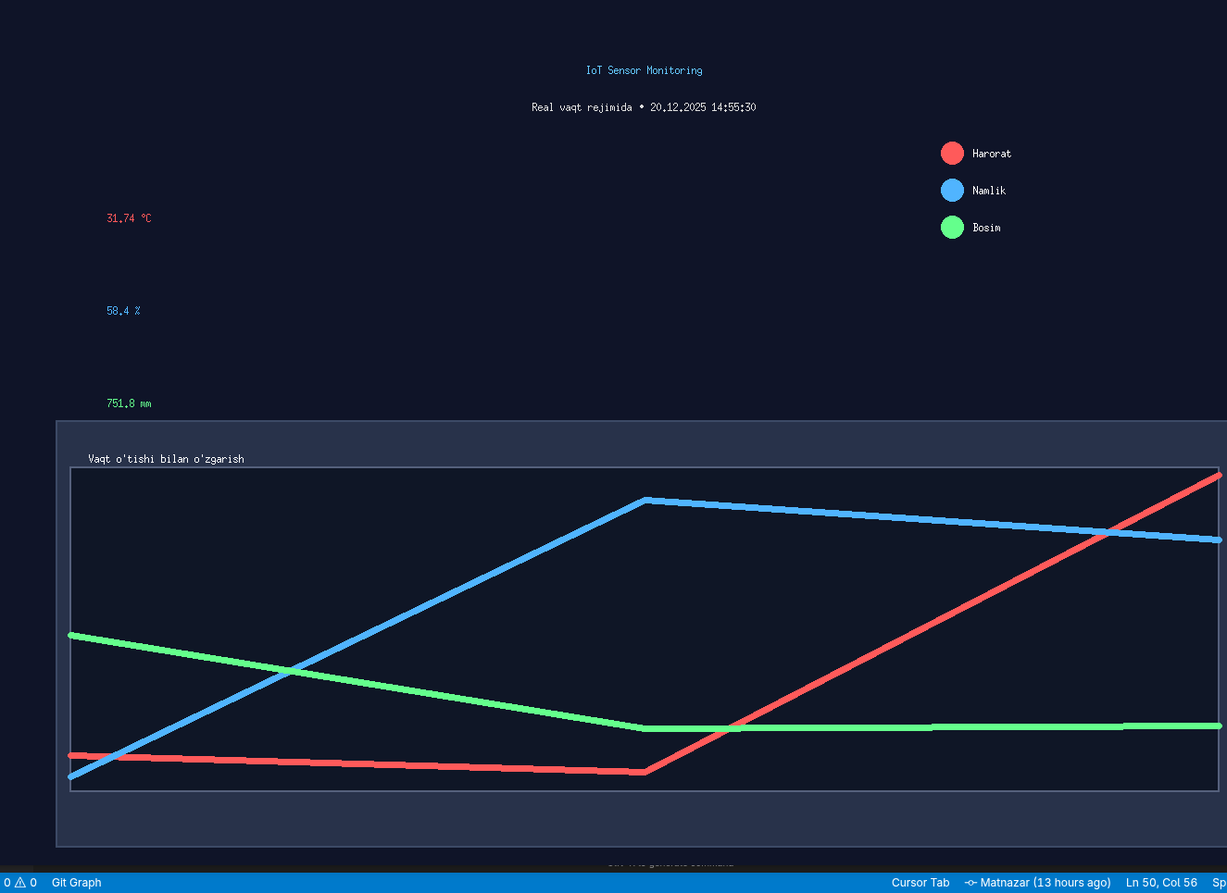

main.py
#!/usr/bin/env python3
# -*- coding: utf-8 -*-
"""
IoT sensor simulyatsiyasi (Tkinter, standart kutubxonalar).
Har 2 soniyada yangi o'lchovlar, real vaqt grafika, CSVga yozish.
Java versiyasiga moslashtirilgan layout.
"""

import tkinter as tk
from tkinter import font
import random
from datetime import datetime
import os

# ---------------- CONFIG ----------------
UPDATE_INTERVAL_MS = 2000
MAX_POINTS = 60

CSV_PATH = "sensor_malumotlari.csv"
TIME_FORMAT = "%d.%m.%Y %H:%M:%S"

BG_COLOR = "#0F1428" # Color(15, 20, 40)
PANEL_COLOR = "#28324A" # Color(40, 50, 80)
TEXT_COLOR = "#D6DCE6"

COL_TEMP = "#FF5A5A" # Color(255, 90, 90)
COL_HUM = "#50B4FF" # Color(80, 180, 255)
COL_PRESS = "#64FF8C" # Color(100, 255, 140)

# Ranges (original units)
TEMP_MIN, TEMP_MAX = 20.0, 32.0
HUM_MIN, HUM_MAX = 35.0, 65.0
PRESS_HPA_MIN, PRESS_HPA_MAX = 990.0, 1050.0
# convert hPa -> mm (1 hPa ≈ 0.75006 mmHg)
HPA_TO_MM = 0.75006
PRESS_MIN = PRESS_HPA_MIN * HPA_TO_MM # ~742.5
PRESS_MAX = PRESS_HPA_MAX * HPA_TO_MM # ~787.5

# ---------------- Data buffers ----------------
temps = []
hums = []
presses = []
times = []

# ---------------- CSV init ----------------
def init_csv():
header = f"{'Vaqt':<20} | {'Harorat (°C)':<12} | {'Namlik (%)':<10} | {'Bosim (mm)':<12}\n"
sep = "-" * (len(header) - 1) + "\n"
# If file doesn't exist or is empty, write header
write_header = not os.path.exists(CSV_PATH) or os.path.getsize(CSV_PATH) == 0
with open(CSV_PATH, "a", encoding="utf-8") as f:
if write_header:
f.write(header)
f.write(sep)

def append_csv(now, t, h, p):
# Format: vaqt | temp | hum | press
line = f"{now} | {t:.2f} | {h:.1f} | {p:.1f}\n"
with open(CSV_PATH, "a", encoding="utf-8") as f:
f.write(line)

# ---------------- Main App ----------------
class IoTMonitorApp(tk.Tk):
def __init__(self):
super().__init__()
self.title("10-amaliy ish • IoT Sensor Simulyatsiyasi")
self.configure(bg=BG_COLOR)
self.geometry("1400x950")
self.minsize(1000, 700)

# Fonts (Java versiyasiga mos)
self.font_title = font.Font(family="Consolas", size=38, weight="bold")
self.font_sub = font.Font(family="Segoe UI", size=18)
self.font_big = font.Font(family="Consolas", size=52, weight="bold")
self.font_legend = font.Font(family="Segoe UI", size=22, weight="bold")
self.font_label = font.Font(family="Segoe UI", size=22, weight="bold")

# Canvas for entire window (like Java Canvas)
self.canvas = tk.Canvas(self, bg=BG_COLOR, highlightthickness=0)
self.canvas.pack(fill="both", expand=True)
self.canvas.bind("<Configure>", self.on_resize)

# initialize csv
init_csv()

# start updates
self.updating = True
self.after(1000, self.update_once) # start after 1s

def on_resize(self, event=None):
# Redraw everything on resize
self.redraw_all()

def redraw_all(self):
self.canvas.delete("all")
w = self.canvas.winfo_width()
h = self.canvas.winfo_height()

if w <= 0 or h <= 0:
return

# Background
self.canvas.create_rectangle(0, 0, w, h, fill=BG_COLOR, outline=BG_COLOR)

# Title
self.canvas.create_text(
w//2, 90,
text="IoT Sensor Monitoring",
font=self.font_title,
fill="#64C8FF",
anchor="center"
)

# Real-time clock
now_text = datetime.now().strftime(TIME_FORMAT)
self.canvas.create_text(
w//2, 130,
text=f"Real vaqt rejimida • {now_text}",
font=self.font_sub,
fill="#E0E0E0",
anchor="center"
)

if not temps:
return

# === YUQORIDA KATTA RAQAMLAR (Java: 120, 250/350/450) ===
t = temps[-1]
hu = hums[-1]
p = presses[-1]

self.canvas.create_text(
120, 250,
text=f"{t:.2f} °C",
font=self.font_big,
fill=COL_TEMP,
anchor="w"
)
self.canvas.create_text(
120, 350,
text=f"{hu:.1f} %",
font=self.font_big,
fill=COL_HUM,
anchor="w"
)
self.canvas.create_text(
120, 450,
text=f"{p:.1f} mm",
font=self.font_big,
fill=COL_PRESS,
anchor="w"
)

# === ENG PASTDA TO'RTBURCHAK ICHIDA GRAFIK ===
box_x = 80
box_y = 520
box_w = w - 160
box_h = h - box_y - 80

# To'rtburchak ramka (rounded rectangle simulation)
self.canvas.create_rectangle(
box_x - 15, box_y - 50,
box_x + box_w + 15, box_y + box_h + 60,
fill=PANEL_COLOR,
outline="#3C4A66",
width=2
)

# Title above graph
self.canvas.create_text(
box_x + 20, box_y - 10,
text="Vaqt o'tishi bilan o'zgarish",
font=self.font_label,
fill="white",
anchor="w"
)

# Inner graph area (dark background)
self.canvas.create_rectangle(
box_x, box_y,
box_x + box_w, box_y + box_h,
fill="#0F1626",
outline="#55607C",
width=2
)

# Draw graphs with clipping (using create_rectangle clipping region)
# Tkinter doesn't have setClip, but we can use canvas clipping by drawing only inside bounds
if len(temps) >= 2:
self._draw_graphs(box_x, box_y, box_w, box_h)

# === AFSONA — O'NG YUQORI BURCHAKDA (grafikdan tashqarida!) ===
legend_x = w - 380
legend_y = 180
self._draw_legend(legend_x, legend_y, COL_TEMP, "Harorat")
self._draw_legend(legend_x, legend_y + 40, COL_HUM, "Namlik")
self._draw_legend(legend_x, legend_y + 80, COL_PRESS, "Bosim")

def _draw_legend(self, x, y, color, text):
# Draw circle
self.canvas.create_oval(
x, y - 12,
x + 24, y + 12,
fill=color,
outline=color
)
# Draw text
self.canvas.create_text(
x + 35, y,
text=text,
font=self.font_legend,
fill="white",
anchor="w"
)

def _draw_graphs(self, box_x, box_y, box_w, box_h):
# Draw graph lines (clipped to box area by ensuring coords are within bounds)
self._draw_graph_line(temps, TEMP_MIN, TEMP_MAX, COL_TEMP, box_x, box_y, box_w, box_h)
self._draw_graph_line(hums, HUM_MIN, HUM_MAX, COL_HUM, box_x, box_y, box_w, box_h)
self._draw_graph_line(presses, PRESS_MIN, PRESS_MAX, COL_PRESS, box_x, box_y, box_w, box_h)

def _draw_graph_line(self, data, vmin, vmax, color, x, y, w, h):
points = min(len(data), MAX_POINTS)
if points < 2:
return

# Draw lines connecting points (like Java version)
for i in range(1, points):
idx1 = len(data) - points + i - 1
idx2 = len(data) - points + i

# Calculate x positions
px1 = x + (i - 1) * w // (points - 1)
px2 = x + i * w // (points - 1)

# Calculate y positions (inverted: larger value -> smaller y)
if vmax == vmin:
py1 = py2 = y + h // 2
else:
py1 = y + h - int((data[idx1] - vmin) / (vmax - vmin) * h)
py2 = y + h - int((data[idx2] - vmin) / (vmax - vmin) * h)

# Clamp to box bounds (simulating clipping)
py1 = max(y, min(y + h, py1))
py2 = max(y, min(y + h, py2))

# Draw line with thick stroke (width=7 like Java)
self.canvas.create_line(
px1, py1, px2, py2,
fill=color,
width=7,
capstyle=tk.ROUND,
joinstyle=tk.ROUND
)

def update_once(self):
# Generate new values (like Java version)
t = 20 + random.random() * 12
hu = 35 + random.random() * 30
p_hpa = 990 + random.random() * 60
p = p_hpa * HPA_TO_MM

# Round values
t = round(t * 100) / 100.0
hu = round(hu * 10) / 10.0
p = round(p * 10) / 10.0

now = datetime.now().strftime(TIME_FORMAT)

# Append to buffers
temps.append(t)
hums.append(hu)
presses.append(p)
times.append(now)

# Keep only last MAX_POINTS
if len(temps) > MAX_POINTS:
temps.pop(0)
hums.pop(0)
presses.pop(0)
times.pop(0)

# Write to CSV
append_csv(now, t, hu, p)

# Redraw canvas
self.redraw_all()

# Schedule next update
if self.updating:
self.after(UPDATE_INTERVAL_MS, self.update_once)

def on_close(self):
self.updating = False
self.destroy()

# ---------------- Run ----------------
if __name__ == "__main__":
app = IoTMonitorApp()
app.protocol("WM_DELETE_WINDOW", app.on_close)
app.mainloop()

