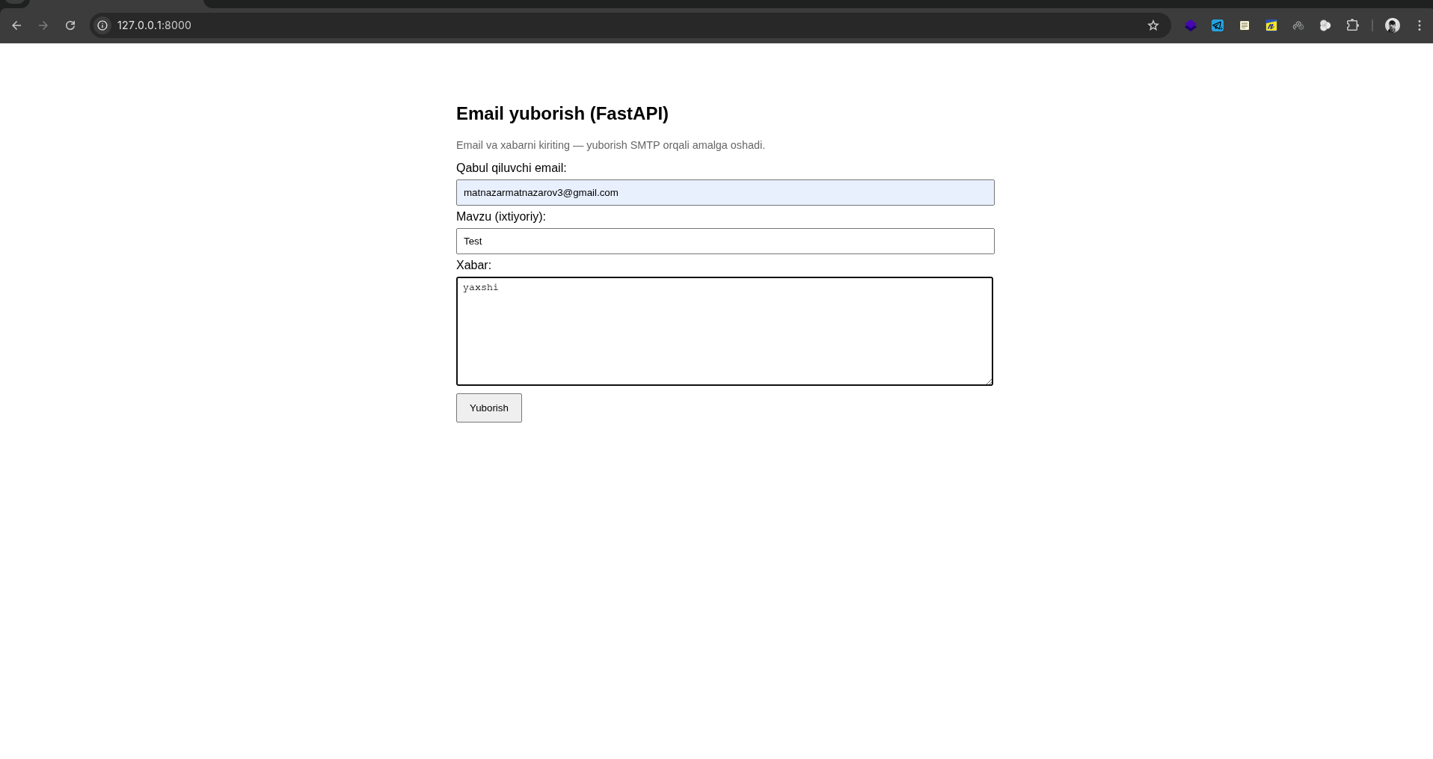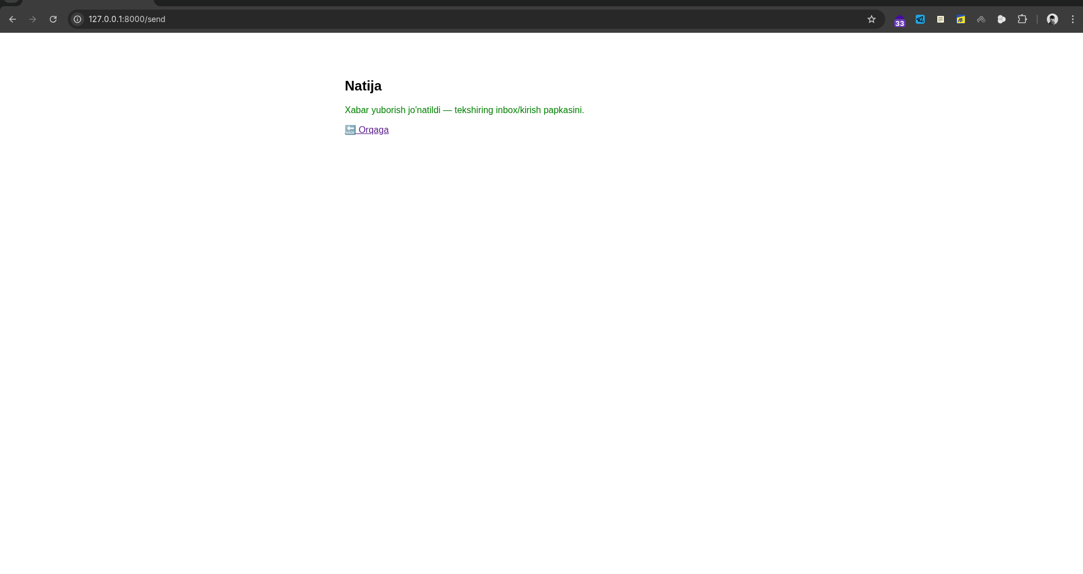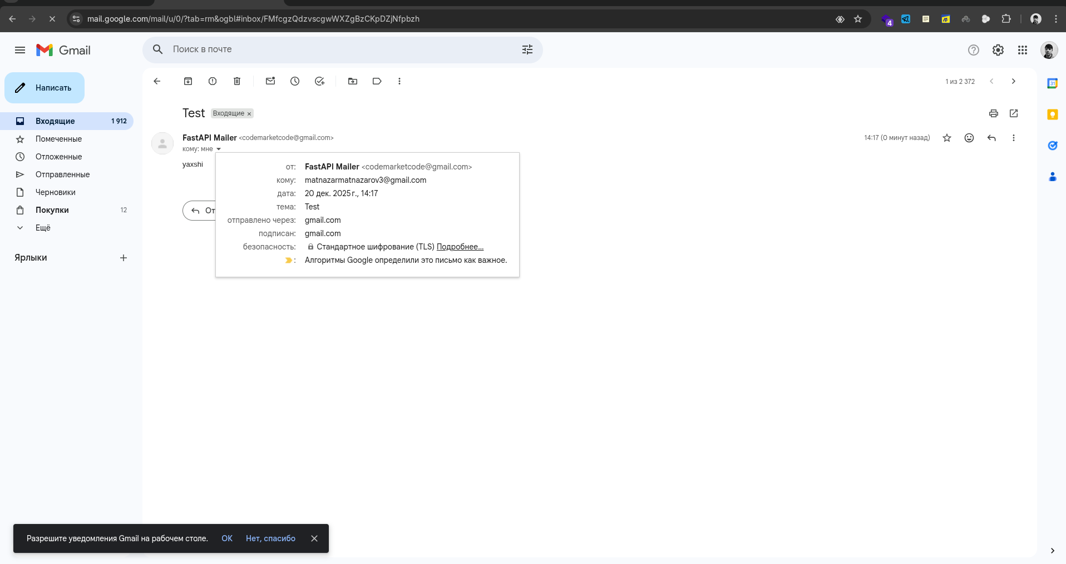

main.py

from fastapi import FastAPI, Request, Form, BackgroundTasks
from fastapi.responses import HTMLResponse
from fastapi.templating import Jinja2Templates
from email_validator import validate_email, EmailNotValidError
import smtplib
from email.message import EmailMessage
from environs import Env
import os

env = Env()
# .env faylni o'qish (mavjud bo'lsa)
env_file = os.path.join(os.path.dirname(__file__), ".env")
if os.path.exists(env_file):
env.read_env(env_file)
else:
# .env fayl mavjud emas, default qiymatlar ishlatiladi
pass

# Environment variables (default qiymatlar bilan)
SMTP_HOST = env.str("SMTP_HOST", default="")
SMTP_PORT = int(env.str("SMTP_PORT", "587"))
SMTP_USER = env.str("SMTP_USER", default="")
SMTP_PASS = env.str("SMTP_PASS", default="")
FROM_NAME = env.str("FROM_NAME", "FastAPI Mailer")
FROM_EMAIL = env.str("FROM_EMAIL", SMTP_USER if SMTP_USER else "")

app = FastAPI()
templates = Jinja2Templates(directory="templates")

def send_email_smtp(to_email: str, subject: str, body: str):
if not all([SMTP_HOST, SMTP_USER, SMTP_PASS]):
raise RuntimeError(
"SMTP sozlamalari topilmadi. .env faylni yarating va quyidagilarni to'ldiring:\n"
"SMTP_HOST=smtp.gmail.com\n"
"SMTP_PORT=587\n"
"SMTP_USER=your_email@gmail.com\n"
"SMTP_PASS=your_app_password\n"
"FROM_NAME=FastAPI Mailer\n"
"FROM_EMAIL=your_email@gmail.com"
)

msg = EmailMessage()
msg["From"] = f"{FROM_NAME} <{FROM_EMAIL}>"
msg["To"] = to_email
msg["Subject"] = subject
msg.set_content(body)

# TLS bilan ulanish
with smtplib.SMTP(SMTP_HOST, SMTP_PORT, timeout=30) as smtp:
_ = smtp.ehlo()
if SMTP_PORT in (587, 25):
_ = smtp.starttls()
_ = smtp.ehlo()
_ = smtp.login(SMTP_USER, SMTP_PASS)
_ = smtp.send_message(msg)

@app.get("/", response_class=HTMLResponse)
async def form(request: Request):
return templates.TemplateResponse("index.html", {"request": request})

@app.post("/send", response_class=HTMLResponse)
async def send(
request: Request,
background_tasks: BackgroundTasks,
email: str = Form(...),
message: str = Form(...),
subject: str = Form("Xabar FastAPI dan"),
):
try:
valid_email_info = validate_email(email)
valid_email = valid_email_info.email
except EmailNotValidError:
return templates.TemplateResponse(
"result.html",
{"request": request, "ok": False, "msg": "Email noto'g'ri kiritildi."},
status_code=400,
)

try:
background_tasks.add_task(send_email_smtp, valid_email, subject, message)
except Exception as e:
return templates.TemplateResponse(
"result.html",
{"request": request, "ok": False, "msg": f"Xatolik: {e}"},
status_code=500,
)

return templates.TemplateResponse(
"result.html",
{
"request": request,
"ok": True,
"msg": "Xabar yuborish jo'natildi — tekshiring inbox/kirish papkasini.",
},
)

if __name__ == "__main__":
import uvicorn

print("=" * 60)
print("🚀 FastAPI Email Sender Server")
print("=" * 60)
print("📍 Server: http://localhost:8000")
print("📧 Email yuborish uchun: http://localhost:8000")
print("📖 API Docs: http://localhost:8000/docs")
print("=" * 60)

if not all([SMTP_HOST, SMTP_USER, SMTP_PASS]):
print("\n⚠️ Eslatma: .env fayl topilmadi yoki to'liq emas!")
print("📝 Email yuborish ishlamaydi. .env.example faylini ko'rib chiqing.")
print(" Yoki quyidagi o'zgaruvchilarni to'ldiring:")
print(" - SMTP_HOST")
print(" - SMTP_USER")
print(" - SMTP_PASS")
print()

uvicorn.run(
"main:app",
host="0.0.0.0",
port=8000,
reload=True,
log_level="info"
)

.env.example
# SMTP Server Configuration
# Email yuborish uchun SMTP server sozlamalari

SMTP_HOST=smtp.gmail.com
SMTP_PORT=587
SMTP_USER=your_email@gmail.com
SMTP_PASS=your_app_password
FROM_NAME=FastAPI Mailer
FROM_EMAIL=your_email@gmail.com

# Eslatma:
# Gmail uchun App Password yaratish kerak:
# 1. Google Account -> Security -> 2-Step Verification
# 2. App passwords -> Generate new password
# 3. Yaratilgan parolni SMTP_PASS ga yozing

