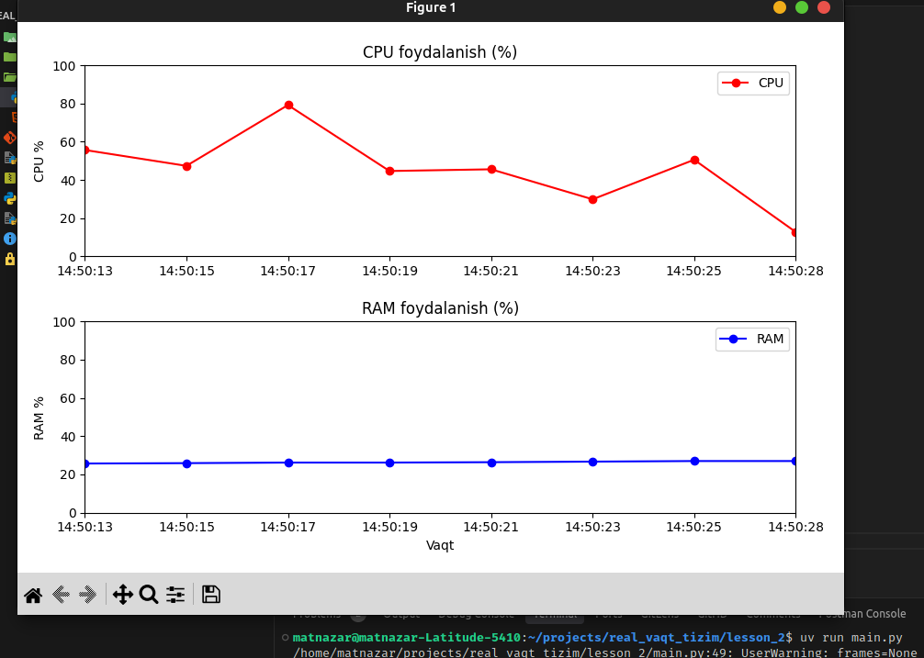

"""
Real-time System Monitoring (CPU va RAM)
----------------------------------------
Ushbu dastur kompyuteringizning CPU va RAM
foydalanishini real vaqt rejimida kuzatadi va grafikda ko‘rsatadi.
"""

import psutil # CPU va RAM ma'lumotlarini olish uchun kutubxona
from collections import deque # Limitlangan navbat (oxirgi N ta elementni saqlash uchun)
import matplotlib.pyplot as plt # Grafik chizish uchun kutubxona
from matplotlib.animation import FuncAnimation # Real-time grafik animatsiyasi
import datetime as dt # Vaqtni formatlash uchun

# ----------------------
# Sozlamalar
# ----------------------
max_points = 30 # Grafikka faqat oxirgi 30 ta qiymat tushadi

cpu_data = deque(maxlen=max_points) # CPU foizlari
ram_data = deque(maxlen=max_points) # RAM foizlari
timestamps = deque(maxlen=max_points) # vaqt belgilarini saqlaydi (soat:daqiq:sekund)

# ----------------------
# Grafik oynasi sozlanmoqda
# ----------------------
fig, (ax1, ax2) = plt.subplots(2, 1, figsize=(9,6))
# 2 ta subplot: 1-chi CPU uchun, 2-chi RAM uchun

fig.tight_layout(pad=3.0)
# Grafiklar orasida joy qoldirish

# ----------------------
# Boshlang'ich chiziqlar
# ----------------------
cpu_line, = ax1.plot([], [], 'r-o', label="CPU") # CPU grafigi (qizil)
ram_line, = ax2.plot([], [], 'b-o', label="RAM") # RAM grafigi (ko‘k)

# ----------------------
# Grafik sarlavhalari va o‘qlar
# ----------------------
ax1.set_title("CPU foydalanish (%)")
ax2.set_title("RAM foydalanish (%)")

ax1.set_ylim(0, 100) # CPU % 0–100
ax2.set_ylim(0, 100) # RAM % 0–100

ax1.set_ylabel("CPU %") # 1-plotning y-o‘qi
ax2.set_ylabel("RAM %") # 2-plotning y-o‘qi
ax2.set_xlabel("Vaqt") # Pastki plotning x-o‘qi (vaqt)

ax1.legend(loc="upper right") # CPU uchun legenda
ax2.legend(loc="upper right") # RAM uchun legenda

# ----------------------
# Har safar chaqiriladigan yangilash funksiyasi
# ----------------------
def update(frame):
cpu = psutil.cpu_percent(interval=0.1) # CPU foizi
ram = psutil.virtual_memory().percent # RAM foizi
t = dt.datetime.now().strftime("%H:%M:%S") # Vaqt (soat:daqiq:sekund)

# Navbatlarga qo‘shish (deque eski qiymatlarni o‘zi o‘chiradi)
cpu_data.append(cpu)
ram_data.append(ram)
timestamps.append(t)

# Chiziqlarni yangilash
cpu_line.set_data(timestamps, cpu_data)
ram_line.set_data(timestamps, ram_data)

# X o‘qini yangilash (faqat oxirgi qiymatlar ko‘rinadi)
ax1.set_xlim(timestamps[0], timestamps[-1])
ax2.set_xlim(timestamps[0], timestamps[-1])

return cpu_line, ram_line

# ----------------------
# Grafikni jonli qilish
# ----------------------
ani = FuncAnimation(fig, update, interval=2000, blit=False)

plt.show() # Grafik oynasini ko‘rsatish

