15-amaliyot ishi.
Soket serverda bir nechta mijozni boshqarish (selectors)
Soket (socket) – bu tarmoq orqali ikki dastur orasida ma’lumot almashishni ta’minlaydigan dasturiy interfeys.
Texnik ta’rif
• Soket — bu operatsion tizim tomonidan taqdim etilgan tarmoq API bo‘lib, dastur TCP/IP yoki UDP protokollari orqali ma’lumot yuborishi va qabul qilishi uchun ishlatiladi.
• Python’da soket bilan ishlash uchun socket moduli bor.
Soketning asosiy turlari
1. Stream socket (SOCK_STREAM)
o TCP protokoli asosida ishlaydi.
o Ulanish o‘rnatiladi, ma’lumot ishonchli va tartibli yuboriladi.
o Masalan: HTTP, FTP.
2. Datagram socket (SOCK_DGRAM)
o UDP protokoli asosida ishlaydi.
o Ulanish yo‘q, ma’lumot paket ko‘rinishida yuboriladi.
o Tez, lekin kafolatlanmagan. Masalan: onlayn o‘yinlar, video oqim.
Soket asosiy amallari
• Server tomonda:
1. socket() – soket yaratish
2. bind() – IP + portga bog‘lash
3. listen() – mijozlarni kutish (TCP)
4. accept() – yangi mijozni qabul qilish
5. recv() / send() – ma’lumot almashish
6. close() – soketni yopish
• Klient tomonda:
1. socket() – soket yaratish
2. connect() – serverga ulanib chiqish
3. send() – xabar yuborish
4. recv() – xabar qabul qilish
5. close() – soketni yopish
Selectors yordamida ko‘p mijozli server
Selectors — bu ko‘p mijozli socket serverni boshqarish uchun ishlatiladigan yengil va tezkor boshqaruvchi mexanizm.
Muammo nima?
• Oddiy socket server odatda accept() orqali bitta ulanishni kutadi.
• Bir nechta mijoz bo‘lsa, server bloklanib qolishi yoki thread/fork ishlatishga to‘g‘ri keladi.
• Bu resurslarni ko‘p ishlatadi.
Yechim: non-blocking I/O va multiplexing. Python’da buni selectors moduli orqali qilish mumkin.
selectors moduli haqida
• selectors — turli platformalardagi I/O multiplexing API’lar uchun abstraksiya:
o Linux → epoll
o BSD/Mac → kqueue
o Windows → select
• U ko‘p soketlarni kuzatish va tayyor bo‘lganda ularga ishlov berishga yordam beradi.
Asosiy maqsadi:
• Ko‘p mijozlarni samarali boshqarish
• Har bir mijoz uchun alohida thread yaratmasdan parallel ishlash
• Resurslardan tejamkor foydalanish
• Non-blocking (asenkron) tarmoq server yaratish
Oddiy kod – echo server (selectors bilan)
import selectors
import socket
sel = selectors.DefaultSelector()
# Har bir yangi ulanish uchun handler
def accept(sock):
conn, addr = sock.accept() # Yangi ulanishni qabul qilish
print("Yangi mijoz:", addr)
conn.setblocking(False)
sel.register(conn, selectors.EVENT_READ, read)
# Mijozdan xabar o‘qish
def read(conn):
data = conn.recv(1024)
if data:
print("Qabul qilindi:", data.decode())
conn.sendall(data) # Echo qilib qaytarish
else:
print("Mijoz uzildi")
sel.unregister(conn)
conn.close()
# Asosiy server soketi
HOST, PORT = "127.0.0.1", 5000
server = socket.socket(socket.AF_INET, socket.SOCK_STREAM)
server.bind((HOST, PORT))
server.listen()
server.setblocking(False)
sel.register(server, selectors.EVENT_READ, accept)
print(f"Server {HOST}:{PORT} da ishlayapti...")
while True:
events = sel.select() # Tayyor bo‘lgan soketlarni olish
for key, mask in events:
callback = key.data
callback(key.fileobj)

Topshiriq
1. selectors modulidan foydalanib oddiy echo server yozing. Server mijozdan matn qabul qilib, uni o‘sha mijozga qaytarib yuborsin.
2. Serverga yangi mijoz ulanayotganda, konsolga “Yangi mijoz ulanmoqda…” degan xabar chiqsin.
3. Soketni setblocking(False) yordamida bloklamasdan ishlaydigan qilib sozlang va dastur hech qachon to‘xtab qolmasligini sinab ko‘ring.
4. Serverga bir vaqtning o‘zida bir nechta mijoz ulanadigan holatni yarating va har biri bilan alohida ishlang.
5. Agar mijoz ulanib turgan paytda chiqib ketsa (data == b''), server uni selector ro‘yxatidan unregister() orqali olib tashlasin va soketni yopsin.
6. Har bir kiruvchi va chiquvchi xabarni server.log fayliga yozib boring, xabar yoniga sana va vaqtni ham qo‘shing.
7. Bitta mijozdan kelgan xabarni boshqa barcha ulangan mijozlarga yuboradigan chat funksiyasini yarating.
8. Mijozga ikki maxsus buyruq qo‘shing: "!exit" buyrug‘i bilan u serverdan chiqsin, "!list" buyrug‘i bilan esa ulangan mijozlar ro‘yxatini ko‘rsatsin.
9. Selector’da select(timeout=5) parametri qo‘llanilsin va agar 5 soniya davomida hech qanday hodisa bo‘lmasa, server konsolida "Hech narsa bo‘lmadi..." degan xabar chiqsin.
10. Server ish jarayonida har 10 soniyada faol mijozlar soni va qabul qilingan xabarlar soni konsolga chiqib tursin.
11. Bitta oqim (thread) yordamida bir vaqtning o‘zida o‘nlab foydalanuvchilarni boshqaruvchi non-blocking chat server yozing.
12. Mijozdan serverga fayl yuborish funksiyasini qo‘shing. Server faylni qabul qilib, diskka saqlasin.
13. Selector asosidagi serverni SSL (TLS) bilan birlashtirib, shifrlangan aloqa (HTTPS uslubida) tashkil qiling.
14. Bitta dasturda ikkita port ishlatadigan server yozing: masalan, 5000-port — matnli xabarlar uchun, 5001-port — fayl yuborish uchun xizmat qilsin.
15. Oddiy real-time monitoring tizimi yarating: mijozlar o‘z kompyuteridagi CPU va RAM ma’lumotlarini yuboradi, server esa ularni qabul qilib konsolga real vaqt rejimida chiqaradi.

Masalalar
1. Chat application web sayti
Kod:

import json
from channels.generic.websocket import AsyncWebsocketConsumer
from channels.db import database_sync_to_async
from django.contrib.auth import get_user_model
from .models import ChatRoom, Message, MessageRead
from django.utils import timezone

User = get_user_model()

class ChatConsumer(AsyncWebsocketConsumer):
async def connect(self):
self.room_id = self.scope['url_route']['kwargs']['room_id']
self.room_group_name = f'chat_{self.room_id}'
self.user = self.scope["user"]

if self.user.is_anonymous:
await self.close()
return

# Verify user is participant of the room before allowing connection
is_participant = await self.user_in_room(self.user.id, self.room_id)
if not is_participant:
await self.close()
return

# Join room group
await self.channel_layer.group_add(
self.room_group_name,
self.channel_name
)

await self.accept()

# Update user online status
await self.update_user_online_status(True)

async def disconnect(self, close_code):
# Leave room group
await self.channel_layer.group_discard(
self.room_group_name,
self.channel_name
)

# Update user online status
await self.update_user_online_status(False)

async def receive(self, text_data):
print(f"Received WebSocket message: {text_data}")
try:
data = json.loads(text_data)
print(f"Parsed data: {data}")
except json.JSONDecodeError:
print("Invalid JSON received")
return

message_type = data.get('type', 'text')
content = (data.get('content') or '').strip()
print(f"Message type: {message_type}, Content: '{content}'")

# Guard: user must be in room for all events
if not await self.user_in_room(self.user.id, self.room_id):
print(f"User {self.user.id} not authorized for room {self.room_id}")
return

if message_type == 'text':
if not content:
print("Empty message content")
return

try:
# Save message to database
message = await self.save_message(content, message_type)
print(f"Message saved: {message.id}")

# Send message to room group
await self.channel_layer.group_send(
self.room_group_name,
{
'type': 'chat_message',
'message': {
'id': str(message.id),
'content': message.content,
'message_type': message.message_type,
'sender': {
'id': str(message.sender.id),
'username': message.sender.username,
'first_name': message.sender.first_name,
'last_name': message.sender.last_name,
},
'created_at': message.created_at.isoformat(),
'file_url': None,
'file_size': None,
}
}
)
print(f"Message broadcasted to group: {self.room_group_name}")
except Exception as e:
print(f"Error sending message: {e}")
return
elif message_type == 'media_uploaded':
# Handle media file upload notification
message_id = data.get('message_id')
if message_id:
message = await self.get_message_by_id(message_id)
if message:
await self.channel_layer.group_send(
self.room_group_name,
{
'type': 'chat_message',
'message': {
'id': str(message.id),
'content': message.content,
'message_type': message.message_type,
'sender': {
'id': str(message.sender.id),
'username': message.sender.username,
'first_name': message.sender.first_name,
'last_name': message.sender.last_name,
'profile_picture': message.sender.profile_picture.url if message.sender.profile_picture else None,
},
'created_at': message.created_at.isoformat(),
'file_url': message.file.url if message.file else None,
'file_size': message.file_size,
'duration': message.duration,
}
}
)
elif message_type == 'typing':
# Handle typing indicator
await self.channel_layer.group_send(
self.room_group_name,
{
'type': 'typing_indicator',
'user': {
'id': str(self.user.id),
'username': self.user.username,
'first_name': self.user.first_name,
},
'is_typing': data.get('is_typing', False)
}
)

Natija:

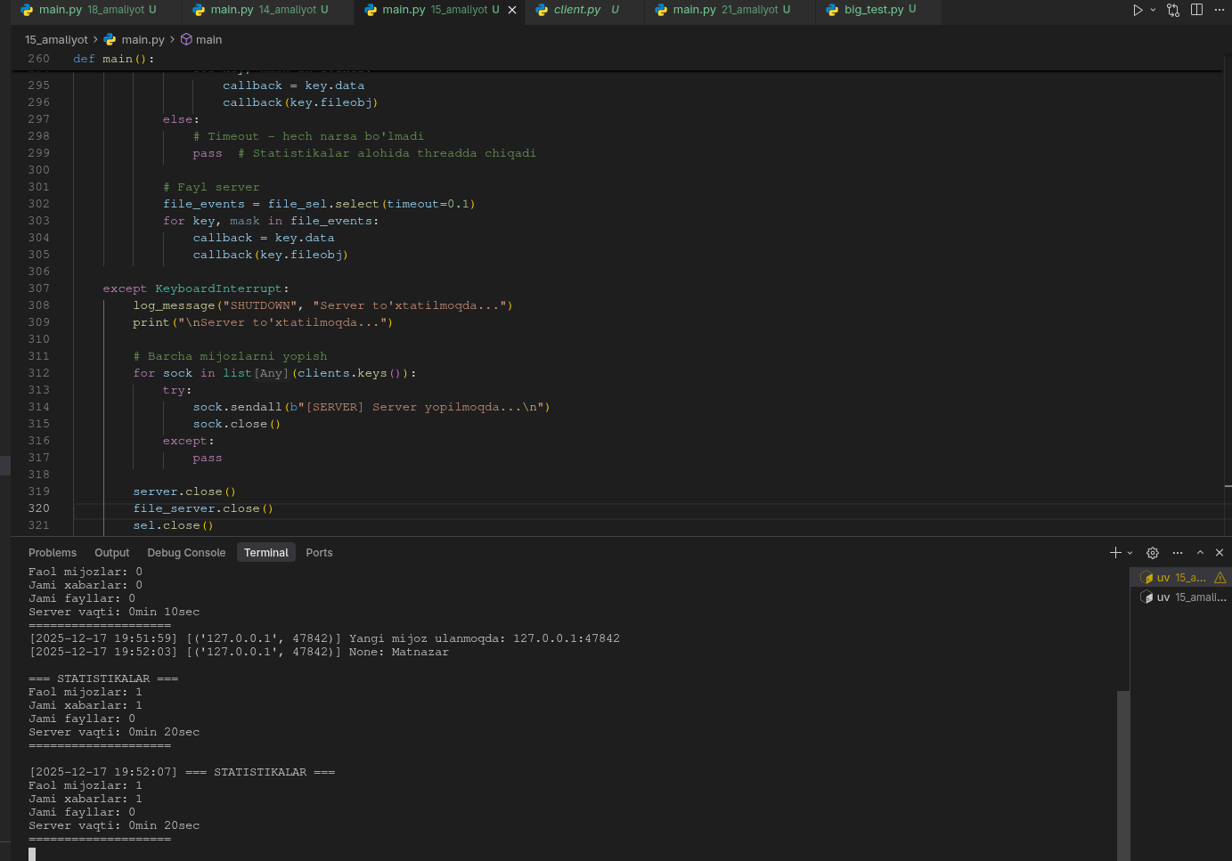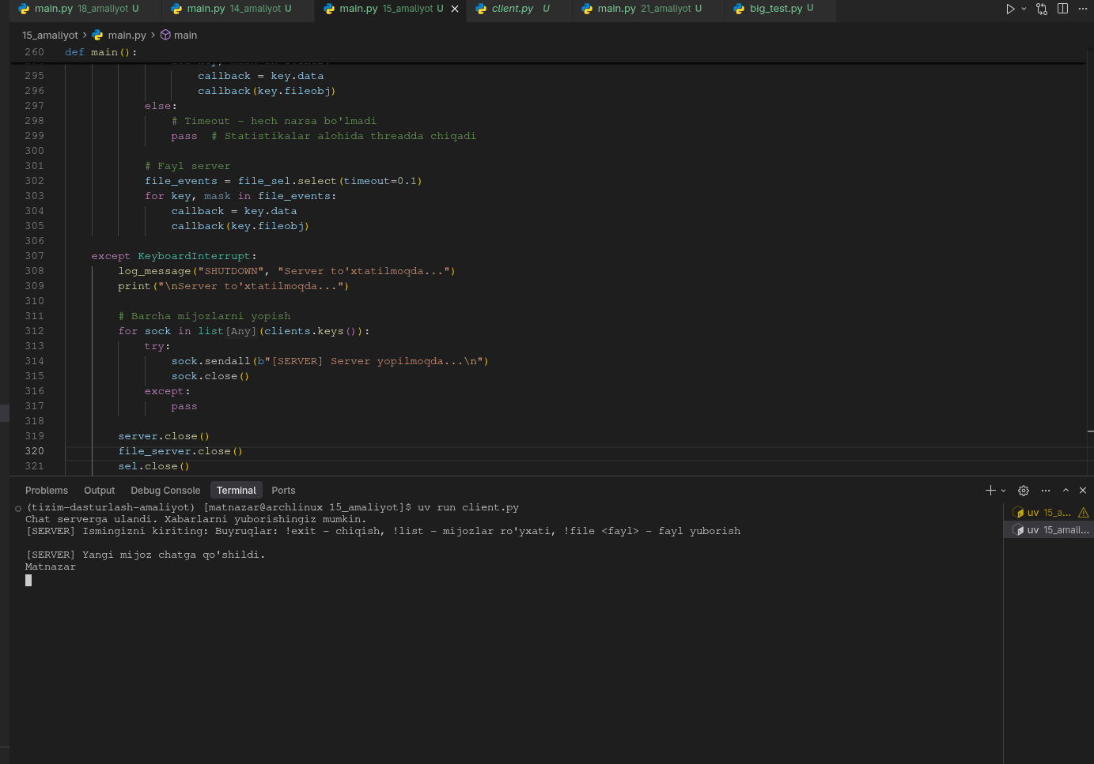
"""
Topshiriq: Multi-Client Chat Server with File Transfer and Commands
Birlashtirilgan topshiriqlar:
- Chat funksiyasi (7)
- Maxsus buyruqlar !exit va !list (8)
- Timeout bilan select (9)
- Statistikalar (10)
- Non-blocking chat server (11)
- Fayl yuborish (12)
- Logging (6)
"""

import selectors
import socket
import threading
import time
import os
from datetime import datetime
from collections import defaultdict

# Global o'zgaruvchilar
HOST = "127.0.0.1"
PORT = 5000
FILE_PORT = 5001
LOG_FILE = "server.log"
UPLOADS_DIR = "uploads"
STATS_INTERVAL = 10 # soniya

# Statistikalar
stats = {
'total_messages': 0,
'total_files': 0,
'active_clients': 0,
'start_time': time.time()
}

# Mijozlar ro'yxati: {socket: {'addr': addr, 'nickname': nickname}}
clients = {}

# Selectorlar
sel = selectors.DefaultSelector()
file_sel = selectors.DefaultSelector()

# Uploads papkasini yaratish
os.makedirs(UPLOADS_DIR, exist_ok=True)

def log_message(message_type, message, client_addr=None):
"""Xabarlarni server.log fayliga yozish"""
timestamp = datetime.now().strftime("%Y-%m-%d %H:%M:%S")
addr_str = f" [{client_addr}]" if client_addr else ""
log_entry = f"[{timestamp}]{addr_str} [{message_type}] {message}\n"

with open(LOG_FILE, "a", encoding="utf-8") as f:
f.write(log_entry)

print(f"[{timestamp}]{addr_str} {message}")

def broadcast_message(sender_sock, message, exclude_sender=True):
"""Barcha mijozlarga xabar yuborish"""
disconnected = []
for sock, client_info in clients.items():
if exclude_sender and sock == sender_sock:
continue
try:
sock.sendall(message.encode('utf-8'))
except (ConnectionError, OSError):
disconnected.append(sock)

# Uzilgan ulanishlarni tozalash
for sock in disconnected:
handle_client_disconnect(sock)

def handle_client_disconnect(sock):
"""Mijoz uzilganda tozalash"""
if sock in clients:
client_info = clients[sock]
addr = client_info['addr']
nickname = client_info.get('nickname', 'Unknown')

log_message("DISCONNECT", f"Mijoz chiqdi: {nickname} ({addr[0]}:{addr[1]})", addr)
broadcast_message(sock, f"[SERVER] {nickname} chatdan chiqdi.\n", exclude_sender=False)

sel.unregister(sock)
sock.close()
del clients[sock]
stats['active_clients'] = len(clients)

def handle_client_command(sock, command, client_info):
"""Maxsus buyruqlarni boshqarish"""
command = command.strip().lower()

if command == "!exit":
handle_client_disconnect(sock)
return True
elif command == "!list":
client_list = []
for s, info in clients.items():
nickname = info.get('nickname', 'Unknown')
addr = info['addr']
client_list.append(f" - {nickname} ({addr[0]}:{addr[1]})")

response = "[SERVER] Ulangan mijozlar:\n" + "\n".join(client_list) + "\n"
try:
sock.sendall(response.encode('utf-8'))
except (ConnectionError, OSError):
handle_client_disconnect(sock)
return True
return True

return False

def read_client(sock):
"""Mijozdan xabar o'qish"""
try:
data = sock.recv(4096)
if not data:
handle_client_disconnect(sock)
return

message = data.decode('utf-8', errors='ignore').strip()
client_info = clients[sock]
addr = client_info['addr']
nickname = client_info.get('nickname', f"Client-{addr[1]}")

# Maxsus buyruqlarni tekshirish
if message.startswith('!'):
if handle_client_command(sock, message, client_info):
return

# Oddiy xabar
formatted_message = f"[{nickname}]: {message}\n"
log_message("MESSAGE", f"{nickname}: {message}", addr)
broadcast_message(sock, formatted_message)
stats['total_messages'] += 1

except (ConnectionError, OSError, UnicodeDecodeError) as e:
handle_client_disconnect(sock)

def accept_client(sock):
"""Yangi mijozni qabul qilish"""
try:
conn, addr = sock.accept()
conn.setblocking(False)

# Nickname so'rash
conn.sendall(b"[SERVER] Ismingizni kiriting: ")

# Mijozni ro'yxatga qo'shish
clients[conn] = {'addr': addr, 'nickname': None}
stats['active_clients'] = len(clients)

sel.register(conn, selectors.EVENT_READ, read_client)
log_message("CONNECT", f"Yangi mijoz ulanmoqda: {addr[0]}:{addr[1]}", addr)

# Boshqa mijozlarga xabar berish
broadcast_message(conn, f"[SERVER] Yangi mijoz chatga qo'shildi.\n", exclude_sender=False)

except (OSError, ConnectionError) as e:
log_message("ERROR", f"Yangi mijozni qabul qilishda xato: {e}")

def handle_file_upload(sock):
"""Fayl yuborishni qabul qilish"""
try:
# Fayl nomi va hajmini olish
header = sock.recv(1024).decode('utf-8', errors='ignore')
if not header:
file_sel.unregister(sock)
sock.close()
return

parts = header.split('|')
if len(parts) != 3:
sock.sendall(b"ERROR: Invalid file header")
file_sel.unregister(sock)
sock.close()
return

filename, file_size_str, client_addr = parts
file_size = int(file_size_str)

# Xavfsizlik: faqat fayl nomini olish
filename = os.path.basename(filename)
filepath = os.path.join(UPLOADS_DIR, f"{int(time.time())}_{filename}")

log_message("FILE_UPLOAD", f"Fayl qabul qilinmoqda: {filename} ({file_size} bytes)", client_addr)

# Faylni qabul qilish
received = 0
with open(filepath, 'wb') as f:
while received < file_size:
chunk = sock.recv(4096)
if not chunk:
break
f.write(chunk)
received += len(chunk)

if received == file_size:
sock.sendall(f"SUCCESS: Fayl saqlandi: {filepath}".encode('utf-8'))
log_message("FILE_SUCCESS", f"Fayl saqlandi: {filepath} ({file_size} bytes)", client_addr)
stats['total_files'] += 1
else:
sock.sendall(f"ERROR: Fayl to'liq yuklanmadi".encode('utf-8'))
os.remove(filepath)
log_message("FILE_ERROR", f"Fayl to'liq yuklanmadi: {filename}", client_addr)

file_sel.unregister(sock)
sock.close()

except (OSError, ValueError, ConnectionError) as e:
log_message("FILE_ERROR", f"Fayl yuklashda xato: {e}")
try:
file_sel.unregister(sock)
sock.close()
except:
pass

def accept_file_client(sock):
"""Fayl yuborish uchun yangi mijozni qabul qilish"""
try:
conn, addr = sock.accept()
conn.setblocking(False)
file_sel.register(conn, selectors.EVENT_READ, handle_file_upload)
log_message("FILE_CONNECT", f"Fayl yuborish ulanishi: {addr[0]}:{addr[1]}", addr)
except (OSError, ConnectionError) as e:
log_message("ERROR", f"Fayl mijozini qabul qilishda xato: {e}")

def print_stats():
"""Statistikalarni chiqarish"""
uptime = int(time.time() - stats['start_time'])
uptime_str = f"{uptime // 60}min {uptime % 60}sec"

stats_msg = (
f"\n=== STATISTIKALAR ===\n"
f"Faol mijozlar: {stats['active_clients']}\n"
f"Jami xabarlar: {stats['total_messages']}\n"
f"Jami fayllar: {stats['total_files']}\n"
f"Server vaqti: {uptime_str}\n"
f"====================\n"
)
print(stats_msg)
log_message("STATS", stats_msg.strip())

def stats_thread():
"""Statistikalarni har 10 soniyada chiqarish"""
while True:
time.sleep(STATS_INTERVAL)
print_stats()

def main():
"""Asosiy server funksiyasi"""
# Chat server
server = socket.socket(socket.AF_INET, socket.SOCK_STREAM)
server.setsockopt(socket.SOL_SOCKET, socket.SO_REUSEADDR, 1)
server.bind((HOST, PORT))
server.listen()
server.setblocking(False)
sel.register(server, selectors.EVENT_READ, accept_client)

# Fayl server
file_server = socket.socket(socket.AF_INET, socket.SOCK_STREAM)
file_server.setsockopt(socket.SOL_SOCKET, socket.SO_REUSEADDR, 1)
file_server.bind((HOST, FILE_PORT))
file_server.listen()
file_server.setblocking(False)
file_sel.register(file_server, selectors.EVENT_READ, accept_file_client)

log_message("START", f"Chat server {HOST}:{PORT} da ishga tushdi")
log_message("START", f"Fayl server {HOST}:{FILE_PORT} da ishga tushdi")
print(f"Chat server {HOST}:{PORT} da ishlayapti...")
print(f"Fayl server {HOST}:{FILE_PORT} da ishlayapti...")
print("Statistikalar har 10 soniyada chiqadi.\n")

# Statistikalar threadini ishga tushirish
stats_thread_obj = threading.Thread(target=stats_thread, daemon=True)
stats_thread_obj.start()

# Asosiy loop
try:
while True:
# Chat server
events = sel.select(timeout=5)
if events:
for key, mask in events:
callback = key.data
callback(key.fileobj)
else:
# Timeout - hech narsa bo'lmadi
pass # Statistikalar alohida threadda chiqadi

# Fayl server
file_events = file_sel.select(timeout=0.1)
for key, mask in file_events:
callback = key.data
callback(key.fileobj)

except KeyboardInterrupt:
log_message("SHUTDOWN", "Server to'xtatilmoqda...")
print("\nServer to'xtatilmoqda...")

# Barcha mijozlarni yopish
for sock in list(clients.keys()):
try:
sock.sendall(b"[SERVER] Server yopilmoqda...\n")
sock.close()
except:
pass

server.close()
file_server.close()
sel.close()
file_sel.close()
log_message("SHUTDOWN", "Server to'xtatildi")

if __name__ == "__main__":
main()

client.py

"""
Chat Client - Server bilan aloqa qilish uchun mijoz dasturi
"""

import socket
import threading
import sys
import os

HOST = "127.0.0.1"
CHAT_PORT = 5000
FILE_PORT = 5001

def receive_messages(sock):
"""Serverdan xabarlarni qabul qilish"""
while True:
try:
data = sock.recv(4096)
if not data:
print("\nServer bilan ulanish uzildi.")
break
print(data.decode('utf-8'), end='')
except (ConnectionError, OSError):
print("\nServer bilan ulanish uzildi.")
break

def send_file(filename, host=HOST, port=FILE_PORT):
"""Fayl yuborish"""
if not os.path.exists(filename):
print(f"Xato: {filename} fayli topilmadi.")
return False

try:
sock = socket.socket(socket.AF_INET, socket.SOCK_STREAM)
sock.connect((host, port))

file_size = os.path.getsize(filename)
header = f"{filename}|{file_size}|{HOST}:{FILE_PORT}"
sock.sendall(header.encode('utf-8'))

with open(filename, 'rb') as f:
while True:
chunk = f.read(4096)
if not chunk:
break
sock.sendall(chunk)

response = sock.recv(1024).decode('utf-8')
print(f"[SERVER] {response}")
sock.close()
return True

except Exception as e:
print(f"Fayl yuborishda xato: {e}")
return False

def main():
"""Asosiy mijoz funksiyasi"""
try:
sock = socket.socket(socket.AF_INET, socket.SOCK_STREAM)
sock.connect((HOST, CHAT_PORT))

# Xabarlarni qabul qilish thread
receive_thread = threading.Thread(target=receive_messages, args=(sock,), daemon=True)
receive_thread.start()

print("Chat serverga ulandi. Xabarlarni yuborishingiz mumkin.")
print("Buyruqlar: !exit - chiqish, !list - mijozlar ro'yxati, !file <fayl> - fayl yuborish\n")

while True:
message = input()

if message.strip() == "!exit":
sock.sendall("!exit".encode('utf-8'))
break
elif message.strip().startswith("!file "):
filename = message.strip()[6:]
send_file(filename)
else:
sock.sendall(message.encode('utf-8'))

sock.close()
print("Chatdan chiqildi.")

except ConnectionRefusedError:
print(f"Xato: Server {HOST}:{CHAT_PORT} da ishlamayapti.")
except KeyboardInterrupt:
print("\nChatdan chiqildi.")
try:
sock.close()
except:
pass
except Exception as e:
print(f"Xato: {e}")

if __name__ == "__main__":
main()

