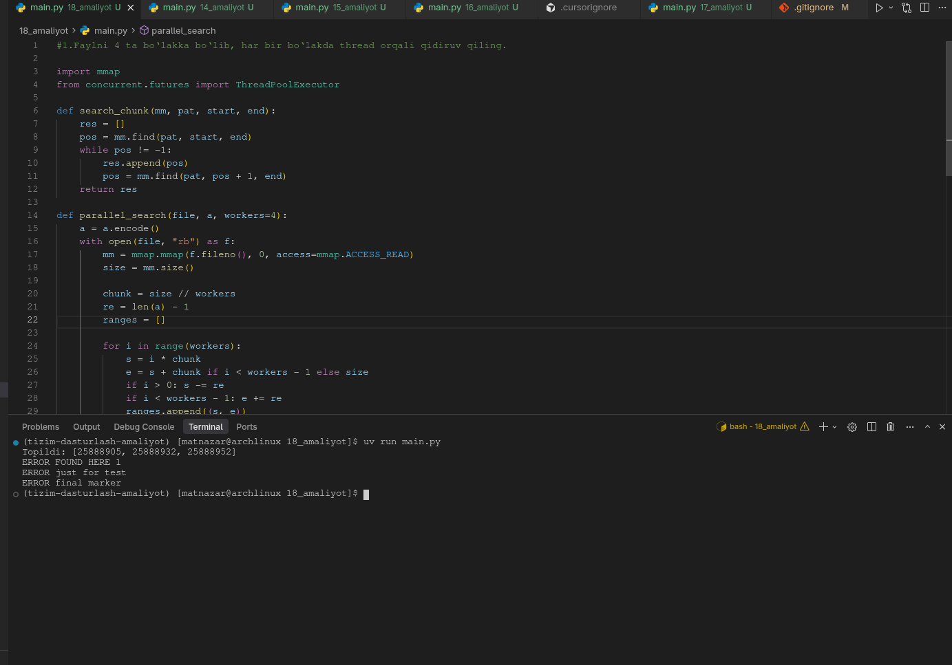
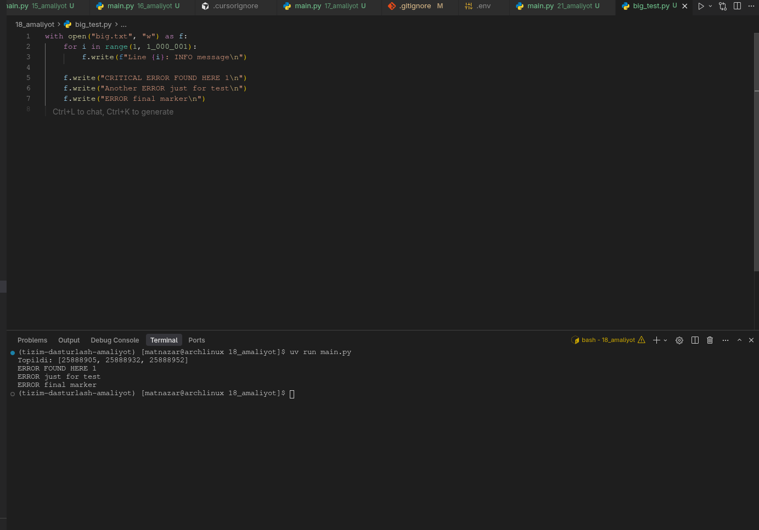
#1.Faylni 4 ta bo‘lakka bo‘lib, har bir bo‘lakda thread orqali qidiruv qiling.

import mmap
from concurrent.futures import ThreadPoolExecutor

def search_chunk(mm, pat, start, end):
res = []
pos = mm.find(pat, start, end)
while pos != -1:
res.append(pos)
pos = mm.find(pat, pos + 1, end)
return res

def parallel_search(file, a, workers=4):
a = a.encode()
with open(file, "rb") as f:
mm = mmap.mmap(f.fileno(), 0, access=mmap.ACCESS_READ)
size = mm.size()

chunk = size // workers
re = len(a) - 1
ranges = []

for i in range(workers):
s = i * chunk
e = s + chunk if i < workers - 1 else size
if i > 0: s -= re
if i < workers - 1: e += re
ranges.append((s, e))

results = []
with ThreadPoolExecutor(workers) as ex:
for r in ex.map(lambda x: search_chunk(mm, a, x[0], x[1]), ranges):
results.extend(r)

mm.close()
return sorted(set(results))

if __name__ == "__main__":
offs = parallel_search("big.txt", "ERROR")
print("Topildi:", offs)
with open("big.txt", "rb") as f:
mm = mmap.mmap(f.fileno(), 0, access=mmap.ACCESS_READ)

for off in offs:
mm.seek(off)
print(mm.readline().decode().rstrip())

mm.close()

