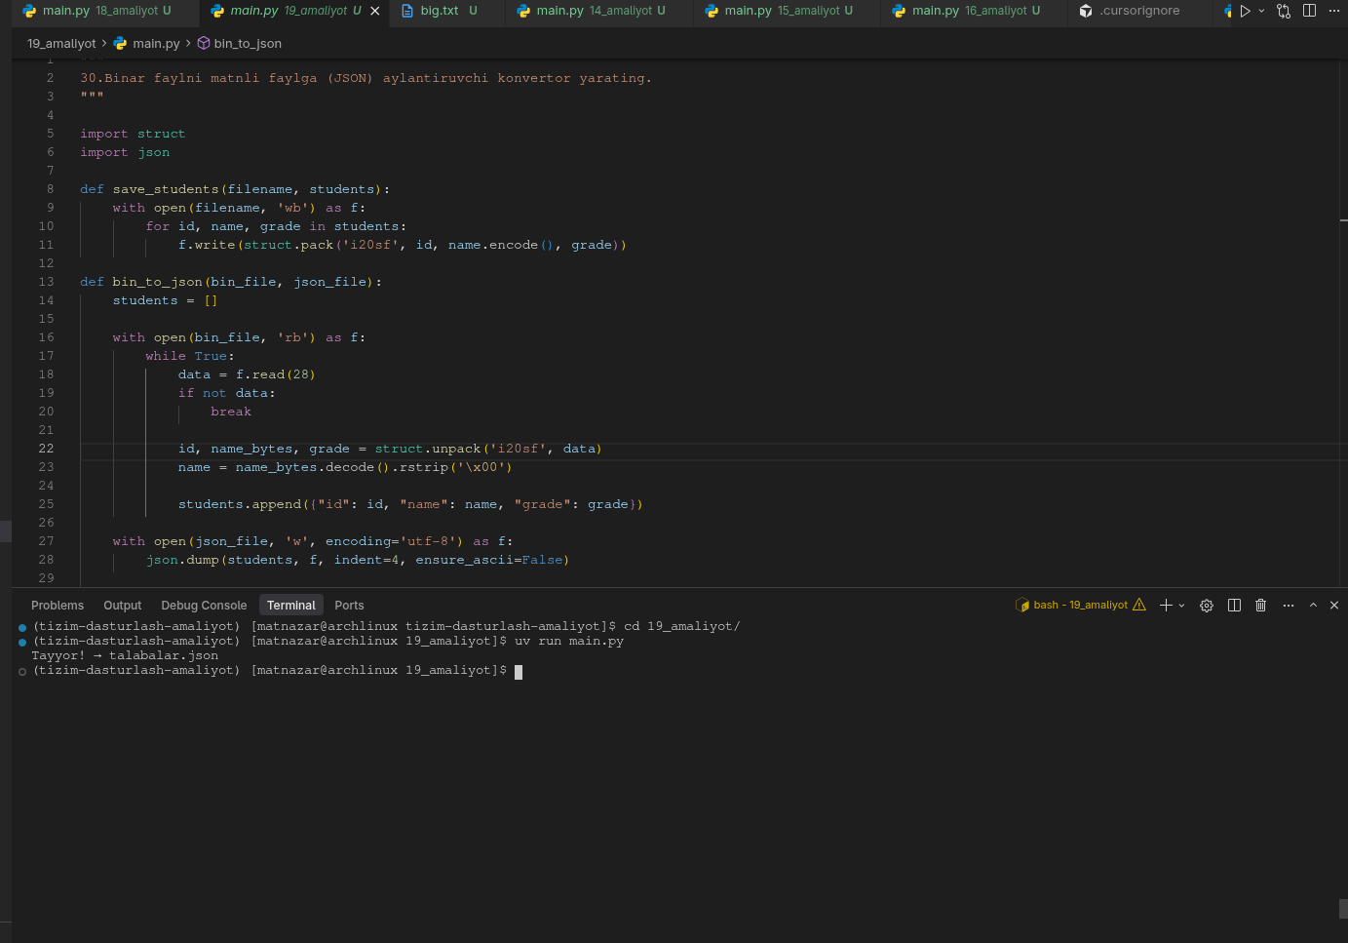
"""
30.Binar faylni matnli faylga (JSON) aylantiruvchi konvertor yarating.
"""

import struct
import json

def save_students(filename, students):
with open(filename, 'wb') as f:
for id, name, grade in students:
f.write(struct.pack('i20sf', id, name.encode(), grade))

def bin_to_json(bin_file, json_file):
students = []

with open(bin_file, 'rb') as f:
while True:
data = f.read(28)
if not data:
break

id, name_bytes, grade = struct.unpack('i20sf', data)
name = name_bytes.decode().rstrip('\x00')

students.append({"id": id, "name": name, "grade": grade})

with open(json_file, 'w', encoding='utf-8') as f:
json.dump(students, f, indent=4, ensure_ascii=False)

print("Tayyor! →", json_file)

if __name__ == "__main__":
talabalar = [
(1, "Ali", 4.5),
(2, "Vali", 3.8),
(3, "Olim", 5.0),
(4, "Sardor", 4.9)
]

save_students("talabalar.bin", talabalar)
bin_to_json("talabalar.bin", "talabalar.json")

talabalar.json
[
{
"id": 1,
"name": "Ali",
"grade": 4.5
},
{
"id": 2,
"name": "Vali",
"grade": 3.799999952316284
},
{
"id": 3,
"name": "Olim",
"grade": 5.0
},
{
"id": 4,
"name": "Sardor",
"grade": 4.900000095367432
}
]
