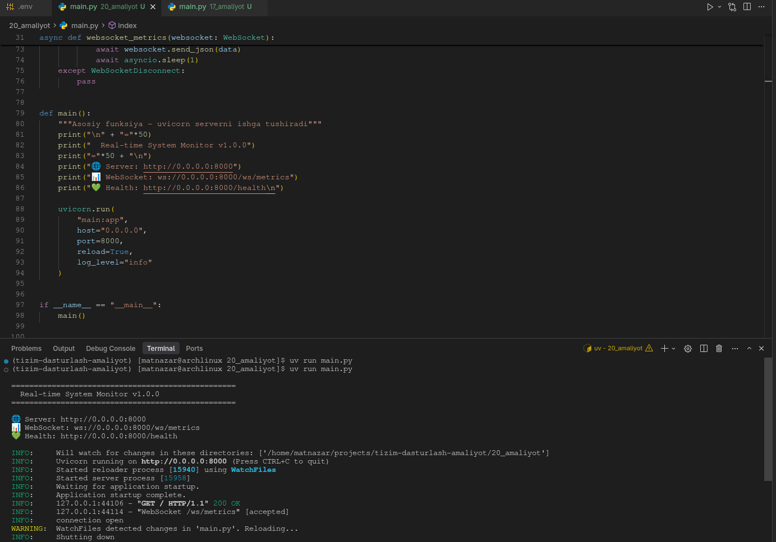
from fastapi import FastAPI, WebSocket, WebSocketDisconnect, Request
from fastapi.responses import HTMLResponse
from jinja2 import Environment, FileSystemLoader, select_autoescape
import asyncio
import psutil
import os
import uvicorn

app = FastAPI(title="Real-time System Monitor", version="1.0.0")

# Jinja2 template environment
jinja_env = Environment(
loader=FileSystemLoader("templates"),
autoescape=select_autoescape(["html", "xml"])
)

@app.get("/", response_class=HTMLResponse)
async def index(request: Request):
"""Asosiy sahifa - HTML template qaytaradi"""
template = jinja_env.get_template("index.jinja")
return template.render()

@app.get("/health")
async def health_check():
return {"status": "healthy"}

@app.websocket("/ws/metrics")
async def websocket_metrics(websocket: WebSocket):
await websocket.accept()
prev_net = psutil.net_io_counters()
try:
while True:
cpu_percent = psutil.cpu_percent(interval=None)
cpu_per_core = psutil.cpu_percent(interval=None, percpu=True)
virtual_mem = psutil.virtual_memory()

try:
load1, load5, load15 = os.getloadavg()
except (OSError, AttributeError):
load1 = load5 = load15 = 0.0

current_net = psutil.net_io_counters()
if prev_net is not None:
bytes_sent_diff = max(current_net.bytes_sent - prev_net.bytes_sent, 0)
bytes_recv_diff = max(current_net.bytes_recv - prev_net.bytes_recv, 0)
else:
bytes_sent_diff = 0
bytes_recv_diff = 0

upload_bps = bytes_sent_diff
download_bps = bytes_recv_diff

data = {
"cpu_percent": cpu_percent,
"cpu_per_core": cpu_per_core,
"memory_percent": virtual_mem.percent,
"memory_used": virtual_mem.used,
"memory_total": virtual_mem.total,
"load_1": load1,
"load_5": load5,
"load_15": load15,
"net_bytes_sent": current_net.bytes_sent,
"net_bytes_recv": current_net.bytes_recv,
"net_upload_bps": upload_bps,
"net_download_bps": download_bps,
}

prev_net = current_net

await websocket.send_json(data)
await asyncio.sleep(1)
except WebSocketDisconnect:
pass

def main():
"""Asosiy funksiya - uvicorn serverni ishga tushiradi"""
print("\n" + "="*50)
print(" Real-time System Monitor v1.0.0")
print("="*50 + "\n")
print("🌐 Server: http://0.0.0.0:8000")
print("📊 WebSocket: ws://0.0.0.0:8000/ws/metrics")
print("💚 Health: http://0.0.0.0:8000/health\n")

uvicorn.run(
"main:app",
host="0.0.0.0",
port=8000,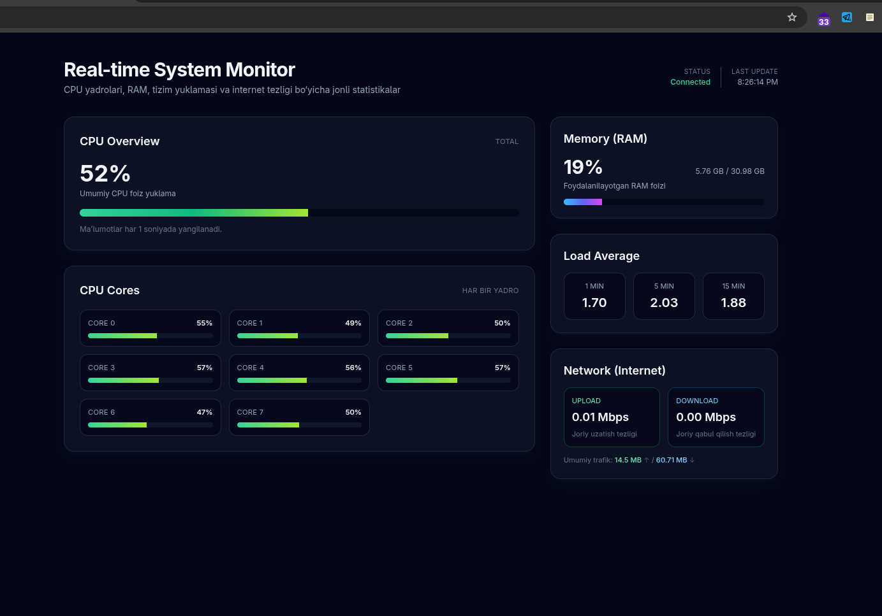
reload=True,
log_level="info"
)

if __name__ == "__main__":
main()

