# 

macOS Mojave Installation Guide

(tested on HP ProBook 450 G5, may work on other laptops too, you might need to use your brains)

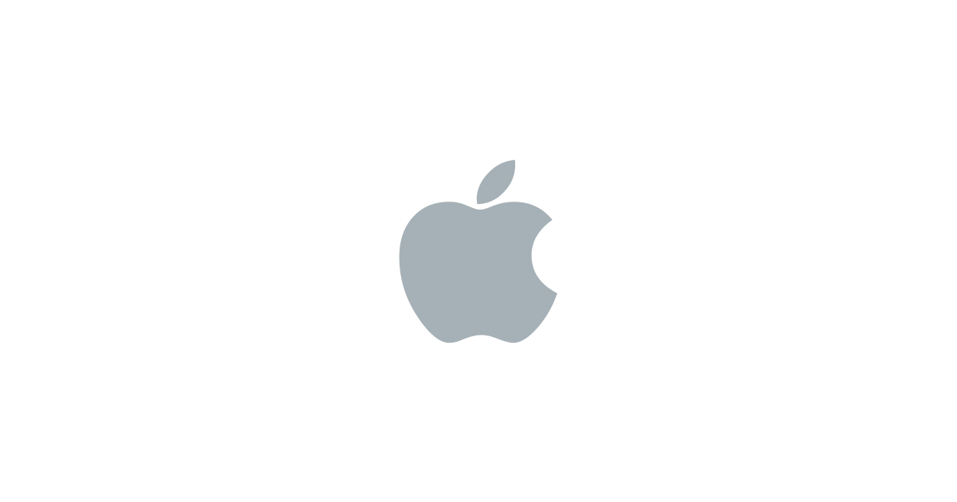

|  |  |  |
| --- | --- | --- |
| MatoXD99 | MatoXD#9114 | MatoXD99 |

Project files at: <https://github.com/MatoXD99/macOS-on-HP>

Content table

About me and this project 3

Equipment 3

Preparation 4

Dowloading tools 4

VirtualBox Settings 4

Downloading official image 5

USB Drive Formatting 6

Creating bootable USB 6

Installation 7

Bios settings 7

Booting USB 7

Post installation 8

Keyboard and trackpad driver 8

Using MultiBeast for self-boot and drivers 8

Configuration 9

Sound 9

Displays 9

Time 9

Mouse 9

Keyboard (CTRL – macOS Control Key) 9

Additional modifications 10

Trackpad Tap-To-Click 10

Not working 10

Other Drivers 11

Touchpad Tap-To-Click 11

Caution: Read everything, please. Also, I am not responsible for any failures, damages, data loss or anything like that. You are doing it on your own with my help. Hope you understand, thank you

# About me and this project

Hi. So, I was able to install macOS Mojave. Almost everything works. I saw a post on Reddit about how someone installed macOS Mojave on HP ProBook 450 G5 and magically everything worked on Vanilla installation and he didn’t want to help other people with installation, so I felt bad for others. I take my self for very persistent person and I decided to install macOS Mojave on my laptop and share it with you guys. I am programmer, I work with computers for my whole life and things like this are no issue for me to achieve, I just need some time to figure them out and perfect them.

Hope you appreciate my donation to the community and that you really read everything 😊

Ps. My native language is not English, so there will probably be a lot of grammatical mistakes and I’m apologizing in advance.

# Equipment

We are going to install pure macOS Mojave on laptop, then we are going to modify it with “kexts” (basically drivers). Be aware, installing macOS on HP is pain in the ass, you will see. If you will follow this process and my tips, you should be mostly good.

What you will need for installation is:

* HP laptop
* Windows or Ubuntu laptop or PC
* USB mouse (because keyboard and trackpad doesn’t work by default – That’s the pain in the ass I was talking about)
* USB keyboard
* Recommended is to have USB splitter, but not needed (so you can use external keyboard and mouse at the same time and don’t have to unplug and plug them when installing and post installing)
* USB (16GB or more, 8GB should work too, but I’m not 100%)
* Extra USB (2GB should do the job)

# Preparation

## Dowloading tools

Since we are installing macOS High Sierra and then from here, downloading macOS Mojave image. In that VirtualBox, we are going to install macOS by “TechsViewer” (if they are not hosting the file anymore, just find some other “.vmdk” macOS image). On 2019/06/21, this linked worked: <https://techsviewer.com/install-macos-high-sierra-vmware-windows-pc/>. If you scroll down, you are going to find “Google Drive (One Full)” and link next to it. Download it (it’s somewhere about 6GB, little less).

Also, ofcourse, install VirtualBox (<https://www.virtualbox.org/wiki/Downloads>), I also suggest you to download “VirtualBox Extension Pack” (it’s located on same page). It will come handy for later, so we can enable USB 3.0 support, so we won’t be stuck with slow ass 1.1. It’s supported by all tree, Windows, Linux and macOS, but you’re going to have to wait for that one 😉

All the files will be also on my GitHub, if in any case you can’t get it anymore. But rather use newer versions, this is just for backup. (<https://github.com/MatoXD99/macOS-on-HP>)

Put next files and programs on USB drive (2GB):

* “Kext Utility” (<http://cvad-mac.narod.ru/index/0-4>) there will be little arrow spinning and pointing on a something like Lego icon.
* VoodooPS2Controller.kext (on GitHub, except if you Google it)
* MultiBeast (Drivers) - <https://www.tonymacx86.com/resources/categories/tonymacx86-downloads.3/>. Download MultiBeast – Mojave

## VirtualBox Settings

* Give it a name “macOS”
* Type: Mac OS X
* Version: macOS 10.13 Mojave (64-bit – I really hope here, that you have 64-bit processor)
* “Use an existing virtual hard disk file” and chose the one you extracted from downloading “TechsViewer macOS High Sierra VMWare/VirtualBox Image” from Google Drive
* 70% of your RAM
* Use an existing
* 128MB of display memory (it actually doesn’t matter)
* Delete “empty” disk under storage
* Network should be set to “bridged adapter”
* USB to USB 3.0 or if you don’t have USB 3.0 on your computer just go with 2.0
* Under same category (USB), press little green plus button on right side and add your USB device (keep in mind, your USB has to be connected to computer to be recognized by VirtualBox)

Now, open CMD as Administrator and execute next commands (if you named your machine differently than “macOS”, you should change device name in this code too, because it’s specific to single VM):

cd "C:\Program Files\Oracle\VirtualBox\"

VBoxManage.exe modifyvm "macOS" --cpuidset 00000001 000106e5 00100800 0098e3fd bfebfbff

VBoxManage setextradata "macOS" "VBoxInternal/Devices/efi/0/Config/DmiSystemProduct" "iMac11,3"

VBoxManage setextradata "macOS" "VBoxInternal/Devices/efi/0/Config/DmiSystemVersion" "1.0"

VBoxManage setextradata "macOS" "VBoxInternal/Devices/efi/0/Config/DmiBoardProduct" "Iloveapple"

VBoxManage setextradata "macOS" "VBoxInternal/Devices/smc/0/Config/DeviceKey" "ourhardworkbythesewordsguardedpleasedontsteal(c)AppleComputerInc"

VBoxManage setextradata "macOS" "VBoxInternal/Devices/smc/0/Config/GetKeyFromRealSMC" 1

Now, power it on and pray. It might take a while, then it will take you through some steps of final setup, when you get to the email part, just press “Set Up Later” (top of the screen – ignore the phone).

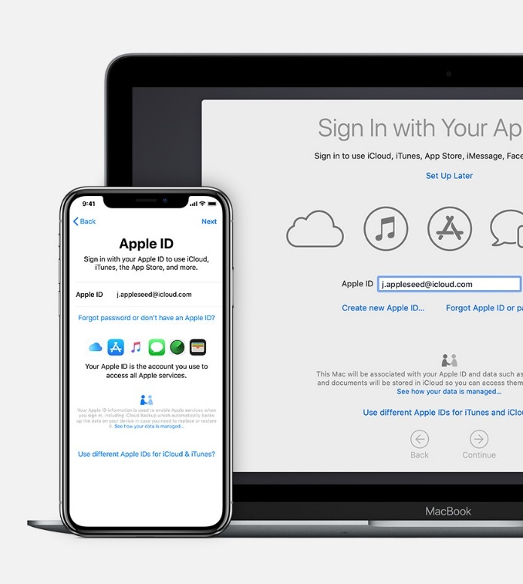

## Downloading official image

After your Mac is booted up, you need to install macOS High Sierra Patcher (thanks to “<http://dosdude1.com>”).

Now you need to download official installation image, press on “Download macOS Mojave…” (On image is High Sierra, but if you downloaded Mojave, there should be Mojave). Make sure you save it in the “Applications” folder.



## USB Drive Formatting

Meanwhile we wait, we can format USB. Open “Disk Utility”. Make sure you press on “View” and check “View all devices”.

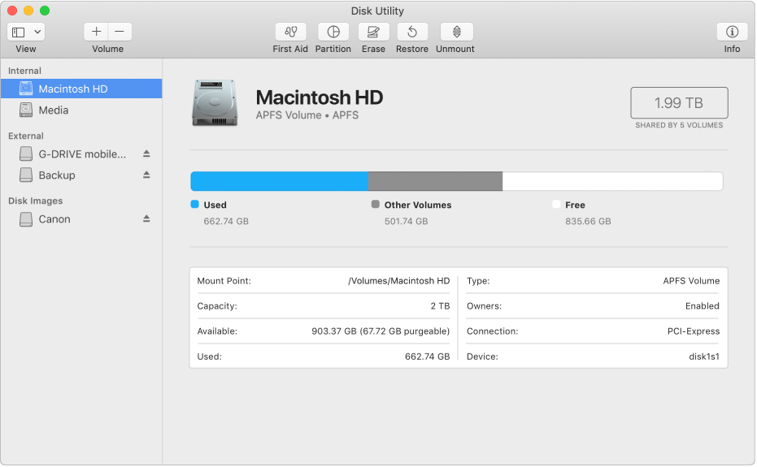

Now click on your USB drive (not partition, DRIVE) and click on erase, make sure you have next settings:

* Name: Doesn’t matter
* Format Mac OS Extended (Journaled)
* Scheme GUID Partitioning

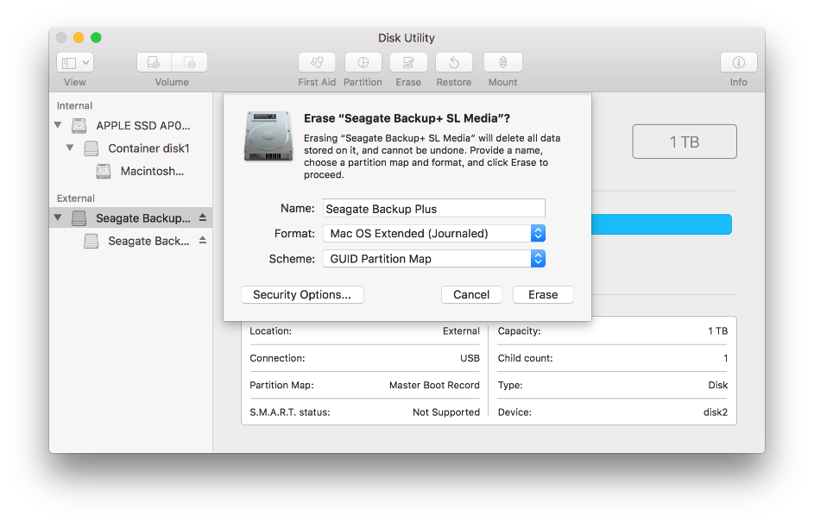

## Creating bootable USB

When image is done downloading, you can download UniBeast for macOS Mojave from official website (<https://www.tonymacx86.com/resources/categories/tonymacx86-downloads.3/>). Run it in VirtuaBox’s macOS, select UEFI boot mode, your USB and macOS Mojave (if you downloaded it, but option is grayed out, it means you didn’t put it into Applications folder. Try to locate it and move it to correct place). If you get an error, that bootable USB could not be created, erase USB with Disk Utility and try again. Now this cloud and it probably will take a while, so go eat something or something else, there’s still a long way to get where we want to be.

# Installation

## Bios settings

To get into BIOS, when computer is booting up, keep pressing ESC. You will get a windows and chose “BIOS Setup”

First, in “Main” tab select “Apply Factory Defaults And Exit”

Then in “Advanced” tab, go to:

* Boot options
  + Disable Fast Boot
  + Disable Network (PXE) Boot
  + Audio Alerts During Boot (Can’t find more annoying thing than this beeping)
* Secure Boot Configuration
  + Configure Legacy Support and Secure Boot: Legacy Support Disable and Secure Boot Disable
* Built-In Device Options
  + Video memory size 128MB

## Booting USB

Once that’s done, you’re ready to install macOS 😊

Now, that’s the part when you have to plug in your USB mouse (it has to be USB 2.0 on left side of your laptop, since USB 3.0 on right side are not working in installation), otherwise you’re toast, or maybe it was just my laptop, that keyboard and trackpad were not working.

When computer boots up, keep pressing ESC again and now chose “BIOS Menu”. From here find your USB device and in front of it, it will say UEFI. Now you should get Clover boot page. Just press enter.

After waiting a while, there you have it, macOS Installation. When it get’s to the point that asks you, if you want to install macOS, open Disk Utility… Open it (Disk Utility I mean). From here, chose your laptop’s disk, erase it, Format Mac OS Extended (Journaled), Scheme GUID Partitioning.

Caution: Your data will be deleted from disk, if you still have something on your disk and not backed up, back it up!!

When disk is done, close Disk Utility and press on “Install macOS”. If you get error message like “Installation is corrupt” or something like that, keep restarting computer and boot up your USB till it will work, but it should work in first try. From here your computer might restart few times for unknown reason. Remember, when it restarts the first time, when you get to the boot menu, chose “Boot macOS Mojave Installation from untitled” (it should be untitled, except if you changed your disk name in Disk Utility when formatting disk).

DONE, YOU’VE INSTALLED IT! Keep your USB plugged in, since you’re going to need it for a while to boot up macOS (We’re going to fix that in a post-installation)

# Post installation

## Keyboard and trackpad driver

Yeah, first that, it’s annoying to have external keyboard… Plug in your 2GB or more USB with files you have to previously download and from there, drag and drop “Kext Utility” and “VoodooPS2Controller.kext” to your desktop, then unzip them. Open Kext Utility once, you will be prompted with “Blah blah can’t open”.

In top left corner, click apple logo, open “System Preferences”, chose “Security & Privacy” and at the bottom you will see, that program was blocked and you can open it from there.

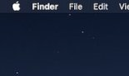

When you open it and close it, now you shouldn’t get this prompt anymore. Now, drag and drop “VoodooPS2Controller.kext” on “Kext Utility” and it will prompt you for password, from here on it will do everything by itself. Boom, keyboard and trackpad are working without restarting your macOS, you can get rid of keyboard, smash it if you want, but mouse is not bad idea to keep, trackpad is not the best for being fast. Also now your right side USB 3.0 ports are working by default as so USB-Type C 😊

## Using MultiBeast for self-boot and drivers

This step is very very important, try not screwing it up

Remember, not all drivers are here, I found just some of them actually useful. Open MultiBeast from USB or copy it to desktop.

Press on Quick start and check:

* UEFI Boot Mode

Drivers:

* Audio – Universal – Voodoo Latest You Can Find
* Disk – Intel Generic AHCI SATA
* Misc
  + FakeSMC
  + Core Graphics Fixup AKA WhateverGreen (This is most important one, once you restart your computer, you will get you intergrated graphics with 1.5GB of RAM)
* Network – RealtekRTL8111 Latest You Can Find
* USB
  + 7-8-9 Series USB Support
  + USBInjectAll

Customize:

* SSDT Options – Sandy Bridge Core i5
* System Definitions – MacBook Pro – MacBook Pro 10.1 (You can chose something else if you want, but this one works for me)

Now install that, you can eject your USB now, since it’s no longer needed, macOS is now standalone bootable and smooth 😊 That is basically it, you just need to install some more drivers, so I am going to link you video links or webpages and follow this tutorials, no point in remaking them, since they already exist, except I will show you some settings I’ve done.

# Configuration

## Sound

Go to:

* System Preferences
* Sound
* Output
* And chose Speaker (Analog)

If you will attach USB headphones, speakers or whatever

## Displays

If you have multiple displays (BTW I checked and both, VGA and HDMI are working after installing intergraded graphics – Don’t forget to restart computer after installing MultiBeast), just play with settings here, everything should work.

## Time

Type “Set Time Zone” in search bar, click on keylock bottom left to unlock settings, put in your password and chose your time zone.

## Mouse

Open mouse settings and disable “Scroll direction: Natural”, because if you’re going from Windows, you are going to find it amazingly annoying.

## Keyboard (CTRL – macOS Control Key)

Open keyboard settings, down right you have “Modifier Keys…”. From here select your keyboard (if you have external, or laptops keyboard…). Put in next settings (I found them closest to Windows):

* Caps Lock Key – No action
* Control Key– Command
* Option Key – Control
* Command Key – Option

Press OK. Now try if copy/paste are working and so on…

One amazing keyboard shortcut is CTRL + Space (Opens spotlight – Basically search for apps)

Thank you for reading whole documentation, now, you basically did it, you have working macOS with some missing drivers, but hey, everything can be fixed, just follow the tutorials I’m going to link you. Enjoy!

# Additional modifications

## Trackpad Tap-To-Click

<http://osxdaily.com/2014/01/28/enable-tap-to-click-mac-trackpad/>

# Not working

* Wi-fi and Bluetooth (Intel Driver)
  + Honestly, writing own driver OR buying WIFI USB for 5$... So I just bought a WIFI USB ☺

If you find drivers or somehow enable those things, I would be grateful if you can tell me and I will put it into this tutorial and credit you.