1. Ability to refill each resource (water, milk, coffee)
2. Throw normalized errors on all inputs, ex:

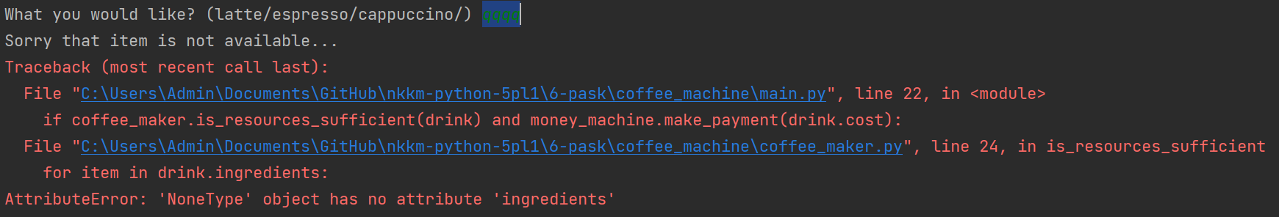

1. Correct printed string inside Menu class, function get_items.



1. Strict type checking in functions.

