Skald
Skald is a tool for modifying quests, dialogues and localization
Projects
Create/Open a project
Click the PAKs button to open/edit a project from game PAKs
Select the root directory of your game
Your root directory should contain
- Data/ folder with Developer,GameData,Script and tables.pak (and/or IPL_ variants).
- Localization folder with language.pak (voiceovers) and language_xml.pak (texts)
- Mods
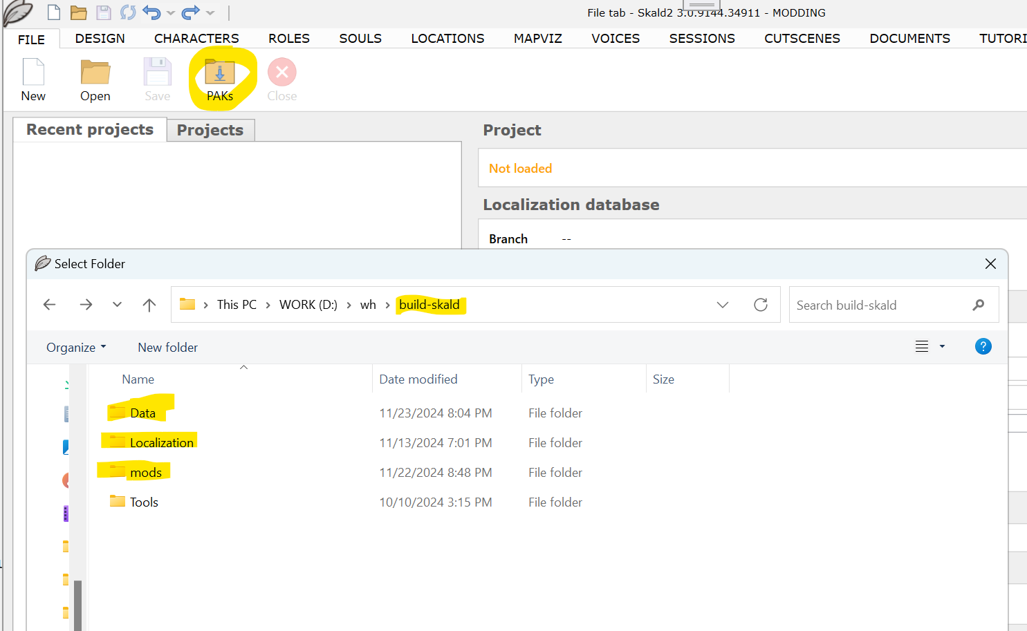
Create a new mod
Just select New mod and fill Name and Modid
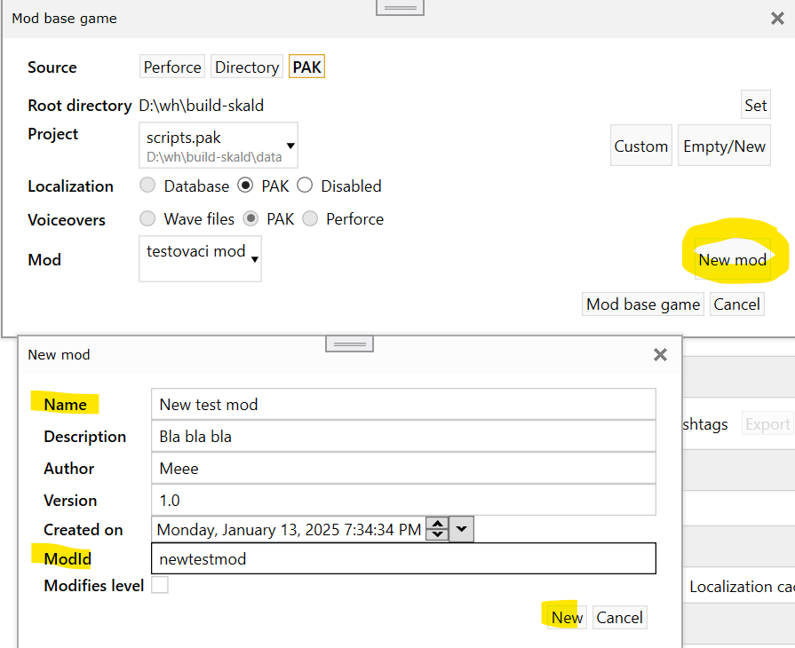
Create new project
Select your mod and Empty/New button, then create New mod project
Your project will be saved to root\mods\modid\data\Quests\modid.xml
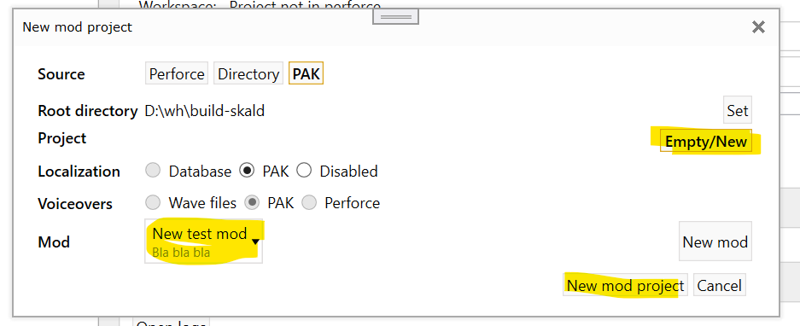
Modify base game
Select script.pak project and click Mod base game button
Changed and new xml files will be saved to root\mods\tmodid\data\Quests\final\Barbora...
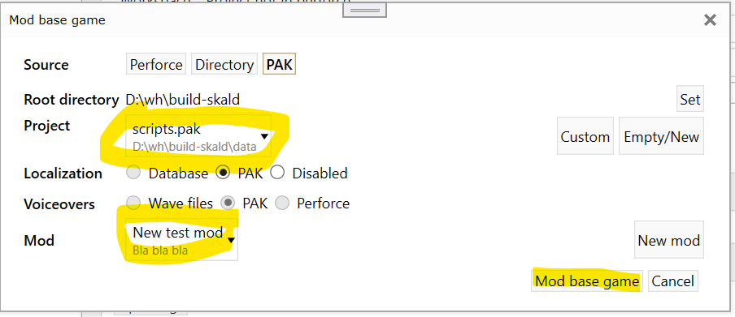
Localization
Disabled
all translations are saved in quest XML, Skald read and write it, but the game can load Text (WHS) attributes only.
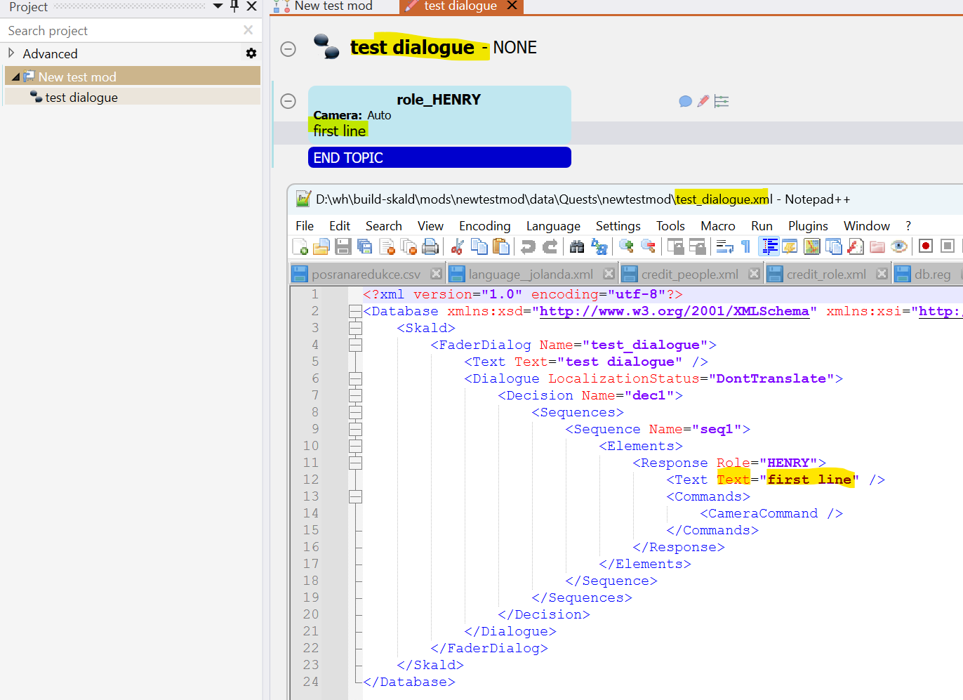
PAKs
translations are saved to separated XMLs per language, each localized string has its own unique StringName attribute
root\mods\modid\localization\language_xml.pak
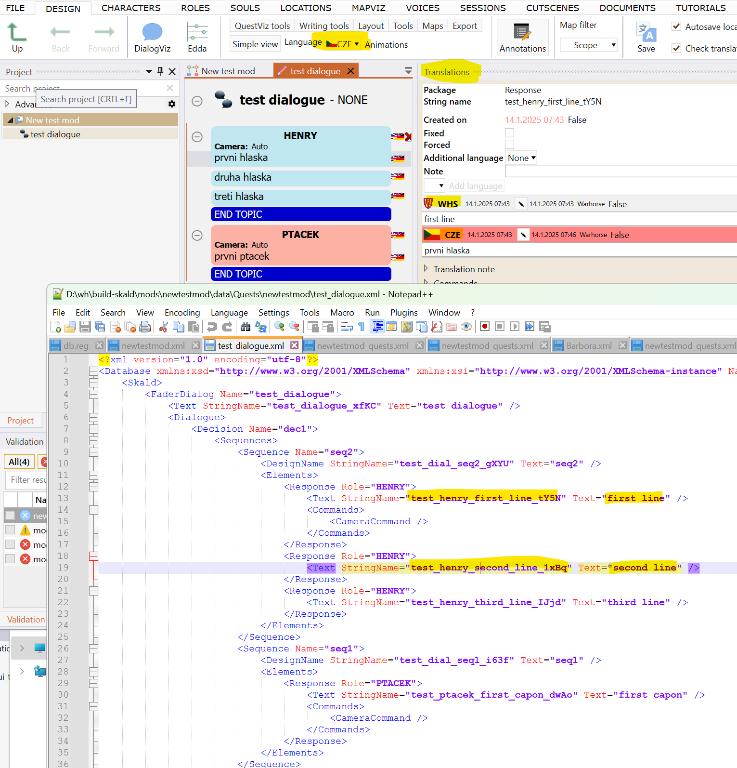
Translation
can be done in the Translation panel, or you can change the language of responses globally in Languages combobox

WHS
primary language, used in Text attribute, in our case it's a mix of uncorrected Czech and English, then corrected and translated to published languages (ENG,GER,CZE etc...)
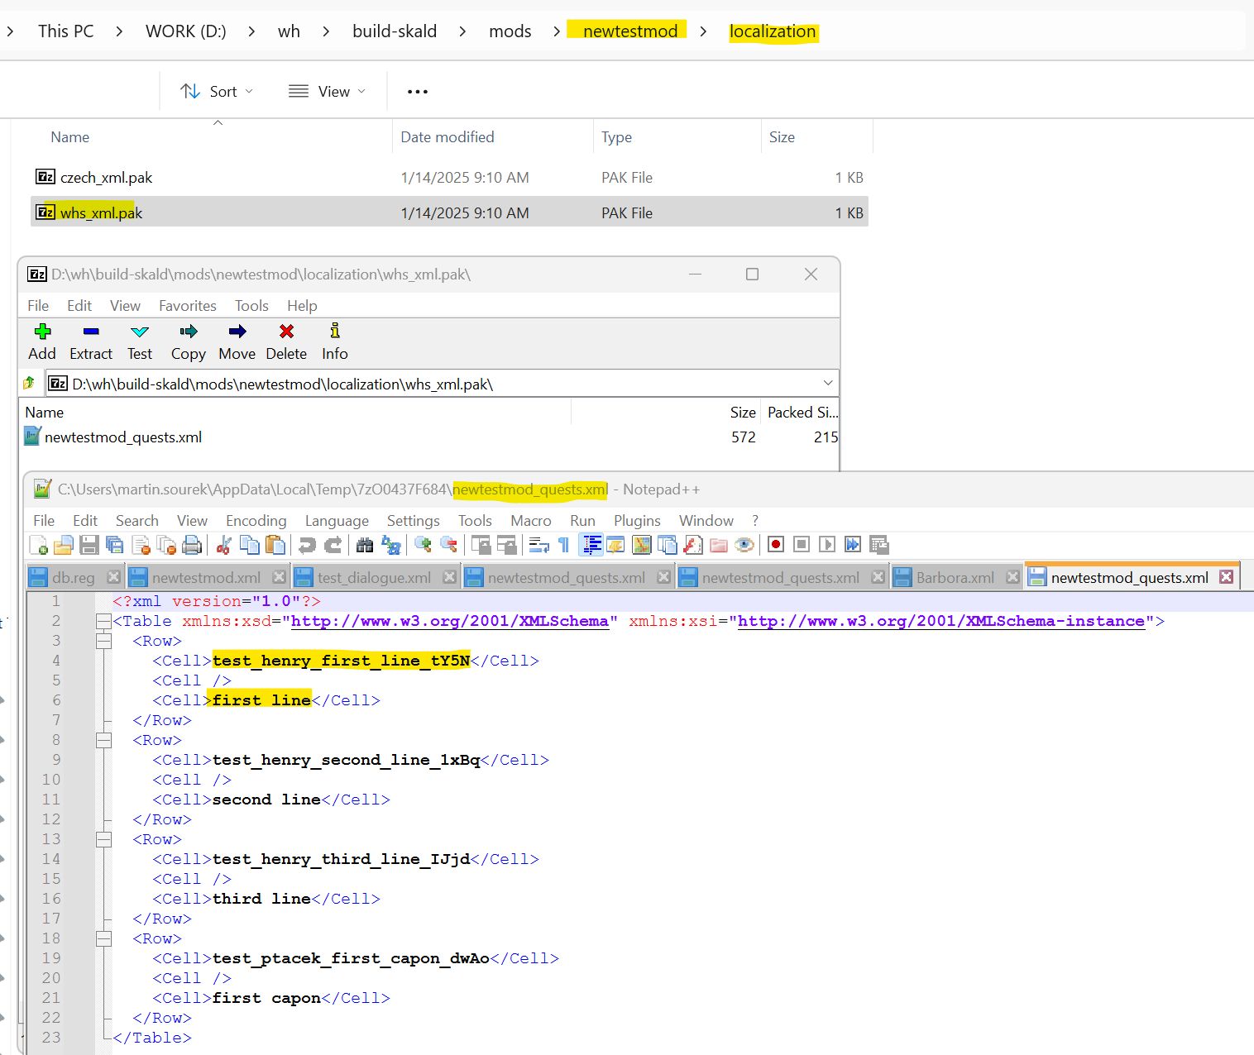
Other languages
You can use Skald to translate, or you can take base WHS xmls, translate them manually to a target language and save them with another language name (eg. you can take whs_xml.pak, translate content and save it as english_xml.pak, so both skald and game now load it as English localization)
Format is following
<Row>
<Cell>StringName</Cell>
<Cell>SourceLanguage (WHS) - optional, not loaded</Cell>
<Cell>TargetLanguage (CZE)</Cell>
</Row>
