Re: comment 1.1: As I had mentioned in my previous comments, the scores for nonsense mutations span almost the entire range of values measured in both experiments. If loss of function of the EF-hand leads to a consistent phenotype of overactivation, shouldn't at least this class of mutation always have a similar effect on cell survival? I understand that it is very difficult to predict if the effects of two missense variants will be similar, but one would expect the nonsense mutants to cluster much tighter together in terms of effects. I think this observation, and the potential implications regarding the variability of DMS scores, should be discussed. Just to be clear, this is not to disparage the work of the authors: as I had mentioned in my first review, STIM1 appears to be far from an easy protein to work with and mutational effects might be particularly difficult to characterize using "bread and butter" survival assays. Nonetheless, I think it's better to be honest and clear about the resolution you were able to obtain with the DMS assay, even if it is not as high as one might have hoped.

In our results and discussion, we have tried to be clear about the spread of the nonsense variant scores and our speculation on the behavior of these variants; particularly the position-dependent effects that affect the mutational scores, including the nonsense variants. These sections are noted below:

Results: “We observed remarkable correlation in survival scores from positionally averaged missense variants and nonsense variants in standard LP cells (Supplementary Fig. 3c; Spearman’s ρ = 0.87). There was reduced correlation with synonymous variants, which also corresponded with smaller magnitude impacts of survival scores (Supplementary Fig. 3d-e). This correlation was largely lost in STIM1 knockout cells (Supplementary Fig. 3f-h).”
Discussion: "Nonsense variants are oftentimes considered controls for DMS data analysis, as they often result in non-functional protein truncation products. Instead, for both the bacterial and standard LP survival scores, we observed a spread of scores for the nonsense variants that seemed to be largely position dependent. There is an absence of STIM1 nonsense variants in human exomes, and none observed yet in the STIM1 cEF-hand. The segment of STIM1 between the signal peptide and cEF-hand remains largely enigmatic, although multiple independent reports suggest that it plays a role in regulating STIM1 activation kinetics (Zhou et al. 2009; Hawkins et al. 2010; Zhu et al. 2018; Sirko et al. 2022). Thus, the various polypeptide fragments created by different STIM1 cEF-hand nonsense variants may each alter ER proteasis and STIM1 regulation to different extents. It is unclear why the knockout cells were the exception, exhibiting little position-specific impacts of nonsense variants."

Although we agree that score variability could play a role in this effect, we do not think it completely answers why the scores are very positional in bacteria and standard LP cells. We have altered our existing text in the discussion to include a sentence about score variability playing a role in the spread of nonsense variants as below (bolded):

[Discussion - lines 470-471]: "...STIM1 regulation to different extents. Experimental variability of assay scores may also play a role, albeit does not account for the positional effect. It is unclear why the knockout cells were the exception, exhibiting little position-specific impacts of nonsense variants."

Re: comment 1.5: The 2-fold reduction in dynamic range observed between the WT and knock-out cells matches almost perfectly the 2-fold reduction in growth rate the authors measured in their experiments. This is a known cause of artifacts in pooled screening assays (see PMID 39349762), even without any additional biological mechanisms involved. I think this could be discussed in the manuscript.

We have now included a sentence in the discussion to more explicitly enumerate the approximate 2-fold reduction in knockout LP scores:

[Discussion - lines 416-418]: An alteration to cell proliferation was observed between the standard and knockout cell backgrounds, as deletion of STIM1 resulted in the cells exhibiting 2-fold slower growth. This growth defect may have contributed to the 2-fold reduction in the magnitude of knockout LP survival scores (Kim et al. 2024).

Re: comment 1.12: Based on the spread of values I think the authors should be more conservative about which variant they consider below the synonymous variant spreads. I would suggest using a statistical test instead of using the mean as an absolute cutoff.

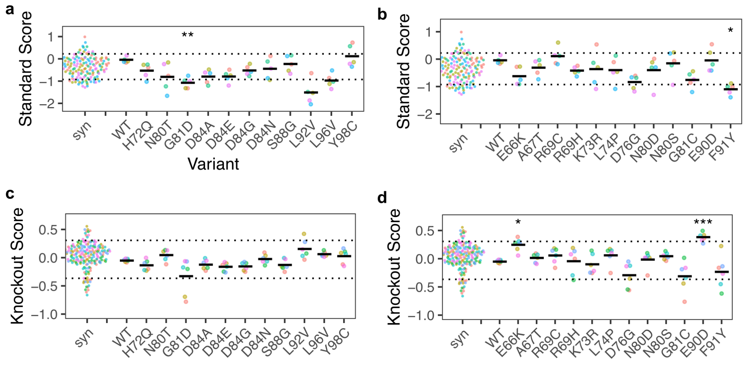
We conducted paired t-tests between the WT replicate scores and each of the pathogenic variants (Supplementary fig a, c) and VUS (Supplementary fig b, d) for both standard and knockout scores. The variants that exhibited significant p-values are marked with stars according to significance level in each graph. Accordingly, we have changed Supplementary fig. 9 and the main text and methods to the following:

[Results - lines 325-332]: 11 of these variants are listed as pathogenic or likely pathogenic, but only 9 were fully within the synonymous range. Myopathy variant G81D had a mean score that was significantly lower than the synonymous range in standard conditions. L92V had lower scores as well but did not reach significance (p-value = 0.07) (Supplementary Fig. 9a). All variants exhibited scores in the synonymous range in knockout conditions (Fig. 8c, Supplementary Fig. 9c).
Of the 12 variants of uncertain significance listed in ClinVar, only F91Y exhibited a score lower than the synonymous range in standard conditions whereas E90D and E66K had scores higher than the synonymous range only in the knockout conditions. (Fig 8C, Supplementary fig 9b, d).

[Materials and Methods - lines 665-669]: Data analysis: “…Mean and replicate survival scores for each variant in standard LP cells and knockout LP cells, and the transformation scores in bacteria, were tabulated into Supplementary Table 1. Statistical testing for variant classification was done using paired t-tests between WT replicate scores and replicate scores for each variant to determine p-values for classification. The p-values were adjusted using the Bonferroni method to account for family-wise error rate due to multiple statistical testing. Adjusted p-values were reported for variants that reached significance using ‘*’ for p-values < 0.05, ‘**’ for p-values < 0.01 and ‘***’ for p-values < 0.001.”

[Supplementary fig. 9 legend]: Paired t-tests with Bonferroni correction were conducted between WT replicate scores and replicate scores for each variant to determine p-values for classification. Adjusted p-values were reported for variants that reached significance using ‘*’ for p-values < 0.05, ‘**’ for p-values < 0.01 and ‘***’ for p-values < 0.001.

