Reviewer #1 :
In this manuscript, Kamath and Matreyek use Deep Mutational Scanning to systematically test the effects of mutations in the cEF-hand domain of STIM1. They use two different cell line backgrounds, one with a functional endogenous copy and the other with a homozygous deletion. They find some overlap between known disease variants and their functional scores and show that deleterious mutations in STIM1 can cause phenotypes even in bacterial cells, suggesting toxicity of the aggregated protein in many contexts. Overall, I enjoyed reading the manuscript, especially the follow-up on library biases when re-transforming in bacteria that led the authors to find out about the deleterious effects in E. coli. STIM1 appears to be a challenging protein to study, and so much of my comments are linked to how its properties as well as experimental design could have affected significantly the results and conclusions of the study.

- The authors mention that overexpression of WT STIM1 can be toxic. This seems to be supported by the fact that the WT was less fit than one of the pathogenic mutants in the pilot sequencing assays, in both backgrounds. This suggest that there exists a goldilocks zone for effective STIM1 concentration (expression x function). In the context of the assay, this would mean that a mutant that is deleterious at endogenous expression levels could end up having the same or even better fitness than the WT because it attenuates the consequences of overexpression. This could explain why so few of the known pathogenic variants were out of the synonymous variant zone. I think quantifying the level of overexpression in both standard and knockout lines would useful to get a better perspective on this.

Author response: The reviewer’s interpretation about a potential goldilocks zone for “expression x function” of STIM1 overexpression is very reasonable, wherein, A) if the absence of STIM1 is detrimental to cell proliferation / overall survival (see response to Reviewer 1 comments 5 and 7), and B) overexpression of even the WT protein is detrimental to cell proliferation / overall survival (demonstrated in Fig 2C), then a hypomorphic loss-of-function variant that is overexpressed in this assay system may exhibit the greatest apparent survival effect. A similar type of relationship is likely contributing to survival of cells expressing the R429C loss-of-function variant tested in our small-scale preliminary assays, such as in Fig 2D.

Despite this, we believe this is likely to be a minor factor in our specific experiments, due to the unique role of the STIM1 EF-hand for intracellular calcium signaling transduction. Variants in the STIM1 cytoplasmic domain that disrupt the ability of the various cytoplasmic coiled-coils to correctly fold, oligomerize, and activate ORAI1/2/3, thus reducing the amount of calcium that enters the cell, may exhibit the expression x function “goldilocks” characteristic hypothesized by the reviewer. In contrast, variants in the STIM1 EF-hand (the subject of our current work) that causes the ER-luminal domain to misfold are expected to be gain-of-function at the cellular and physiological levels, since their propensity to lose the calcium-bound conformation likely biases the protein to enter its activated state. This is consistent with the vast majority of disease variants of the STIM1 EF-hand resulting in myopathy in heterozygotes (including TAM and STRMK), which is a gain-of-function physiological phenotype associated with heightened calcium signaling, rather than immunodeficiency, which is caused by loss of calcium signaling when present in homozygous states. This is also consistent with the large number of STIM1 variants, including myopathy-associated disease variants, exhibiting low survival scores in our assay. Thus, while we cannot officially exclude the mechanism hypothesized by the reviewer as being a potential factor in our assay results, due to these characteristics of the STIM1 EF-hand, we suspect that other factors, such as alternative gain-of-function modes of reduced survival (eg. overloading of ER proteostasis machinery), and a limited dynamic range of survival output associated with STIM1 EF-hand misfolding, being reasons for the large number of myopathy-associated STIM1 disease variants having WT-like scores in our assay.

Despite our best efforts, we have found it incredibly difficult to truly quantitate the fold-increase in STIM1 steady-state abundance that occurs through overexpression from the landing pad as compared to endogenous expression. Roughly speaking, we believe this is likely to be a relatively gross level of overexpression, on the order of 10- to 100-fold increases. We believe the level of overexpression of WT STIM1 between standard landing pad and STIM1 knockout landing pads are comparable (please see our response to Reviewer 1, comment 3). This is further complicated by differences in steady-state abundance seemingly observable with various STIM1 variants (see Reviewer 2, comment 1), although the likely involvement of negative regulation pathways complicates assessment, and it is currently unclear whether these are direct or indirect effects due to the STIM1 coding variants.

We have added the following sentence in the discussion to acknowledge the potential for subset of loss-of-function variants to exhibit a higher score in this assay:

[Discussion - lines 427-430]: “Some dysfunctional variants, while expected to be rare in the STIM1 EF-hand, may present as high-scoring in our assay if they selectively attenuate the survival reduction observed through overexpression of WT STIM1 (Fig 2C) without conferring any other reductions to cell survival or proliferation.”

- Figure 1D please highlight the STIM1 band on the western blot.

Author response: Thank you for pointing this out. We have labeled the western blot with STIM1 with the molecular weight of the band expected (90 kDa).

- Figure 2B and S1C: is there any reason why WT-STIM1 expression from the LP appears to be higher in the knockout cells? In theory the landing pad promoter should not be regulated differentially between these two backgrounds, so what could be causing this difference?

Author response: You are correct that the landing pad promoter should not be regulated differently between the standard and knockout LP cells, and overexpression of STIM1 should be comparable between the two cell backgrounds. Unfortunately, it has been difficult to obtain a singular representative western blot image showing endogenous STIM1 and transgenically overexpressed STIM1 protein levels in standard and knockout cells, in the same blot. Our best attempt to show the vast difference in resulting protein levels between endogenous and transgenically overexpressed STIM1 is shown in Fig 2B, although that comes with a minor caveat that it is not truly representative of the difference between overexpressed STIM1 in the two cell backgrounds. We originally included the first blot in Supplementary fig 1E to help demonstrate that the overexpression levels are more comparable than in Fig 2B, but based on this comment, we have further included two additional, independent Western blotting experiments to Supplementary fig 1E. We have also included quantification of the band intensities which shows that the average band intensity between STIM1 overexpression in standard and knockout cells are similar when averaged between the 5 experiments (Supplementary fig 1D). To make these points clearer, we have added the following text to the manuscript:

Manuscript changes:
[Results – lines 107-110]: “...STIM1 protein produced from the landing pad locus was substantially higher than endogenously present in these HEK 293T cells (Figure 2B, Supplementary fig 1C) and the level of overexpression is comparable between the two cell backgrounds (Supplementary fig 1D,E)”
[Materials and Methods – lines 603-604]: Raw .tif files were exported and quantification of band intensities were performed using ImageJ 1.54g.

- Figure S2C: The correlation between the replicates is not distributed randomly, with some pairs (e.g. R1-R2) showing stronger correlation (>0.9) and while with other replicates it is ~0.6. Is there any reason why these specific replicate pairs have such different correlation strengths? Any significant differences in sequencing depth?

Author response: In Supplementary fig 2C, we show a replicate correlation plot of the plasmid library sequenced 5 times. The first two replicates, R1 and R2, are library A, which was used for the DMS with the standard LP cells. The other three replicates, R3-R5, are from library B, which was used for the DMS with the knockout LP cells and had the loss of variants during the re-transformation in bacteria (as seen in Figure 4). We do not think it is a difference in sequencing depth, as the replicates of library A and B separately have a strong correlation amongst themselves (above 0.9). To make this more clear, we have separated the replicate correlation plots in Supplementary fig 2C and labeled them as either library A or library B.

- The dynamic range of log10-FC in the knock-out background seems to be much smaller compared to the standard background. This type of variation can often be caused by a lower number of generations that leads to less time for differences in abundance to increase. Does the knock-out strain have a fitness defect compared to the standard background? Looking at figure 3C, there is basically no signal in the experiment: stop codons have scores spanning almost the entire range of log10FC values.

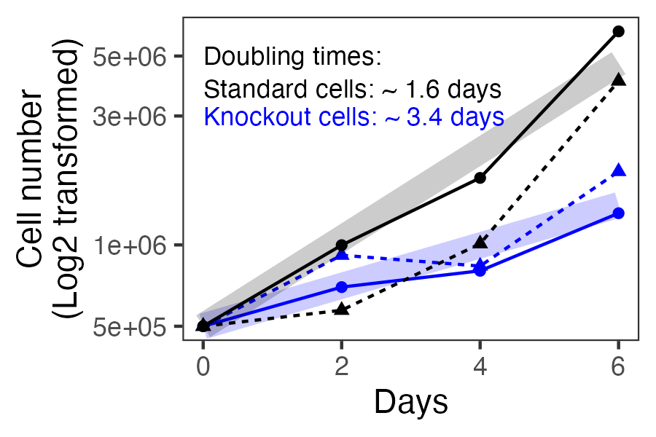

Author response: We quantified the fold difference of growth between standard and knockout LP cells and found the knockout LP cells to grow about two-fold slower than the standard LP cells. This is consistent with the reviewer’s hypothesis about the knockout cells exhibiting a narrower range of scores also having a fitness defect. However, the score differences may also be biological, with the absence of the endogenous WT copy altering the cell in a way that it is less affected by the impacts of the overexpressed STIM1 copy. In actuality, both factors could simultaneously be at play.

Manuscript changes: We have added the above plot to the manuscript as Supplementary fig 1A. We have also made the following changes to the text:

[Results – lines 90-92]: STIM1 knockout appeared to impact cell proliferation, as doubling time of the knockout LP cells were 2-fold longer than that for standard LP cells (Supplementary fig 1A).

[Discussion – lines 412-416]: Furthermore, we cannot determine whether each low survival score variant actively triggered cell death, disturbed homeostatic cell metabolism in a way that slows proliferation relative to cells with WT STIM1, or a combination of the two. An alteration to cell proliferation was observed between the standard and knockout cell backgrounds, as deletion of STIM1 resulted in the cells exhibiting slower growth and impacted the magnitude of survival scores (Supplementary fig 1A).

[Methods – lines 575-578]: To determine the growth rates of standard and knockout cells, 500,000 cells were plated in D10X media. Cells were detached using Trypsin-EDTA and sampled at 2, 4 and 6 days after plating and counted using trypan blue exclusion assay (Thermo Fisher). Cell number was converted to log2 transformed values and plotted against time to determine doubling rate of cells.

- The same comment can be applied to the experiment in the different E. coli strains

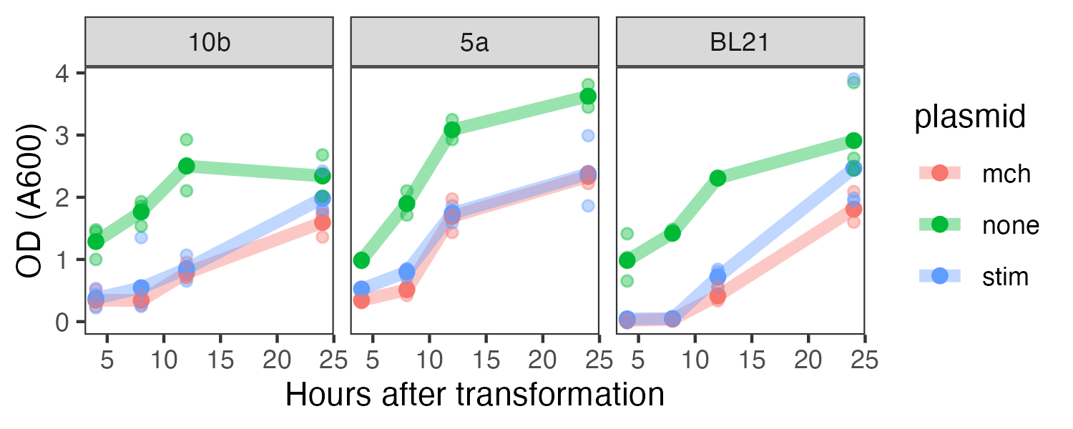

Author response: To address this comment, we performed an experiment in which all three bacterial strains of E.coli tested in the manuscript were either mock transformed (green), or transformed with either the WT STIM1 recombination construct (blue) or an irrelevant plasmid only encoding mCherry (red). They were grown in media with (for plasmid transformed samples; red, blue) or without ampicillin (mock transformation; green), with timepoints taken at 4, 8, 12, and 24 hours thereafter. This process was repeated on three different occasions, to yield the figure above. The DH5a cells were electroporated, while the others were chemically competent and heatshocked, identical to the transformation methods already used and described in the manuscript.

We believe that the DH5-alpha do grow at a faster rate than the 10-beta and BL21 cells, while the latter two appear largely indistinguishable from each other. Thus, unlike knockout LP cells which simultaneously exhibited slower cell cycling and reduced magnitude in score range, there seems to be no clearly discernible pattern between cell cycling times and magnitude score ranges in bacteria.

Manuscript changes:
[Results – lines 209-210]: The DH5α strain grew at a faster rate than the DH10β and BL21 which had similar growth rates (Supplementary Fig. 5c).

[Methods – lines 644-647]: To determine growth rates, each strain was either transformed as detailed above with attB-mCherry or pNK005C or a mock transformation was done. OD measurements were taken at 4, 8, 12 and 24 hours after transformation using a Nanodrop spectrophotometer (Thermo Fisher Scientific). OD measurements were plotted against time to determine growth curves.

- Related to this, is the screen the authors performed in cell lines an enrichment screen or a depletion screen? Are the main differences in genotype abundances expected to occur via difference in proliferation speed or stead survival rates? I found this unclear in the text.

Author response: This DMS was a depletion screen, in that the vast majority of library members was expected to, and did, deplete relative to the WT construct. Unfortunately, due to the complexity of STIM1 function, we cannot confidently state whether the main differences in genotype abundances occurred via difference in proliferation speed, survival from active cell death caused by STIM1 dysfunction, or both. We hypothesize that the mode of depletion is likely variant and condition specific, and we hope that additional assays in our follow-up studies to evaluate ER stress, calcium influx, and transcriptional responses will uncover the range of ways that different STIM1 variants can affect cell activities, especially in the ways that most closely relate to disease in people.

As noted in the response to Reviewer comment 5, we have added a sentence noting our inability to determine this with our current data in the discussion.

- Please provide more information on the screens performed in bacteria in the methods, as well as correlation coefficients for replicate pairs.

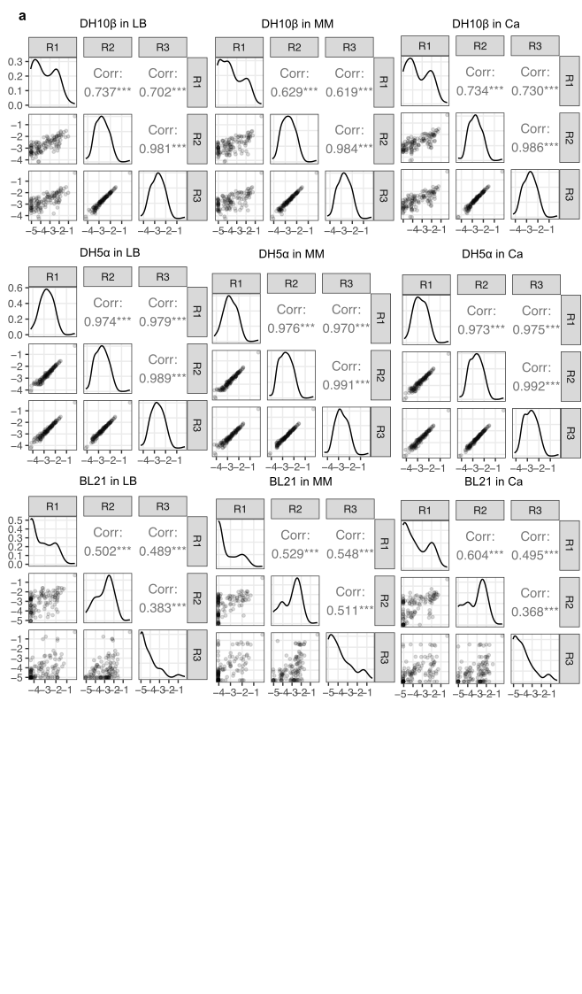

Author response: We thank the reviewer for pointing out the absence of the replicate correlation coefficients. We have added all 9 correlation plots, with 3 replicates for each condition as a Supplementary fig 5a. The methods for the bacteria screens are explained under “DMS of select STIM1 cEF-hand positions in bacteria”. We have included the following text about replicate numbers and how the scores were calculated:

Manuscript changes:
[Materials and Methods – lines 641-643] “This experiment was repeated three separate times, and variant frequencies and scores were calculated as described below.”
[Legend for figure 4]: “Scores represent average values from three separate replicate experiments”
[Results – lines 202-204]: This mini-library was independently transformed into the different E.coli strains and conditions three separate times, and each compared to the original plasmid library counts to calculate repeat transformation scores (Fig. 4d, Supplementary Fig. 5a).

- Please provide more information on how the small-scale validation assays were performed and how mutants were constructed/sampled from the DMS library.

Author response: We have added the following text to the methods section to better describe how the small-scale validation was performed:

Manuscript changes:
[Materials and Methods – lines 618-627]: “Small-scale validation experiments: Select variants were randomly chosen based on if they had WT-like, low or high survival scores in the standard LP cell and the knockout LP cell DMS. It was also verified that these variants were present in all DMS replicates. Each variant was individually cloned using Gibson assembly with custom primers using untagged, WT STIM1 (plasmid pNK005C) as the template. Clones were verified to contain the intended mutation using whole plasmid sequencing (Plasmidsaurus, Oxford Nanopore Technologies). The variants were mixed in equimolar concentrations and recombined into standard LP and knockout LP cells as outlined above. Experiments were conducted three separate times with cells sampled 5, 7 and 9 days after transfection. Variant counts were determined through sequencing and survival scores were calculated as detailed above.”

- Figure 5A: please provide a more detailed description of the variables being tested for correlation on the x-axis of the heatmap
Author response: Thank you for pointing out that this analysis required more explanation; reviewer 3 had a similar request. To achieve this, we have created a new Supplementary figure 6 which shows pairwise scatterplots between each data subset and variable combination, and also helps explain each series of plots. We have also added brief descriptions to the legend of figure 5A, as well as a call-out to the supplementary figure for more detail.
Manuscript changes:
[Legend for figure 5A]: Missense, all missense variant scores; position, scores averaged by residue being mutated; mutant aa, scores averaged by amino acid replacement; synonymous variants only; nonsense variants only. See supplementary figure 6 for details.

[Supplementary fig 6]:
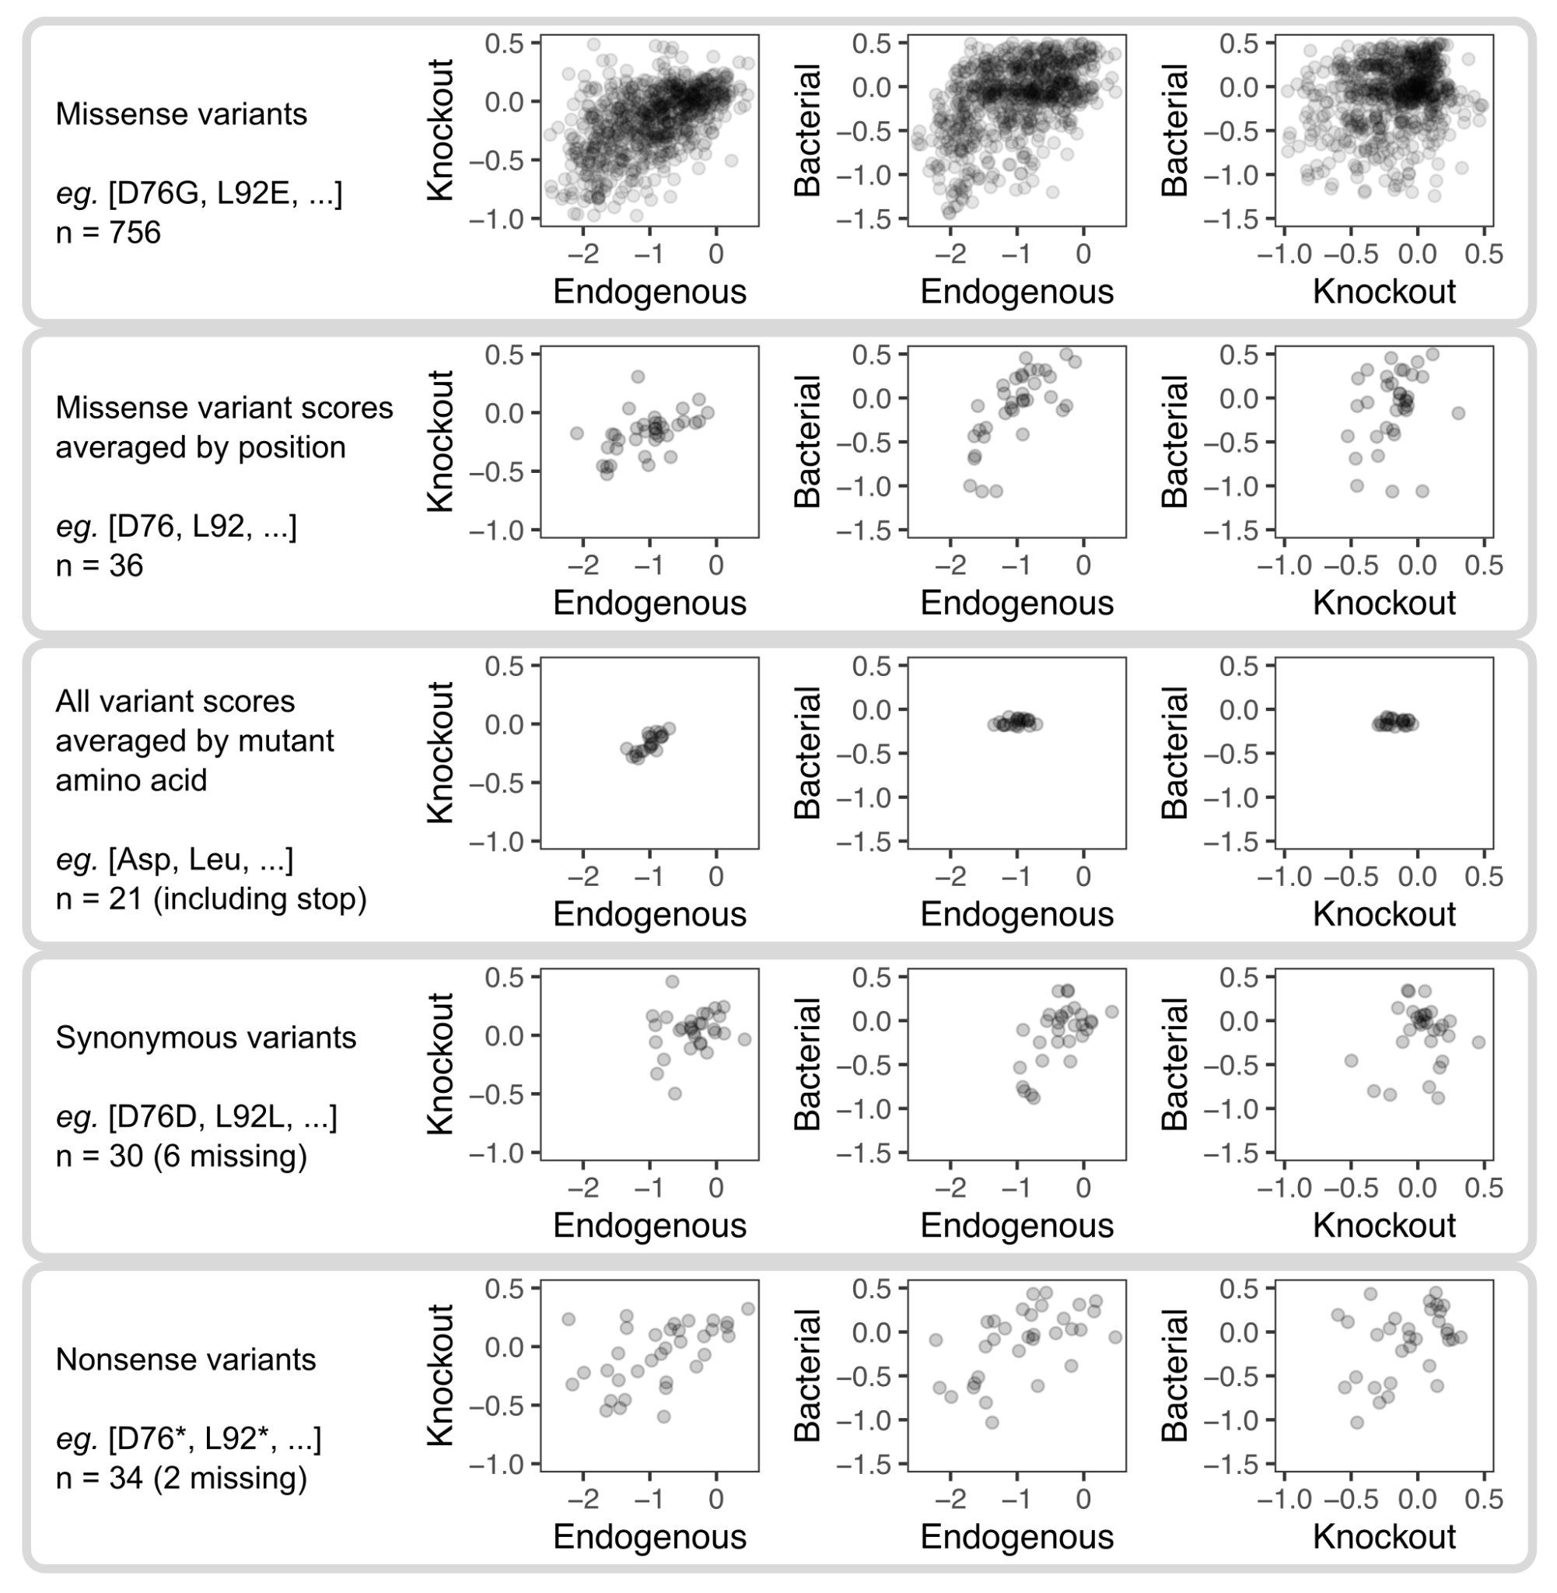

- Figure 8A: SNVs are on average more likely to lead to missense mutations towards amino acids with similar properties. This, and the high level of noise in the assay, should be controlled for before hypothesizing on purifying selection or implying potential evolution for robustness.

Author response: This is a great point. We were perhaps a bit misguided by one of our previous datasets, wherein sort-seq scores for a library of EGFP-fused PTEN variants where PTEN variants possible through SNV were present in a similar proportion as the entire site-saturation mutagenesis library (Figures 2b here vs Fig 4a in PMID: 29785012). We agree that the pattern of reduced low-survival variants through SNV that we observe for STIM1, especially for this assay, can potentially be explained by the characteristics of the codon table. We have thus removed our statement speculating on an evolutionary pressure, and have chosen to end the paragraph with a different sentence:

Manuscript change:
[Discussion – lines 447-448]: “Altogether, low scoring variants in our assay are expected to be rare in living organisms.”

- Figure 8: based on the level of noise of the experiment, what is the confidence of the authors on their classification of variants? Error bars around standard and knock-out scores could help better visualize the uncertainty in saying they are or not in the range of synonymous codon scores.

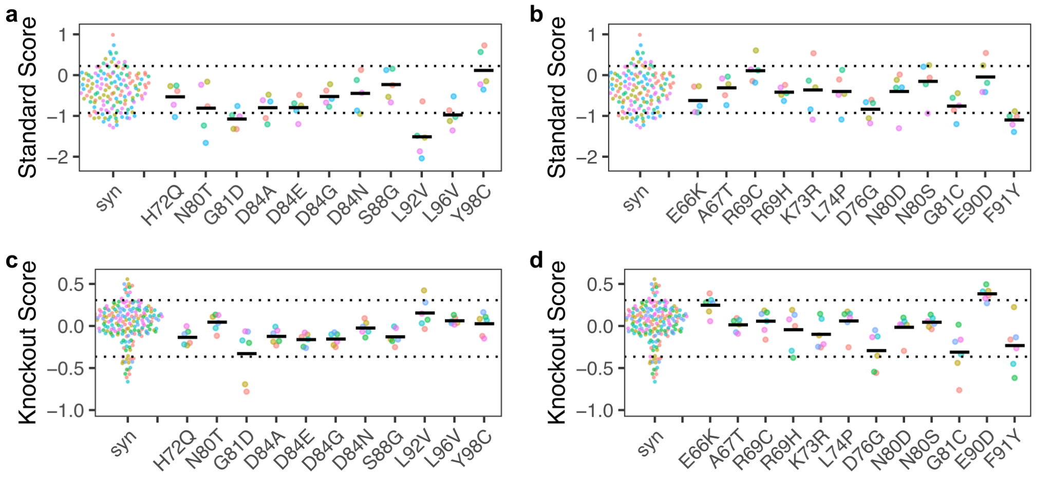

Author response: We have created a new Supplementary fig 9, which shows the individual replicate scores for the pathogenic STIM1 variants and the STIM1 variants of uncertain significance, alongside individual replicate scores for the synonymous variants. As evident with the individual replicate scores, those for some variants were relatively precise, whereas others were highly variable. Due to this variability, along with the relatively small mean score differences observed with variants possible through single nucleotide variation, contributed to relatively small effect sizes. Regardless, the scores for pathogenic variants G81D, L92V and L96V in the standard LP cells substantially deviated from the others. Of the variants of uncertain significance, F91Y gave consistent scores on the edge of the synonymous distribution. We hope this will give the reader an accurate view of the data that goes along with the scatterplot of geometric mean values shown in Fig 8. Aside from the display of replicate scores for disease-related variants in Supplementary fig 9, we are also providing these scores in Supplementary table 1, and have made the following changes in the main text to make the above points clearer.

[Results – lines 325-330]: 11 of these variants are listed as pathogenic or likely pathogenic, and only 8 were fully within the synonymous range. Myopathy variants L92V, G81D, and L96V had mean scores below the synonymous range in standard conditions (Supplementary Fig. 9a). All variants exhibited scores in the synonymous range in knockout conditions (Fig. 8c, Supplementary Fig. 9c).
Of the 12 variants of uncertain significance listed in ClinVar, only F91Y exhibited a score outside of the synonymous range in standard conditions but not in knockout cells (Fig 8C, Supplementary fig 9b, d)..

[Discussion – lines 451-452]: In contrast, only one of the eleven known pathogenic or likely pathogenic variants exhibited low scores (Fig. 8c, Supplementary Fig. 9).

[Materials and Methods – lines 660-661]: Data analysis: “…Mean and replicate survival scores for each variant in standard LP cells and knockout LP cells, and the transformation scores in bacteria, were tabulated into Supplementary Table 1.”

- Figure 9: how were standard scores determined for R304W and R429C? The methods are unclear as to how they would have been added to the large-scale assay

Author response: The standard LP scores for R304W and R429C came from the initial small-scale pooled assay (Fig 2D). These are distinct from the scores for L74P and D84G, which were scores from the EF-hand site-saturation mutagenesis library. As these data points come from two distinct experiments (with different library complexities, expected to yield differing survival score values), we have made this distinction by indicating samples from each experiment format with different symbols. Despite this, we do find that the WT scores were similar with the two datasets, and thus general trends of scores higher and lower than WT are likely preserved in this analysis.

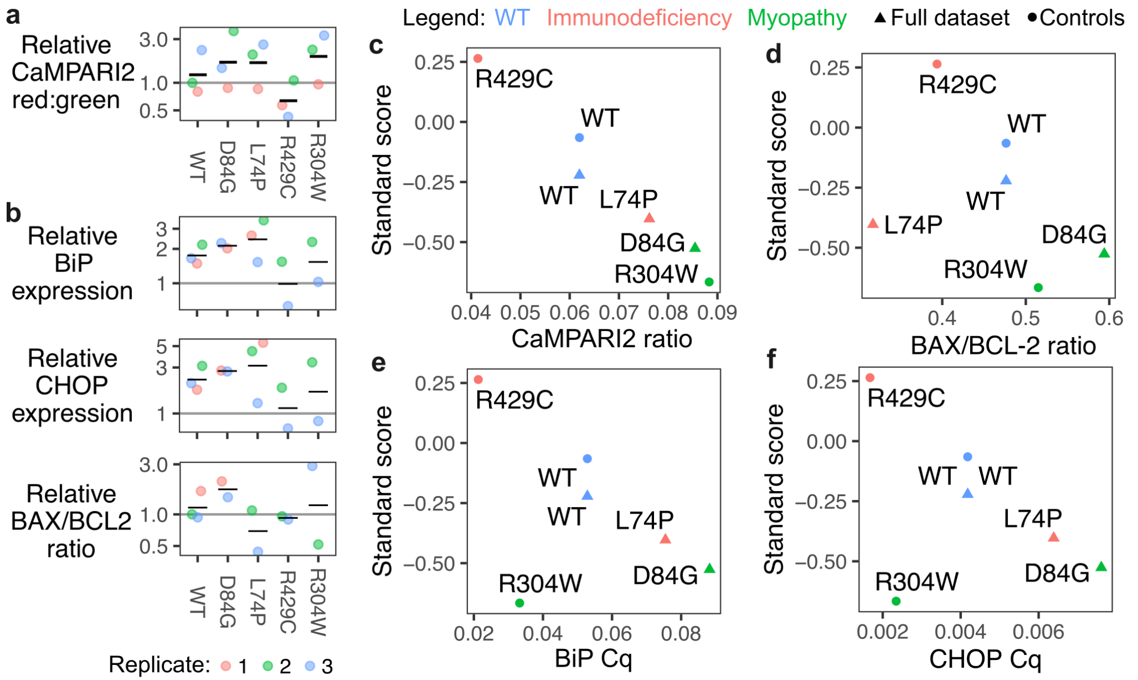
- Also figure 9: please provide error bars for the values on the x axis (and also ideally on the y-axis).

Author Response: We have modified figure 9 with two additional panels, which shows data points for independently performed replicate experiments (colored points), as well as the geometric mean value of the replicate values (black bars), for each of qPCR and CaMPARI datasets tested.

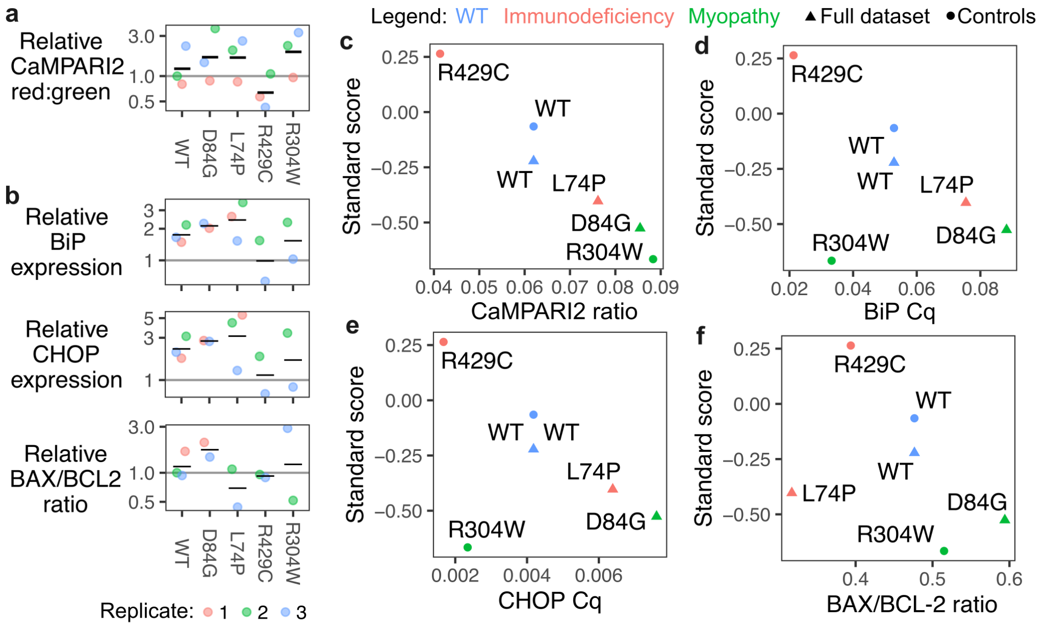

- As a final note, please make GitHub accessible for review, the link was dead when I tried it.

Author response: Thank you for pointing out this oversight; we have now made the repository public.

Reviewer #2 :

I had the pleasure of reviewing the manuscript by Kamath and Matreyek entitled "Comprehensive mutational characterization of the calcium-sensing STIM1 EF-hand reveals residues essential for structure and function" submitted to Genetics. In the manuscript the authors employ deep mutational scanning to study the effects of >700 variants in the STIM1 EF-hand domain using cell fitness as a readout. The results show varying mutational patterns, dependent on aggregation and multimerization of the protein variants. The manuscript is well written and presents an interesting example of how mutational scanning can be utilized to disentangle variant effects. The results are clear, not over-interpreted and reflect a careful underlying experimental design. Altogether I only found very few and minor problems with the work listed below.

Minor points:
- The authors do not comment on the importance of different levels of abundance of the variants. For instance, in Fig. 5E and S5, it seems like the level of R93W is reduced, while F91D is increased. Could variations in abundance play a role for the results from the fitness assay?

Author Response: We agree that the abundance of STIM1 in the cell could relate to the results of the survival assay, although it is difficult to determine whether this is causative or correlative. We have added a new Supplementary fig 7b, where we quantitated the green fluorescence intensity from mGreenLantern fused with WT STIM1 and variants F91D, L92K, R93W and E94P, from our fluorescent microscopy images. Consistent with the reviewer’s observation, the mean fluorescence intensity of F91D was similar to WT STIM1, while L92K, R93W and E94P exhibited fluorescence lower than WT. Interestingly, there seems to be no obvious pattern between variant abundance and cell survival; for example, F91D has higher overall abundance but low survival, L92K has lower abundance and low survival, and R93W has low abundance but more WT-like survival. Much like most aspects of STIM1, this too appears to be a complex interplay of factors, potentially involving other pathways of cell death, such as ER stress. In this paper, we sought to determine the effect of STIM1 variants on a long-term phenotype such as cell survival, knowing that there are likely intermediate phenotypes affecting variant-specific impacts on cell survival, such as protein abundance. We intend to tackle this complexity in a follow-up study, where we are diving deeper into select variants and investigating the effect of abundance, along with ER stress and calcium influx to determine the intermediate mechanisms that cause cell death.
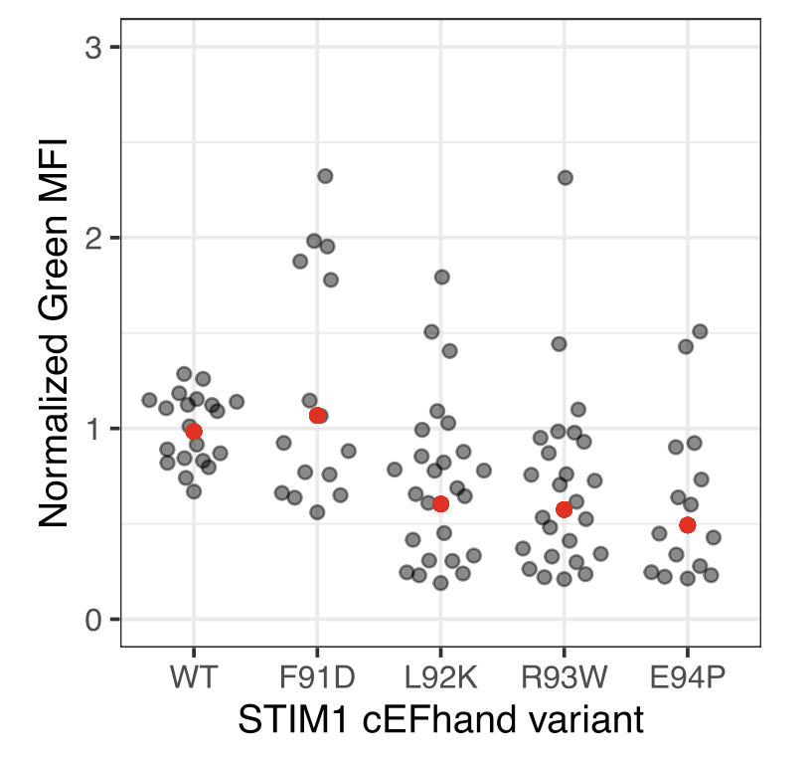
Manuscript changes:
[Methods – lines 696-699]: “Fluorescent microscopy with mGreenLantern-tagged STIM1”: To measure fluorescence intensity of mGreenLantern, images were converted to .tif files and loaded into ImageJ (version 1.54g). The fluorescence intensity of five random cells and the background signal was measured per image. This was done for three replicates. The background was subtracted from the signal to produce the mean fluorescence intensity values.
[Results – lines 251-255]: In contrast to the largely diffuse ER- and cell surface fluorescence exhibited by WT STIM1, many of the cells that survived expression of F91D and L92K variants exhibited perinuclear puncta indicative of aggregated protein. However, when quantified, the mean fluorescence intensity of F91D was similar to WT STIM1 whereas L92K was lower (Supplementary fig 7b). R93W and E94P variants had diffuse fluorescence similar to WT STIM1 but also exhibited lower fluorescence than WT (Fig 5e, Supplementary figs 7a,b).
[Discussion – lines 405-411]: Alternatively, prolonged unresolved ER stress is a possible mechanism of cell death, as misfolded proteins within the ER result in the activation of ER stress pathways and the unfolded protein response (Wang and Kaufman 2016), which can trigger apoptosis. This mechanism is likely particularly relevant with STIM1 cEF-hand domain variants, such as D84G. ER stress can reduce protein abundance through global downregulation of translation machinery (Pakos-Zebrucka et al. 2016). Thus, it remains unclear whether the reduced abundance of STIM1 variants like L92K, R93W, and E94P, are direct effects on those proteins, or more indirect global effects through ER stress response.

- Do the depleted variants at positions Asn70, Phe91, Leu92, Arg93, and Glu94 somehow stand out e.g. by Rosetta-based predictions of thermodynamic stability?

Author response: We chose to investigate this with FoldX total free energy (ΔG) scores, as these values were more accessible and have also been shown to correlate with variant-associated disruption in other proteins (PMID: 28422960). High FoldX total free energy scores indicate increased predicted instability in protein folding. We found that variants at Asp76, and to a lesser extent, Leu92, exhibited high scores, consistent with their strong impacts on cell survival. Aside from these examples, there was relatively little correspondence between FoldX total free energy and survival score, suggesting that the effects on cell survival cannot be predicted by this computational predictor of folding energy. This is consistent with STIM1 conformational change and oligomerization being a major experimental factor that is absent from computational predictors like FoldX, which only considers the calcium-bound STIM1 EF-SAM domain structural conformation in isolation. Regardless, we believe this analysis would still be informative for the reader, and have provided it as Supplementary fig 10a-b, and have correspondingly made a number of changes to the manuscript text.
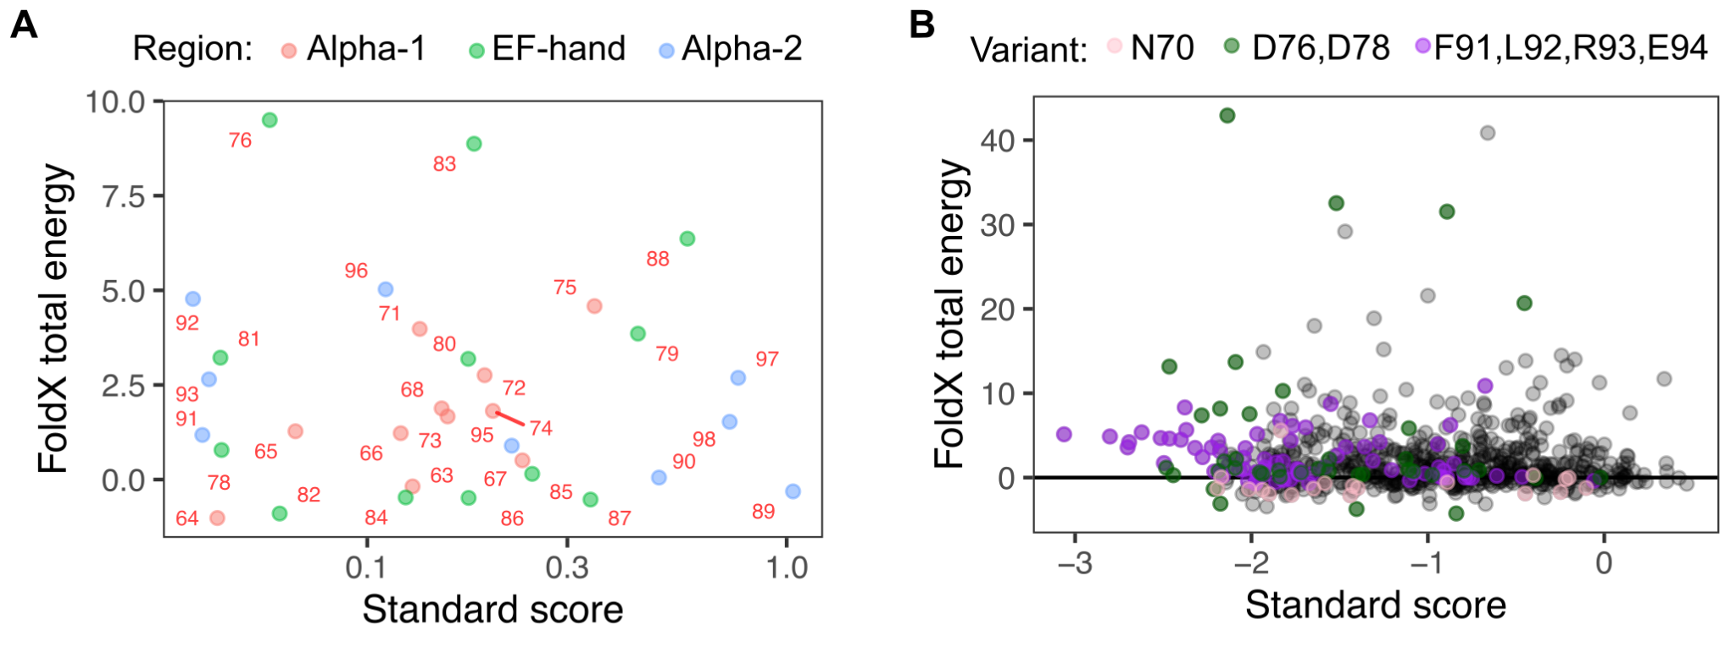
Manuscript changes:
[Results – lines 243-248]: “Due to the uniquely cytotoxic effects exhibited by variants of the FLRE motif, we investigated whether mutation of these residues may cause drastic misfolding identifiable through computational predictors. We compared the predicted total free energy (ΔG) scores from FoldX for these variants, and found that mutations at Leu92 indeed caused relatively high ΔG scores caused by disruption in protein structure. Other variants within this motif had comparable scores to the rest of the variants, including low survival-scoring EF-hand motif variants (Supplementary fig 10a-b). To assess the aggregation phenotypes…”

[Materials and Methods – lines 677-680]: FoldX scores were generated by running the Stability command on the STIM1 cEF-hand structure (PDB: 2k60) and variant list. ‘Total Energy’ was used as total free energy (ΔG) scores for analysis (Schymkowitz et al. 2005) (See Supplementary Table 6).

- In general, how do the results match computational variant effect predictions, e.g. by ESM?

Author response: We compared the standard LP scores with the scores generated from ESM1b (Brandes et al. 2023), where the more negative a variant score is, the more unlikely that mutation is predicted to occur through this protein language model. Similar to our observation for AlphaMissense scores (see response to Reviewer 3, comment 4), the vast majority of ESM1b predicted scores for STIM1 variants were highly negative, likely due to the high evolutionary conservation of the STIM1 EF-hand domain. There was a weak correlation for all variants when we compared our standard LP survival scores to the ESM1b scores (ρ = 0.31). We are currently working on a follow-up study, where we are performing additional experimental phenotyping of a subset of STIM1 variants, and we believe a more comprehensive comparison with computational predictors will be more appropriate in that separate study. Therefore, we have chosen not to edit the manuscript to include this plot.

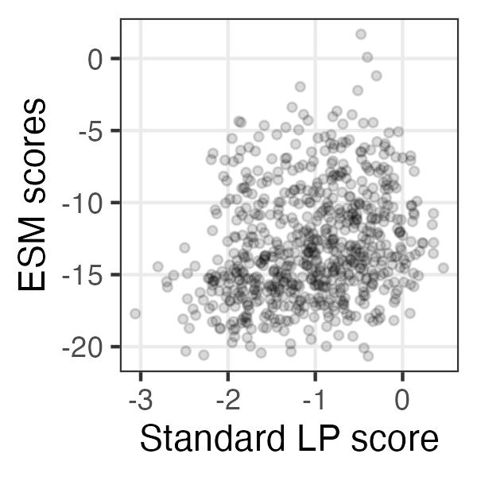

- Fig. 1A: Please change uM to µM.

Author response: Thank you for pointing this out; we have incorporated the change into the manuscript.

- Fig. 1C: The western blot appears very faint. Please include a longer exposure.

Author response: We looked through our records, and found that the displayed image is the longest exposure we had taken for this experiment. Regardless of the exposure, we believe this still demonstrates the crucial point underlying the image: that the STIM1 knockout we originally characterized through an orthogonal PCR-based analysis (confirmation of deletion of the second exon of STIM1, likely resulting in a frameshift and premature protein stop codon) indeed resulted in the absence of full-length STIM1 protein.  We have left the image in the manuscript unchanged, as that is the raw and unmodified image (in other words, all 0 to 65,535 pixel intensities are possible). In case it is helpful, we have left an image adjusted for brightness / contrast, to the right, in this response document. Again, we have not included the adjusted image in the manuscript, as there is information-loss that will occur in the adjustment process, and such images are unsuitable for publication. | 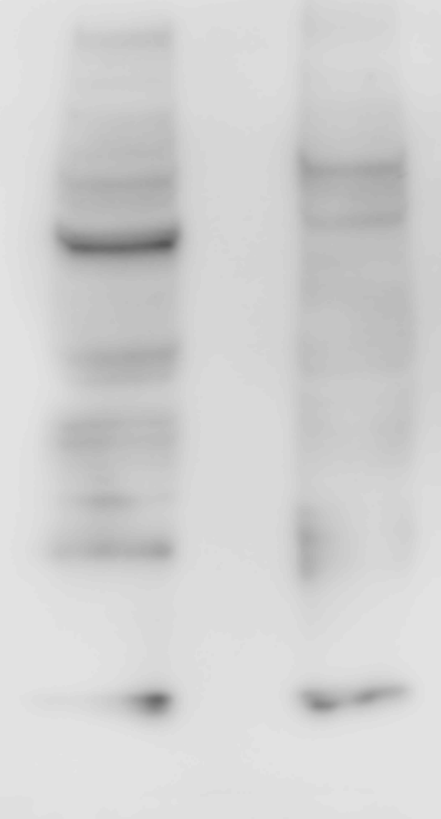Left: standard cells  Right: STIM1 knockout cells

- Fig. 2B: Please mark the lanes, A, B and C.

Author response: We have incorporated the requested change into the manuscript.

Reviewer #3 :
This manuscript by Kamath and Matreyek presents a well-written and significant contribution to the field of functional genomics through a comprehensive deep mutational scan of the STIM1 canonical EF-hand domain. While the study may not fully predict disease pathogenicity across all known variants, it offers valuable mechanistic insights into the structural and functional roles of key residues, such as those in the FLRE motif, in regulating STIM1 activity and store-operated calcium entry. The dataset generated provides a valuable resource for future studies. However, I do have a few issues that the authors should address:

- The positional correlation between nonsense and missense transformation scores in Fig 4 is very strange to me. In addition, there appears to be a fairly strong positional correlation between the nonsense and missense variant survival scores in the standard LP scores in Figure 3 that the authors don't mention, but they should mention and quantify. It's hard to imagine a biological mechanism where truncating and missense variants would correlate like this, suggesting a technical issue. I don't know the answer, but it would be good to discuss a bit more.

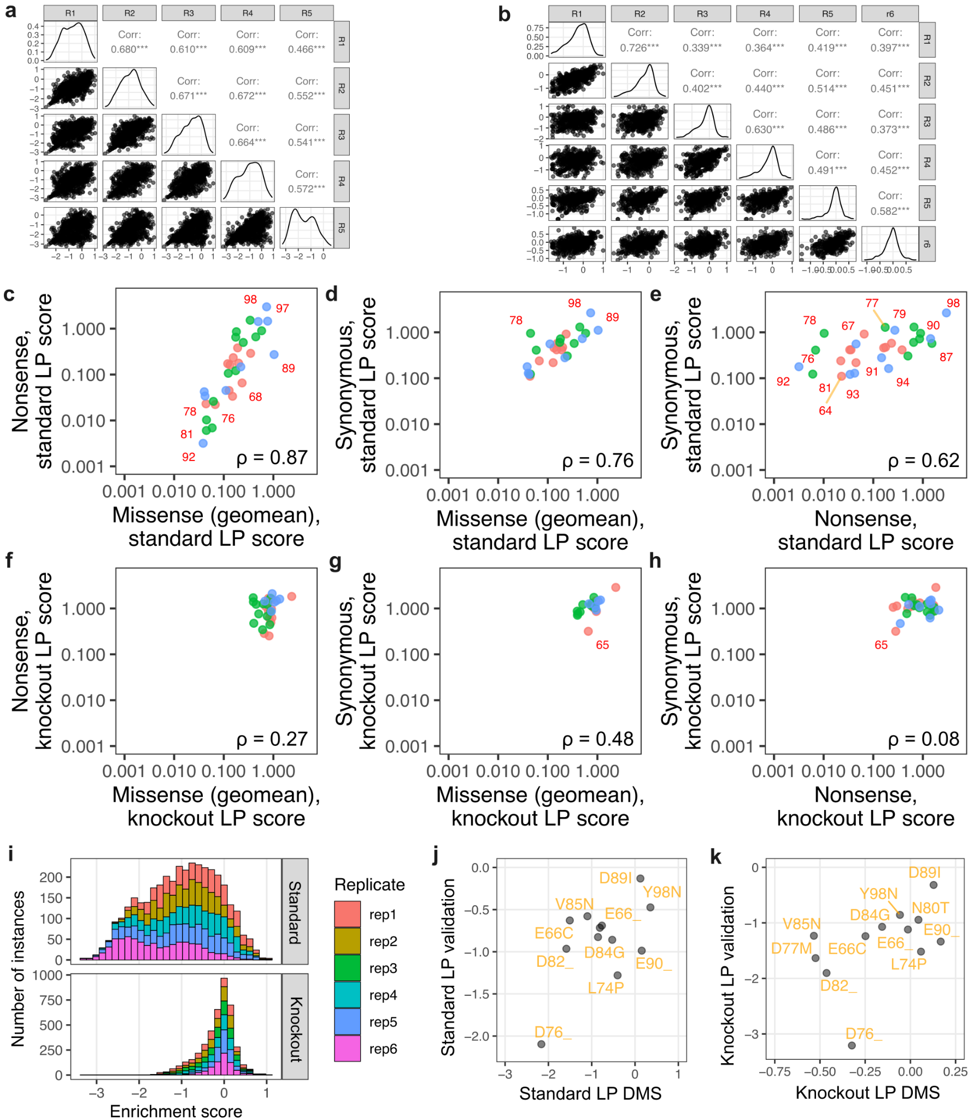

Author response: We thank the reviewer for this comment. We agree that the result is unexpected, and we have puzzled over it for a couple of years. While we do mention the nonsense variant phenotype in the discussion, we acknowledge that more analysis and discussion is warranted.

We created a new set of panels Supplementary fig 3C-H to better demonstrate and communicate this phenomenon. We quantified the positionally averaged scores for nonsense and missense variants in both standard (ρ = 0.87) and knockout (ρ = 0.27) LP cells and found that the positional correlation only holds true for the standard LP cells. The lack of effect in knockout cells lead us to speculate that the nonsense variant effect is dependent on the presence of endogenous WT STIM1. The answer is likely not that simple, since as the reviewer notes, there is a very strong correlation between nonsense and missense variant scores in bacteria (ρ = 0.96, Fig 4C), and bacteria do not endogenously encode and express STIM1-related sequences.

Regardless, we have modified the manuscript text in the following ways:

[Results – lines 160-164]: “We observed remarkable correlation in survival scores from positionally averaged missense variants and nonsense variants in standard LP cells (Supplementary Fig. 3c; Spearman’s ρ = 0.87). There was reduced correlation with synonymous variants, which also corresponded with smaller magnitude impacts of survival scores (Supplementary Fig. 3d-e). This correlation was largely lost in STIM1 knockout cells (Supplementary Fig. 3f-h).”
[Discussion – lines 459-468]: "Nonsense variants are oftentimes considered controls for DMS data analysis, as they often result in non-functional protein truncation products. Instead, for both the bacterial and standard LP survival scores, we observed a spread of scores for the nonsense variants that seemed to be largely position dependent. There is an absence of STIM1 nonsense variants in human exomes, and none observed yet in the STIM1 cEF-hand. The segment of STIM1 between the signal peptide and cEF-hand remains largely enigmatic, although multiple independent reports suggest that it plays a role in regulating STIM1 activation kinetics (Zhou et al. 2009; Hawkins et al. 2010; Zhu et al. 2018; Sirko et al. 2022). Thus, the various polypeptide fragments created by different STIM1 cEF-hand nonsense variants may each alter ER proteasis and STIM1 regulation to different extents. It is unclear why the knockout cells were the exception, exhibiting little position-specific impacts of nonsense variants."

- Related to the above, I wonder if it would be possible to attempt some sort of positional controlling for survival scores? Maybe it would lead to better agreement with the disease mutations.

Author response: In response to this reviewer comment, we reanalyzed our variant counts with Rosace, which uses amino acid position information and mean-variance shrinkage to positionally control variant scores (Rao et al. 2024). The output scores from Rosace correlated strongly with our survival scores in both cell backgrounds (ρ = 0.97 for standard LP scores, ρ = 0.91 for knockout LP scores). We have included the below scatter plots comparing our original scores with the Rosace scores as a new Supplementary Figure 10e-f. We have also included the Rosace scores in the Supplementary Table 6 of variant scores associated with this manuscript. We have opted not to incorporate the Rosace scores in regenerating the plots / analyses performed in the manuscript, due to 1) the high concordance of the two scores, which is unlikely to change the conclusions in the work, 2) the simplicity of our original scoring scheme, which comes with a certain ease of reader understanding, and 3) to avoid new errors that may creep in from regenerating a large number of plots. We are quite heartened that our scores correspond so well with the Rosace scores, and do intend to incorporate these scores further in our follow-up work.

Manuscript changes:
[Results – lines 164-167]: We analyzed our variant counts using Rosace, a framework that utilizes amino acid position information and mean-variance shrinkage to positionally control variant scores (Rao et al. 2024). The scores correlated strongly with our existing scores in both cell backgrounds (ρ = 0.97 for standard LP scores, ρ = 0.91 for knockout LP scores, Supplementary Fig. 10e-f).
[Materials and Methods – lines 674-676]: Rosace scores were generated by using the rosace package in R (https://pimentellab.com/rosace/vignettes/) (Rao et al. 2024). The code used for this analysis can be found in the R markdown file “rosace_9apr25.rmd” in Github.
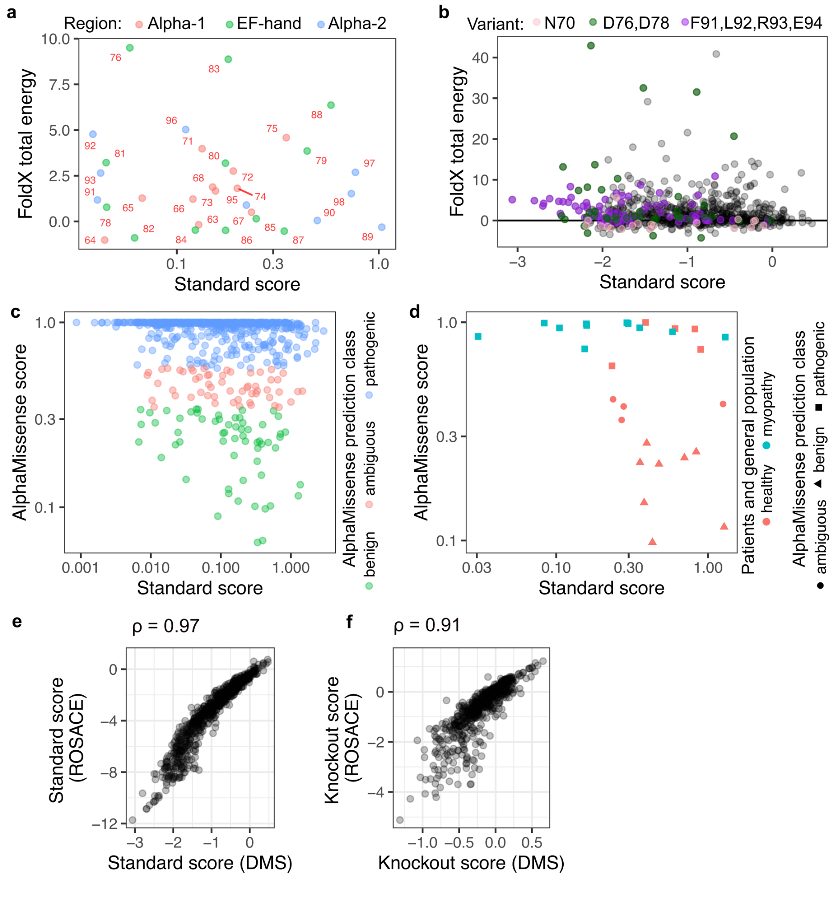

- What does 'mutated' mean in Fig 5A?

Author response: Reviewer 1 also noted this figure lacked sufficient explanation (please see our response to Reviewer 1 comment 10 for a full description of changes made to fix this). But to also answer this question directly: “mutated” referenced a dataset created when we averaged the variant scores based on the identity of the replacing amino acid. We agree that this label is rather ambiguous, and have changed it to “mutated aa” in figure 5A. We have also included better description of this in the legend for figure 5A, and also provide a new supplementary figure 6 that further explains each category, and shows underlying scatterplots for the associated with the reporter correlation coefficients.

- It would be interesting to see how the survival scores correlated with in silico predictions of missense variant impact, e.g. AlphaMissense and others. It would also be useful to show how they compare in terms of discriminating between known pathogenic and population variants (although I emphasize that doing 'worse' than the computational predictors does not mean that this data is valuable for other reasons, it just helps put things in context).

Author Response: Variants with the lowest survival scores are consistently classified as pathogenic by AlphaMissense, demonstrating concordance with these extremely disrupted variants. But, likely due to the high level of sequence conservation in the STIM1 EF-hand, AlphaMissense classifies 83% of variants as pathogenic, 8% of variants as ambiguous, and 9% of variants as benign. Consistent with this bias, AlphaMissense correctly calls all 11 myopathy-associated germline variants from patients as pathogenic, but also incorrectly calls roughly half of the variants from the general population as not clearly benign (5 pathogenic, 4 ambiguous, 8 benign). Thus, AlphaMissense appears to exhibit the opposite sensitivity and specificity characteristics as the survival assay. For the curiosity of the reviewer and reader, we have included the plots that support this statement as Supplementary fig 10c-d. We intend to unpack this relationship further, including comparison with other in silico pathogenicity predictors, as well as potential advantages of integrating both datasets, in subsequent work.

Manuscript changes:
[Results – lines 343-349]: Computational predictors like AlphaMissense have been developed to predict if protein variants are pathogenic based on evolutionary conservation and structure (Cheng et al. 2023). We compared our survival scores with the AlphaMissense prediction classes and found that 83% of variants were classified as pathogenic, 8% as ambiguous, and 9% as benign likely due to the high sequence conservation of the STIM1 cEF-hand (Supplementary fig 10c). AlphaMissense calls 11 myopathy-associated germline variants as pathogenic but incorrectly calls half of variants from the general population as pathogenic, exhibiting opposite sensitivity and specificity characteristics as the survival assay (Supplementary fig 10d).

[Materials and Methods – lines 676-677]: Scores for AlphaMissense were generated by searching for “STIM1” in the AlphaMissense database (https://alphamissense.hegelab.org) (Cheng et al. 2023).


- "while our assay results are insufficient for use in clinical interpretation" - this might not be true. Although this assay is certainly not identifying most pathogenic variants, with the "OddsPath" approach that people have been using for DMS data, what really matters is not the overall classification performance (e.g. AUC), but whether there are regions of the score distribution where you can be confident something is pathogenic or benign. It qualitatively looks to me from Fig 8 that the lowest scoring variants could conceivably reach moderate ACMG evidence strengths according to this framework. I don't think you need to add this to the study, but it's just something to keep in mind.

Author response: Thank you for this suggestion! We will definitely investigate this approach in our follow-up studies, which is focused on performing additional phenotypic assays for a panel of STIM1 variants, and integrating those results with the survival scores, in an attempt to better relate variant-specific STIM1 dysregulation with pathogenicity in people.

- "Somatic STIM1 variants are also sporadically observed in cancers, with a subset of observed variants likely contributing to cancer development" - is there a citation for this? Note than nearly every human gene is full of (essentially random) variants in COSMIC, very few of these are drivers, so unless there is evidence of specific cancer drivers, I don't think the low-scoring cancer-associated variants are likely to be meaningful.

Author response: STIM1 has not been classified as a driver of cancer (Tamborero et al. 2013). However, STIM1 overexpression has been linked to cancer progression in several cancers such as hepatocellular carcinoma, breast cancer, cervical cancer, and colorectal cancer (Hoth 2016). There have not been studies specifically showing that STIM1 variants contribute to cancer, but somatic cEF-hand variants could contribute to cancer progression through dysregulated calcium flux (Monteith et al. 2017; Marchi et al. 2020). We agree that our statement of somatic STIM1 variants contributing to cancer development was too strong and definitive. We have changed the wording of the statement to the following:

Manuscript changes:
[Results – lines 335-337]: “Increased overexpression of STIM1 has been linked to cancer development (Hoth 2016), and somatic STIM1 variants that may likely exhibit downstream effects similar to STIM1 overexpression may potentially contribute to cancer development”

- What version of gnomAD are you using - I'm guessing v4?

Author response: You are correct; since the data was last accessed in September 2024, we were indeed using data from gnomAD v4.1. We have altered the text in the materials in methods to now explicitly mention this.

Manuscript changes:
[Materials and Methods – lines 667-668]: “Germline STIM1 coding variants in generally healthy individuals were compiled after accessing the following databases: GnomAD v4.1 (Chen et al., 2024) on September 24, 2024,...”

- Make sure to define and cite the Mexico City MCPC data

Author response: We regret that there was a typo in the figure legend (MCPC should have been MCPS, for Mexico City Prospective Study), that likely resulted in the reviewer being unable to find the associated definition and citation in the materials and methods (“... and Regeneron Mexico City Prospective Study (MCPS) (Ziyatdinov et al., 2023)).

- It's great that the sequencing data has been deposited, but the authors should also deposit their variant scores to MaveDB.

Author response: Thank you for this reminder; we have added our mutational data to MaveDB, found at the following web address -
https://www.mavedb.org/experiments/urn:mavedb:00001221-a

Manuscript changes:
[Materials and Methods – lines 744-745]: “Data availability”: STIM1 cEF-hand DMS data is deposited in MaveDB (Rubin et al. 2025) (https://www.mavedb.org/experiments/urn:mavedb:00001221-a).

