Additional files

Supplement Tables:
- Supplement Table 1: Survival scores for cell survival DMS in standard LP, knockout LP, bacteria strains, and validation experiments
- Supplement Table 2: Primers used for NGS experiments
- Supplement Table 3: Names of FASTQ files
- Supplement Table 4: qPCR primers used for gene expression experiments
- Supplement Table 5: Compilation of results from all databases accessed for this study
- Supplement Table 6: Compilation of computational predictor scores

Supplement Figures:

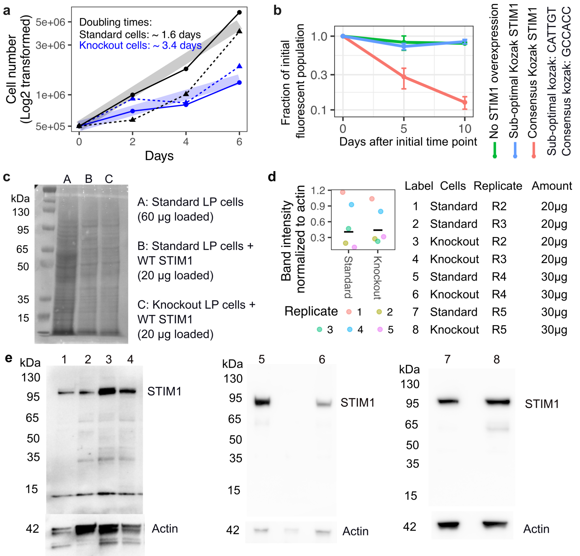
Supplementary fig 1: A) Graph of standard and knockout LP cell growth of two replicate experiments. Doubling times were calculated as the slope of the curves. B) Relative fraction of STIM1 overexpressing cells remaining in culture over time, as measured by flow cytometry for mCherry fluorescence, for STIM1 overexpression under an sub-optimal or consensus Kozak sequence. C) Total protein analysis for western blot of standard LP cells, standard LP cells with WT STIM1 overexpressed, and knockout LP cells with WT STIM1 overexpressed. D) Dot plot of band intensity of the replicates from C. E) Western blot of four additional replicates of overexpressed STIM1 in standard LP cells and knockout LP cells included in analysis shown in panel D.

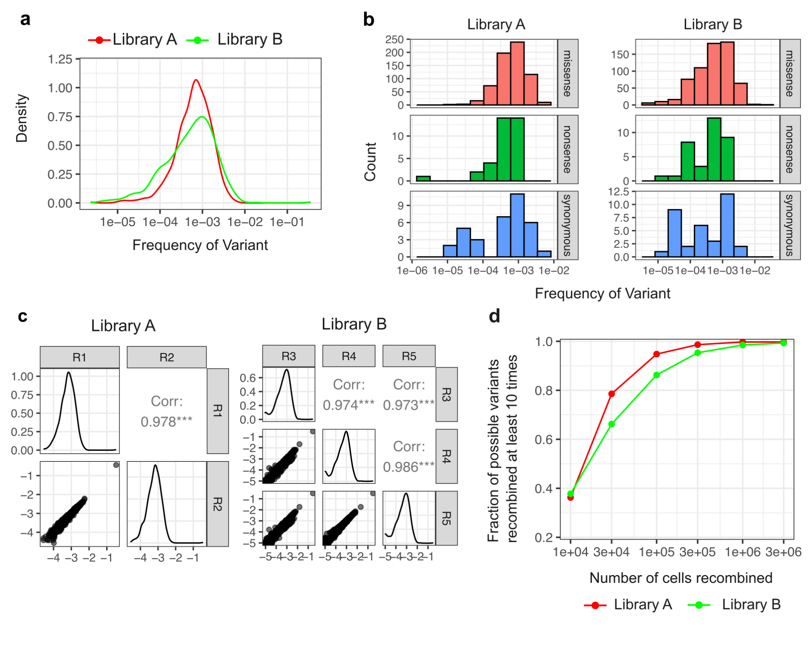
Supplementary fig 2: A) Density plot of frequency of variants in plasmid libraries used for standard (library A) and knockout LP (library B) DMS experiments. B) Histogram of missense, nonsense and synonymous STIM1 cEF-hand variants present in both plasmid libraries. C) Correlation plot of each sequenced replicate of the plasmid library. R1 and R2 were library A, R3-R5 were library B. D) Simulation to determine the number of recombined cells needed to observe a variant at least 10 times.

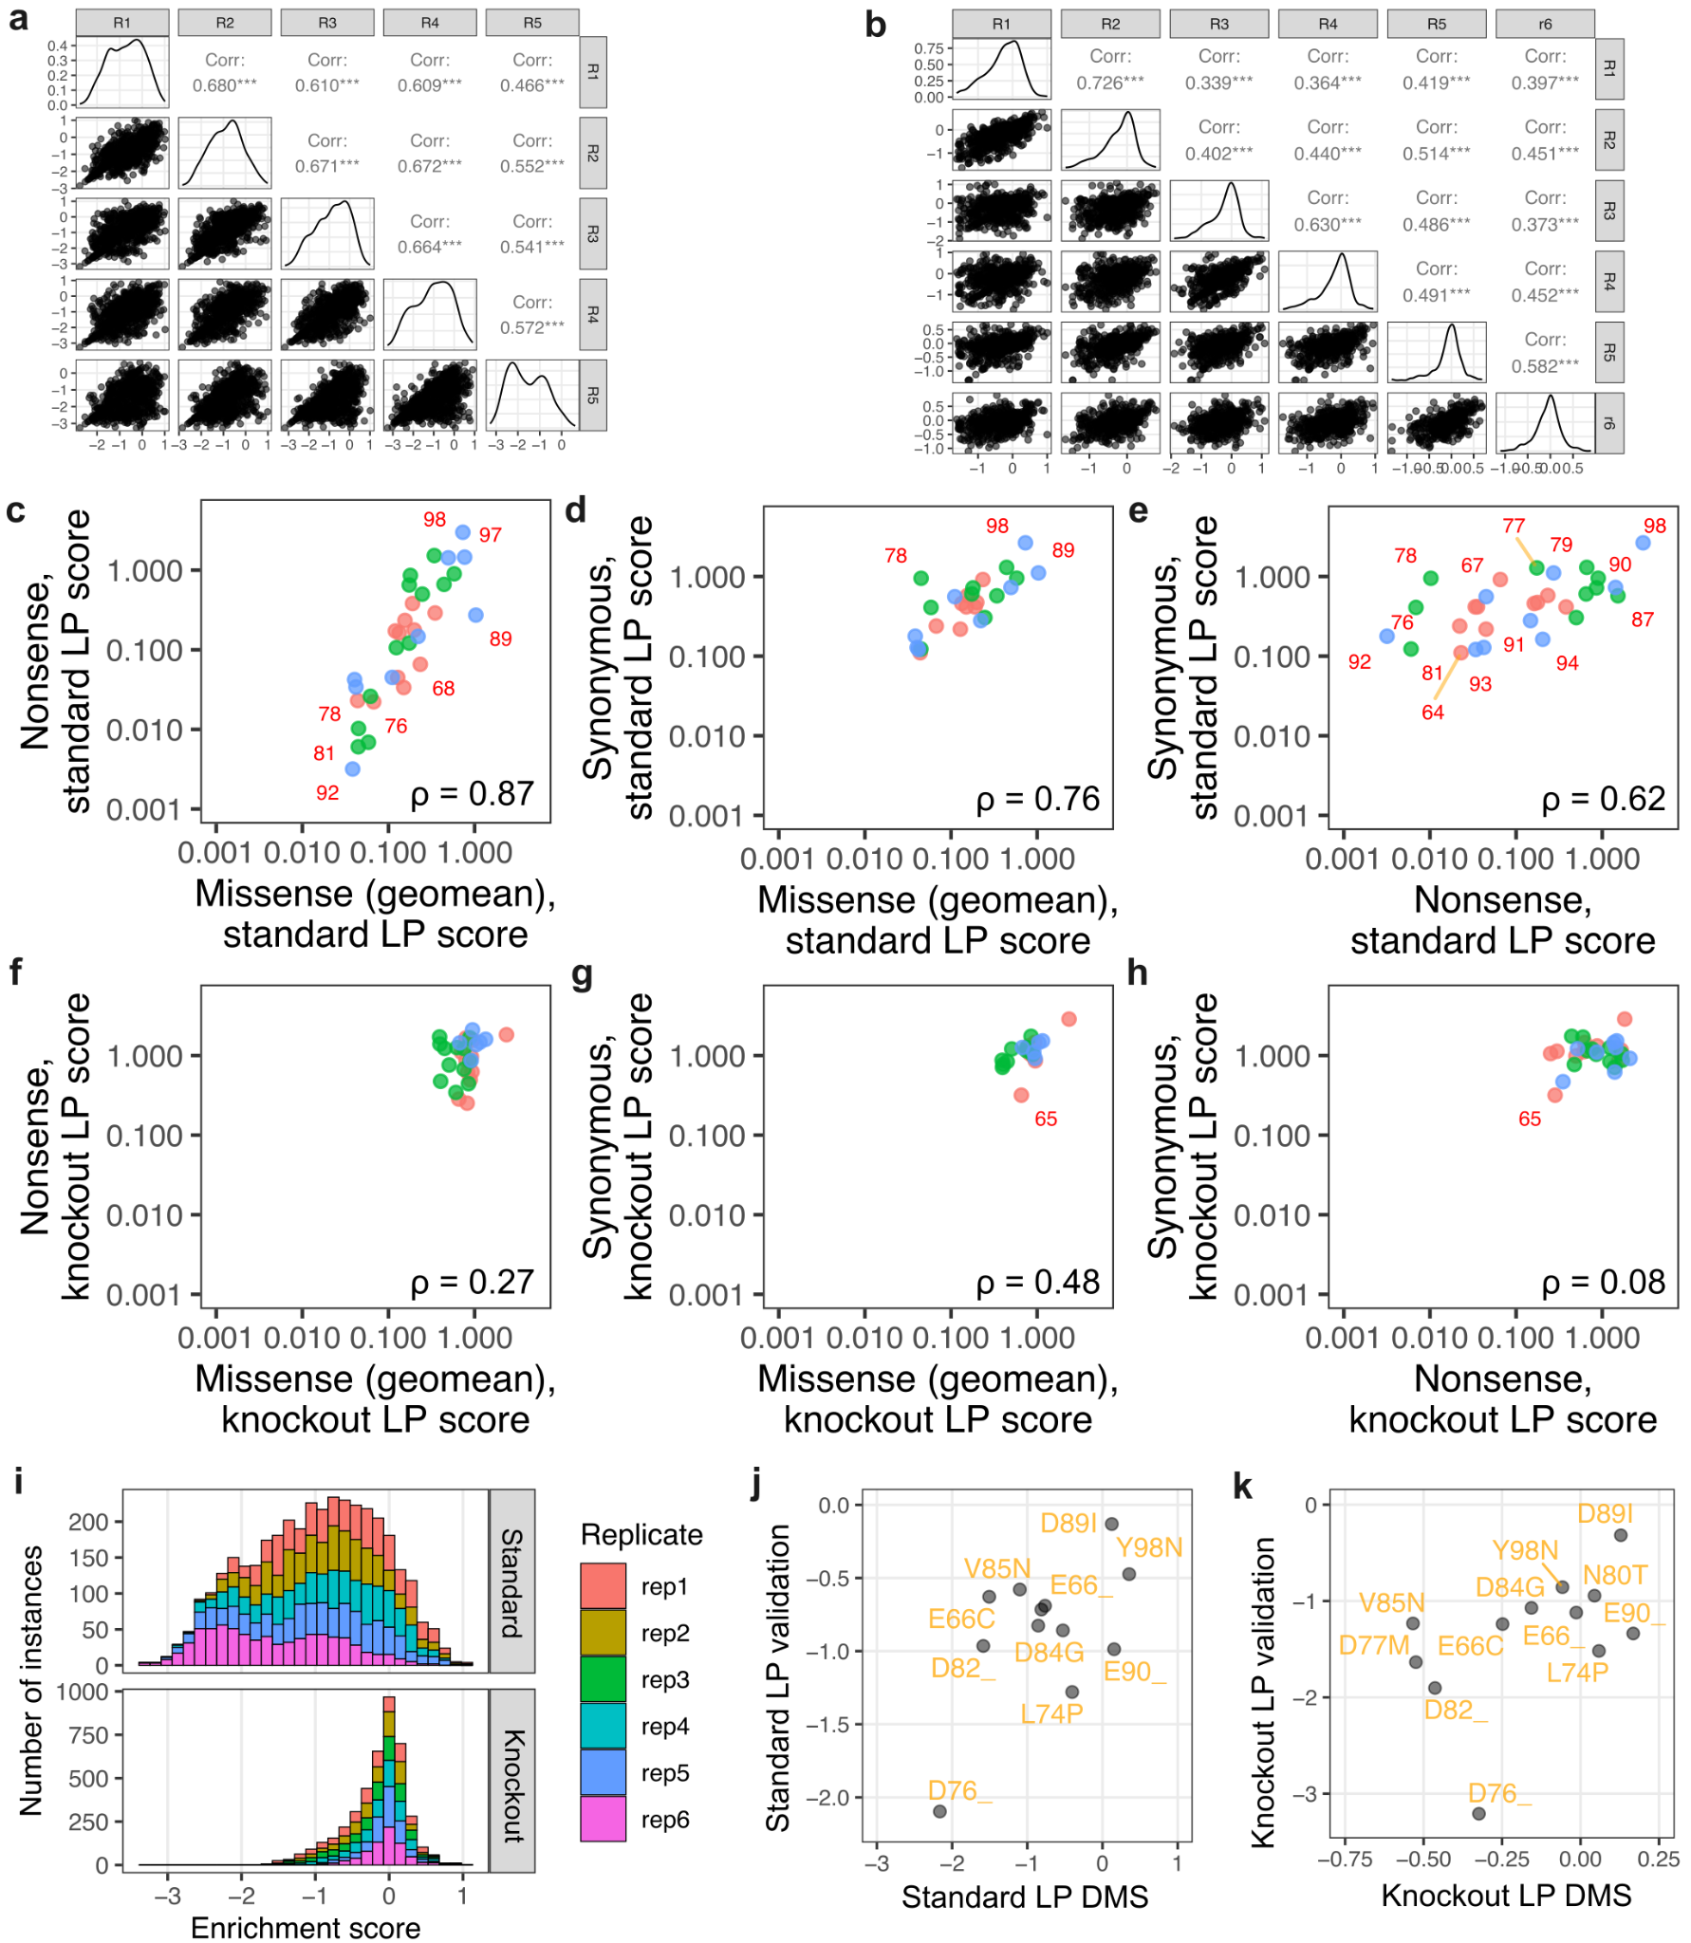
Supplementary fig 3: A) Correlation plot of standard LP DMS replicates. B) Correlation plot of knockout LP DMS replicates. C through H) Scatterplots comparing the relationships between the mean missense variant score at a given position, with the mean nonsense and synonymous variant scores at that position, with standard LP scores shown in the top row, and knockout LP scores on the bottom row. Points are colored by domain: red, alpha-1 helix; green, EF-hand motif; alpha-2 helix, alpha-2 helix. I) Histogram of variant score distributions seen in standard and knockout LP DMS, colored by replicate experiment. J) Scatterplot of DMS score vs small scale validation scores in standard LP cells. K) Scatterplot of DMS score vs small scale validation scores in knockout LP cells.

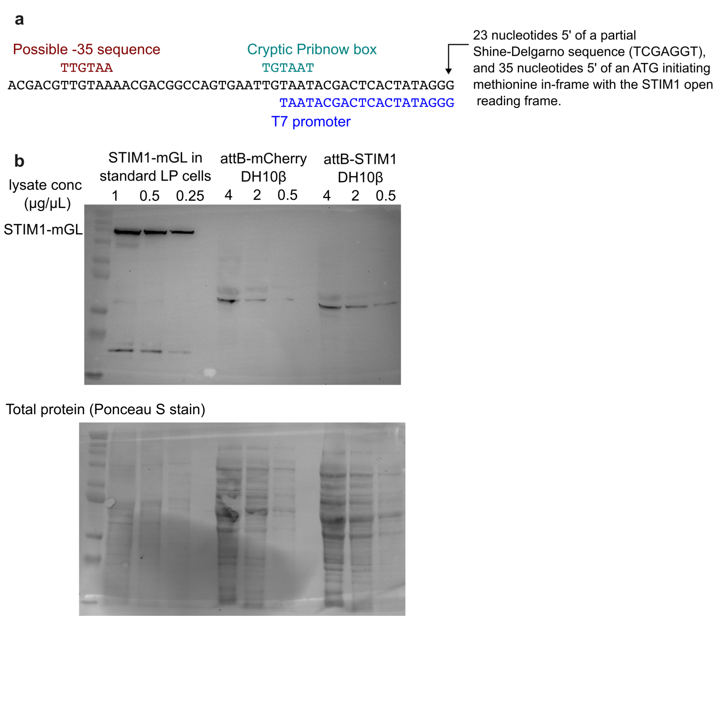
Supplementary fig 4: A) Schematic representation of the cryptic bacterial promoter retrospectively identified in the plasmid. B) Western blot of STIM1 overexpression in DH10β bacteria.

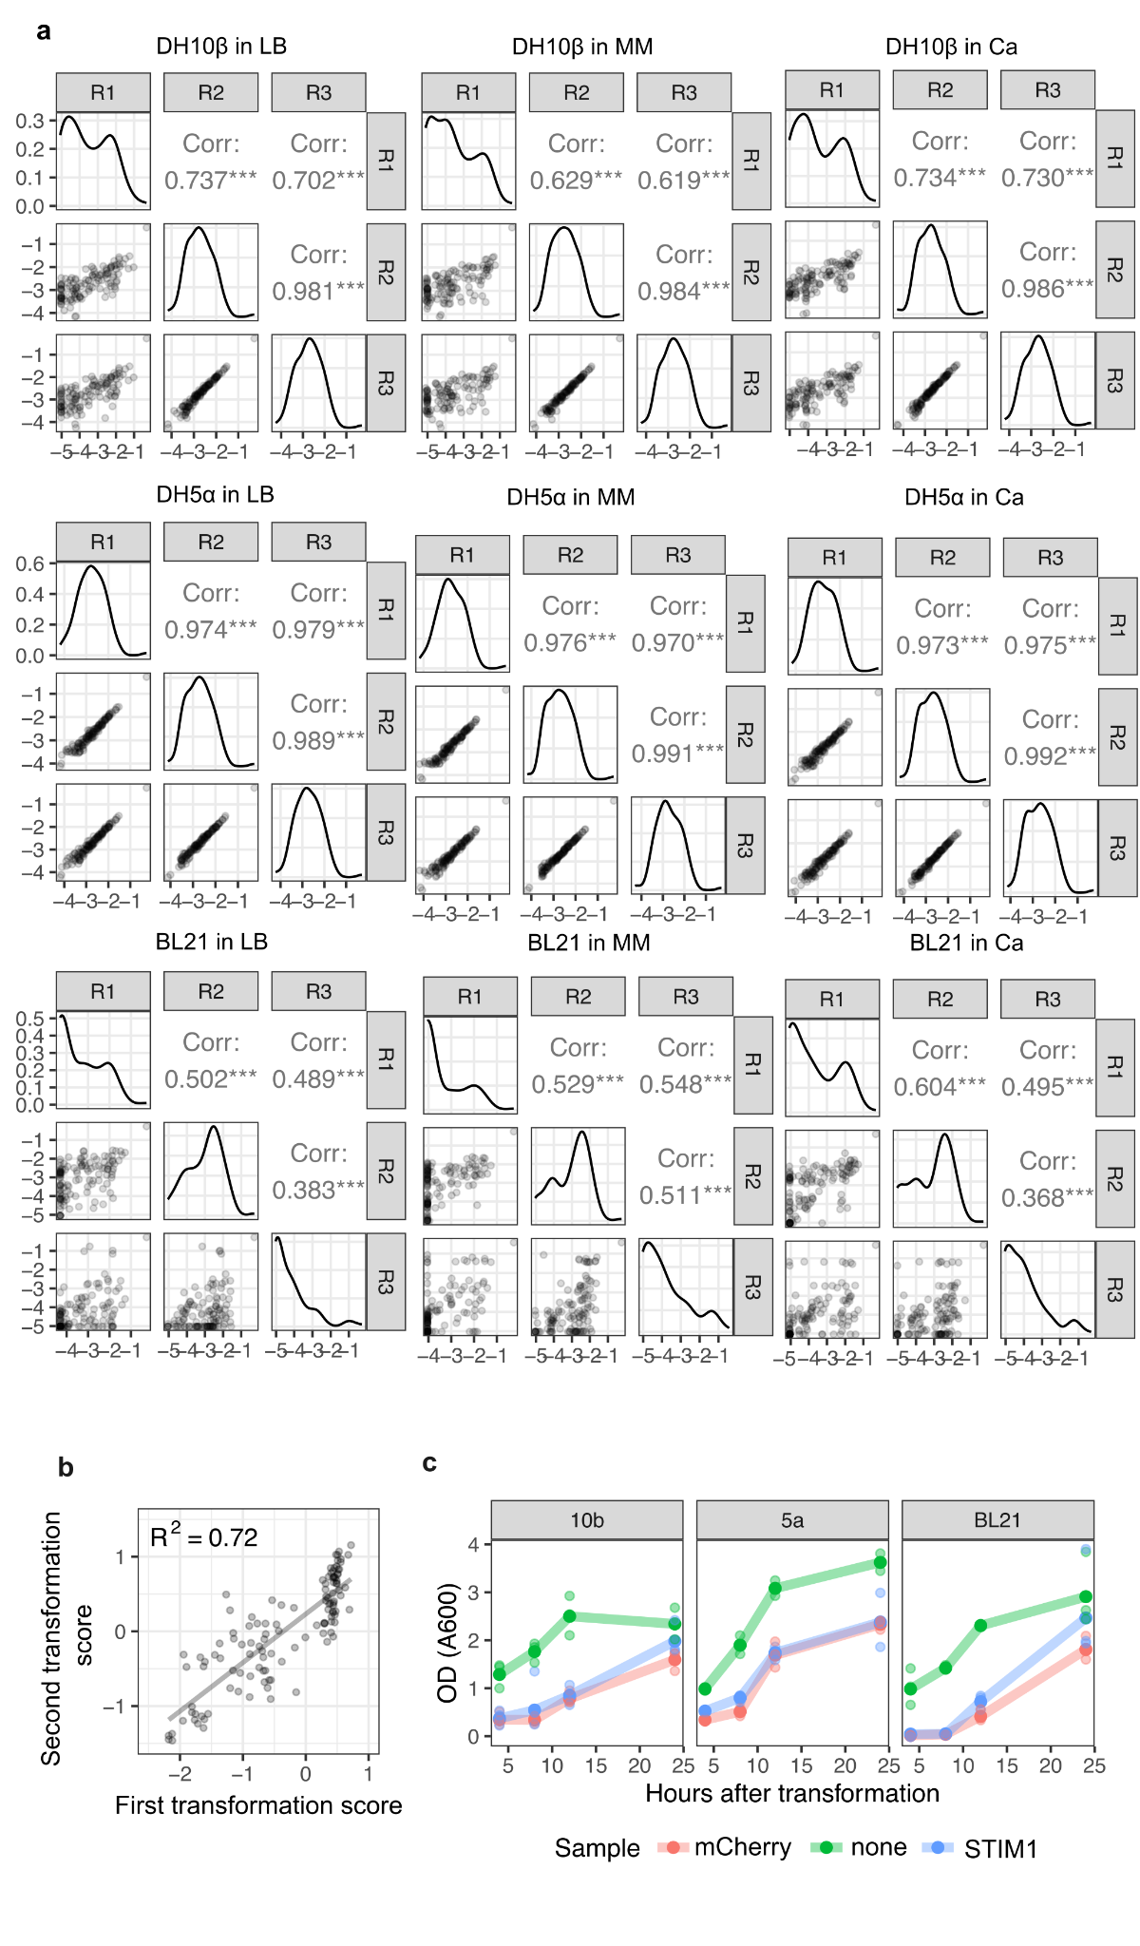
Supplementary fig 5: A) Replicate correlation plots of Figure 4E samples separated by bacteria strain and media used. B) Scatterplot of transformation scores from first DMS to the scores from the second DMS in DH10β cells. C) Growth curves of bacteria strains transformed with mCherry, STIM1 or a mock transfection and grown in LB.

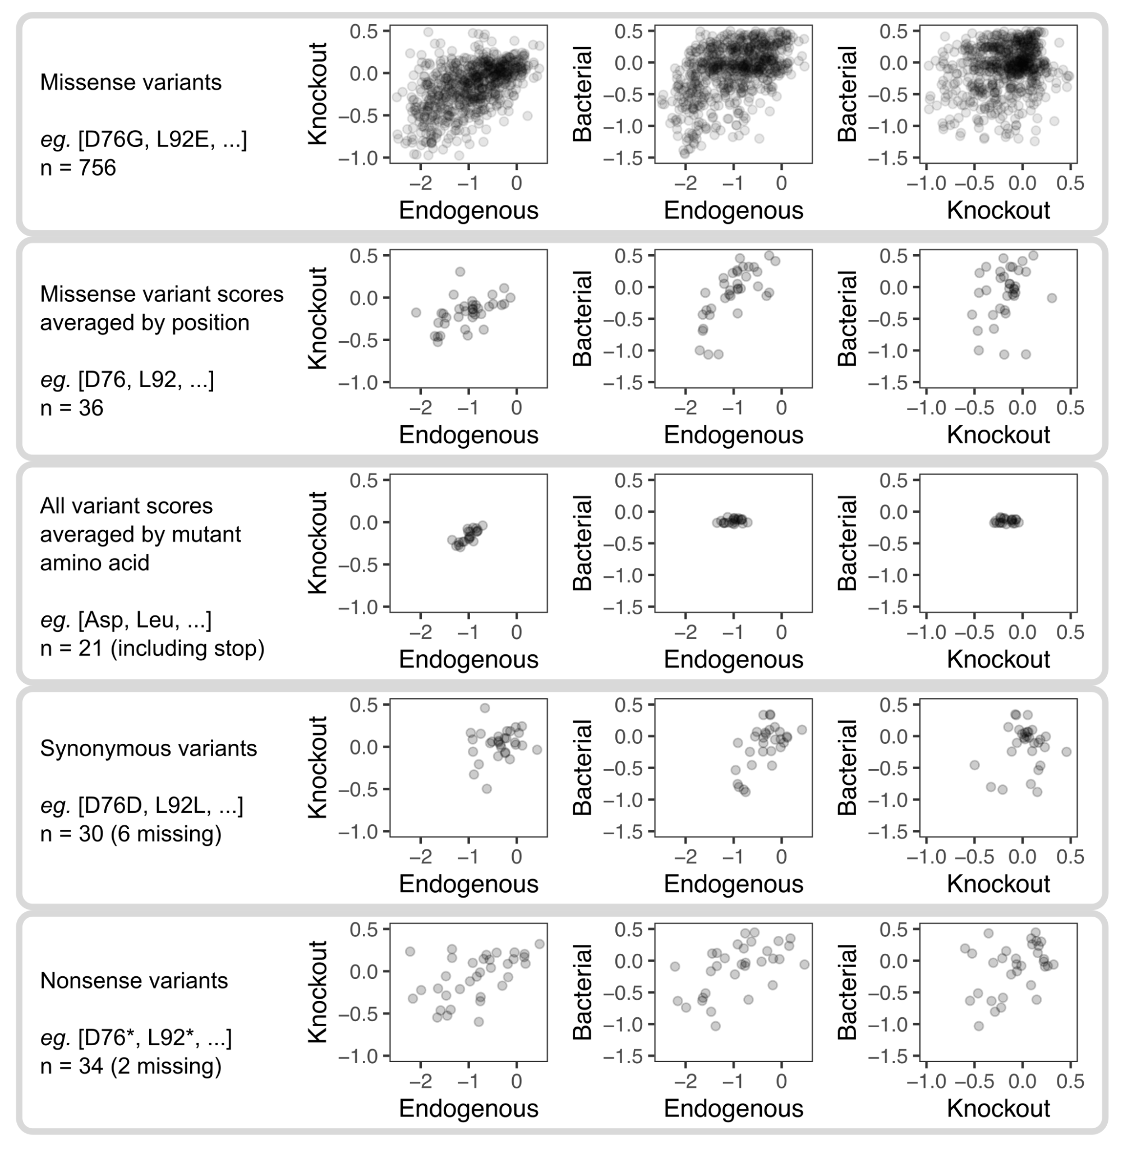
Supplementary fig 6: Scatterplots of standard, knockout and bacterial score for each category listed on the left. Spearman ρ of each scatterplot were used for Figure 5A.

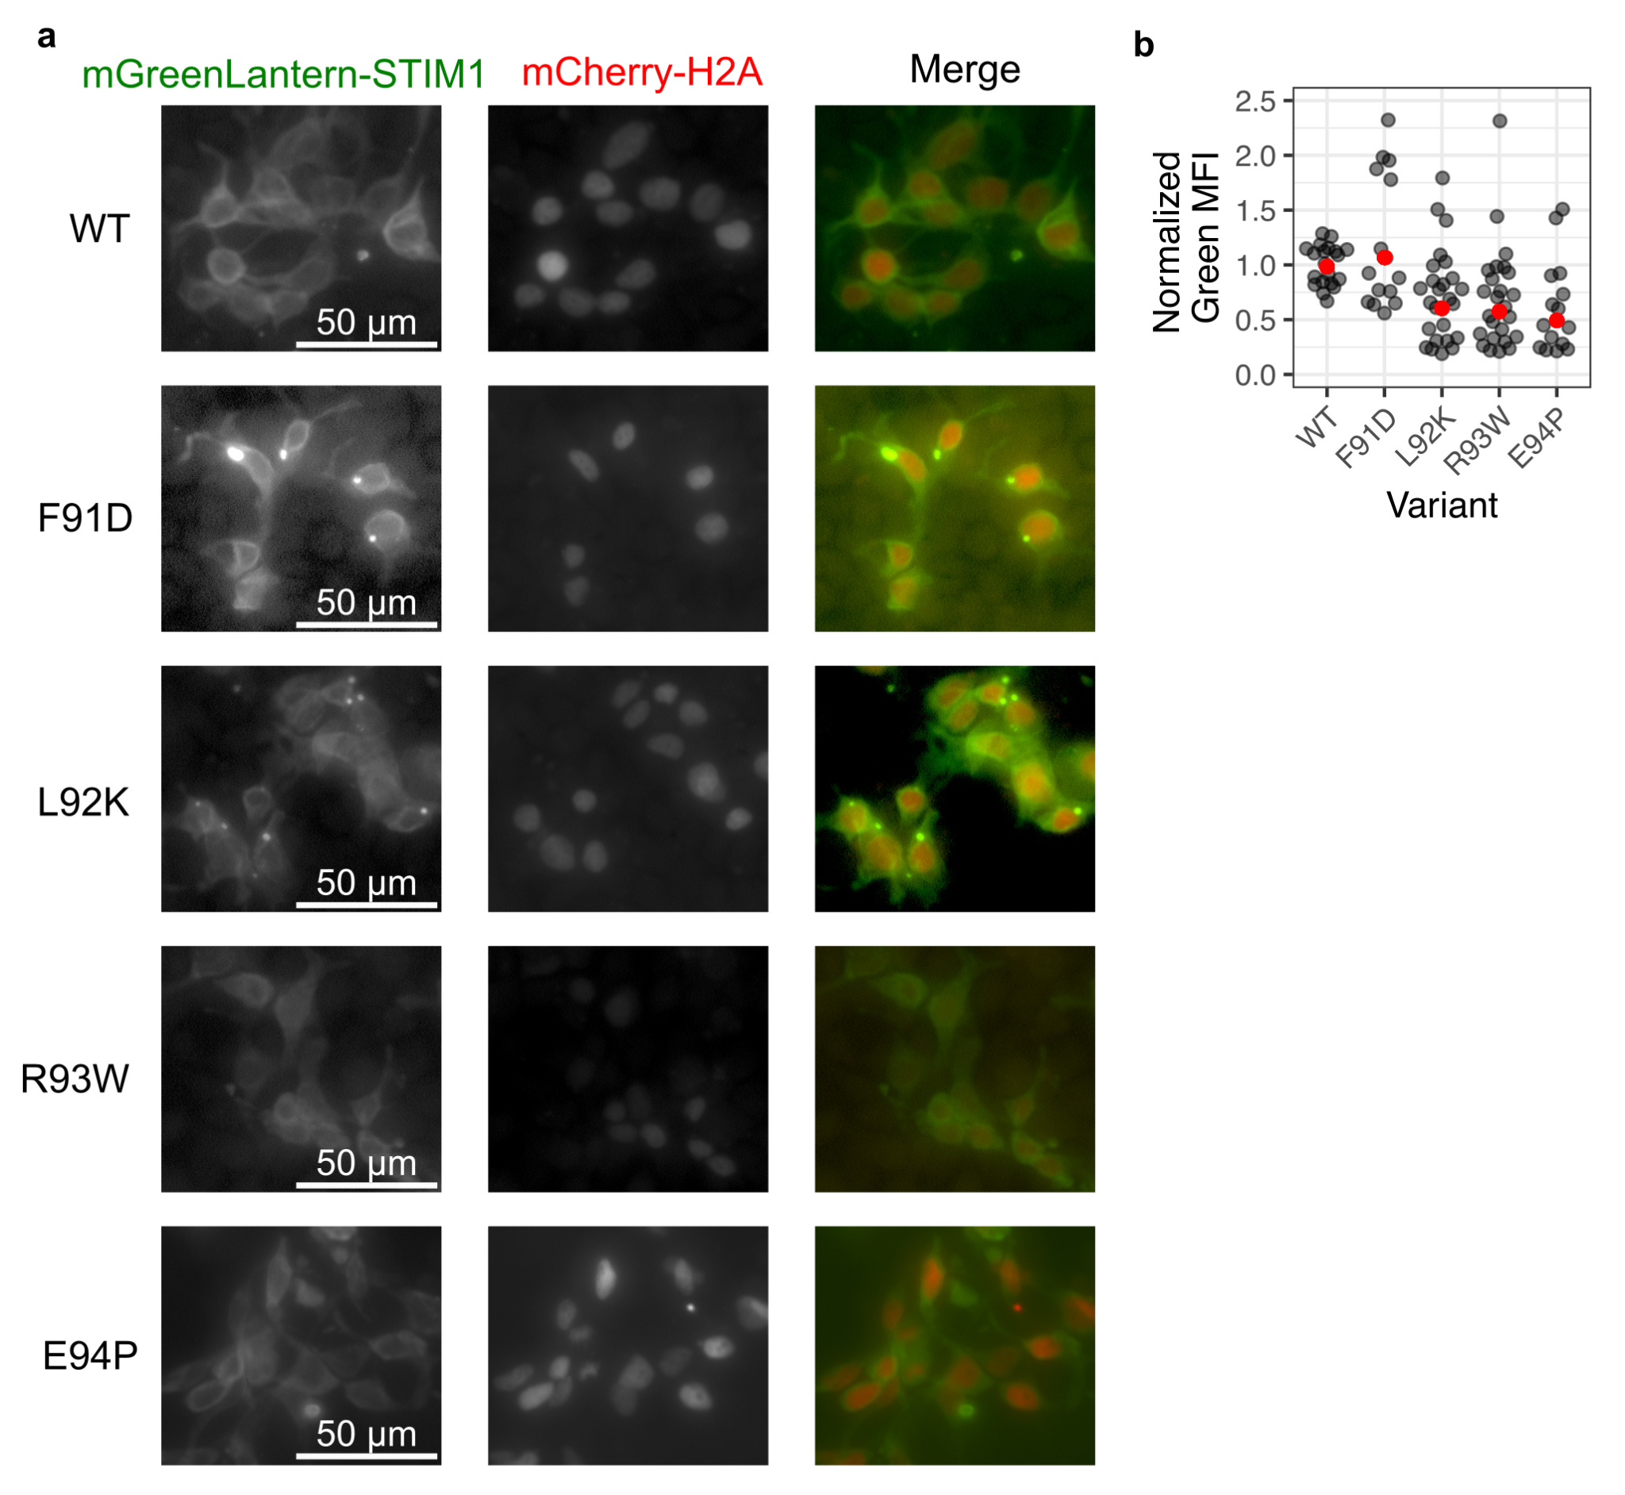
Supplementary fig 7: A) Raw fluorescence microscopy images of mGreenLantern-tagged STIM1 variants in standard LP cells. B) Quantification of green fluorescence intensity normalized to WT for variants in A.

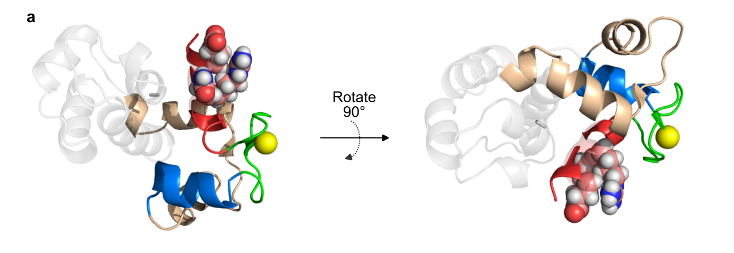
Supplementary fig 8: Pymol visualization of the STIM1 EF-SAM calcium loaded NMR structure (PDB: 2k60), with the STIM1 cEF-hand positions differing in mammalian orthologs (Glu66, Arg69, Asn70) shown as spheres. The calcium ion is shown as a yellow sphere. Helix α1 is color red, the EF-motif is colored green, and helix α2 is colored blue. The hidden EF-hand is colored beige, whereas the SAM domain is shown in semi-transparent gray.

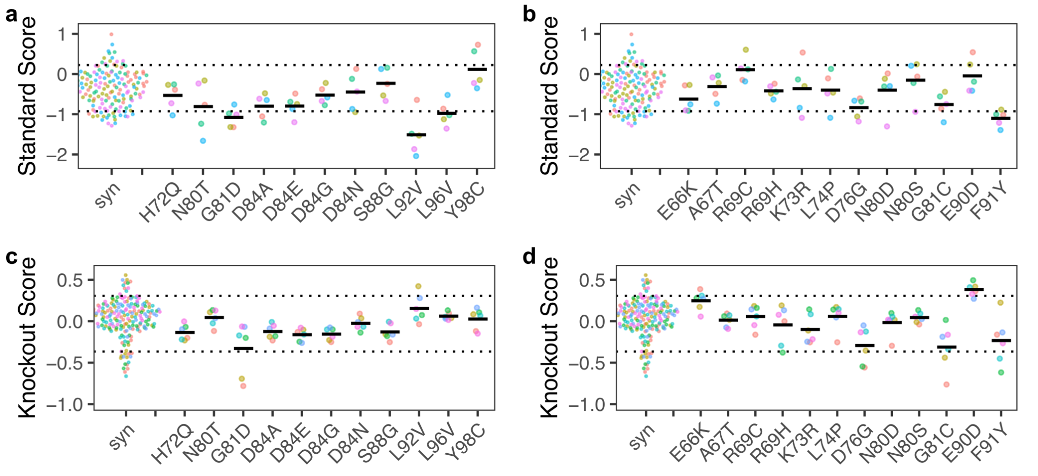
Supplementary Fig 9: Replicate survival scores for known pathogenic variants in (A) standard and (C) knockout LP cells. Replicate survival scores for STIM1 variants of uncertain significance in (B) standard and (D) knockout LP cells. ‘Syn’ refers to the replicate survival scores of the synonymous variants.

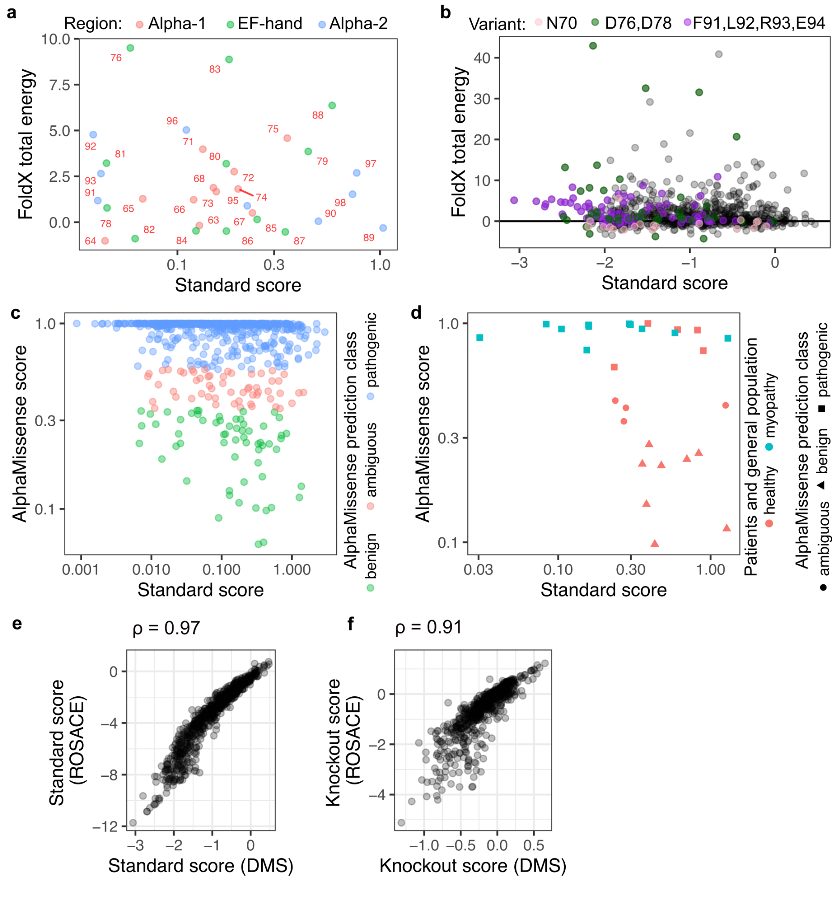
Supplementary fig 10: A) Scatterplot of FoldX total free energy scores and variant survival scores from standard LP cells averaged on position. B) Scatterplot of FoldX total energy and variant survival scores from standard LP cells. Scatterplot of AlphaMissense scores and variant survival scores in standard LP cells for C) all variants and D) for variants listed in ClinVar. Scatterplot of scores computed by ROSACE and survival scores from our assay for all variants in E) standard LP cells and F) knockout LP cells.

