

Project Report: Music Player with Lyrics using REST API

Tarun V
23BTCE284
Full Stack Development

1. Introduction
The Music Player with Lyrics project is a web-based application built using React (Vite), Spotify Web API, and Bootstrap for styling.
The main objective of this project is to provide users with a seamless experience of:
- Searching for songs
- Playing previews
- Viewing lyrics
- Creating and managing playlists
This project combines the functionality of a modern music app with a simple UI and dark theme for better contrast.

2. Objectives
- To implement a music player interface using React.
- To integrate with Spotify Web API for music search and previews.
- To use a lyrics API to fetch and display lyrics for selected songs.
- To allow users to create, add, and remove songs from playlists.
- To design the UI with a dark theme for better readability.

3. Tools & Technologies
- Frontend Framework: React (Vite)
- Styling: Bootstrap 5, Custom CSS (Dark Theme)
- APIs:
  - Spotify Web API (for search and preview playback)
  - Lyrics API (e.g., lyrics.ovh or Musixmatch API)
- IDE: Visual Studio Code
- Language: JavaScript (React JSX)

4. System Requirements
- Software: Node.js (LTS version), npm, VS Code
- Browser: Chrome / Edge / Firefox
- Dependencies Installed:
  - react, react-dom
  - vite
  - bootstrap
  - axios (for API calls)

5. Project Structure
music-player-lyrics/
│── index.html
│── package.json
│── vite.config.js
│
├── src/
│ ├── main.jsx
│ ├── App.jsx
│ ├── App.css
│ ├── components/
│ │ ├── Player.jsx
│ │ ├── Playlist.jsx
│ │ └── Lyrics.jsx
│
└── node_modules/

6. Implementation Details

6.1 Authentication
- Users authenticate with Spotify API using a Redirect URI.
- A temporary access token is generated for searching and previewing songs.

6.2 Search & Player Component
- Users can search for songs or artists.
- Search results display thumbnail, song name, and artist name in a grid view (library style).
- A play preview button allows playback of 30-second samples.
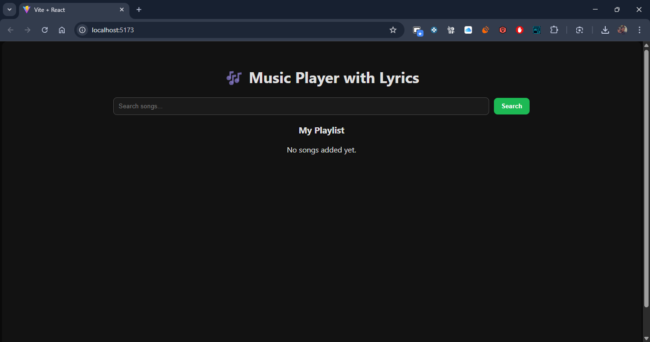

6.3 Lyrics Component
- When a user selects a track, lyrics are fetched via an external Lyrics API.
- Lyrics are displayed below the player with proper formatting.
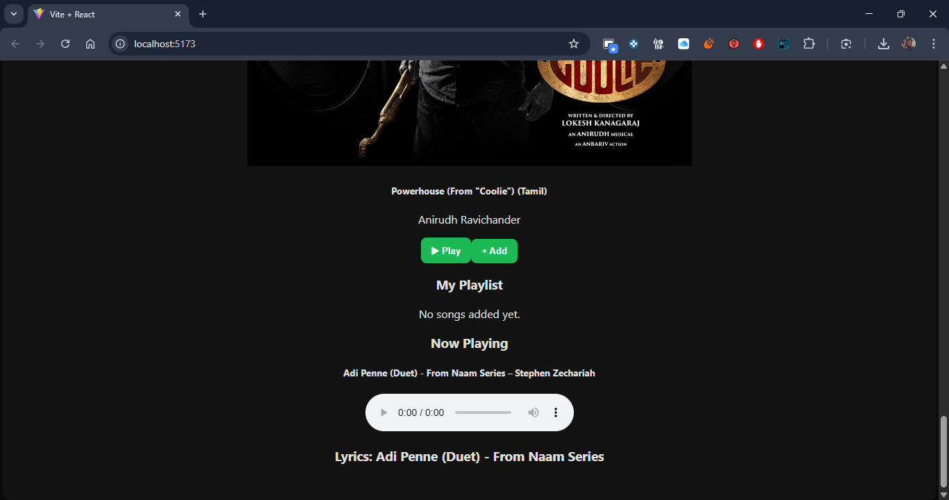

6.4 Playlist Component
- Users can add/remove songs from a playlist.
- The playlist is displayed in a card/grid format with song thumbnails.
- Each track in the playlist has a "Remove" button.

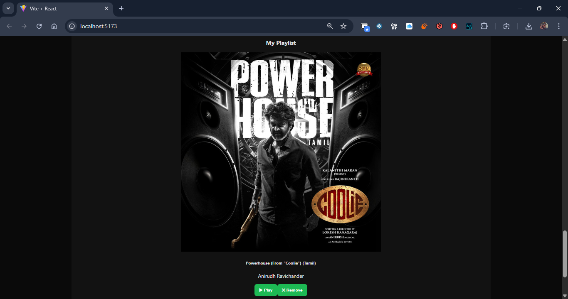

7. User Interface
- The application uses a dark theme (background: #121212; color: #fff;).
- Buttons and search bar styled with Bootstrap (btn-dark, btn-primary).
- Layout divided into 3 main sections:
  - Search Results (library style grid)
  - Lyrics Viewer
  - Playlist Manager

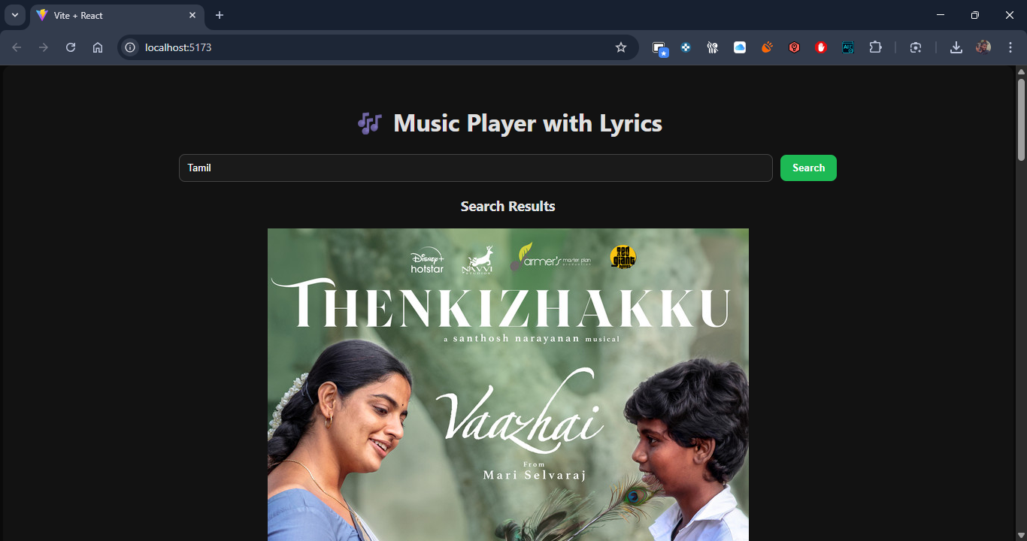

8. Challenges Faced
- Handling CORS issues while calling external APIs.
- Managing Spotify token expiry.
- Designing a responsive layout for both desktop and mobile screens.
- Styling the search results as a grid (library view) instead of list view.

9. Future Enhancements
- Add full track playback using Spotify Web Playback SDK.
- Implement user authentication (Spotify login).
- Allow saving playlists to Spotify user account.
- Add mood-based playlist generation (Happy, Chill, Workout).

10. Conclusion
The Music Player with Lyrics project successfully demonstrates the integration of multiple APIs within a React app. It provides users with an interactive music experience, combining search, play, lyrics, and playlist management in one place.

