Recommender Systems - Course Project Report
Cumulative report template - Parts 1, 2, and 3
Team | Group 20
Members | Youssef Zougari-Belkhayat
For Part 3 track: select one | A / B / C
GitHub repository link | https://github.com/Matrix02Gold/recommender-systems-project

How to use this template
- This is one cumulative report. Extend and revise the same document at each project stage.
- Maximum length: 4 pages at Part 1, 8 pages at Part 2, and 12 pages for the final report, excluding references.
- Keep the section headings below. You may add subsections where useful.
- All explanations and justifications requested in the project specification belong in this report.
- The Results Sheet contains the complete standardized numerical record. In the report, include only the tables and figures needed to support your analysis.
- Delete all italic instructional text before the final submission.

1. Part 1 - Data, Protocol and Baselines

1.1 Data characterization

MovieLens 1M contains 1,000,209 explicit 1–5-star ratings from 6,040 users on a 3,883-movie catalogue, 3,706 movies have ratings and 177 have none.
The user-item matrix has a density of 4.26% and a sparsity of 95.74%, meaning most possible user-movie interactions are unobserved. This sparsity presents a challenge as many user preferences cannot be inferred directly from existing ratings.
User activity is unevenly distributed. Users provided an average of 165.60 ratings, while the median was only 96. The most active user rated 2,314 movies, compared with 20 for the least active user. Movie popularity follows a similar right-skewed distribution: movies received an average of 257.59 ratings, but the median was 109, with the most frequently rated movie receiving 3,428.
These differences indicate a pronounced long-tail distribution, where a relatively small number of popular movies account for a substantial proportion of interactions.
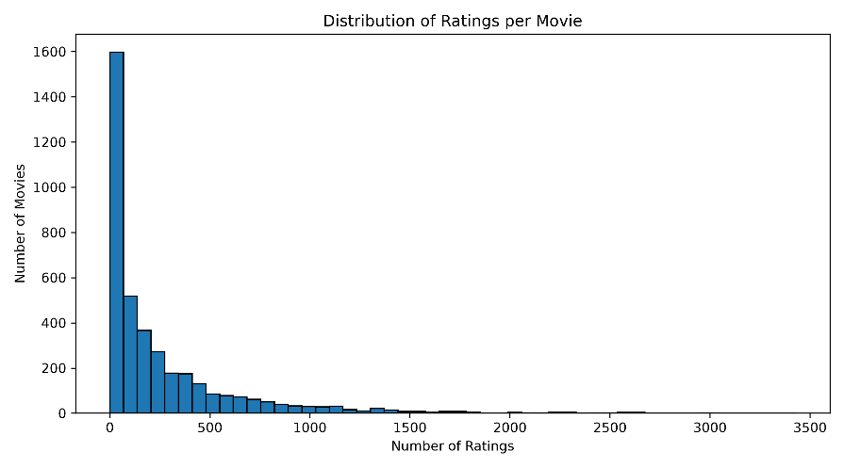
Figure 1. Ratings per movie.
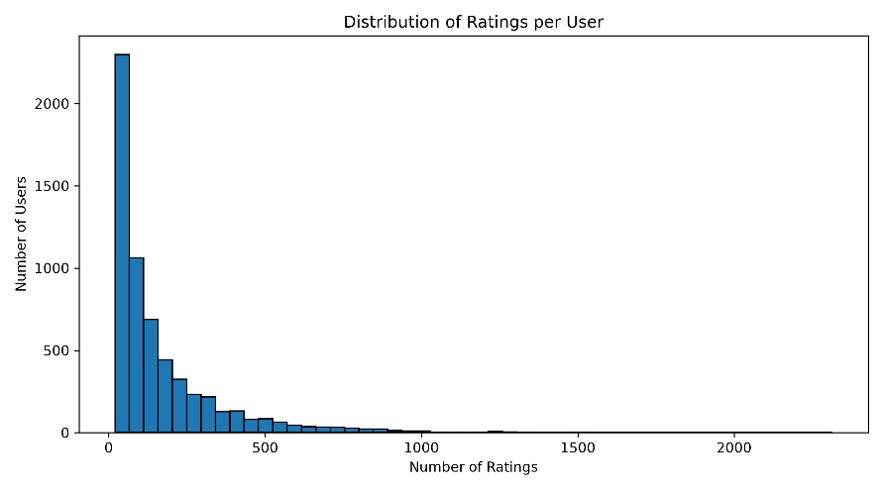
Figure 2. Ratings per user.

The rating distribution is also skewed toward positive feedback, with approximately 57.5% of ratings being 4 or 5 stars.
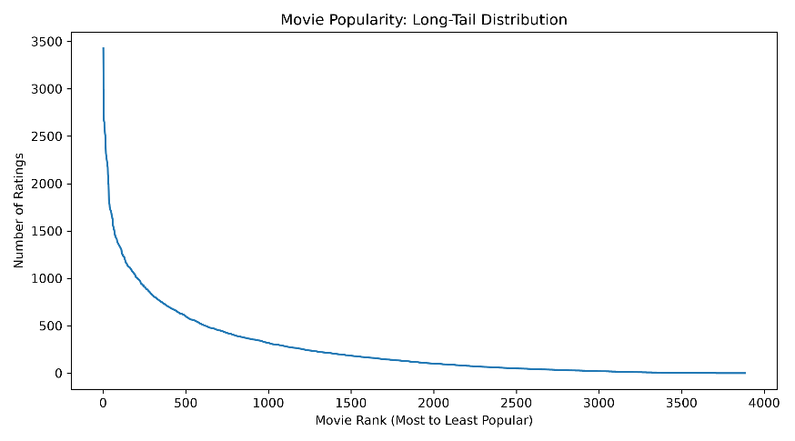
Figure 3. Popularity long tail.
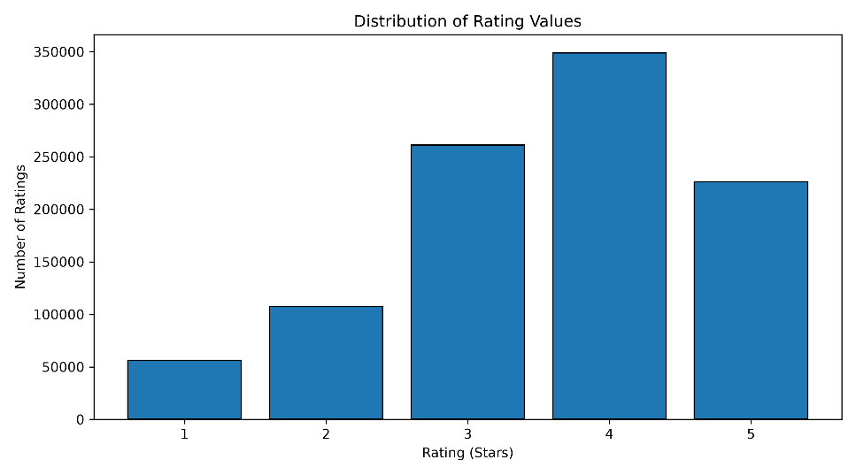
Figure 4. Rating-value distribution.
The dataset covers April 25, 2000, to February 28, 2003. However, 904,757 ratings (approximately 90.5%) were recorded during 2000.
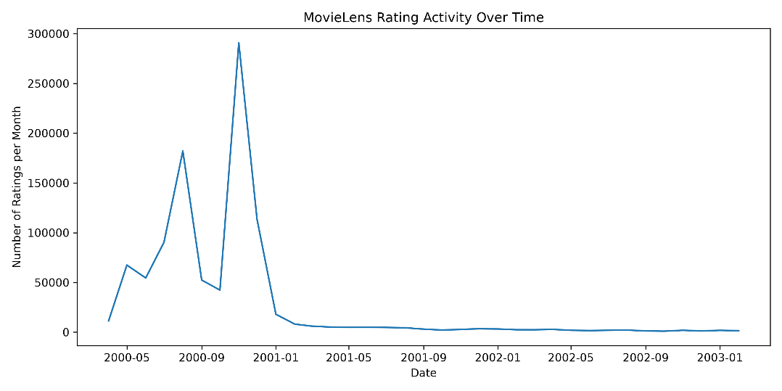
Figure 5. Monthly rating activity throughout the observation period.

1.2 Preprocessing and feedback treatment
The original MovieLens 1M files were loaded using Pandas, with users, movies and ratings stored in separate DataFrames.
All ratings and catalogue movies were retained before splitting. No users, movies or interactions were removed based on their activity levels.
The dataset contains explicit feedback through ratings from 1 to 5 stars. Missing user-movie interactions were treated as unknown preferences rather than negative feedback.
For ranking evaluation, ratings of 4 or 5 stars were considered relevant, while ratings below 4 were not considered positive feedback.
This threshold was also used for the positive-only popularity baseline.
For evaluation, users were required to have at least five ratings in the training dataset and at least one relevant movie in the held-out dataset. These conditions were applied to evaluation eligibility without modifying the original training, validation or test splits.

1.3 Train/validation/test split
A global chronological split was used to divide the dataset into 80% training, 10% validation and 10% testing interactions.
Dataset | Interactions | Percentage
Training | 800,168 | 80%
Validation | 100,020 | 10%
Testing | 100,021 | 10%

The training period ended on December 2, 2000, at 14:52:18 UTC. Validation covered subsequent interactions until December 29, 2000, and testing contained the remaining later interactions.
A temporal split was chosen instead of a random split to prevent future interactions from influencing model training. It provides a more realistic evaluation setting in which recommendations are based on past observations.
However, chronological splitting introduces cold start challenges. In validation, 611 users had no interactions in training, accounting for 76,176 interactions. Only 23.84% of validation interactions involved previously observed users and movies.
In testing, 200 users were unseen during training, and 80.59% of interactions involved known users and movies.

1.4 Evaluation protocol
All recommenders were evaluated using a Top 10 ranking protocol. For each eligible user, the model generated ten recommendations, excluding movies the user had already rated in training.
A movie was considered relevant if the user assigned it a rating of at least four stars in the held-out dataset.
Four evaluation metrics were used:
- Precision@10: The proportion of the ten recommended movies that were relevant.
- Recall@10: The proportion of a user's relevant held-out movies that appeared in the recommendation list.
- NDCG@10: A ranking metric that rewards relevant movies appearing earlier in the recommendation list.
- Catalogue coverage: The proportion of distinct catalogue movies recommended across evaluated users.
Precision, Recall and NDCG were averaged across eligible users. Coverage was calculated using the complete catalogue of 3,883 movies.
The evaluation included 490 validation users and 986 test users, with the same eligible users used for each model within a given split.
Hyperparameters were selected using validation NDCG@10. The test dataset was reserved for final evaluation rather than parameter tuning.
One limitation concerns the candidate sets: the popularity baselines rank the complete catalogue, while the current item-based kNN implementation scores only training-observed movies with positive-neighbour evidence. A fallback for unsupported candidates would be needed to ensure strict full-catalogue ranking comparability.

1.5 Baseline methods and settings
Three recommendation approaches were evaluated: two Most Popular variants and item-based collaborative filtering.
Most Popular – All Ratings: This baseline ranks movies according to the total number of ratings received in the training dataset. Each rating contributes equally, regardless of its value.
Most Popular – Positive Ratings: This baseline ranks movies by the number of training ratings equal to or greater than four stars. The purpose is to prioritize movies receiving positive feedback rather than simply attracting many ratings.
Both popularity models use a global ranking, excluding previously rated movies when generating recommendations for an individual user.
Item-based k-Nearest Neighbours (kNN):
The item-based collaborative filtering model uses rating patterns to measure similarities between movies.
Two similarity methods were investigated:
- Cosine similarity, calculated using the user-item rating matrix.
- Adjusted cosine similarity, where ratings are centered by each user's average rating to reduce differences in individual rating tendencies.
For each candidate movie, the model selects its nearest positively similar neighbours among movies already rated by the user. A similarity weighted average is then calculated to estimate the user's preference.
A shrinkage parameter was also introduced to reduce the influence of predictions supported by weak similarity evidence, pulling estimated ratings toward the user's average rating.
The following configurations were evaluated using the validation dataset:
Parameter | Values tested
Cosine neighbourhood size | 5, 10, 20, 50, 100
Adjusted cosine neighbourhood size | 5, 10, 20
Shrinkage (adjusted cosine, k=10) | 0, 0.1, 0.5, 1, 2, 5

The configuration with the highest validation NDCG@10 used adjusted cosine similarity, 10 neighbours and shrinkage of 5.0, achieving an NDCG@10 of 0.1229.
This configuration was selected before final test evaluation.

1.6 Results and analysis
Model | Precision@10 | Recall@10 | NDCG@10 | Coverage
Most Popular (All) | 0.1731 | 0.0482 | 0.1860 | 3.50%
Most Popular (Positive) | 0.1815 | 0.0533 | 0.1969 | 3.32%
Item-based kNN | 0.1657 | 0.0498 | 0.1807 | 18.00%

All models were evaluated on the same 986 eligible test users. Positive-rating popularity led on ranking accuracy (NDCG@10 = 0.1969), while item-kNN achieved lower NDCG@10 (0.1807) but much greater catalogue coverage (18.00% versus 3.32%). On validation, adjusted cosine generally performed better than ordinary cosine. Increasing shrinkage improved NDCG@10 for the tested settings while reducing coverage. The results illustrate a trade-off between accuracy and catalogue reach.

2. Part 2 - Models and Honest Comparison

2.1 Models
Describe the additional models and paradigms. Clearly identify the self-implemented algorithm and explain its implementation.

2.2 Hyperparameter tuning and variability
Describe the validation-only tuning procedure, search spaces/budgets, random seeds, and confidence intervals or statistical testing.

2.3 Overall results
Present and discuss the main comparison. Explain important differences and avoid unsupported claims.

2.4 Disaggregated analysis
Report and interpret results broken down by at least two of the required dimensions: items with few vs. many training interactions, low- vs. high-activity users, popular vs. long-tail items, and early vs. late test period. Define any thresholds used and focus on findings that change or qualify the overall conclusions.

2.5 Sparsity ablation
Report and discuss the 100%, 50%, and 20% training-interaction experiments, including changes in the ranking between models.

3. Part 3 - Beyond Accuracy

3.1 Selected track and motivation
State Track A, B, or C and briefly motivate the selected intervention/extension.

3.2 Method
Describe only your selected track. The Track A/B/C guidance below is provided as instructions; delete the guidance for the two tracks you did not select before submission.

If Track A - Diversity and popularity bias
State the base recommender, selected re-ranking method, genre-vector item representation, trade-off parameter, and exact item-distance measure. Describe how the parameter was swept.

If Track B - Fairness
Define the release-decade provider proxy, report and justify the final decade boundaries and group sizes, state and justify the adopted fairness notion, describe the consumer groups based on MovieLens user attributes, and identify the stage and form of the mitigation.

If Track C - Group recommendations
State the selected synthetic group type and justify the chosen group size (3-5). Describe the three aggregation strategies. Identify which strategy was extended to the sequential scenario and explain how satisfaction is carried forward between recommendation rounds.

3.3 Results and trade-offs
Present the required track-specific results. Track A: report intra-list diversity, catalogue coverage, Gini and calibration error across the parameter sweep, and discuss the accuracy-diversity frontier. Track B: report position-weighted exposure against catalogue share, per-group consumer-side accuracy, and the fairness-performance frontier. Track C: compare group satisfaction, disagreement and minimum member satisfaction across the three aggregation strategies, then analyse how member and group satisfaction develop in the sequential scenario.

3.4 Cost and interpretation
State what is gained, what is lost, and who bears the cost where applicable. Explain what operating choice or strategy you would select and why.

3.5 "One number we cannot explain"
Identify one result you do not fully understand and describe how you would investigate it.

4. Discussion and Conclusions
Part 1 established a reproducible evaluation pipeline for MovieLens 1M using chronological splitting, popularity baselines and item-based collaborative filtering.
The positive-rating popularity baseline achieved the strongest ranking accuracy, while item-based kNN recommended a substantially wider selection of movies.
These findings demonstrate that more complex personalized recommendation algorithms do not necessarily outperform simpler baselines on accuracy metrics.
The main limitations are the uneven temporal distribution of interactions, the exclusion of cold-start users from ranking evaluation, and the restricted candidate set of the current item-based kNN implementation.
Future experiments should address full-catalogue comparability and investigate whether more advanced recommendation models can improve ranking accuracy without sacrificing catalogue coverage.

5. Contribution Statement
This project was completed individually by me (Youssef Zougari-Belkhayat).
I carried out the dataset exploration and visualizations, implemented the chronological splitting and cold-start analysis, developed and tuned the popularity and item-based kNN recommenders, and evaluated their performance.
I also organized the Python code and prepared the experimental results and report, with AI assistance disclosed below.

6. Use of AI Assistants
ChatGPT (OpenAI) was used to help understand Python and Pandas functions, explain recommender system concepts, assist with some code implementation and debugging, simplify the project structure, and helped me revise this report.

References
Tampere University. Recommender Systems lecture materials
GroupLens Research. MovieLens 1M Dataset. https://grouplens.org/datasets/movielens/1m/

