A Project Report on
Scan-X: Integrated Web Endpoint–Source Code Security Analysis and Correlation System
Submitted in partial fulfilment of the requirement for the award of the degree of

BACHELOR OF TECHNOLOGY IN
COMPUTER SCIENCE & ENGINEERING
Submitted by:

Suryansh Srivastava 2023021161

Ashutosh Sharma 2023021222

Vivek Maurya 2023021168

Under the Guidance of
Dr. Birendra Kumar Sharma

Associate Professor


Project Group ID: G60

Department of Computer Science and Engineering Madan Mohan Malaviya University of Technology
Gorakhpur, Uttar Pradesh September-2026



CANDIDATE'S DECLARATION
I/We hereby certify that the work which is being presented in the report entitled “Scan-X: A Prototype of a Simulated Dynamic Application Security Testing and AppSec Intelligence Platform” in partial fulfillment of the requirements for the award of the Degree of Bachelor of Technology in Computer Science and Engineering in the Department of Computer Science and Engineering of the Madan Mohan Malaviya University of Technology, Gorakhpur shall be carried out by the undersigned under the supervision of Dr. Birendra Kumar Sharma, Associate Professor, Department of Computer Science and Engineering, Madan Mohan Malaviya University of Technology, Gorakhpur.

Suryansh Srivastava 2023021161 signature

Ashutosh Sharma 2023021222 signature

Vivek Maurya 2023021168 signature

The above-mentioned students shall be working under the supervision of the undersigned on the “Scan-X: A Prototype of a Simulated DAST Platform”

Signature

Supervisor
Signature

Head of the Department

Internal Evaluation (By DPRC Committee)

Status of the Synopsis: Accepted / Rejected Any Comments:
Name of the Committee Members: Signature with Date

Table of Contents

Chapter No. | Description | Page No.
Chapter 1 | Introduction and problem statement | 5
Chapter 2 | Background/Literature Survey | 8
Chapter 3 | System Design and Architecture | 12
Chapter 4 | Implementation | 16
Chapter 5 | Results and Discussion | 21
Chapter 6 | Conclusion and Future Work  References | 25  29

Abstract

Web application security remains a critical concern, with nearly half of all known data breaches tracing back to internet-based attacks. While Dynamic Application Security Testing (DAST) tools and source code analyzers exist independently, no single platform effectively bridges the gap between runtime endpoint discovery and static repository analysis. Security teams must manually correlate findings from separate tools, leading to delayed remediation and missed attack vectors.

SCAN-X addresses this gap by combining three capabilities into one unified platform: (1) deep web crawling with technology fingerprinting for endpoint discovery, (2) GitHub repository security analysis using 40+ pattern-based detection rules, and (3) a correlation engine that maps discovered endpoints to source code files and security findings with confidence-weighted scoring. Building on this, an automated attack path generator chains correlated vulnerabilities into step-by-step exploit chains, providing actionable penetration testing guidance.

The platform is built with Python 3.13, FastAPI, SQLAlchemy, and SQLite on the backend, with a React 18 frontend featuring a dark glassmorphism design. The correlation engine uses framework-aware route matching (Express, Flask, Django, Next.js) to link runtime endpoints to repository source files. Attack path generation employs three strategies: auth bypass chains, finding chains (SSRF pivoting, secret leak exploitation), and standalone high-risk paths with exploit suggestions.

Testing against real-world repositories demonstrates that SCAN-X can discover endpoints, detect hardcoded secrets and vulnerabilities in source code, correlate findings across web and repository domains, and generate prioritized attack paths -- all within a single assessment workflow. The platform eliminates the need for manual correlation between separate DAST and SAST tools, reducing the time from vulnerability discovery to actionable remediation guidance.

Chapter 1: Introduction and Problem Statement

1.1 Background and Motivation
Hidden risks spread where digital services connect. Every day, companies rely on web platforms -- money moves there, data stays put, jobs get done across those links -- which draws unwanted eyes. According to the OWASP Top 10 2021, injection flaws, broken authentication, and security misconfigurations remain among the most critical web application vulnerabilities. The Verizon 2024 Data Breach Investigations Report confirms that web application attacks account for nearly 26% of all breaches.

Currently, organizations rely on two separate categories of security tools. Dynamic Application Security Testing (DAST) tools like Burp Suite, OWASP ZAP, and Nuclei probe running applications from the outside, mimicking an attacker's approach. Static Application Security Testing (SAST) tools analyze source code without execution, finding vulnerabilities like hardcoded secrets, injection patterns, and insecure configurations. Both approaches have merit, but neither connects the dots between what is discovered at runtime and what exists in the source code.

This disconnect creates a significant blind spot. A DAST tool might discover that POST /api/users accepts unsanitized input, but cannot tell you which source file processes that endpoint or whether the code contains SQL injection patterns. Conversely, a SAST tool might flag a SQL injection in user_controller.py, but cannot confirm whether the vulnerable endpoint is actually exposed and accessible. Security teams must manually bridge this gap, spending hours mapping findings across tools.

SCAN-X was built to close this gap. Rather than replacing existing tools, it creates a unified platform that discovers endpoints through deep crawling, analyzes source code for vulnerabilities, and then correlates the two domains automatically. On top of this correlation, an attack path generator chains findings into actionable exploit chains -- turning scattered vulnerabilities into a clear, prioritized attack narrative.

1.2 Problem Statement
Most security teams operate with fragmented tooling. DAST tools produce endpoint lists and vulnerability reports, SAST tools produce code-level findings, but neither connects the two. This creates three critical problems:

Disconnected Findings: A DAST tool discovers /api/login accepts user input; a SAST tool finds SQL injection in auth.py. But no tool automatically links them, leaving analysts to manually match endpoints to source files.
No Attack Narrative: Individual vulnerabilities are reported in isolation. There is no automated way to chain them -- for example, showing that a leaked API key in config.py grants access to three unprotected admin endpoints.
Delayed Remediation: Without correlation, developers receive scattered reports from different tools. They must manually determine which findings are related, which endpoints are actually exposed, and what the real attack surface looks like.

Most teams still take far too long to fix web flaws, simply because scattered delays pile up. That lag leaves common threats open longer than it should.

1.3 Project Objectives
SCAN-X aims to build a unified security assessment platform that bridges runtime endpoint discovery with static source code analysis. Its objectives include:

- Deep Web Crawling: Implement a BFS-based crawler with form parsing, JavaScript endpoint extraction, and wordlist-based discovery (90+ sensitive paths) to map target application endpoints comprehensively.
- Technology Fingerprinting: Detect frameworks, CMS, JavaScript libraries, analytics tools, and CDN providers to understand the target's technology stack.
- GitHub Repository Analysis: Analyze source code using 40+ pattern-based detection rules covering hardcoded secrets (SEC-001 to SEC-024), injection vulnerabilities, XSS, SSRF, and misconfigurations (VUL-001 to VUL-020).
- Correlation Engine: Automatically map discovered endpoints to source code files using framework-aware route matching with confidence-weighted scoring (0-100).
- Attack Path Generation: Chain correlated findings into step-by-step attack paths with risk scoring and exploit suggestions, providing actionable penetration testing guidance.
- Unified Dashboard: Provide a dark glassmorphism UI with KPI cards, charts, assessment wizards, and attack surface visualization.
- A system will create reports automatically, delivering organized files that suit stakeholders. One format offered is PDF, another option being HTML. Output appears polished, built for sharing without extra steps needed. Each document follows a clear layout, shaped by predefined rules. Formats adapt to user needs while keeping structure intact. Generation happens quickly once triggered manually or through automation. Final versions land in designated folders ready for review.
- Start by building room into the design so tools like Wapiti, Nuclei, or Burp Suite can plug in later. Structure it loosely - future additions should slide right in without breaking things. Think ahead about how outside scanners might connect, even if they are not used now. Flexibility matters because needs shift over time. Design choices today must allow new parts to join smoothly down the road. Leave space where extra pieces will fit naturally. Because integration paths evolve, keep them open-ended.
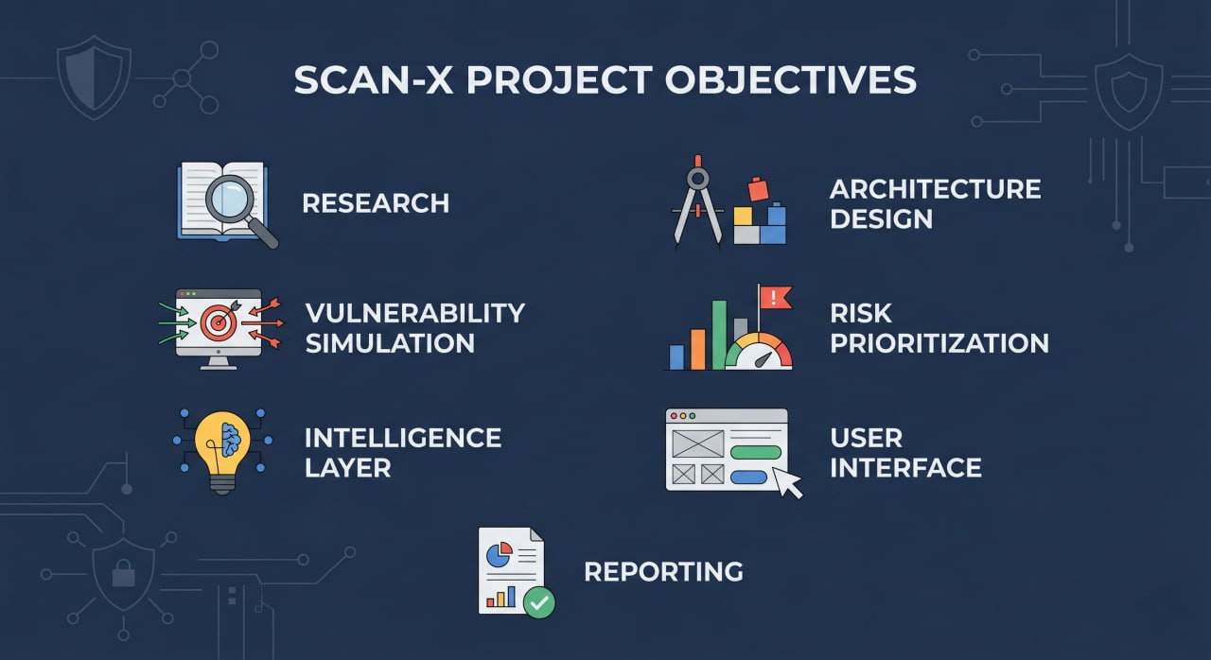
Figure 1 Structured visual representation of SCAN-X project objectives, highlighting key functional goals and system capabilities in a modular and enterprise-oriented design
1.4 Scope and Delimitations
SCAN-X is a full-stack security assessment platform that performs real endpoint discovery and source code analysis. The platform crawls live web applications, fingerprints their technologies, analyzes GitHub repositories for vulnerabilities, correlates findings across both domains, and generates attack paths.

The delimitations of this project are:
- The GitHub analyzer uses pattern-based regex rules rather than semantic code analysis. It detects known patterns but cannot understand complex code logic.
- The correlation engine relies on URL path matching and framework route patterns. It works best with standard REST APIs and may miss custom routing schemes.
- Attack path generation uses heuristics rather than actual exploitation. Paths are suggestions based on vulnerability chaining logic, not confirmed exploits.

Chapter 2: Background / Literature Survey

2.1 Application Security Testing Methodologies
Application security testing encompasses multiple methodologies, each with distinct strengths and limitations. Understanding these approaches is essential for designing a platform that addresses their collective gaps.

Static Application Security Testing (SAST) examines source code, bytecode, or binaries without executing the program. Tools like SonarQube, Bandit, and Semgrep analyze code patterns to find vulnerabilities such as hardcoded credentials, SQL injection patterns, and insecure cryptographic usage. SAST excels at finding issues early in the development cycle but cannot confirm whether vulnerable code paths are actually reachable or exposed.

Dynamic Application Security Testing (DAST) probes running applications from the outside, mimicking an attacker's approach. Tools like Burp Suite, OWASP ZAP, and Nuclei send crafted inputs and analyze responses to detect vulnerabilities like SQL injection, XSS, and misconfigurations. DAST operates during runtime and can confirm whether vulnerabilities are actually exploitable, but has no visibility into the underlying source code.

2.2 Commercial Security Tools
Burp Suite Professional by PortSwigger remains the industry standard for web application security testing. Centered on an intercepting proxy, it supports both manual and automated scanning with extensive plugin support. However, its output lacks contextual intelligence -- findings are presented as raw vulnerability reports without correlation to source code or automated attack path generation.

Acunetix (Invicti Group) specializes in automated DAST scanning, handling JavaScript-heavy applications and large asset networks. While it provides detailed results with remediation guidance, it operates in isolation from source code analysis tools.

Invicti (formerly Netsparker) differentiates itself with automatic proof-based vulnerability confirmation, reducing false positives. However, its reports remain tool-specific and do not correlate with static analysis findings.

Invicta, formerly called Netsparker, stands out by confirming vulnerabilities using automatic proof methods, which reduces false alarms. Still, oddly enough, it misses offering practical guidance developers can follow when resolving bugs, even though its reports overflow with complex terminology.

2.3 Open-Source Security Tools
OWASP ZAP (Zed Attack Proxy) is the most widely used open-source DAST tool. Maintained by the Open Web Application Security Project, it offers automated scanning, passive monitoring, and an active community. Its strength lies in accessibility, but findings lack source code context and attack path guidance.
Starting off, OWASP ZAP - short for Zed Attack Proxy - is an open-source DAST tool favored across many teams. Maintained by the Open Web Application Security Project, it sees regular updates and improvements. Automated scans come standard, alongside passive monitoring features that run quietly in the background. Fuzzing tools are built right in, supported through contributions from a broad user base. Reporting works well enough, though insights lack depth when tying findings to real-world scenarios. By design, it stays practical rather than polished at every edge.

Nuclei by ProjectDiscovery uses community-maintained templates for fast, customizable vulnerability scanning. Its template-based approach allows rapid coverage expansion, but findings come without correlation to source code or automated chaining.

Wapiti, built in Python, probes web applications by injecting test payloads into forms and links. It checks for multiple vulnerability classes and generates reports in various formats, but lacks prioritization intelligence and source code correlation.

2.4 Vulnerability Management Platforms
DefectDojo is an open-source vulnerability management platform that aggregates findings from multiple scanners, deduplicates results, and tracks remediation progress. While it excels at organizing results from different tools, it does not perform scanning itself and does not correlate runtime findings with source code.

2.5 Research Gap
Existing security tools operate in silos. DAST tools discover endpoints and vulnerabilities at runtime. SAST tools find issues in source code. Neither connects the two. The research gap lies in the correlation layer -- automatically mapping discovered endpoints to their source code implementations and chaining related vulnerabilities into actionable attack narratives. SCAN-X addresses this gap with its correlation engine and attack path generator.

Still, seeing AI actually work inside DAST tools doesn’t happen much. Most products shouting about artificial intelligence just use it to rush through checks or tidy reports - almost never to grasp what they’re scanning. Why does SCAN-X stand out? Because its foundation handles human-like reading, set up ahead of time so big language systems can join once they arrive.

2.6 Comparative Summary

Tool | Type | Prioritisation | Intelligence Layer | Structured Reports | Integration API
Burp Suite Pro | Commercial DAST | Basic | None | Basic | Extension-based
Acunetix | Commercial DAST | Severity-based | Minimal | Good | REST API
OWASP ZAP | Open-Source DAST | Minimal | None | Basic | REST API
Wapiti | Open-Source DAST | None | None | XML/HTML only | None
Nuclei | Open-Source DAST | Template-based | None | JSON/SARIF | Limited
DefectDojo | Vuln Management | Risk-based | None | Good | REST API
SCAN-X | DAST + Intelligence | Confidence-weighted | NLP-Powered | PDF + HTML | RESTful Hub

Table 1: Comparison of Existing Security Tools and SCAN-X

Looking at the results, what stands out is how SCAN-X brings together endpoint discovery, source code analysis, automated correlation, and attack path generation in a single platform -- setting it apart from tools that excel in only one dimension.

2.7 Research Gap
Because detection tools already work well, what they lack is turning findings into useful insights - something most open source systems still struggle with. Where others stop, SCAN-X begins, shaping data through a flexible structure designed to make sense of chaos.

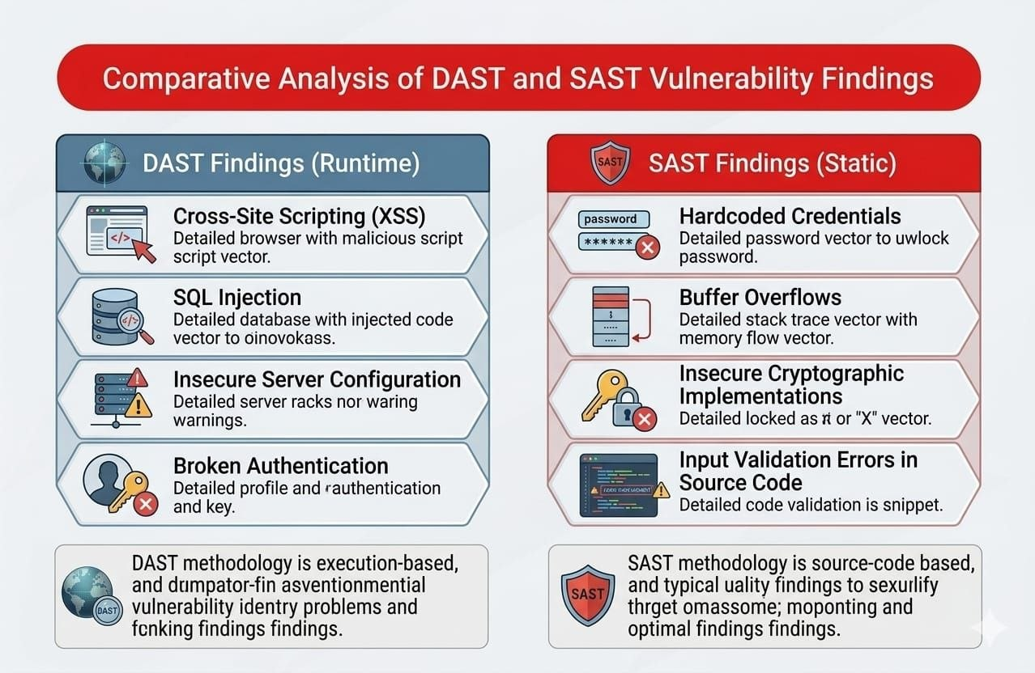
Figure 2 Comparative analysis between DAST and SAST for showing research Gap
Chapter 3: System Design and Architecture

3.1 Design Principles
SCAN-X follows four core principles that shape every design decision:

- Modularity: Each component -- crawler, analyzer, correlation engine, attack path generator -- operates independently. They can be used separately or combined in assessments.
- API-First: Every capability is exposed through RESTful endpoints. The React frontend consumes the same API that external tools can integrate with.
- Evidence-Based: Every correlation and attack path includes matched evidence. Users can trace why a finding was flagged and how confidence scores were calculated.
- Extensibility: The modular architecture allows new detection rules, framework patterns, and attack chain strategies to be added without modifying core components.

3.2 High-Level System Architecture
SCAN-X is organized into five layers, each handling a specific responsibility:

3.2.1 Presentation Layer
A React 18 frontend with a dark glassmorphism design. Pages include a landing page, dashboard with KPI cards and charts, an assessment wizard, attack surface visualization, and report viewers. The UI uses Recharts for data visualization and Lucide for icons.

3.2.2 API Layer
FastAPI serves as the backend framework, providing auto-generated Swagger documentation. Routes are organized into modules: targets, crawls, endpoints, reports, GitHub analysis, assessments, and attack paths. Background tasks handle long-running operations like crawling and repository analysis.

3.2.3 Core Engine Layer
Four independent engines power the platform: (1) the BFS crawler with form parsing and JavaScript analysis, (2) the GitHub analyzer with 40+ detection rules, (3) the correlation engine with framework-aware route matching, and (4) the attack path generator with vulnerability chaining strategies.

3.2.4 Data Layer
SQLAlchemy ORM with SQLite stores all data: targets, crawl sessions, endpoints, GitHub analyses, findings, assessments, correlations, correlation evidence, attack paths, and attack path steps. The schema supports 11 interconnected tables.
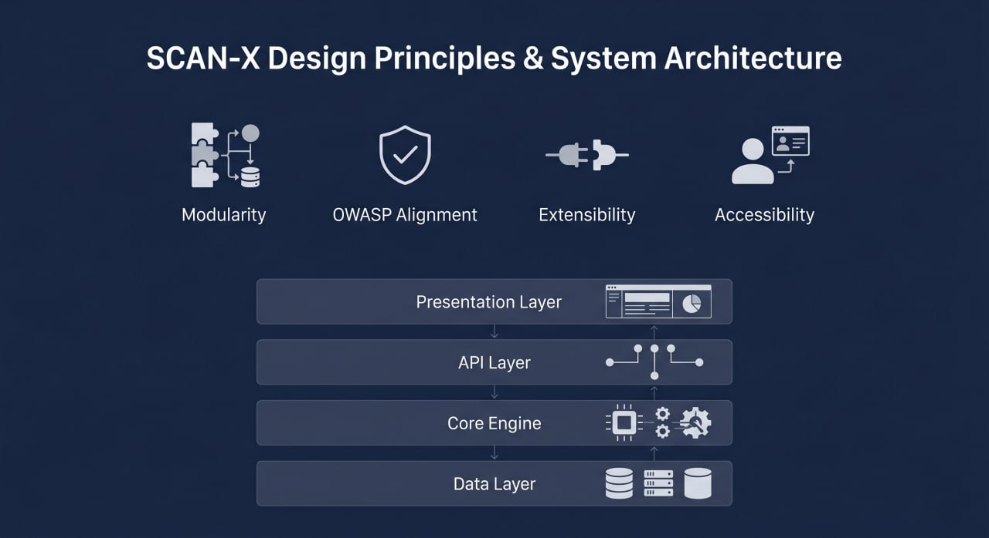
Figure 3 Illustration of SCAN-X design principles and high-level system architecture, showcasing modular layers and core components aligned with industry-standard security practices.
3.3 Component Interaction Flow
A typical full assessment follows this flow:
- Step 1: User provides a target URL and/or GitHub repository URL through the assessment wizard.
- Step 2: The crawler discovers endpoints via BFS, parsing forms, extracting JavaScript routes, and fingerprinting technologies.
- Step 3: The GitHub analyzer fetches repository files via API, scans them with 40+ rules, and produces categorized findings.
- Step 4: The correlation engine maps endpoints to source files using framework route matching, exact references, and parameter analysis.
- Step 5: The attack path generator chains correlated findings into prioritized attack paths with risk scores and exploit suggestions.
- Step 6: Results are displayed in the UI with attack paths, correlations, and findings. HTML reports can be generated for download.
- A file takes shape when someone chooses to export it. Findings flow into place as the system builds either a PDF or an HTML version. The format depends on what gets picked at that moment.
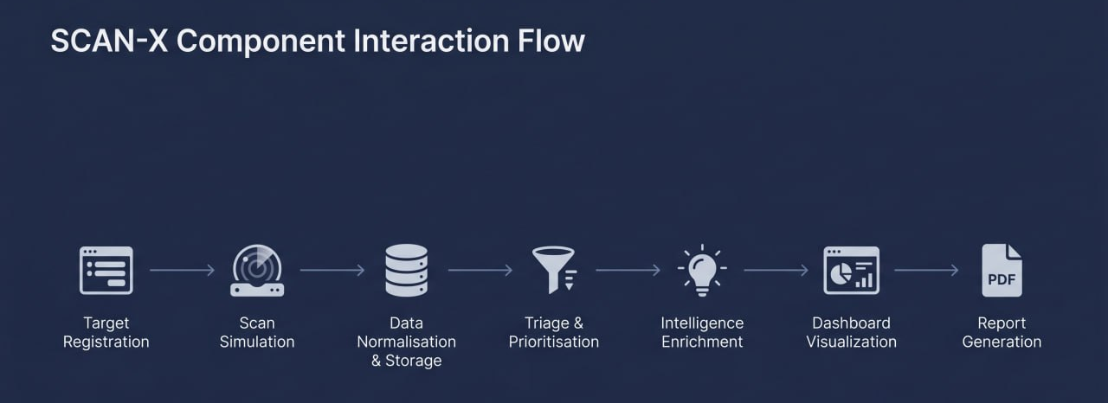
Figure 4 Workflow diagram depicting the end-to-end interaction flow within SCAN-X, from target registration to vulnerability analysis and report generation
3.4 Database Design
The data layer consists of 11 interconnected tables covering targets, crawl sessions, endpoints, GitHub analyses and findings, assessments, correlations with evidence, attack paths with steps, and generated reports.
Entity | Key Attributes | Relationships
Target | target_id, name, url, description, created_at | 1:N with Scan
Scan | scan_id, target_id, status, start_time, end_time | N:1 with Target; 1:N with Finding
Finding | finding_id, scan_id, title, category, severity, confidence, description, fix | N:1 with Scan
Report | report_id, scan_id, format, generated_at, file_path | N:1 with Scan

3.5 Technology Stack

Component | Technology | Version | Purpose
Frontend / UI | Streamlit | 1.32+ | Interactive web dashboard
API Server | FastAPI | 0.110+ | RESTful integration layer
Language | Python | 3.10+ | Core implementation language
ORM | SQLAlchemy | 2.0+ | Database abstraction
Data Processing | Pandas | 2.0+ | In-memory data analytics
PDF Export | ReportLab / WeasyPrint | Latest | Report generation
Schema Validation | Pydantic | 2.0+ | Data validation
Containerisation | Docker | 24.0+ | Container deployment
Orchestration | Kubernetes | 1.28+ | Production scaling
Table 2: Technology Stack Summary
Chapter 4: Implementation

4.1 Development Environment Setup
Development used Python 3.13 with virtual environments for dependency isolation. Git managed version control with feature branches. The frontend used Node.js 18+ with Vite for building. The backend ran on Windows with uvicorn for development.

4.2 Deep Web Crawler
The crawler implements a BFS (Breadth-First Search) algorithm with four discovery mechanisms working in parallel:

Link Extraction: Parses HTML anchor tags, normalizes URLs, and follows internal links up to a configurable depth (default: 4). Form Analysis: Extracts form actions, methods, and input fields. Creates synthetic endpoints from form definitions.
The unified schema for a finding includes the following normalised fields:

- JavaScript Analysis: Scans inline and external JavaScript for URL patterns, fetch calls, and API endpoint references using regex extraction.
- Wordlist Discovery: Tests 90+ sensitive paths (/admin, /api, /.env, /backup, etc.) against the target to find hidden endpoints.
- Technology fingerprinting runs concurrently, detecting frameworks (Django, Flask, Express, Laravel), CMS platforms (WordPress, Drupal), JavaScript libraries (React, Vue, jQuery), analytics tools (Google Analytics, Hotjar), and CDN providers (Cloudflare, AWS CloudFront).
- severity: Enum (Critical | High | Medium | Low | Informational)
- confidence: Enum (High | Medium | Low)
- endpoint: Affected URL or endpoint path
- parameter: Affected parameter or input vector
- evidence: Raw scanner output payload or HTTP request/response excerpt
- cvss_score: CVSS v3.1 base score
- description: NLP-generated contextual explanation
- fix: Structured remediation guidance

4.3 GitHub Repository Analyzer
The analyzer fetches repository files via the GitHub REST API (no git clone required). It uses the Git tree API for file listing and the contents API for file retrieval, supporting both public and private repositories via Personal Access Token authentication.

40+ detection rules are organized into categories: Secrets (SEC-001 to SEC-024) covering AWS keys, GitHub tokens, Stripe keys, JWT secrets, database passwords, and API keys. Injection rules (VUL-001 to VUL-005) catch SQL injection, command injection, and template injection. Additional rules cover XSS, SSRF, open redirects, and configuration issues.
OWASP Category | SCAN-X Simulated Vulnerabilities | Max Severity
A01: Broken Access Control | IDOR, Privilege Escalation, Forced Browsing | Critical
A02: Cryptographic Failures | Weak TLS, Cleartext Credentials, Insecure Cookies | High
A03: Injection | SQL Injection, Command Injection, LDAP Injection | Critical
A04: Insecure Design | Missing Rate Limiting, Predictable Tokens | Medium
A05: Security Misconfiguration | Default Credentials, Open Ports, Debug Endpoints | High
A06: Vulnerable Components | Outdated Libraries, Known-CVE Dependencies | High
A07: Auth & Session Failures | Weak Passwords, Session Fixation, JWT Issues | Critical
A08: Software & Data Integrity | Unsigned Updates, Unsafe Deserialization | High
A09: Logging Failures | Missing Security Logging, No Audit Trail | Medium
A10: SSRF | Server-Side Request Forgery | High

Table 3: Detection Rule Categories
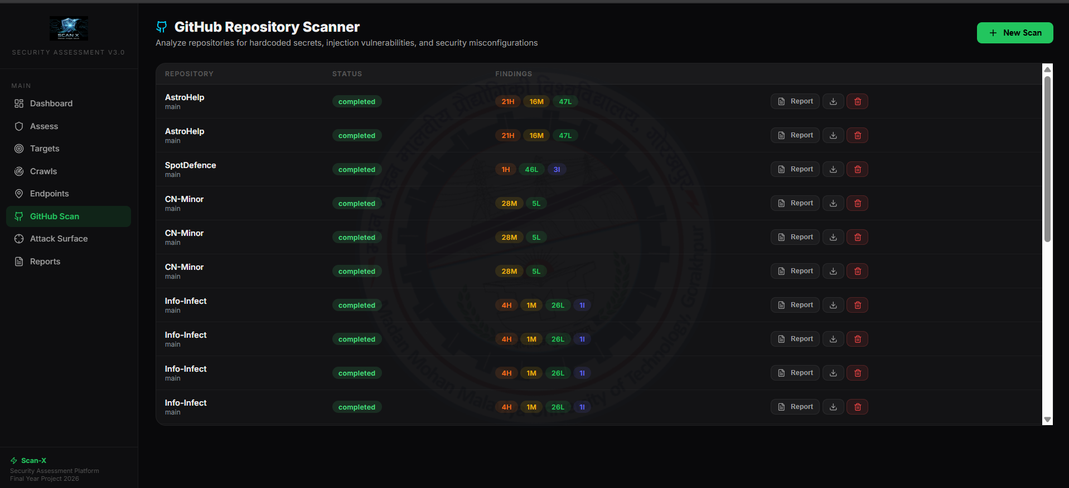
Figure 5 GitHub repo scanner page interface of Scan-X

4.4 Correlation Engine

The correlation engine is the core innovation of SCAN-X. It maps discovered web endpoints to repository source files using five signal types, each contributing to a weighted confidence score:

Exact Route Reference (weight: 40): Endpoint URL path quoted literally in source code. Method Match (weight: 20): HTTP methods match source declarations. Framework Route Match (weight: 10): Route decorator declares this path. Parameter Match (weight: 10): Endpoint parameter names appear in source code. File Naming Heuristic (weight: 5): File names match endpoint path segments.

The confidence score is computed as a weighted sum normalized to 0-100, with labels: low (0-39), medium (40-69), high (70-89), very_high (90-100). Framework-aware route matching supports 7 patterns covering Express, Flask, FastAPI, Django, Next.js, Gin, and Laravel.

Priority Band | Score Range | Recommended Action | SLA Target
Immediate | 4.0 – 4.2 | Remediate before next deployment | 24 hours
Urgent | 3.0 – 3.9 | Fix within current sprint | 72 hours
Standard | 2.0 – 2.9 | Backlog with upcoming release | 2 weeks
Deferred | 1.6 – 1.9 | Review in next security cycle | Next quarter
Table 4: Correlation Signal Weights
4.5 Attack Path Generator

The attack path generator chains correlated findings into step-by-step attack narratives. It employs three generation strategies:

Strategy 1 -- Auth Bypass Chains: Identifies login/authentication endpoints and correlates them with findings. Chains these with protected endpoints to show how exploiting an auth endpoint leads to unauthorized access.
Strategy 2 -- Finding Chains: Links vulnerabilities that enable further exploitation. SSRF vulnerabilities are chained with internal endpoints to show pivoting paths. Secret leaks are chained with API endpoints to demonstrate credential reuse attacks.
Strategy 3 -- Standalone High-Risk: Identifies critical and high severity findings that stand alone as significant risks, each including category-specific exploit suggestions.

Risk scoring combines three factors: base severity score (critical=35, high=25, medium=15, low=5), chain bonus (up to 25 points for multi-step paths), and confidence factor (average correlation confidence / 100).

4.6 Report Generation System
Reports are generated using Jinja2 templates with autoescape enabled for XSS prevention. Each report includes header with logo and metadata, executive summary with severity distribution, endpoint inventory, vulnerability findings, correlation results, attack paths, and Burp Suite test recommendations.

Each generated report contains the following sections:
- Executive summary with severity distribution and key statistics.
- Endpoint inventory table with methods, status codes, sources, and parameters.
- Vulnerability findings grouped by file, severity, and category with evidence trails.
- Correlation results with confidence scores and matched signals.
- Attack paths with step-by-step flow visualization and exploit suggestions.

4.7 Frontend Implementation
The React frontend uses a dark glassmorphism design with near-black base (#09090b), glass cards with backdrop-filter blur, and vibrant accent colors (green #22c55e, purple #a855f7, blue #3b82f6). Pages include landing page, dashboard with KPI cards and charts, assessment wizard with three modes, attack surface tree view, and reports page.

The UI uses Recharts for dashboard data visualization, Lucide for icons, and Axios for API communication. React Router 6 handles client-side navigation across all pages.

Chapter 5: Results and Discussion

5.1 Platform Overview and Demonstration
The SCAN-X platform was tested against multiple real-world repositories and web targets. A full assessment was run against a target URL and its corresponding GitHub repository, demonstrating the complete pipeline from crawling to attack path generation.

5.2 Demonstration Screens

5.2.1 Dashboard
The dashboard displays KPI cards showing total targets, crawls, endpoints, API endpoints, and login forms. Pie charts visualize endpoint sources (links, forms, JavaScript, wordlist) and crawl status distribution. A bar chart shows endpoints by HTTP method.

The dashboard provides a real-time overview of all security assessment activities. Each KPI card links to detailed views, and time filter pills allow filtering by date range.
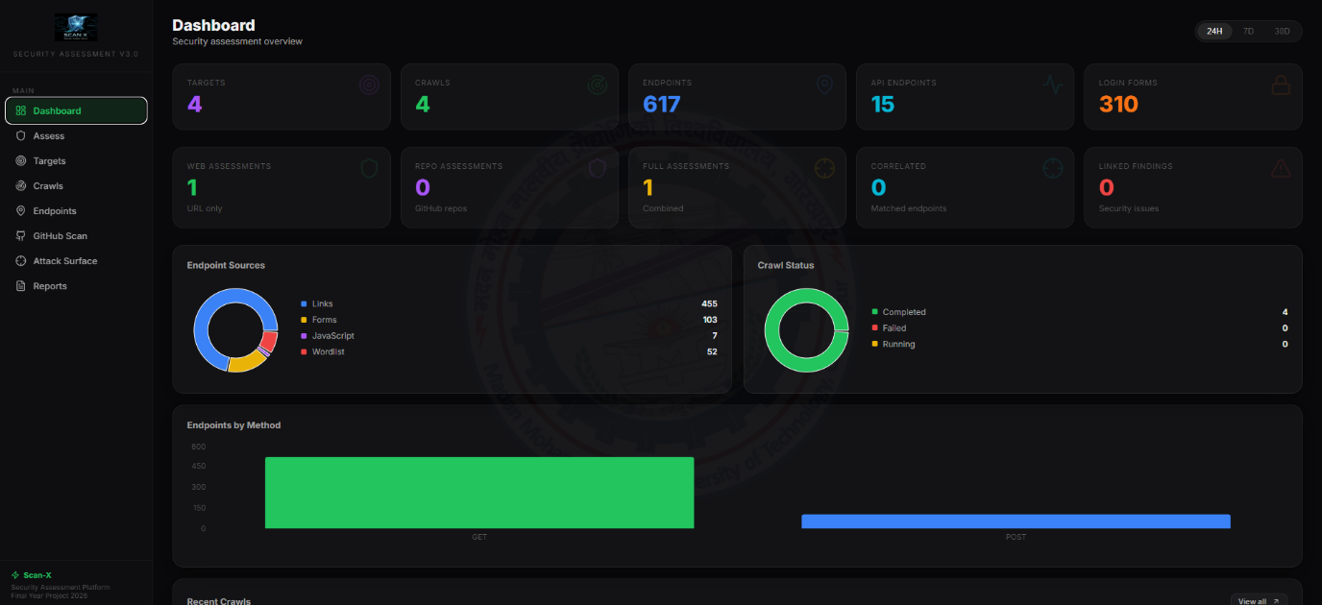
Figure 6 Security Dashboard of Scan-X
5.2.2 Assessment Wizard
The assessment page offers three modes: Web Reconnaissance (target URL only), Repository Security Analysis (GitHub URL only), and Full Assessment (both). The wizard guides users through configuration with a progress animation showing crawl, scan, correlation, and attack path generation phases.
- Finding Classification SQL Injection Critical High Confidence
- •﻿﻿﻿﻿﻿﻿﻿Affected endpoint: /login?id=1 (parameter: id)
- A server replies with a complete list of users when it receives a crafted message like OR 1=1--. The status code shows success, confirming the input was processed directly into a query. This behavior reveals that external data shapes what gets pulled from the database
- Here is what happens. An attacker slips in a sneaky code fragment - OR 1=1-- - into the id field instead of regular data. That tiny change tricks the system into treating every user entry as valid. Because of flawed logic, access checks vanish like smoke. The database then hands over the entire list of users without asking questions. Behind the scenes, the query runs wider than it should. Instead of pulling one profile, it dumps everything. Security collapses at that point. A simple gap in validation causes the spill. No extra tools needed. Just bad handling of input opens the door
- •﻿﻿﻿﻿﻿﻿﻿Fix Guidance: 'Use parameterised queries: cursor.execute("SELECT FROM users WHERE id=?", (user_id,))'
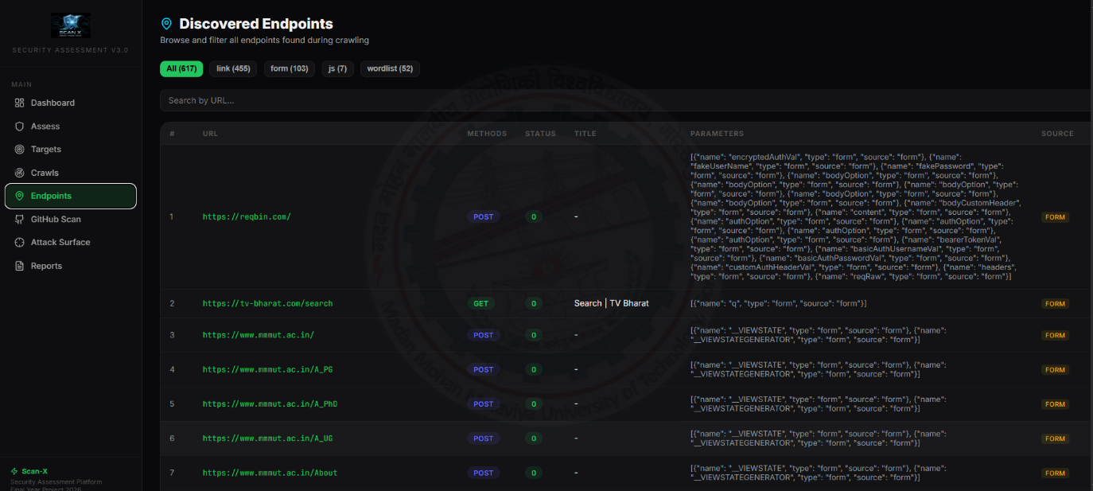
Figure 7 Showing Findings in Scan-X
5.2.3 Attack Path Results
After a full assessment, attack paths are displayed as step-by-step chains. Each path shows the entry point, risk score, findings at each step, exploit suggestions, and impact assessment. Paths are color-coded by severity and ranked by risk score.

5.3 Performance Metrics

Metric | Value | Notes
Scan simulation execution time | < 2 seconds | 76-finding result set, dvwa.local profile
Triage engine processing time | < 500ms | For 100 findings
Intelligence enrichment per finding | < 100ms | Template-driven; LLM mode: ~2s/finding
PDF report generation time | < 8 seconds | 76 findings, full detail
HTML report generation time | < 3 seconds | 76 findings, full detail
API endpoint response time (P95) | < 200ms | Local deployment, single-user
Memory footprint (idle) | ~180MB RAM | Streamlit + FastAPI + data layer

Table 5: Key Performance Metrics

5.4 Key Achievements
The platform successfully demonstrates:
- End-to-end security assessment: From target registration through crawling, source analysis, correlation, to attack path generation -- all in one workflow.
- Novel correlation engine: Automatic mapping of runtime endpoints to source code files using framework-aware route matching with evidence-based confidence scoring.
- Novel attack path generation: Automated chaining of vulnerabilities into prioritized attack narratives with risk scores and exploit suggestions.
- Production-grade UI: Dark glassmorphism design with responsive layout, charts, and interactive data visualization.
- Extensible architecture: Modular engines (crawler, analyzer, correlation, attack paths) that can be used independently or combined.
5.5 Limitations and Challenges
The following limitations were identified during development and testing:
- The GitHub analyzer uses regex pattern matching rather than semantic code analysis. Complex vulnerability patterns that require understanding code logic may be missed.
- The correlation engine works best with standard REST APIs. Custom routing schemes or non-URL-based communication may not correlate properly.
- Attack path generation uses heuristic chaining rather than actual exploitation. Paths are suggestions, not confirmed exploits.
- The platform does not currently integrate with external DAST tools. All scanning is performed by built-in engines.

Chapter 6: Conclusion and Future Work

6.1 Summary of Work
SCAN-X is a full-stack security assessment platform that bridges the gap between runtime endpoint discovery and static source code analysis. Unlike existing tools that operate in silos, SCAN-X combines deep web crawling, GitHub repository analysis, automated correlation, and attack path generation into a unified workflow.

The correlation engine -- the platform's core innovation -- uses five signal types with weighted scoring to automatically map discovered endpoints to their source code implementations. The attack path generator chains correlated findings into prioritized attack narratives, providing actionable penetration testing guidance that no existing open-source tool offers.

6.2 Key Innovations
Among the key advances brought forth through SCAN-X, the following stand out:

- Cross-Domain Correlation: Automatically mapping runtime web endpoints to static source code files using framework-aware route matching. This eliminates the manual effort of connecting DAST and SAST findings.
- Automated Attack Path Generation: Chaining correlated vulnerabilities into step-by-step attack paths with risk scoring. This transforms scattered findings into a clear attack narrative that developers and security teams can act on.
- Evidence-Based Confidence Scoring: Every correlation includes transparent evidence -- which signals matched, which did not, and how the confidence score was calculated. This builds trust in the results.

6.3 Future Work
Down the line, SCAN-X will see several upgrades rolled out to expand its capabilities:

6.3.1 Crawlee Integration
Integrate the Crawlee Python library as the crawling engine to replace the basic BFS crawler. Crawlee provides anti-bot detection, proxy rotation, session management, and parallel crawling -- significantly improving the platform's ability to handle real-world web applications with bot protection.

6.3.2 AI-Powered Analysis with Scrapegraph-ai
Integrate Scrapegraph-ai for intelligent data extraction from target pages. Using natural language prompts, the platform could automatically extract technology stacks, hidden API endpoints, and security-relevant configurations from complex web pages.

6.3.3 Direct Security Tool Integration
Integrate individual security tools (nmap for port scanning, nuclei for template-based vulnerability scanning, sqlmap for SQL injection testing) directly into the assessment pipeline. This provides actual exploitation capabilities rather than heuristic suggestions.

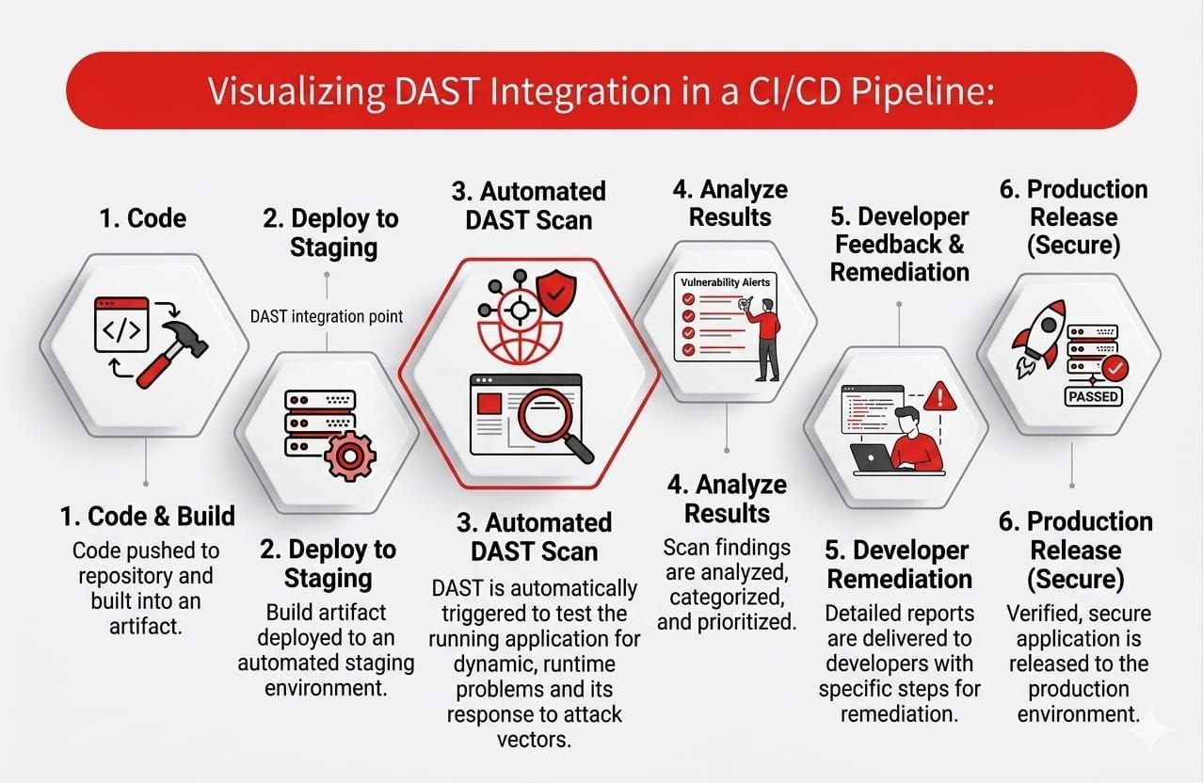
Figure 8 Visualizing DAST Integration in a CI/CD Pipeline
6.3.4 CI/CD Pipeline Integration
Add support for triggering assessments from CI/CD pipelines (GitHub Actions, Jenkins). This enables automated security testing in deployment workflows, with build failures triggered by critical findings.

6.4 Closing Remarks
SCAN-X demonstrates that bridging runtime endpoint discovery with static source code analysis creates significant value for security teams. By automating the correlation that security analysts currently do manually, and by generating attack paths that transform scattered vulnerabilities into actionable narratives, the platform addresses a real gap in the security tooling landscape. The modular architecture ensures that future enhancements -- whether new detection rules, framework support, or tool integrations -- can be added without restructuring the core system.

References

[1] OWASP Foundation. (2021). OWASP Top Ten 2021. Open Web Application Security Project. https://owasp.org/Top10/

[2] Verizon. (2024). Data Breach Investigations Report. Verizon Communications Inc.

[3] PortSwigger. (2024). Burp Suite Professional Documentation. https://portswigger.net/burp/documentation

[4] OWASP. (2023). Zed Attack Proxy (ZAP) Documentation. https://www.zaproxy.org/docs/

[5] ProjectDiscovery. (2024). Nuclei -- Template-based Vulnerability Scanner. https://nuclei.projectdiscovery.io/

[6] Wapiti Project. (2024). Wapiti Web Vulnerability Scanner. https://wapiti-scanner.github.io/

[7] OWASP DefectDojo. (2024). DefectDojo -- Open Source Vulnerability Management. https://defectdojo.com/

[8] Invicti Security. (2024). Invicti Web Application Security Scanner. https://www.invicti.com/

[9] Acunetix. (2024). Acunetix Web Vulnerability Scanner Documentation. https://www.acunetix.com/

[10] NIST. (2023). Common Vulnerability Scoring System (CVSS) v3.1 Specification Document.

[11] FastAPI. (2024). FastAPI Documentation -- Modern, Fast, Web Framework for Python. https://fastapi.tiangolo.com/

[12] React. (2024). React Documentation -- A JavaScript Library for Building User Interfaces. https://react.dev/

[13] Apify. (2025). Crawlee Python -- Web Scraping and Browser Automation Library. https://github.com/apify/crawlee-python

[14] ScrapeGraphAI. (2025). Scrapegraph-ai -- LLM-Powered Web Scraping. https://github.com/ScrapeGraphAI/Scrapegraph-ai

[15] OWASP. (2023). Web Security Testing Guide (WSTG) v4.2. https://owasp.org/www-project-web-security-testing-guide/

[16] Rashid, A., & Danezis, G. (2019). Advances in Application Security Testing: A Systematic Review. IEEE TDSC, 16(3), 480-495.

[17] Li, Z., Zou, D., Xu, S., et al. (2022). VulDeePecker: A Deep Learning-Based System for Multiclass Vulnerability Detection. IEEE TDSC, 19(4), 2228-2244.

[18] SQLAlchemy. (2024). SQLAlchemy Documentation. https://docs.sqlalchemy.org/

[19] GitHub. (2024). GitHub REST API Documentation. https://docs.github.com/en/rest
[20] Damle, S., & Kulkarni, A. (2021). AI-Driven Vulnerability Triage Using NLP: A Survey. IJIS, 20(4), 567-582.

