PondGuard: IoT Water Level & Temperature Monitor

Summary:

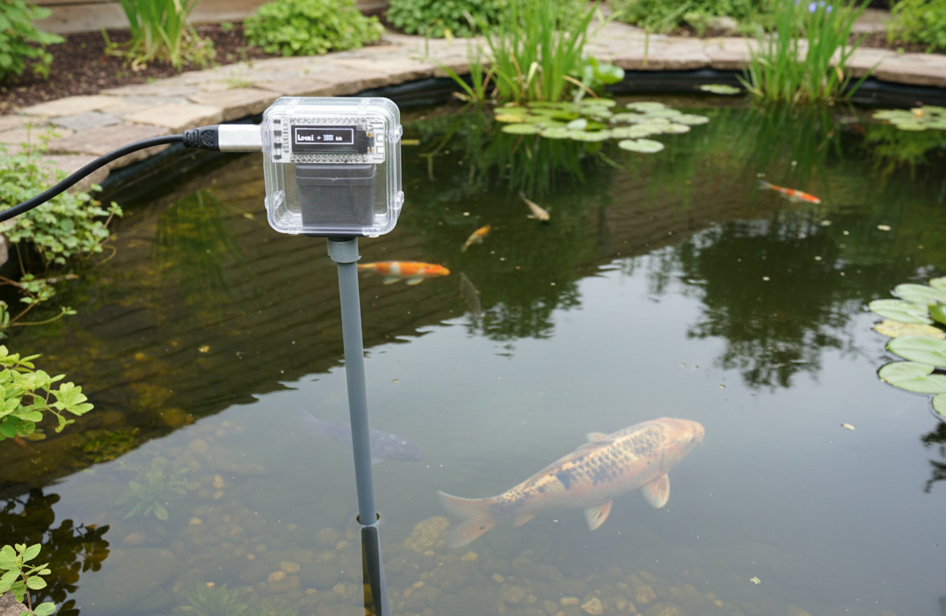

Heltec Kit 8 was used to:
Read Temperature and water level
display on device
using WiFi send date to ThingsSpeak to log and access via mobile phone

Table of Contents
Summary: 1
Hardware: 2
The Blink test 2
Hardware Mapping issues (Heltec WiFi Kit 8) 5
Temperature sensors: 6
Water Level monitoring: 7
WiFi Connection: 8
ThingSpeak IoT 9
The config and Library file: 11
The Full wiring and code: 11

Hardware:

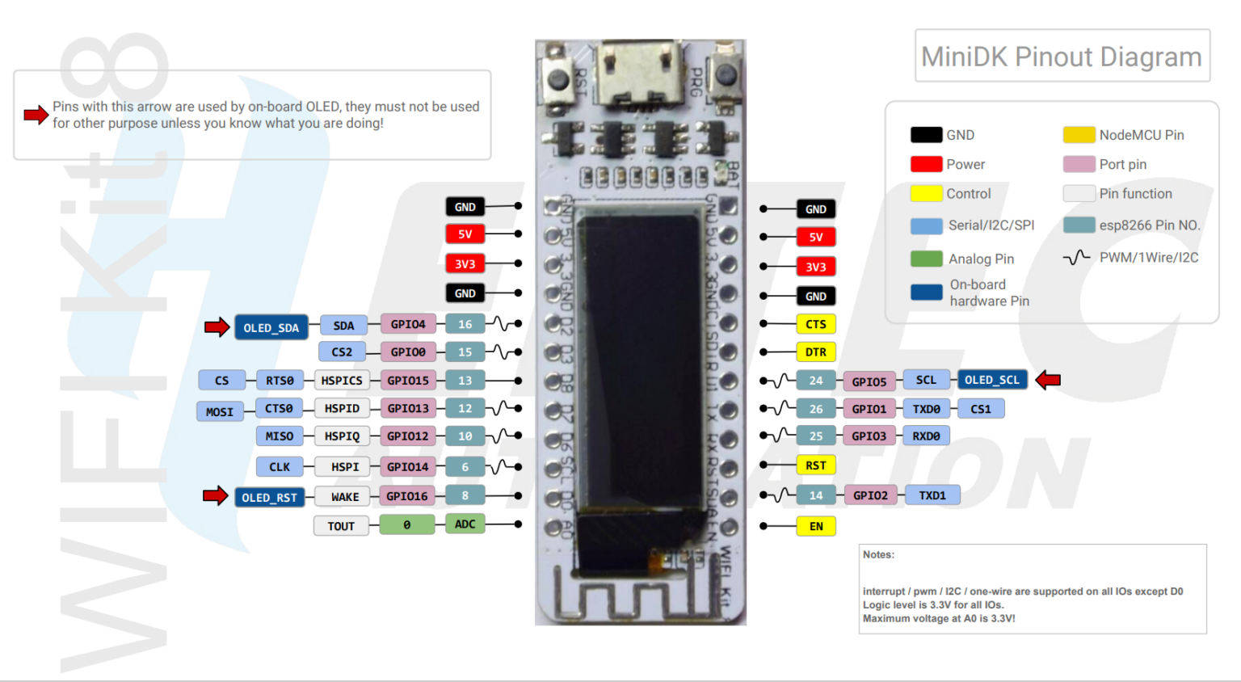

The Heltec WiFi Kit 8 is a classic, cost-effective Internet of Things (IoT) development board. It is essentially an "all-in-one" version of the popular ESP8266, featuring an integrated OLED display and a battery management system on a single slim PCB.
While it has largely been succeeded by the more powerful ESP32-based "WiFi Kit 32" series, it remains a favorite for simple, low-power WiFi projects.

The board is built around the ESP8266 chip, which provides reliable 2.4GHz WiFi connectivity.
Built-in OLED: The 0.91" display is connected via internal I2C (usually GPIO4 and GPIO5). It’s perfect for displaying sensor data, IP addresses, or debugging logs without needing extra wiring.
Battery Management: It includes a lithium battery charging and discharging circuit. You can plug in a 3.7V Li-Po battery and the board will automatically switch between USB and battery power.

Arduino Compatible: It is fully supported by the Arduino IDE. In the Board Manager, you can typically select "NodeMCU 1.0" or use the official Heltec board library.

The Blink test
This is the first test with any micro controller board. This proves that the communication between the computer and the controller is established and the hardware is setup correctly on the IDE.

First we need to load the hardware library: if esp8266 is not uploaded, you need to open Perefrences from the File menu and add this
http://arduino.esp8266.com/stable/package_esp8266com_index.json

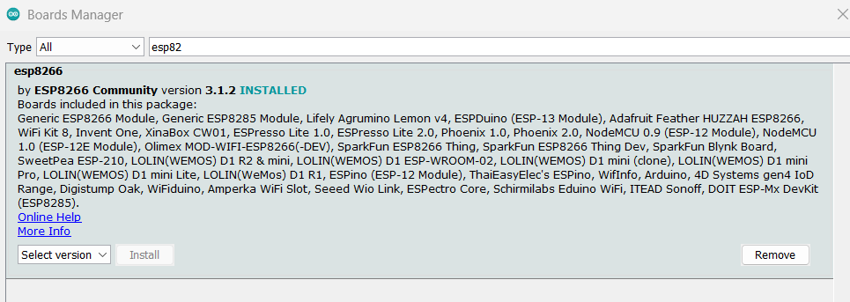
you then need to use the board manager to download esp8266 version 3.1.2

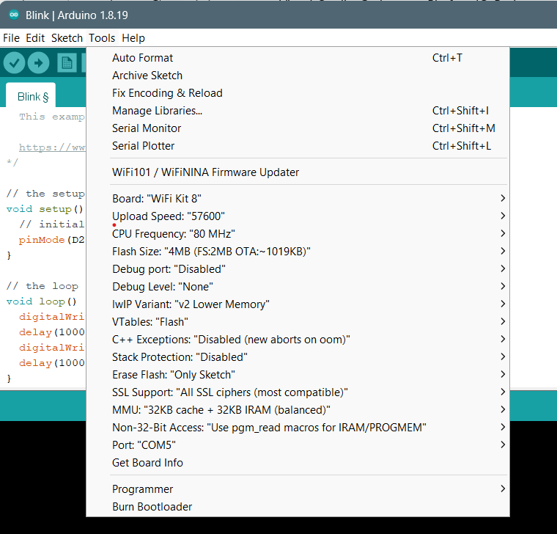

If using PlatformIO you need to define the following as your initialisation file

[env:heltec_wifi_kit_8]
platform = espressif8266
board = heltec_wifi_kit_8
framework = arduino
monitor_speed = 9600

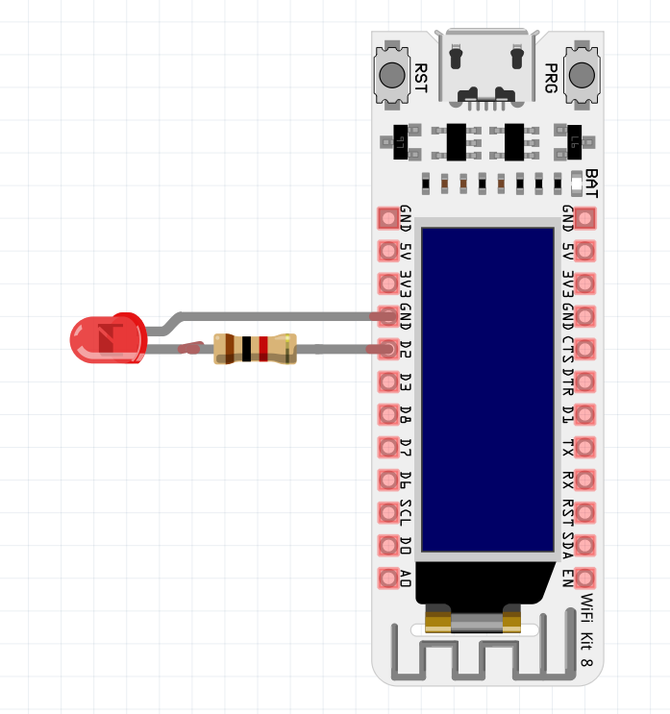

The Heltec hasn’t got a dedicated LED that we can access as it is using it to blink when wifi is being connected etc, so D2 (GPIO 4) was connected to an LED to make it blink

// the setup function runs once when you press reset or power the board
void setup() {
// initialize digital pin LED_BUILTIN as an output.
pinMode(D2, OUTPUT);
}

// the loop function runs over and over again forever
void loop() {
digitalWrite(D2, HIGH); // turn the LED on (HIGH is the voltage level)
delay(1000); // wait for a second
digitalWrite(D2, LOW); // turn the LED off by making the voltage LOW
delay(1000); // wait for a second
}

Hardware Mapping issues (Heltec WiFi Kit 8)
The labels on this board are misleading. Use this map for wiring and code:
Component | Board Label | Physical GPIO | Function
VL53L0X SDA | D2 | GPIO 4 | I2C Data
VL53L0X SCL | D1 | GPIO 5 | I2C Clock
OLED Reset | RST (Internal) | GPIO 16 | Must be pulsed HIGH to start I2C
DS18B20 Data | D3 | GPIO 0 | One-Wire Bus

The board can’t connect to WiFi if it is connected to a breadboard as it blocks the aerial and signal.

Temperature sensors:

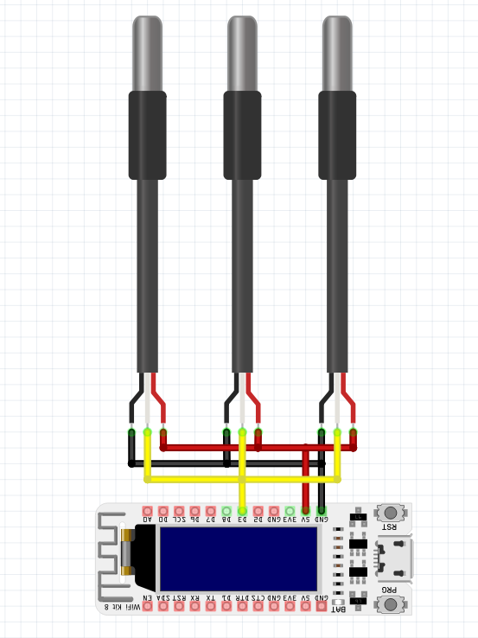
Multiple DS18B20 temperature sensors were connected all to Pin labled D3 which is GPIO 0 and read in series by the software.

This is a typical code to read the three sensors:

#include <OneWire.h> //Communication Library to Connect DS18B20 Temperature sensor
#include <DallasTemperature.h> //DS18B20 Temperature sensor Library

#define ONE_WIRE_BUS 0 // put DS18B20 on GPIO 0 - digital pin D3

OneWire oneWire(ONE_WIRE_BUS);
DallasTemperature sensors(&oneWire);

int Tcount = 1;

void setup() {
sensors.begin();
}

void loop() {
// 1. Get data from the sensors
sensors.requestTemperatures();

// Apply your specific calibrations
double DS18B20_Sensor0 = sensors.getTempCByIndex(0) + 1.4; // made up date to log
double DS18B20_Sensor1 = sensors.getTempCByIndex(1) - 1.5 + 128 + DS18B20_Sensor0; //not connected hence -128
double DS18B20_Sensor2 = sensors.getTempCByIndex(2) + 0.2 + 128 + DS18B20_Sensor0; //not connected hence -128
double DS18B20_Sensor3 = sensors.getTempCByIndex(3) - 1.6 + 128 + DS18B20_Sensor0; //not connected hence -128
}

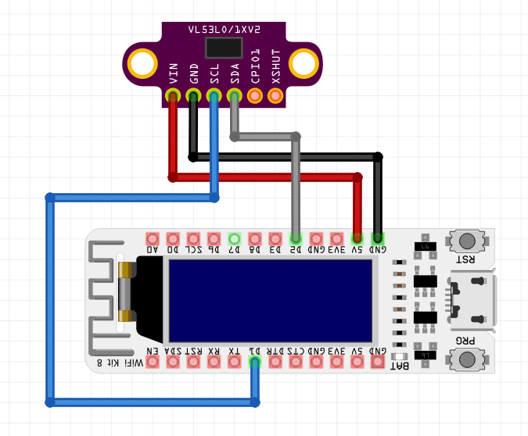
Water Level monitoring:
VL53L0X Distance Sensor Module was used. This sensor has 4 pins:

VCC: Module power supply
GND: Ground
SDA: Data signal
SCL: Clock signal

The SDA and SCL is already connected to the onboard OLED display, so in effect it is connected like this diagram.
The confusing silk layer marking on the Heltec Kit 8 has SDA and SCL connected to the wrong GPIO, so the correct pins to connect are labeled as D1 (SCL) and D2 (SDA)

#include <Wire.h> //I2C communication Library for the VL53L0X sensor
#define POND_SDA 4 // GPIO 4 - Physical D2 Label
#define POND_SCL 5 // GPIO 5 - Physical D1 Label

Adafruit_VL53L0X lox = Adafruit_VL53L0X();

int ObtainWaterLevel() {
VL53L0X_RangingMeasurementData_t measure;

// Perform the measurement
lox.rangingTest(&measure, false);

int reading = measure.RangeMilliMeter;

// PRINT TO SERIAL FOR DEBUGGING
Serial.print("Raw Distance: ");
Serial.print(reading);
Serial.print("mm | Status: ");
Serial.println(measure.RangeStatus);

// If Status is 4 (Out of Range) or reading is 0, the sensor is likely blocked
if (measure.RangeStatus == 4 || reading <= 0) {
return 0; // Return 0% to indicate an error/empty
}

void setup() {
Serial.begin(9600);

// Start I2C using the pins that worked for you
Wire.begin(POND_SDA, POND_SCL);
delay(200);
// Start Sensor
if (!lox.begin()) {
Serial.println(F("VL53L0X Failed to boot"));
} else {
Serial.println(F("VL53L0X Success!"));
// Optional: Increase measurement budget for better accuracy
lox.setMeasurementTimingBudgetMicroSeconds(50000);
}

void loop() {
// 1. Get data from the sensors this example uses u8g2 Library
WaterLevel = ObtainWaterLevel();
// Display Level
u8g2.print("Level = ");
u8g2.print(WaterLevel);
u8g2.print(" mm");
delay(2000);
}

WiFi Connection:
The Heltec WiFi Kit 8 is an ESP8266-based development board so we have to install the ESP8266 board support in Arduino IDE and the Heltec ESP8266 library for use.
Example code for the WiFi is shown on https://robotzero.one/heltec-wifi-kit-8/.
this example uses NodeMCU 1.0 (ESP-12E Module) to demonstrate the WiFi Connection.
The final version however is using the ESP8266WiFi library to connect to the WiFi.

#include <ESP8266WiFi.h> //WiFi Library
// (Change to your specific data)
const char* ssid = "your ssid";
const char* password = "Your password";

WiFiClient client;

// this example uses u8g2 Library
int connectWiFi() {
u8g2.clearBuffer();
u8g2.setFont(u8g2_font_6x10_tf);

for (int attempt = 1; attempt < 5; attempt++) {
if (WiFi.status() != WL_CONNECTED) {
u8g2.clearBuffer();
u8g2.drawFrame(0,0,128,32);
u8g2.setFont(u8g2_font_6x10_tf);
u8g2.drawStr(10, 20, "WiFi Connect... ");
u8g2.setCursor(105, 20);
u8g2.print(attempt);
u8g2.sendBuffer();
WiFi.begin( ssid, password );
delay(7000);
} else {
break;
}
}
if (WiFi.status() == WL_CONNECTED) {
u8g2.clearBuffer();
u8g2.drawFrame(0,0,128,32);
u8g2.setFont(u8g2_font_6x10_tf);
u8g2.drawStr(10, 20, "WiFi Connected ");
u8g2.sendBuffer();
delay(2000);
ThingSpeak.begin(client);
return 1;
}
else{
u8g2.clearBuffer();
u8g2.drawFrame(0,0,128,32);
u8g2.setFont(u8g2_font_6x10_tf);
u8g2.drawStr(10, 20, "No WiFi .....");
u8g2.sendBuffer();
delay(2000);
return 1;
}
return 0;
}

ThingSpeak IoT

https://thingspeak.mathworks.com/

You need to create and setup an account to use it. It gives your project a unique code to use.

#include <ThingSpeak.h> //ThingSpeak IoT library

// ThingSpeak information (Change to your specific data)
unsigned long channelID = 012345;
const char* readAPIKey = "G1G1G1G1G1G1G1G1";
const char* writeAPIKey = "C2C2C2C2C2C2C2C2";

unsigned long lastUpdateTime = 0;
const unsigned long postingInterval = 300000; // 5 mins

// Send data to ThingSpeak
if (millis() - lastUpdateTime >= postingInterval) {
lastUpdateTime = millis();
ThingSpeak.setField(1, (float)WaterLevel);
ThingSpeak.setField(2, (float)DS18B20_Sensor0);
ThingSpeak.setField(3, (float)DS18B20_Sensor1);
ThingSpeak.setField(4, (float)DS18B20_Sensor2);
ThingSpeak.setField(5, (float)DS18B20_Sensor3);
ThingSpeak.writeFields(channelID, writeAPIKey);
}
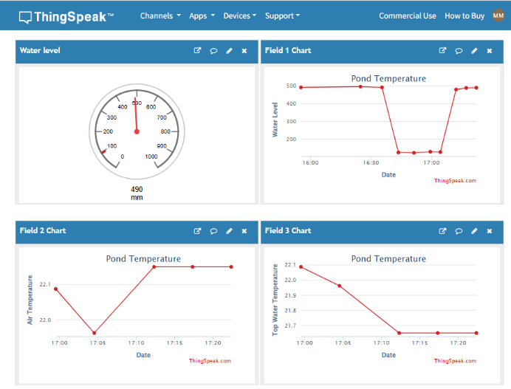

The config and Library file:

[env:heltec_wifi_kit_8]
platform = espressif8266
board = heltec_wifi_kit_8
framework = arduino
monitor_speed = 9600

lib_deps =
greiman/SSD1306Ascii @ ^1.3.5
mathworks/ThingSpeak @ ^2.0.0
paulstoffregen/OneWire @ ^2.3.7
milesburton/DallasTemperature @ ^3.9.1
adafruit/Adafruit BusIO @ ^1.14.1
https://github.com/adafruit/Adafruit_VL53L0X.git#1.2.4

The Full wiring and code:

/* ****************************************************************************************
PondProbe_v4
****************************************************************************************
Board Driver: ESP8266 Ver 3.1.2
Board: WiFi Kit 8
Upload speed 57600
CPU frequency 80MHz
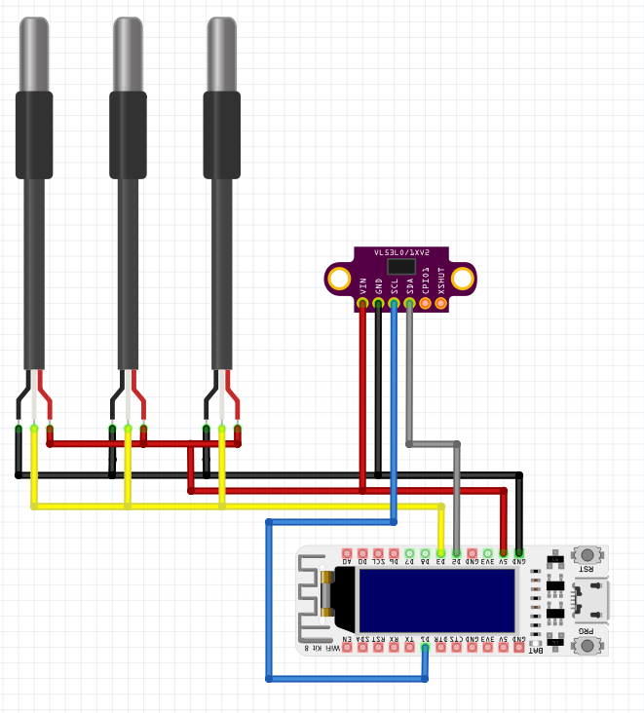
SCL Pin D1 (GPIO 5)
SDA pin D2 (GPIO 4)

I2C Scanning...
I2C device found at address 0x3C ! OLED
I2c device found at address 0x29 ! VL53L0X
****************************************************************************************
*/

#include <Arduino.h>

#include <Wire.h> //I2C communication Library for the VL53L0X sensor
#include <Adafruit_VL53L0X.h> //I2C Library for the VL53L0X sensor

#include <OneWire.h> //Communication Library to Connect DS18B20 Temperature sensor
#include <DallasTemperature.h> //DS18B20 Temperature sensor Library

#include "SSD1306Ascii.h" // OLEAD display library
#include "SSD1306AsciiWire.h" // OLEAD display library

#include <ESP8266WiFi.h> //WiFi Library
#include <ThingSpeak.h> //ThingSpeak IoT library

// --- Definitions ---
#define ONE_WIRE_BUS 0 // put DS18B20 on GPIO 0 - digital pin D3
#define I2C_ADDRESS 0x3C
#define OLED_RESET 16
#define POND_SDA 4 // GPIO 4 - Physical D2 Label
#define POND_SCL 5 // GPIO 5 - Physical D1 Label

//(Change to your specific data)
const char* ssid = "your ssid";
const char* password = "Your password";

// ThingSpeak information (Change to your specific data)
unsigned long channelID = 012345;
const char* readAPIKey = "G1G1G1G1G1G1G1G1";
const char* writeAPIKey = "C2C2C2C2C2C2C2C2";

// --- Global Objects ---
WiFiClient client;
SSD1306AsciiWire oled; // New Lightweight Object
OneWire oneWire(ONE_WIRE_BUS);
DallasTemperature sensors(&oneWire);
Adafruit_VL53L0X lox = Adafruit_VL53L0X();

// --- Helper Variables ---
unsigned long lastUpdateTime = 0;
const unsigned long postingInterval = 300000;
int Tcount = 1;
long WaterLevel;

void connectWiFi() {
oled.clear();
oled.setFont(System5x7);

for (int attempt = 1; attempt < 5; attempt++) {
if (WiFi.status() != WL_CONNECTED) {
oled.setCursor(0, 1);
oled.print("Connecting WiFi ... ");
oled.print(attempt);
WiFi.begin(ssid, password);
delay(7000);
} else {
break;
}
}

if (WiFi.status() == WL_CONNECTED) {
oled.clear();
oled.setCursor(0, 1);
oled.println("WiFi Connected !");
delay(2000);
ThingSpeak.begin(client);
} else {
oled.clear();
oled.setCursor(0, 1);
oled.println("WiFi Not Found !");
delay(2000);
}
}

int ObtainWaterLevel() {
VL53L0X_RangingMeasurementData_t measure;
lox.rangingTest(&measure, false);
int reading = measure.RangeMilliMeter;

if (measure.RangeStatus == 4 || reading <= 0) return 0;
return reading;
}

void setup() {
Serial.begin(9600);

// Reset Heltec Screen
pinMode(OLED_RESET, OUTPUT);
digitalWrite(OLED_RESET, LOW);
delay(100);
digitalWrite(OLED_RESET, HIGH);

Wire.begin(POND_SDA, POND_SCL);
// The warning occurs because the library disables its AVR-specific 400kHz shortcut for the ESP8266,
// safely defaulting to 100kHz while allowing you to manage speed via the standard Wire library instead.

oled.begin(&Adafruit128x32, I2C_ADDRESS);
oled.setFont(System5x7); // Using a small font for the borders
oled.clear();

if (!lox.begin()) {
Serial.println(F("VL53L0X Failed"));
} else {
lox.setMeasurementTimingBudgetMicroSeconds(50000);
}

sensors.begin();
connectWiFi();
}

void loop() {
WaterLevel = ObtainWaterLevel();
sensors.requestTemperatures();

double DS18B20_Sensor0 = sensors.getTempCByIndex(0) + 1.4; // +1.4 is calibration factor for sensor 0
// double DS18B20_Sensor1 = sensors.getTempCByIndex(1) - 1.5; // -1.5 is calibration factor for for sensor 1
// double DS18B20_Sensor2 = sensors.getTempCByIndex(2) + 0.2; // +0.2 is calibration factor for sensor 2
// double DS18B20_Sensor3 = sensors.getTempCByIndex(3) - 1.6; // -1.6 is calibration factor for sensor 3

// --- Display Data ---
// TOP BORDER
oled.setFont(System5x7);

oled.setCursor(0, 0);
oled.print("---------------------");

// MIDDLE DATA ROW
oled.setCursor(0, 1);
oled.set2X(); // Make the text big

// Create a temporary string to hold our display text
String displayStr = "";

// Change Tcount to 5 is other three Temperature sensors are connected
if (Tcount == 2) {
displayStr = "Lvl: " + String(WaterLevel) + "mm";
} else {
displayStr = "T" + String(Tcount) + ": ";
double val = 0;
if (Tcount == 1) val = DS18B20_Sensor0;
// else if (Tcount == 2) val = DS18B20_Sensor1; // if sensor1 is present
// else if (Tcount == 3) val = DS18B20_Sensor2; // if sensor2 is present
// else if (Tcount == 4) val = DS18B20_Sensor3; // if sensor3 is present

displayStr += String(val, 1) + " C";
}

// PADDING LOGIC:
// We need to make sure the string is always the same length
// to "wipe" previous text and reach the right-side wall.
// In 2X mode, about 10-11 characters fit between walls.
while(displayStr.length() < 10) {
displayStr += " ";
}

oled.print(displayStr);
oled.set1X(); // Back to normal size

// BOTTOM BORDER
oled.setCursor(0, 3);
oled.print("---------------------");

// --- ThingSpeak Logic ---
if (millis() - lastUpdateTime >= postingInterval) {
lastUpdateTime = millis();
ThingSpeak.setField(1, (float)WaterLevel);
ThingSpeak.setField(2, (float)DS18B20_Sensor0);
// ThingSpeak.setField(3, (float)DS18B20_Sensor1); // if sensor1 is present
// ThingSpeak.setField(4, (float)DS18B20_Sensor2); // if sensor2 is present
// ThingSpeak.setField(5, (float)DS18B20_Sensor3); // if sensor3 is present
ThingSpeak.writeFields(channelID, writeAPIKey);
}

// if the other three sensors are present
// Tcount = (Tcount >= 5) ? 1 : Tcount + 1;
//
Tcount = (Tcount >= 2) ? 1 : Tcount + 1;
delay(2000);
}

