DAE_8 Problem 2.5

Given:

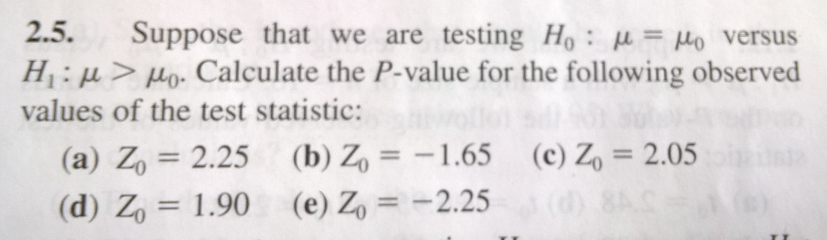

Solution:

The Z statistic is related to the standard normal distribution N(µ,sigma)=N(0,1).The test is one sided as only more extremely larger values are considered under H1 (see figure below).

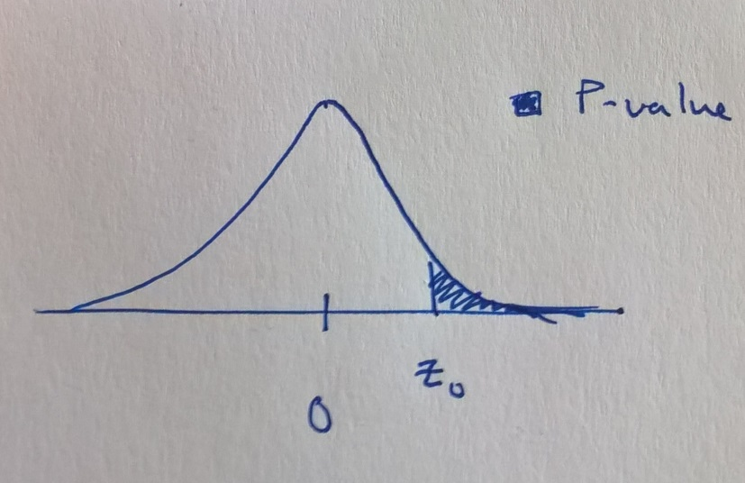

The P-value the probability of more extreme cases than Z0, P(z>Z0), i.e.

P=P(z>Z0)

This probability in turn is derived from the CDF as

P(z>Z0)=1-P(z≤Z0)=1-CDF(Z0)

The CDF of the normal distribution is determined by the error function, which does not have an analytical solution for the 1-D case. Using MATLAB/OCTAVE the following code will determine the P-values.

Z0=[2.25, -1.65, 2.05, 1.90, -2.25]'; %Vector cases A-E

P=(1-normcdf(Z0,0,1))

P =

0.0122

0.9505

0.0202

0.0287

0.9878