DAE8 Problem 2.6

Given:

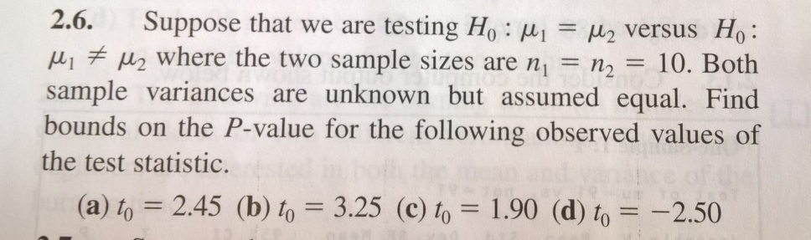

Solution:

The reference distribution is the students t-distribution as the variances are unknown. The test is double sided. The distribution is symmetric (see figure) and the P-value is therefore

P=2\*(1-P(t>abs(t0)))

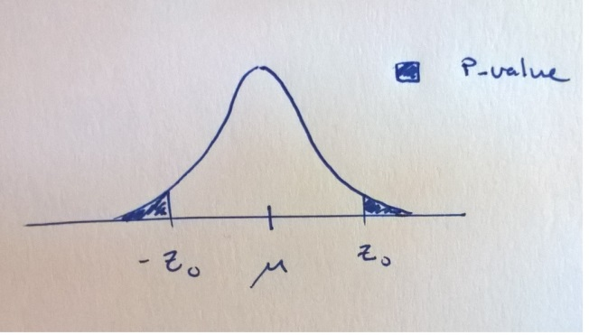

This is determined by the CDF of the t-distribution with dF degrees of freedom. The number of degrees of freedom in this case is

dF=n1+n2-2=10+10-2=18

The test statistics were computed as

t0=µ1-µ0/(Sp\*sqrt(1/n1+1/n2)))

where Sp is the weighted average of the sample variances

Sp^2=[(n1-1)S1^2+(n2-1)S2^2]/dF

The sample variances are

S^2=sum(i={1,n},(yi-<y>)^2)/(n-1)

The following MATLAB code generates the P-values

t0=[2.45,3.25,1.9,-2.5]'; %cases A-D in a col.-vector

n1=10;

n2=n1;

dF=(n1+n2-2);

P=2\*(1-tcdf(abs(t0),dF))

P =[0.0247,0.0044,0.0736,0.0223]’

Where smaller values are more likely under H1