DAE8 Problem 2.7

Given:

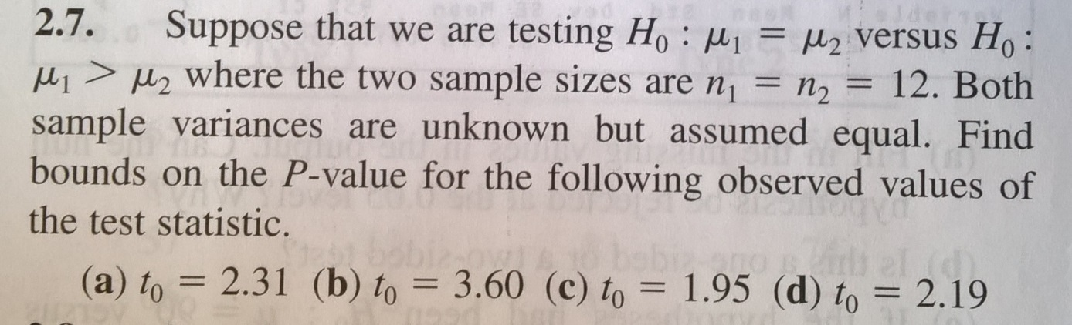

Solution:

Unknown sample variances, assumed equal => t-distribution with dF number of degrees of freedom

Number of degrees of freedom, dF=n1+n2-2=12+12-2=24-2=22

The test is one sided and therefore the P-value is the probability of greater values than t0 (see figure)

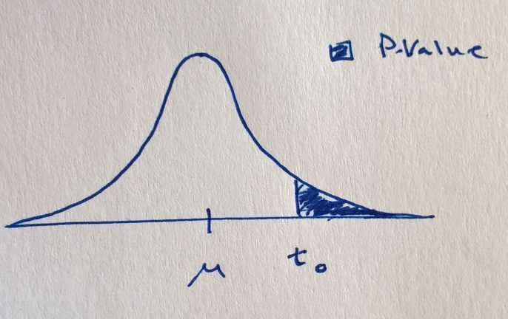

The P-value is therefore, P=P(t>t0)=1-tCDF(t0,dF)

Smaller values are more likely under H1.

The test statistic is computed as t0=(µ1-µ2)/(Sp\*sqrt(1/n1+1/n2))

where Sp^2=[(n1-1)S1^2+(n2-1)S2^2]/dF

And S^2=sum(i={1,n},(yi-<y>)^2)/(n-1)

The following MATLAB code computes the P-values

t0=[2.31,3.6,1.95,2.19]';

n1=12;

n2=n1;

dF=n1+n2-2;

P=1-tcdf(t0,dF)

P =[0.0153,0.0008,0.0320,0.0197]';