DAE8th Problem 2.8

Given:

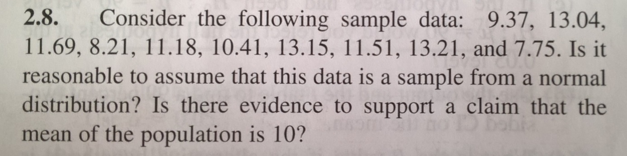

Solution

To investigate if the data was generated from a normal distribution, we generate a normality plot where order the data from smaller to larger according to index j

x=[x1,x2,…,xn]

x_sort={xj}

we set

yj=100(j-0.5)

and plot x against y. A normaly distributed data set should appear along a reasonably straight line. The following code in MATLAB

x=[9.37,13.04, 11.69,8.21,11.18,10.41,13.15,11.51,13.21,7.75]';

n=length(x); %10

x_sort=sort(x,1,'ascend');

j=1:n;

y=100*(j-0.5)/n;

figure;

plot(x_sort,y,'ok');

grid on;

xlim([0,20]);

ylim([0,100]);

xlabel('value');

ylabel('percent data')

generates the normality plot [the basic fitting tool was used to fit a linear function to the data]

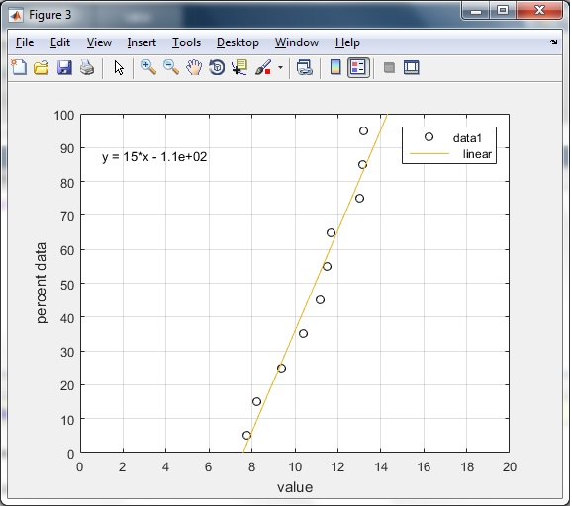

As the transformed data is reasonably linear, the normality assumption on the data holds.

The true variance is not known and therefore the t-distribution can be used as a reference when testing:

H0: µ=10

H1: µ≠10

The number of degrees of freedom is dF =n-1=10-1=9.

The test statistic is computed as t0=(<y>-10)/(S/sqrt(n)).

The acceptable probability of falsely rejecting H0 is selected as alfa=0.05

Therefore the significance level of the test is 1-0.05=0.95

The test is double sided and H0 should be rejected if abs(t0)>talfa/2,dF see figure

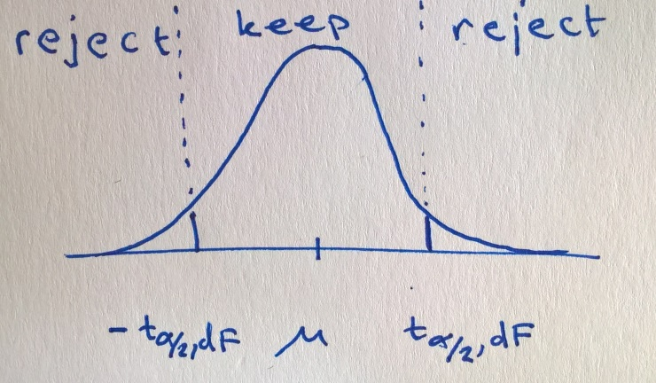

The following code in MATLAB generates statistics and the reference value from the t-distribution

y=[9.37,13.04, 11.69,8.21,11.18,10.41,13.15,11.51,13.21,7.75]';

n=length(y);

dF=n-1;

y_mean=mean(y);

y_ref=10;

alfa=0.05;

S=sqrt(sum((y-y_mean).^2)/dF); %NOTE: n-1 and NOT n

t0=(y_mean-y_ref)/(S/sqrt(n));

t_ref=tinv(alfa/2,dF);

if abs(t0)>abs(t_ref) %note abs since the test is double sided

disp('reject H0!')

else

disp('keep H0!');

end

Which outputs

t0 =

1.5102

t_ref =

-2.2622

keep H0!