DAE8th Problem 2.9

Given: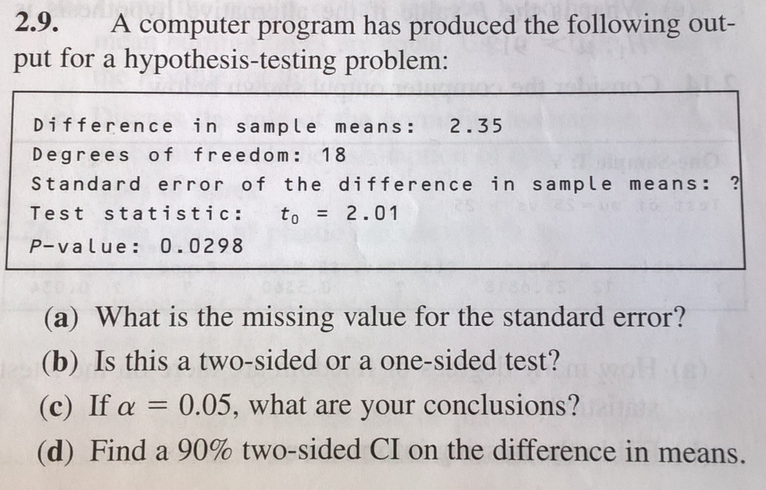

Solution:

a)

The test statistic is t0=(µ0-µ1)/stderr

Which implies that the stderr=t0/(µ0-µ1)=2.01/2.35=0.8553

b) Using 1-tcdf(2.01,18)=0.0298, which is the p-value, hence it is a one sided test.

c) a one sided test is performed by comparing the test statistic to a reference value of the t-distribution with alfa=0.05 and dF=18, which is t_ref=1.7341

as t0> t_ref, we shall **REJECT H0**.

c) here we need to construct the following inequality

Δ-talfa/2,dF*stderr ≤ Δ ≤ Δ+talfa/2,dF*stderr

Where Δ is the difference in the sample means and the stderr as above. We need to realize that alfa should be 0.1 instead of 0.05 and therefore we need to find t0.05,18 , which is 1.7341. The 90% confidence interval for the difference in sample means is therefore

CI: 2.35-1.7341*0.8553 ≤ 2.35 ≤ 2.35+1.7341*0.8553

Or more compactly

CI: 0.8668 ≤ 2.35 ≤ 3.8332