DAE 8th Problem 2.10

Given:

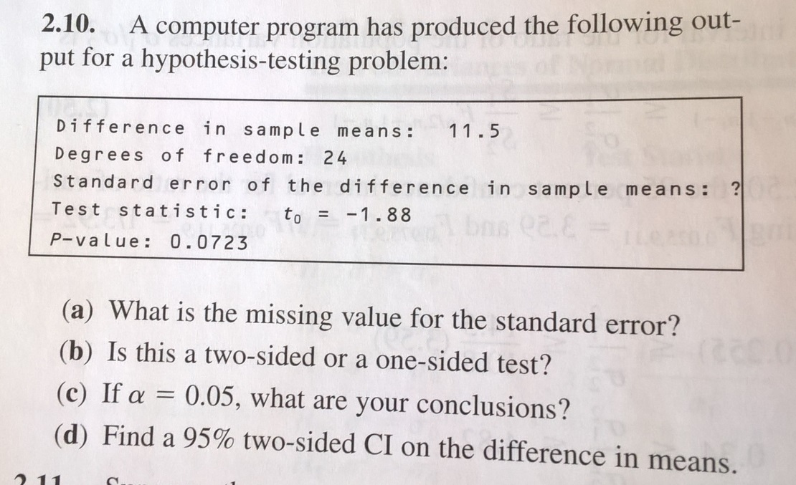

Solution:

See the solutions to problem 2.09 for more details

a) as t0=D/stderr, we find that stderr=D/t0=11.5/1.88=6.1170

b) using tinv for the p-value 0.0723 and 24 degrees of freedom we find -1.5080, rather than -1.88.

Further we find that tcdf(-1.88,24)=0.0362=0.0723/2 which implies that it is a two sided test.

Q: why is the test statistic negative? Doesn’t that imply that the sample difference is negative?

I’ve assumed that the test is to see if it is different from zero…

c) We find t_ref by interrogating the t-distritution with significance level 1-alfa=1-0.05/2=0.975 and 24 degrees of freedom. In MATLAB we write

t_ref=tinv(0.975,24)

which returns 1.7109. Thus

abs(t0)= 1.7109 < abs(t_ref)= 2.0639

we shall KEEP H0!

c) here we need to construct the following inequality

Δ-talfa/2,dF*stderr ≤ Δ ≤ Δ+talfa/2,dF*stderr

Where Δ is the difference in the sample means and the stderr as above. Here, alfa should be 0.05 and we need to find t0.05/2,24 , which in MATLAB is

t_ref=tinv(0.975,24)

which returns 2.0639. The 90% confidence interval for the difference in sample means is therefore

CI: 11.5-2.0639*6.1170 ≤ 11.5 ≤ 11.5+2.0639*6.1170

Or more compactly

CI: -1.1249≤ 11.5 ≤ 24.1249