DAE 8th Problem 2.20

Given:

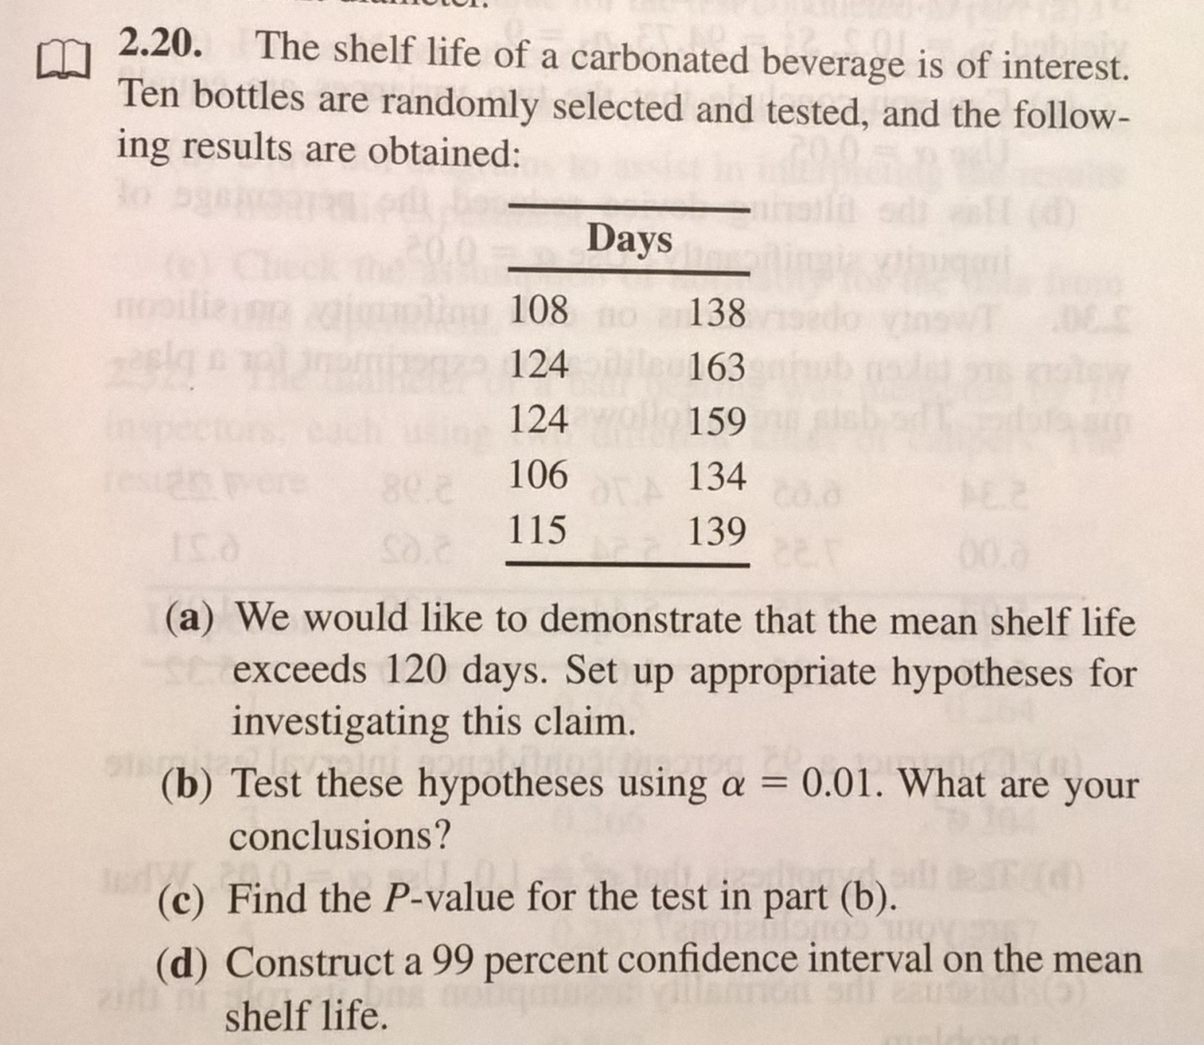

Solution:

A) An Approriate set hypothesis’ is

H0: µ > 120

H1: µ ≤ 120

B) First test the normality assumption. In MATLAB this is achieved using

x=[108,124,124,106,115,138,163,159,134,139]';

n=length(x);

x_sort=sort(x,1,'ascend');

j=1:n;

y=100*(j-0.5)/n;

BETA=glmfit(x_sort,y(:));

figure;

plot(x_sort,y,'ok');

hold on;

plot(x_sort,BETA(1)+x_sort*BETA(2),'r');

legend('data','linear fit');

grid on;

xlim([100,170]);

xlabel('data values');

ylabel('percent data');

ylim([-10,130]);

which produces the following plot

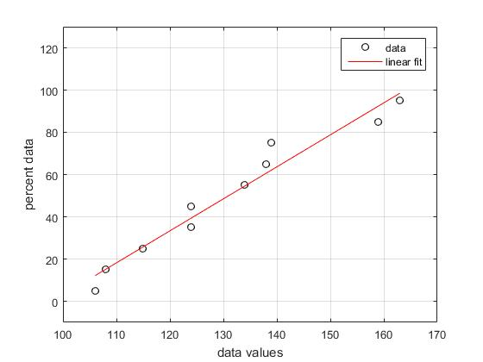

Clearly the normality assumption cannot be falsified. The variance is unknown and therefore the t-distribution should be used as a reference distribution. The statistic computed as

t0=(<y>-120)/(S/sqrt(n))

where <y> is the arithmetic mean, n is the number of samples and S is the sample standard deviation

S=sqrt(sum(i={1,n},(yi-<y>)^2)/(n-1))

This statistic is to be compared to a reference value using alfa=0.05 or equivalently a significance level of 1-alfa= 0.95, with n-1=10-1=9 degrees of freedom. As the test is one sided, the test consists of comparing which of t0 and t_ref is greatest (see figure).

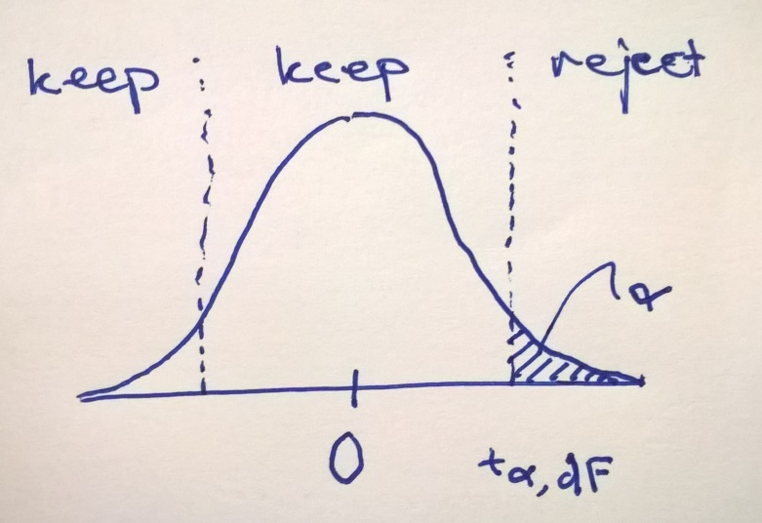

In MATLAB code this consists of:

Which outputs

t0 =

1.7798

tref =

2.8214

Which implies that we cannot reject H0, so we keep it!

C) The P-value is found computing the compliment to the CDF of the t-distribution with 9 degrees of freedom for t0. In MATLAB this is 1-tcdf(t0,dF) which returns 0.0544

D) The 99% confidence interval for the self life µ is

<y>-t0.01/2,9*S/sqrt(n) ≤ <y> ≤ <y>+t0.01/2,9*S/sqrt(n)

Which is

131- 3.2498*6.1806≤ 131 ≤ 131+ 3.2498* 6.1806

Or more compactly

110.9143 ≤ 131 ≤ 151.0857