# DAE8th Problem 2.32

## GIVEN:

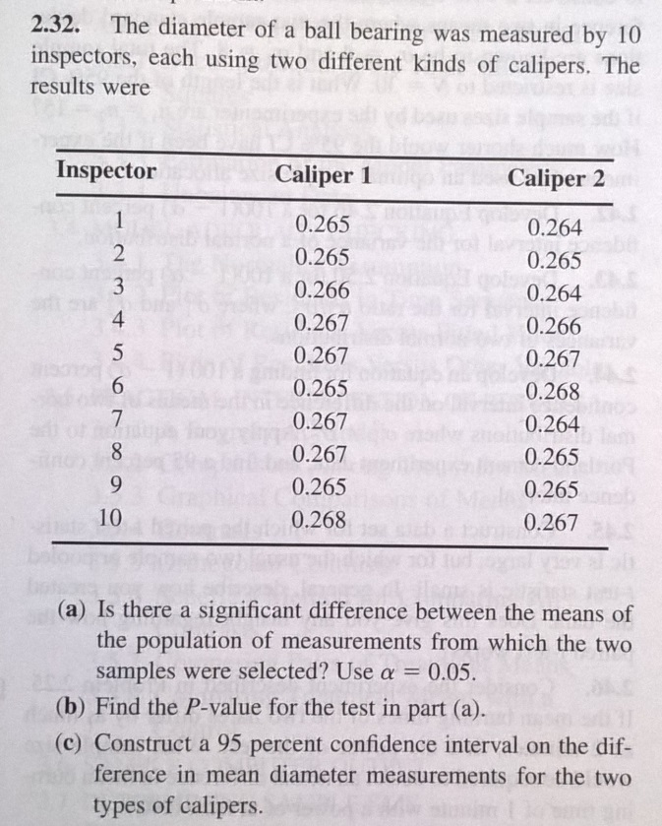

## SOLUTION:

A) in MATLAB code

x1=0.26+1e-3*[4,5,4,6,7,8,4,5,5,7]';

x2=0.26+1e-3*[5,5,6,7,7,5,7,7,5,8]';

X=[x1,x2];

n=size(X,1);

% A) H0: µ0=µ1 vs H1: µ0~=µ1

% unknown variance, assumed equal

% double sided test

m1=mean(x1);

m2=mean(x2);

alfa=0.05;

dF=(n+n-2);

S1=sqrt(sum((x1-m1).^2)/(n-1));

S2=sqrt(sum((x2-m2).^2)/(n-1));

Sp=sqrt(((n-1)*S1^2+(n-1)*S2^2)/(n+n-2));

stdErr=Sp*sqrt(n^-1+n^-1);

t0=(m1-m2)/stdErr

tR=tinv(1-alfa/2,dF)

rejectH0=abs(t0)>=abs(tR)

t0 =-1.2104

tR = 2.1009

rejectH0 = 0

B) In MATLAB code

pVal= 2*(1-tcdf(abs(t0),dF))

pVal = 0.2418

C) In MATLAB code

tRci=tinv(1-alfa/2,dF)*stdErr;

%tRci = 0.0012

deltaM=m1-m2

ciUp=deltaM+tRci

% ciUp = 5.1499e-04

ciLo=deltaM-tRci

% ciLo = -0.0019

Note that the test will be different if the variances are different.