# DAE 8th Example 3.1

## Given:

## Solution:

ANOVA-comparing the variance for different cases

The total variance can be estimated using the total sum of squares, which are derived as in the figure

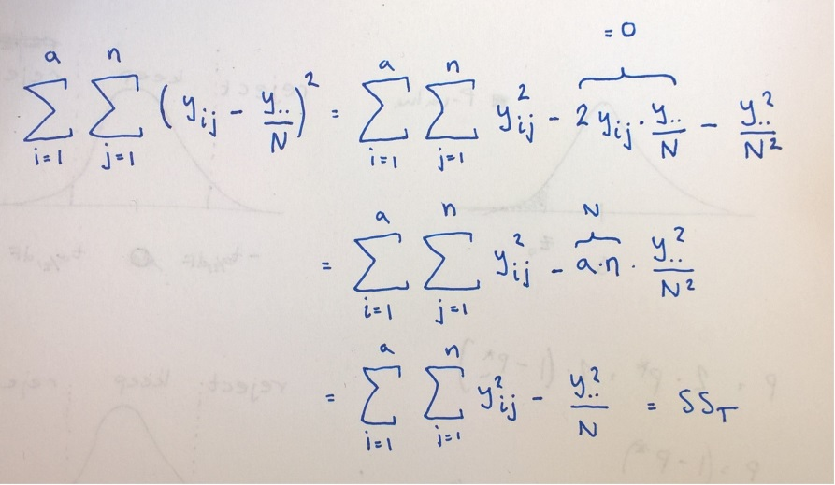

Where double dot indicates the total sum (over i and j)

Q: why is the SS_treat the way it is?

Anyhow in MATLAB it is:

% Example 03.01 DAE 8th, Montgomery

% One-factor, ANOVA

% Testing H0: all means identical

alfa=0.05;

% The data.

Y=[575, 542, 530, 539, 570;

565, 593, 590, 579, 610;

600, 651, 610, 637, 629;

725, 700, 715, 685, 710];

%power levels [W], corresponding to rows in Y

P=[160, 180, 200, 220];

n=size(Y,2); %number of replicates

N=size(Y,1)*size(Y,2); %number of runs

a=length(P); % number of treatments

S_treat=sum(Y,2); %sum over replicates

S_total=sum(S_treat); %total sum

%Y_mean_treat=S_treat/n;

%Y_mean_total=sum(Y_mean_treat);

SS_total=sum(Y(:).^2)-(S_total^2)/N; %sum of squared error relative the total mean

SS_treat=(n^-1)*sum(sum(Y,2).^2)-(S_total^2)/N;

dF_treat=a-1;

dF_E=N-a;

%model SS_total=SS_treat+SS_E=> SSE=SS_total-SS_treat

SS_E=SS_total-SS_treat;

%How much of the variance can be explained this way?

%form the F-statistic

F0=(SS_treat/dF_treat)/(SS_E/dF_E); %66.80

F_ref=finv(1-0.05,dF_treat,dF_E); %3.24

%F0>>F_ref => reject H0!