final_analysis
LIKERTS <- c(
# English
"strongly disagree" = 1L,
"disagree" = 2L,
"neutral" = 3L,
"agree" = 4L,
"strongly agree" = 5L,
# Polish variants
"zdecydowanie nie zgadzam się" = 1L,
"zdecydowanie się nie zgadzam" = 1L,
"nie zgadzam się" = 2L,
"raczej się nie zgadzam" = 2L,
"neutralny" = 3L,
"nie mam opinii" = 3L,
"ani się zgadzam, ani się nie zgadzam" = 3L,
"ani się zgadzam, ani nie" = 3L,
"zgadzam się" = 4L,
"raczej się zgadzam" = 4L,
"zdecydowanie zgadzam się" = 5L,
"zdecydowanie się zgadzam" = 5L
)
# ── 1.2 Purchase frequency ───────────────────────────────────────────────────
PURCHASE_FREQ <- c(
"less than once a month / occasionally" = 1L,
"rzadziej niż raz w miesiącu / sporadycznie" = 1L,
"once a month" = 2L,
"raz w miesiącu" = 2L,
"2–3 times a month" = 3L,
"2-3 razy w miesiącu" = 3L,
"once a week" = 4L,
"raz w tygodniu" = 4L,
"a few times a week" = 5L,
"kilka razy w tygodniu" = 5L,
"daily" = 6L,
"codziennie" = 6L
)
# ── 1.3 Purchase intention (F1) ──────────────────────────────────────────────
F1_INTENT <- c(
"no, i intend to decrease it" = 1L,
"i'm not sure" = 2L,
"no, i will maintain the same level" = 3L,
"pozostanie na tym samym poziomie" = 3L,
"yes, slightly" = 4L,
"raczej tak" = 4L,
"yes, significantly" = 5L,
"zdecydowanie tak" = 5L
)
# ── 1.4 Certification logo familiarity ───────────────────────────────────────
CERT_FAM <- c(
"i do not recognize this logo at all" = 1L,
"nie, nie rozpoznaję tego logo" = 1L,
"i have seen this logo but don't know much about it" = 2L,
"widziałem/am je, ale niewiele o nim wiem" = 2L,
"i recognize this logo and know what it means" = 3L,
"znam to logo i wiem, co oznacza" = 3L
)
# ── 1.5 Certification / logo importance ─────────────────────────────────────
CERT_IMP <- c(
"not important - it doesn't affect my purchasing decisions" = 1L,
"nieważne - nie wpływa na moje decyzje zakupowe" = 1L,
"i don't pay attention to certification logos" = 1L,
"nie zwracam uwagi na logo certyfikatów" = 1L,
"somewhat important - it influences my choice, but i sometimes buy uncertified" = 2L,
"dość ważne - wpływa na mój wybór, ale czasem kupuję produkty niecertyfikowane" = 2L,
"very important - i look for it and usually only buy certified products" = 3L
)
# ── 1.6 Household economic situation (SES proxy) ────────────────────────────
HOUSEHOLD_ECON <- c(
"poor" = 1L,
"fair/average" = 2L,
"przeciętna" = 2L,
"good" = 3L,
"dobra" = 3L,
"bardzo dobra" = 4L,
"very good" = 4L
)
# ── 1.7 Employment status ────────────────────────────────────────────────────
# EMPLOYMENT <- c(
# "Employed full-time" = 1L,
# "Praca na pełny etat" = 1L,
# "Employed part-time" = 2L,
# "Praca w niepełnym wymiarze czasu" = 2L,
# "self-employed / Freelancer" = 3L,
# "Unemployed" = 4L,
# "Bezrobotna/ny" = 4L,
# "Retired" = 5L,
# "Student" = 6L,
# "Homemaker" = 7L,
# "Osoba prowadząca gospodarstwo domowe" = 7L
# )
EMPLOYMENT <- c(
"employed full-time" = 5L,
"praca na pełny etat" = 5L,
"self-employed / freelancer" = 5L,
"employed part-time" = 4L,
"praca w niepełnym wymiarze czasu" = 4L,
"student" = 3L,
"homemaker" = 3L,
"osoba prowadząca gospodarstwo domowe" = 3L,
"retired" = 3L,
"unemployed" = 2L,
"bezrobotna/ny" = 2L,
"NA" = 1L
)
# ── 1.8 Education ────────────────────────────────────────────────────────────
EDUCATION <- c(
# Level 1: Primary
"primary or Less" = 1L,
"podstawowe" = 1L,
# Level 2: Vocational (Lower Secondary/Trade)
"szkoła zawodowa" = 2L,
# Level 3: Secondary / High School
"secondary/high school" = 3L,
"średnie / liceum / technikum" = 3L,
"technical/vocational training" = 3L, # Technikum is often here
"college" = 3L,
# Level 4: Bachelor's / Engineer
"bachelor's degree" = 4L,
"wykształcenie wyższe (licencjat/inżynier)" = 4L,
# Level 5: Master's or PhD
"master's degree or higher" = 5L,
"postgraduate Degree (masters, phd)" = 5L,
"doctorate" = 5L,
"wykształcenie wyższe (magister lub wyższe)" = 5L,
"magister lub wyższy" = 5L
)
# ── 1.9 Colour palette (reused in all plots) ─────────────────────────────────
COL_COUNTRY <- c("Poland" = "#e41a1c", "Zimbabwe" = "#377eb8")
# ── 2.1 Read raw Excel ───────────────────────────────────────────────────────
# Update the path to point to your local copy of the Excel file.
raw <- readxl::read_excel(
"data/Consumer Behavior towards Organic Food Comparative Study_ Poland vs Zimbabwe (Responses) (2) (1).xlsx"
)
# ── 2.2 Bilingual column coalescing ─────────────────────────────────────────
# For each construct the survey has parallel English + Polish columns.
# coalesce() picks the first non-NA value, so bilingual responses map
# to a single canonical column.
coalesce_map <- list(
consent = c("Do you agree to participate in this study after reading the information above?", "Czy po zapoznaniu się z powyższymi informacjami wyraża Pan/Pani zgodę na udział w tym badaniu?"),
purchased_last_12m = c("A1. Have you purchased or consumed any organic food products in the last 12 months?", " A1. Czy w ciągu ostatnich 12 miesięcy kupował (a) Pan/Pani lub spożywał(a) produkty ekologiczne? "),
age = c("A2. Age:", "A2. Wiek:"),
gender = c("A3. Gender", "A3. Płeć:"),
education = c("A4. Highest Educational Level Completed:", "A4. Najwyższy ukończony poziom wykształcenia:"),
household_econ = c("A5. How would you describe the economic situation of your household?", "A5. Jak ocenia Pani/Pan sytuację ekonomiczną swojego gospodarstwa domowego?"),
employment = c("A6. Current Employment Status:", "A6. Obecny status zatrudnienia:"),
country = c("A7. Country of Residence:", "A7. Kraj zamieszkania:"),
awareness_duration = c("B1. How long have you been aware of organic food products?", "B1. Od jakiego czasu zna Pan/i produkty żywności ekologicznej?"),
pct_income_food = c("B2. Approximately what percentage of your total monthly household income is spent on food?", "B2. Jaki procent swojego całkowitego miesięcznego dochodu gospodarstwa domowego przeznacza Pan/i średnio na żywność?"),
pct_budget_organic = c("B3. Of your total food budget, what percentage is typically spent on organic products?", "B3. Jaki procent swojego budżetu przeznaczonego na żywność wydaje Pan/i średnio na produkty ekologiczne?"),
purchase_frequency = c("B4. How often do you typically purchase organic food?", "B4. Jak często kupuje Pan/i żywność ekologiczną?"),
area_population = c("B5. What is the population size of your area of residence?", "B5. Jaka jest wielkość populacji Pana/i miejsca zamieszkania?"),
buy_where = c("B6. Where do you most often buy organic food? (Select all that apply)", "B6. Gdzie najczęściej kupuje Pan/i żywność ekologiczną? (Można wybrać kilka odpowiedzi)"),
buy_for_whom = c("B7. For whom do you primarily buy organic food? (Select all that apply)", "B7. Dla kogo głównie kupuje Pan/i żywność ekologiczną? (Można wybrać kilka odpowiedzi)"),
identify_method = c("B8. What is your primary method for identifying organic products?", "B8. Jaka jest Pana/i główna metoda identyfikacji produktów ekologicznych? (Proszę wybrać jedną odpowiedź)"),
c1_organic_belief = c("Part 1: Your Beliefs About Organic Food\r\nPlease indicate your level of agreement with the following statements based on your beliefs. [C1. Organic food is healthier than conventional food.]", "Część 1: Przekonania na temat żywności ekologicznej\r\nProszę wskazać stopień zgodności z poniższymi stwierdzeniami, opierając się na swoich przekonaniach. [C1. Żywność ekologiczna jest zdrowsza niż konwencjonalna.]"),
c2_pesticides_belief = c("Part 1: Your Beliefs About Organic Food\r\nPlease indicate your level of agreement with the following statements based on your beliefs. [C2. Avoiding pesticides and harmful chemicals is a major advantage of organic food.]", "Część 1: Przekonania na temat żywności ekologicznej\r\nProszę wskazać stopień zgodności z poniższymi stwierdzeniami, opierając się na swoich przekonaniach. [C2. Unikanie pestycydów i szkodliwych chemikaliów jest główną zaletą żywności ekologicznej.]"),
c3_environment_belief = c("Part 1: Your Beliefs About Organic Food\r\nPlease indicate your level of agreement with the following statements based on your beliefs. [C3. Organic farming is better for the environment.]", "Część 1: Przekonania na temat żywności ekologicznej\r\nProszę wskazać stopień zgodności z poniższymi stwierdzeniami, opierając się na swoich przekonaniach. [C3. Rolnictwo ekologiczne jest lepsze dla środowiska]"),
c4_ethics_belief = c("Part 1: Your Beliefs About Organic Food\r\nPlease indicate your level of agreement with the following statements based on your beliefs. [C4. Organic farming ensures better ethical treatment of animals.]",
"Część 1: Przekonania na temat żywności ekologicznej\r\nProszę wskazać stopień zgodności z poniższymi stwierdzeniami, opierając się na swoich przekonaniach. [C4. Rolnictwo ekologiczne zapewnia bardziej etyczne traktowanie zwierząt.]"),
cert_eu = c("C5. EU Organic Logo (Used in Poland and the EU)\r\nHow familiar are you with this logo?", "Proszę zapoznać się z poniższymi logo certyfikatów ekologicznych i odpowiedzieć na pytania.\r\nPICTURE OF EU ORGANIC LOGO\r\nrozpoznaje Pan/i powyższe logo ekologiczne UE?"),
cert_zw = c("C6. Zimbabwe Organic Certification Logo\r\nHow familiar are you with this logo?", "C6. Czy rozpoznaje Pan/i powyższe logo certyfikacji ekologicznej Zimbabwe?"),
cert_importance = c("C7. How important is seeing an official organic certification logo when you shop?", "C7. Jak ważne jest dla Pana/Pani oficjalne logo certyfikatu ekologicznego podczas zakupów?"),
d1_taste_emotion = c("Please indicate your level of agreement with the following statements based on your feelings. [D1. Organic food tastes better than non-organic food.]", "Proszę określić w jakim stopniu zgadza się Pan(i) z poniższymi stwierdzeniami, w oparciu o swoje odczucia. [D1. Żywność ekologiczna smakuje lepiej niż konwencjonalna.]"),
d2_assurance_emotion = c("Please indicate your level of agreement with the following statements based on your feelings. [D2. I feel confident and reassured when I see an official organic certification label.]","Proszę określić w jakim stopniu zgadza się Pan(i) z poniższymi stwierdzeniami, w oparciu o swoje odczucia. [D2. Czuję się pewnie i spokojnie, gdy widzę logo ekożywności]"),
d3_satisfaction_emotion = c("Please indicate your level of agreement with the following statements based on your feelings. [D3. Buying organic food gives me a sense of personal satisfaction.]", "Proszę określić w jakim stopniu zgadza się Pan(i) z poniższymi stwierdzeniami, w oparciu o swoje odczucia. [D3. Zakup żywności ekologicznej daje mi poczucie osobistej satysfakcji.]"),
d4_health_worry = c("Please indicate your level of agreement with the following statements based on your feelings. [D4. I feel worried about the long-term health effects of consuming conventional food.]", "Proszę określić w jakim stopniu zgadza się Pan(i) z poniższymi stwierdzeniami, w oparciu o swoje odczucia. [D4. Czuję się zaniepokojony/a długoterminowymi skutkami zdrowotnymi spożywania konwencjonalnej żywności.]"),
d5_local_trust = c("Please indicate your level of agreement with the following statements based on your feelings. [D5. I feel a stronger sense of trust when I buy from a local farmer I know than from a certified supermarket product.]", "Proszę określić w jakim stopniu zgadza się Pan(i) z poniższymi stwierdzeniami, w oparciu o swoje odczucia. [D5. Czuję większe zaufanie, gdy kupuję od znanego mi lokalnego rolnika niż do certyfikowanego produktu z supermarketu.]"),
price_perception = c("E3. \u201cOrganic food is too expensive for my budget.\u201d", "E3. Żywność ekologiczna jest dla mnie zbyt droga."),
f1_intent = c("F1. Compared to now, do you intend to increase your consumption of organic food in the future?", "F1. W porównaniu do obecnej sytuacji, czy zamierza Pan/Pani zwiększyć w przyszłości spożycie żywności ekologicznej?\n"))
# Apply coalescing: for each canonical name, combine bilingual columns
for (canonical in names(coalesce_map)) {
cols <- coalesce_map[[canonical]]
valid_cols <- cols[cols %in% names(raw)] # only keep cols that exist
raw[[canonical]] <- do.call(coalesce, raw[valid_cols])
}

Data Cleaning
# ── 3.1 Helper: apply a named lookup vector (case-insensitive) ───────────────
# This replaces all repeated instances of map[str_to_lower(str_trim(x))].
apply_map <- function(x, lookup) {
lookup[str_to_lower(str_trim(as.character(x)))]
}
# ── 3.2 Filter to Poland & Zimbabwe; standardise country labels ──────────────
df <- raw |>
clean_names() |>
filter(country %in% c("Poland", "Polska", "Zimbabwe")) |>
mutate(
country = if_else(country == "Polska", "Poland", country),
country = factor(country, levels = c("Poland", "Zimbabwe"))
)
# ── 3.3 Balanced sample: 100 per country ─────────────────────────────────────
set.seed(123)
df <- df |>
group_by(country) |>
slice_sample(n = 100) |>
ungroup()
cat(sprintf("\nSample: %d total (%s)\n", nrow(df),
paste(names(table(df$country)), table(df$country), sep = " = ",
collapse = " | ")))
Sample: 200 total (Poland = 100 | Zimbabwe = 100)
# ── 3.4 Apply all lookup mappings ────────────────────────────────────────────
# Likert items: C1–C4 (cognitive beliefs) and D1–D5 (affective emotions)
cognitive_cols <- c("c1_organic_belief", "c2_pesticides_belief",
"c3_environment_belief", "c4_ethics_belief")
affective_cols <- c("d1_taste_emotion", "d2_assurance_emotion",
"d3_satisfaction_emotion", "d4_health_worry")
# Note: d5_local_trust excluded from composite (cross-loads; see MIs below)
likert_cols <- c(cognitive_cols, affective_cols)
df <- df |>
# Likert items → numeric
mutate(across(all_of(likert_cols),
~ as.integer(apply_map(.x, LIKERTS)),
.names = "{.col}_n")) |>
# Purchase frequency → ordinal 1–6
mutate(
purchase_frequency_clean = str_replace_all(
str_to_lower(str_trim(purchase_frequency)), "–", "-"),
purchase_freq_n = as.integer(PURCHASE_FREQ[purchase_frequency_clean])
) |>
# F1 purchase intention → ordinal 1–5
mutate(
f1_intent_n = as.integer(
apply_map(f1_intent, F1_INTENT))
) |>
# Certification familiarity (EU & ZW) → 1–3
mutate(
cert_eu_n = as.integer(apply_map(cert_eu, CERT_FAM)),
cert_zw_n = as.integer(apply_map(cert_zw, CERT_FAM)),
cert_imp_n = as.integer(apply_map(cert_importance, CERT_IMP))
) |>
# Socioeconomic proxies
mutate(
household_econ_n = as.integer(apply_map(household_econ, HOUSEHOLD_ECON)),
employment_n = as.integer(apply_map(employment, EMPLOYMENT)),
education_n = as.integer(apply_map(education, EDUCATION))
) |>
# Price perception: take first response only (handles multi-select edge cases)
mutate(
price_perception_n = as.integer(
apply_map(str_extract(price_perception, "^[^,]+"), LIKERTS))
) |>
# Country-appropriate certification familiarity
mutate(
cert_familiar_n = if_else(country == "Poland", cert_eu_n, cert_zw_n)
) |>
# Gender harmonisation
mutate(
gender_clean = case_when(
str_to_lower(gender) %in% c("female", "kobieta", "woman") ~ "Female",
str_to_lower(gender) %in% c("male", "mężczyzna", "man") ~ "Male",
TRUE ~ "Other / Prefer not to say"
)
)
# ── 4.1 Cognitive and Affective composites ───────────────────────────────────
cog_items <- paste0(cognitive_cols, "_n") # c1…c4_n
aff_items <- paste0(affective_cols, "_n") # d1…d4_n (d5 excluded)
df <- df |>
mutate(
Cognitive = rowMeans(across(all_of(cog_items)), na.rm = TRUE),
Affective = rowMeans(across(all_of(aff_items)), na.rm = TRUE),
# Mean-centred versions for moderation models (Ha3) to reduce multicollinearity
Affective_c = Affective - mean(Affective, na.rm = TRUE),
price_c = price_perception_n - mean(price_perception_n, na.rm = TRUE),
# SEP composite (Ha4): mean of household SES, education, employment
SEP = rowMeans(across(c(household_econ_n, education_n, employment_n)), na.rm = TRUE)
)
# ── 4.2 Internal consistency ─────────────────────────────────────────────────
cat("\n--- Reliability ---\n")
--- Reliability ---
cat("Cognitive Beliefs (C1–C4): α =",
round(psych::alpha(df[, cog_items], na.rm = TRUE)$total$raw_alpha, 3), "\n")
Warning in response.frequencies(x, max = max): response.frequency has been
deprecated and replaced with responseFrequecy. Please fix your call
Cognitive Beliefs (C1–C4): α = 0.872
cat("Affective Emotions (D1–D4): α =",
round(psych::alpha(df[, aff_items], na.rm = TRUE)$total$raw_alpha, 3), "\n")
Warning in response.frequencies(x, max = max): response.frequency has been
deprecated and replaced with responseFrequecy. Please fix your call
Affective Emotions (D1–D4): α = 0.892
# ── 4.3 Descriptive overview ─────────────────────────────────────────────────
cat("\n--- Descriptive Statistics ---\n")
--- Descriptive Statistics ---
df |>
select(Cognitive, Affective, purchase_freq_n, cert_familiar_n,
price_perception_n, f1_intent_n, SEP, education_n) |>
psych::describe() |>
round(2) |>
print()
vars n mean sd median trimmed mad min max range skew
Cognitive 1 195 3.36 1.05 3.50 3.41 1.11 1.00 5.00 4 -0.32
Affective 2 200 3.39 0.98 3.50 3.43 1.11 1.00 5.00 4 -0.34
purchase_freq_n 3 174 4.50 1.27 5.00 4.69 0.00 1.00 6.00 5 -1.43
cert_familiar_n 4 160 2.39 0.87 3.00 2.48 0.00 1.00 3.00 2 -0.83
price_perception_n 5 196 2.54 1.00 2.00 2.51 1.48 1.00 5.00 4 0.31
f1_intent_n 6 189 4.43 0.72 5.00 4.54 0.00 1.00 5.00 4 -1.52
SEP 7 200 3.50 0.59 3.67 3.51 0.49 1.67 4.67 3 -0.29
education_n 8 197 3.62 0.82 3.00 3.57 0.00 1.00 5.00 4 0.23
kurtosis se
Cognitive -0.53 0.08
Affective -0.31 0.07
purchase_freq_n 1.44 0.10
cert_familiar_n -1.17 0.07
price_perception_n -0.42 0.07
f1_intent_n 3.73 0.05
SEP -0.24 0.04
education_n -0.17 0.06
# ── 5.1 Pretty section header ────────────────────────────────────────────────
section <- function(title) {
bar <- strrep("=", 60)
cat("\n\n", bar, "\n ", title, "\n", bar, "\n", sep = "")
}
# ── 5.2 Robust coefficient test with HC3 SEs ─────────────────────────────────
# Returns the coeftest object AND prints it with a label.
rob_test <- function(model, label = "") {
if (nchar(label) > 0) cat("\n---", label, "---\n")
ct <- coeftest(model, vcov = vcovHC(model, "HC3"))
print(ct)
invisible(ct)
}
# ── 5.3 Bootstrapped mediation (wrapper to keep sims consistent) ─────────────
run_mediation <- function(model_m, model_y, treat, mediator,
sims = 2000, seed = 2025) {
set.seed(seed)
med_out <- mediate(
model.m = model_m,
model.y = model_y,
treat = treat,
mediator = mediator,
boot = TRUE,
sims = sims,
boot.ci.type = "bca"
)
print(summary(med_out))
invisible(med_out)
}
# ── 5.4 Sobel Z-test ─────────────────────────────────────────────────────────
sobel_test <- function(model_a, treat, model_b, mediator) {
a <- coef(model_a)[treat]
b <- coef(model_b)[mediator]
se_a <- sqrt(vcov(model_a)[treat, treat])
se_b <- sqrt(vcov(model_b)[mediator, mediator])
z <- (a * b) / sqrt(b^2 * se_a^2 + a^2 * se_b^2)
p <- 2 * pnorm(-abs(z))
cat(sprintf("\n--- Sobel Test ---\n Z = %.4f | p = %.4f\n", z, p))
invisible(list(z = z, p = p))
}
# ── 5.5 SEM fit summary ──────────────────────────────────────────────────────
sem_fit_summary <- function(fit, label = "") {
if (nchar(label) > 0) cat("\n---", label, "---\n")
cat("Fit indices:\n")
print(fitMeasures(fit, c("cfi", "tli", "rmsea", "srmr", "aic", "bic")))
invisible(fit)
}
# ── 5.6 Extract & print labelled SEM paths ───────────────────────────────────
sem_paths <- function(fit, labels) {
parameterEstimates(fit, boot.ci.type = "bca.simple", ci = TRUE,
standardized = TRUE) |>
filter(label %in% labels) |>
select(label, est, se, z, pvalue, ci.lower, ci.upper, std.all) |>
print()
}
# ── 5.7 H₀ rejection decision for indirect effect ───────────────────────────
decide_indirect <- function(fit, label = "indirect") {
est <- parameterEstimates(fit, boot.ci.type = "bca.simple", ci = TRUE) |>
filter(.data$label == !!label)
cat(sprintf("\n>>> Decision (%s): est = %.3f [%.3f, %.3f] p = %.4f\n",
label, est$est, est$ci.lower, est$ci.upper, est$pvalue))
if (est$ci.lower > 0 | est$ci.upper < 0) {
cat(" REJECT H\u2080 \u2014 CI excludes zero.\n")
} else {
cat(" FAIL TO REJECT H\u2080 \u2014 CI includes zero.\n")
}
invisible(est)
}
# ── 5.8 Consistent ggplot2 theme ─────────────────────────────────────────────
theme_study <- function(base_size = 13) {
theme_minimal(base_size = base_size) +
theme(plot.title = element_text(face = "bold"),
plot.subtitle = element_text(colour = "grey40"),
strip.text = element_text(face = "bold"))
}

The Theory of Cognitive-Affective Mediation
Alternative (H₁): Affective emotions are positively impacted by cognitive beliefs, which raise the frequency of purchases.
Null (H₀): Affective sentiments do not enhance the frequency of purchases, while cognitive ideas have no effect on affective feelings.
#| fig-width: 10
#| fig-height: 8
#| fig-align: "center"
# 6. Ha1: THEORY OF COGNITIVE-AFFECTIVE MEDIATION
#
# Path: Cognitive Beliefs (C1–C4)
# → Affective Emotions (D1–D4) [a-path]
# → Purchase Frequency [b-path]
# Also tests direct path Cognitive → Purchase (c'-path)
#
ha1_data <- df |>
select(country, all_of(c(cog_items, aff_items)),
Cognitive, Affective, purchase_freq_n) |>
drop_na()
cat(sprintf("\nHa1 n = %d\n", nrow(ha1_data)))
Ha1 n = 174
# ── 6.2 Baron-Kenny steps ────────────────────────────────────────────────────
# Step 1: total effect — Cognitive → Purchase
bk1 <- lm(purchase_freq_n ~ Cognitive, data = ha1_data)
rob_test(bk1, "Step 1 – Total effect: Cognitive → Purchase_Freq")
--- Step 1 – Total effect: Cognitive → Purchase_Freq ---
t test of coefficients:
Estimate Std. Error t value Pr(>|t|)
(Intercept) 4.5293546 0.3392419 13.3514 <2e-16 ***
Cognitive -0.0087274 0.0999366 -0.0873 0.9305
---
Signif. codes: 0 '***' 0.001 '**' 0.01 '*' 0.05 '.' 0.1 ' ' 1
# Step 2: a-path — Cognitive → Affective
bk2 <- lm(Affective ~ Cognitive, data = ha1_data)
rob_test(bk2, "Step 2 – a-path: Cognitive → Affective")
--- Step 2 – a-path: Cognitive → Affective ---
t test of coefficients:
Estimate Std. Error t value Pr(>|t|)
(Intercept) 1.611593 0.284094 5.6727 5.843e-08 ***
Cognitive 0.540509 0.081675 6.6178 4.451e-10 ***
---
Signif. codes: 0 '***' 0.001 '**' 0.01 '*' 0.05 '.' 0.1 ' ' 1
# Step 3: b & c' paths — Cognitive + Affective → Purchase
bk3 <- lm(purchase_freq_n ~ Cognitive + Affective, data = ha1_data)
rob_test(bk3, "Step 3 – b & c' paths: Cognitive + Affective → Purchase_Freq")
--- Step 3 – b & c' paths: Cognitive + Affective → Purchase_Freq ---
t test of coefficients:
Estimate Std. Error t value Pr(>|t|)
(Intercept) 4.5211551 0.3818610 11.8398 <2e-16 ***
Cognitive -0.0114774 0.1361009 -0.0843 0.9329
Affective 0.0050878 0.1398486 0.0364 0.9710
---
Signif. codes: 0 '***' 0.001 '**' 0.01 '*' 0.05 '.' 0.1 ' ' 1
# ── 6.3 Bootstrapped mediation ───────────────────────────────────────────────
cat("\n--- Ha1: Bootstrapped ACME / ADE / Total ---\n")
--- Ha1: Bootstrapped ACME / ADE / Total ---
ha1_med <- run_mediation(bk2, bk3, treat = "Cognitive", mediator = "Affective")
Running nonparametric bootstrap
Causal Mediation Analysis
Nonparametric Bootstrap Confidence Intervals with the BCa Method
Estimate 95% CI Lower 95% CI Upper p-value
ACME 0.0027500 -0.0942416 0.2607806 0.920
ADE -0.0114774 -0.3544605 0.1978971 0.859
Total Effect -0.0087274 -0.2054693 0.1829638 0.921
Prop. Mediated -0.3151011 -9.2329918 8.7275914 0.913
Sample Size Used: 174
Simulations: 2000
# ── 6.4 SEM with CFA measurement model ──────────────────────────────────────
# Using ML estimator (MLR available but requires FIML; drop_na used above)
ha1_sem_spec <- '
# Measurement model
Cog =~ c1_organic_belief_n + c2_pesticides_belief_n +
c3_environment_belief_n + c4_ethics_belief_n
Aff =~ d1_taste_emotion_n + d2_assurance_emotion_n +
d3_satisfaction_emotion_n + d4_health_worry_n
# Structural model
Aff ~ a * Cog
purchase_freq_n ~ b * Aff + cp * Cog
# Derived effects
indirect := a * b
total := cp + (a * b)
'
ha1_fit <- sem(ha1_sem_spec, data = ha1_data,
estimator = "ML",
se = "bootstrap",
bootstrap = 2000)
sem_fit_summary(ha1_fit, "Ha1 SEM Fit Indices")
--- Ha1 SEM Fit Indices ---
Fit indices:
cfi tli rmsea srmr aic bic
0.961 0.944 0.093 0.058 4011.902 4075.083
cat("\n--- Ha1: Structural path estimates ---\n")
--- Ha1: Structural path estimates ---
sem_paths(ha1_fit, c("a", "b", "cp", "indirect", "total"))
label est se z pvalue ci.lower ci.upper std.all
1 a 0.647 0.092 7.018 0.000 0.461 0.819 0.710
2 b -0.033 0.205 -0.161 0.872 -0.351 0.430 -0.025
3 cp 0.091 0.190 0.479 0.632 -0.356 0.368 0.076
4 indirect -0.021 0.145 -0.147 0.883 -0.222 0.310 -0.018
5 total 0.070 0.101 0.688 0.492 -0.129 0.260 0.058
decide_indirect(ha1_fit, "indirect")
>>> Decision (indirect): est = -0.021 [-0.222, 0.310] p = 0.8828
FAIL TO REJECT H₀ — CI includes zero.
# ── 6.5 SEM path diagram ─────────────────────────────────────────────────────
semPlot::semPaths(ha1_fit, what = "std", layout = "circle",
edge.label.cex = 1.2, nCharNodes = 0,
sizeMan = 8, sizeLat = 10, title = FALSE)
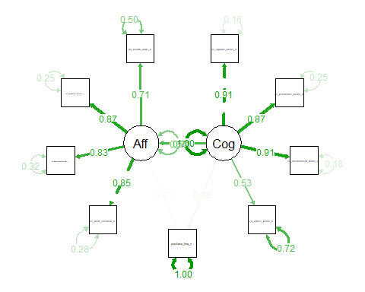
# ── 6.6 Modification indices (for model improvement guidance) ────────────────
cat("\n--- Ha1: Top 10 modification indices ---\n")
--- Ha1: Top 10 modification indices ---
modificationIndices(ha1_fit, sort. = TRUE, maximum.number = 10) |>
print()
lhs op rhs mi epc sepc.lv
68 d4_health_worry_n ~~ purchase_freq_n 12.262 -0.287 -0.287
58 c4_ethics_belief_n ~~ purchase_freq_n 11.383 -0.380 -0.380
55 c4_ethics_belief_n ~~ d2_assurance_emotion_n 7.790 -0.162 -0.162
48 c3_environment_belief_n ~~ c4_ethics_belief_n 7.457 0.153 0.153
32 Aff =~ c4_ethics_belief_n 6.067 -0.371 -0.358
33 c1_organic_belief_n ~~ c2_pesticides_belief_n 5.642 0.117 0.117
41 c2_pesticides_belief_n ~~ c3_environment_belief_n 5.127 -0.111 -0.111
46 c2_pesticides_belief_n ~~ d4_health_worry_n 4.539 0.089 0.089
27 Cog =~ d3_satisfaction_emotion_n 4.413 0.166 0.176
59 d1_taste_emotion_n ~~ d2_assurance_emotion_n 4.185 0.093 0.093
sepc.all sepc.nox
68 -0.282 -0.282
58 -0.260 -0.260
55 -0.240 -0.240
48 0.265 0.265
32 -0.261 -0.261
33 0.436 0.436
41 -0.388 -0.388
46 0.191 0.191
27 0.169 0.169
59 0.263 0.263
# ── 6.7 Plot ─────────────────────────────────────────────────────────────────
ggplot(ha1_data, aes(x = Cognitive, y = purchase_freq_n)) +
geom_jitter(aes(colour = Affective), alpha = 0.55, width = 0.04, height = 0.15) +
geom_smooth(method = "lm", se = TRUE, colour = "#2171b5", linewidth = 1) +
scale_colour_gradient(low = "#deebf7", high = "#08306b", name = "Affective\nScore") +
facet_wrap(~country) +
labs(
title = "Ha1: Cognitive Beliefs → Purchase Frequency",
subtitle = "Point shade = Affective Emotion composite; line = OLS fit",
x = "Cognitive Beliefs (mean score)", y = "Purchase Frequency (1–6)"
) +
theme_study()
`geom_smooth()` using formula = 'y ~ x'
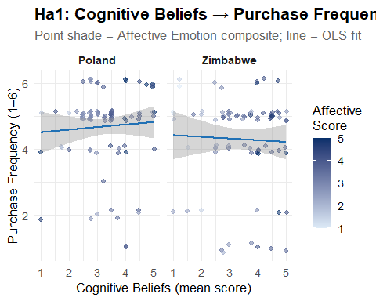
# ggsave("Ha1_cognitive_affective_mediation.png", p_ha1,
# width = 10, height = 5, dpi = 300)

The Theory of the Certification Trust Chain
Alternative (H₁): Purchase likelihood is increased by certification familiarity, which then boosts confidence after the purchase.
Null (``H₀``): buy experience does not boost post-buy confidence, and certification familiarity does not raise purchase likelihood.
# 7. Ha2: THEORY OF THE CERTIFICATION TRUST CHAIN
#
# Path: Cert Familiarity (C5/C6)
# → Purchase Frequency (B4) [a-path]
# → Post-purchase Confidence (D2) [b-path]
# D2 ("I feel confident when I see an organic cert label") is the
# closest available proxy for post-purchase confidence.
# ── 7.1 Complete-case dataset for Ha2 ────────────────────────────────────────
ha2_data <- df |>
select(country, cert_eu_n, cert_zw_n, cert_familiar_n,
cert_imp_n, d2_assurance_emotion_n, purchase_freq_n, f1_intent_n) |>
drop_na()
cat(sprintf("\nHa2 n = %d\n", nrow(ha2_data)))
Ha2 n = 123
# ── 7.2 Baron-Kenny steps ────────────────────────────────────────────────────
# Step 1: total effect — Cert familiarity → Post-purchase confidence (D2)
bk1_ha2 <- lm(d2_assurance_emotion_n ~ cert_eu_n + cert_zw_n, data = ha2_data)
rob_test(bk1_ha2, "Step 1 – Total: Cert familiarity → D2 confidence")
--- Step 1 – Total: Cert familiarity → D2 confidence ---
t test of coefficients:
Estimate Std. Error t value Pr(>|t|)
(Intercept) 2.877665 0.270398 10.6423 <2e-16 ***
cert_eu_n 0.182629 0.159092 1.1479 0.2533
cert_zw_n 0.076818 0.156765 0.4900 0.6250
---
Signif. codes: 0 '***' 0.001 '**' 0.01 '*' 0.05 '.' 0.1 ' ' 1
# Step 2: a-path — Cert familiarity → Purchase frequency
bk2_ha2 <- lm(purchase_freq_n ~ cert_eu_n + cert_zw_n, data = ha2_data)
rob_test(bk2_ha2, "Step 2 – a-path: Cert familiarity → Purchase_Freq")
--- Step 2 – a-path: Cert familiarity → Purchase_Freq ---
t test of coefficients:
Estimate Std. Error t value Pr(>|t|)
(Intercept) 3.683186 0.410964 8.9623 5.032e-15 ***
cert_eu_n 0.092541 0.255600 0.3621 0.7179
cert_zw_n 0.305020 0.233583 1.3058 0.1941
---
Signif. codes: 0 '***' 0.001 '**' 0.01 '*' 0.05 '.' 0.1 ' ' 1
# Step 3: b & c' paths — Cert + Purchase → D2
bk3_ha2 <- lm(d2_assurance_emotion_n ~ cert_eu_n + cert_zw_n + purchase_freq_n,
data = ha2_data)
rob_test(bk3_ha2, "Step 3 – b & c' paths: Cert + Purchase → D2 confidence")
--- Step 3 – b & c' paths: Cert + Purchase → D2 confidence ---
t test of coefficients:
Estimate Std. Error t value Pr(>|t|)
(Intercept) 2.959146 0.361244 8.1916 3.338e-13 ***
cert_eu_n 0.184677 0.161008 1.1470 0.2537
cert_zw_n 0.083566 0.161859 0.5163 0.6066
purchase_freq_n -0.022122 0.081122 -0.2727 0.7856
---
Signif. codes: 0 '***' 0.001 '**' 0.01 '*' 0.05 '.' 0.1 ' ' 1
# ── 7.3 Sobel test ───────────────────────────────────────────────────────────
# Using EU logo as primary treatment (ZW logo held in model as covariate)
sobel_test(bk2_ha2, treat = "cert_eu_n", model_b = bk3_ha2, mediator = "purchase_freq_n")
--- Sobel Test ---
Z = -0.2521 | p = 0.8009
# ── 7.4 Bootstrapped mediation ───────────────────────────────────────────────
cat("\n--- Ha2: Bootstrapped ACME / ADE / Total (EU logo → Purchase → Confidence) ---\n")
--- Ha2: Bootstrapped ACME / ADE / Total (EU logo → Purchase → Confidence) ---
ha2_med <- run_mediation(bk2_ha2, bk3_ha2,
treat = "cert_eu_n",
mediator = "purchase_freq_n")
Running nonparametric bootstrap
Causal Mediation Analysis
Nonparametric Bootstrap Confidence Intervals with the BCa Method
Estimate 95% CI Lower 95% CI Upper p-value
ACME -0.0020472 -0.0401223 0.0490119 0.986
ADE 0.1846767 -0.1149741 0.5221787 0.241
Total Effect 0.1826295 -0.1116704 0.5271670 0.228
Prop. Mediated -0.0112097 -0.1954039 3.0938622 0.995
Sample Size Used: 123
Simulations: 2000
# ── 7.5 SEM ──────────────────────────────────────────────────────────────────
ha2_sem_spec <- '
purchase_freq_n ~ a2 * cert_eu_n + a2z * cert_zw_n
d2_assurance_emotion_n ~ b2 * purchase_freq_n +
c2 * cert_eu_n + c2z * cert_zw_n
indirect2 := a2 * b2
total2 := c2 + (a2 * b2)
'
ha2_fit <- sem(ha2_sem_spec, data = ha2_data,
estimator = "ML", se = "bootstrap", bootstrap = 2000)
sem_fit_summary(ha2_fit, "Ha2 SEM Fit Indices")
--- Ha2 SEM Fit Indices ---
Fit indices:
cfi tli rmsea srmr aic bic
1.000 1.000 0.000 0.000 729.175 748.860
cat("\n--- Ha2: Path estimates ---\n")
--- Ha2: Path estimates ---
sem_paths(ha2_fit, c("a2", "b2", "c2", "indirect2", "total2"))
label est se z pvalue ci.lower ci.upper std.all
1 a2 0.093 0.237 0.391 0.696 -0.360 0.580 0.066
2 b2 -0.022 0.078 -0.285 0.776 -0.181 0.130 -0.027
3 c2 0.185 0.162 1.142 0.253 -0.133 0.499 0.160
4 indirect2 -0.002 0.020 -0.102 0.919 -0.068 0.022 -0.002
5 total2 0.183 0.161 1.135 0.256 -0.139 0.497 0.158
decide_indirect(ha2_fit, "indirect2")
>>> Decision (indirect2): est = -0.002 [-0.068, 0.022] p = 0.9190
FAIL TO REJECT H₀ — CI includes zero.
# ── 7.6 Plot ─────────────────────────────────────────────────────────────────
ha2_data |>
mutate(cert_label = factor(cert_familiar_n,
levels = 1:3,
labels = c("Unrecognised", "Seen", "Familiar"))) |>
ggplot(aes(x = cert_label, y = d2_assurance_emotion_n)) +
geom_boxplot(aes(fill = cert_label), alpha = 0.7, show.legend = FALSE) +
scale_fill_brewer(palette = "Greens") +
facet_wrap(~country) +
labs(
title = "Ha2: Certification Familiarity → Post-purchase Confidence (D2)",
subtitle = "Country-appropriate logo (EU for Poland; ZW for Zimbabwe)",
x = "Certification Familiarity", y = "D2 Confidence Score (1–5)"
) +
theme_study()
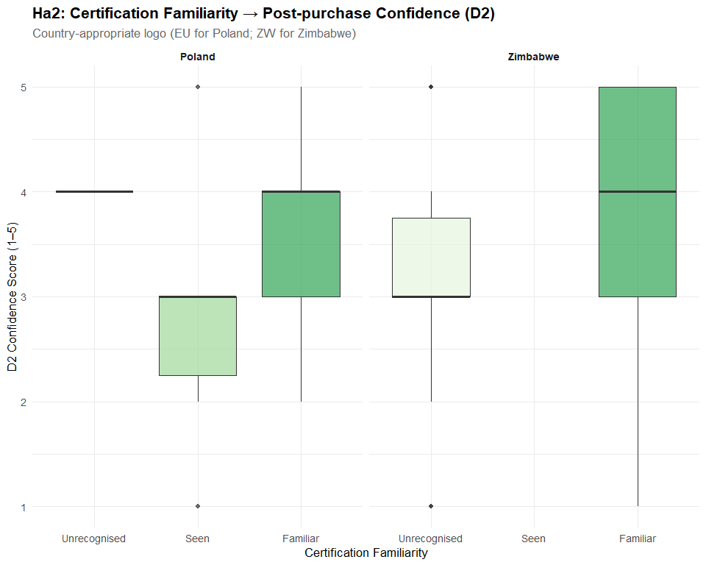
# ggsave("Ha2_cert_trust_chain.png", p_ha2, width = 10, height = 5, dpi = 300)

The Moderating Hypothesis of Price Barriers
Alternative (H₁): The positive correlation between affective sentiments and purchase intentions is weakened by price perception, particularly for consumers with lower incomes.
Null (H₀): Regardless of economic level, the link between affective emotions and purchase intentions is not weakened by price perception.
# 8. Ha3: MODERATING HYPOTHESIS OF PRICE BARRIERS
# Model: F1_intent ~ Affective × Price_Perception × Employment_Group
# Ha3 tests whether high price perception weakens the positive
# Affective → Intent link, especially among lower-SES consumers.
# Mean-centred predictors reduce multicollinearity in interaction terms.
#
ha3_data <- df |>
select(country, Affective, Affective_c, price_perception_n, price_c,
employment_n, f1_intent_n) |>
drop_na()
cat(sprintf("\nHa3 n = %d\n", nrow(ha3_data)))
Ha3 n = 189
# ── 8.2 Base 2-way moderation: Affective × Price → Intent ───────────────────
ha3_base <- lm(f1_intent_n ~ Affective_c * price_c, data = ha3_data)
rob_test(ha3_base, "Ha3 Base: Affective × Price → F1_intent")
--- Ha3 Base: Affective × Price → F1_intent ---
t test of coefficients:
Estimate Std. Error t value Pr(>|t|)
(Intercept) 4.429649 0.052879 83.7699 <2e-16 ***
Affective_c 0.081326 0.066773 1.2179 0.2248
price_c -0.043564 0.052150 -0.8354 0.4046
Affective_c:price_c -0.066206 0.065819 -1.0059 0.3158
---
Signif. codes: 0 '***' 0.001 '**' 0.01 '*' 0.05 '.' 0.1 ' ' 1
cat(sprintf(" R² = %.4f\n", summary(ha3_base)$r.squared))
R² = 0.0236
# ── 8.3 3-way moderation: adds Employment as second moderator ────────────────
ha3_3way <- lm(f1_intent_n ~ Affective_c * price_c * employment_n, data = ha3_data)
rob_test(ha3_3way, "Ha3 3-Way: Affective × Price × Employment → F1_intent")
--- Ha3 3-Way: Affective × Price × Employment → F1_intent ---
t test of coefficients:
Estimate Std. Error t value Pr(>|t|)
(Intercept) 4.463121 0.223372 19.9806 < 2e-16 ***
Affective_c -0.297389 0.256498 -1.1594 0.24781
price_c -0.550919 0.240648 -2.2893 0.02322 *
employment_n -0.015808 0.055318 -0.2858 0.77538
Affective_c:price_c -0.455915 0.212691 -2.1436 0.03340 *
Affective_c:employment_n 0.085037 0.063500 1.3392 0.18219
price_c:employment_n 0.116124 0.058129 1.9977 0.04725 *
Affective_c:price_c:employment_n 0.085281 0.055282 1.5427 0.12466
---
Signif. codes: 0 '***' 0.001 '**' 0.01 '*' 0.05 '.' 0.1 ' ' 1
cat(sprintf(" R² = %.4f | ΔR² = %.4f\n",
summary(ha3_3way)$r.squared,
summary(ha3_3way)$r.squared - summary(ha3_base)$r.squared))
R² = 0.0654 | ΔR² = 0.0419
# ── 8.4 Model comparison via ANOVA ───────────────────────────────────────────
cat("\n--- Ha3: ANOVA — does adding Employment improve fit? ---\n")
--- Ha3: ANOVA — does adding Employment improve fit? ---
print(anova(ha3_base, ha3_3way))
Analysis of Variance Table
Model 1: f1_intent_n ~ Affective_c * price_c
Model 2: f1_intent_n ~ Affective_c * price_c * employment_n
Res.Df RSS Df Sum of Sq F Pr(>F)
1 185 95.968
2 181 91.854 4 4.1146 2.027 0.09249 .
---
Signif. codes: 0 '***' 0.001 '**' 0.01 '*' 0.05 '.' 0.1 ' ' 1
# ── 8.5 Simple slopes by employment tier ─────────────────────────────────────
# Low = 1–2 (part-time / full-time employed at lower scale)
# High = 5–6 (retired / student — proxy for constrained income)
# simple_slopes <- function(emp_vals, label) {
# m <- lm(f1_intent_n ~ Affective_c * price_c,
# data = filter(ha3_data, employment_n %in% emp_vals))
# rob_test(m, paste("Simple slopes —", label))
# }
#
# simple_slopes(1:2, "Lower employment tier")
# simple_slopes(5:7, "Higher/non-employment tier")
# ── 8.6 Johnson-Neyman interval ─────────────────────────────────────────────
cat("\n--- Ha3: Johnson-Neyman — where is price moderation significant? ---\n")
--- Ha3: Johnson-Neyman — where is price moderation significant? ---
jn <- interactions::johnson_neyman(
model = ha3_base, pred = "Affective_c", modx = "price_c", alpha = 0.05
)
print(jn)
JOHNSON-NEYMAN INTERVAL
The Johnson-Neyman interval could not be found. Is the p value for your
interaction term below the specified alpha?
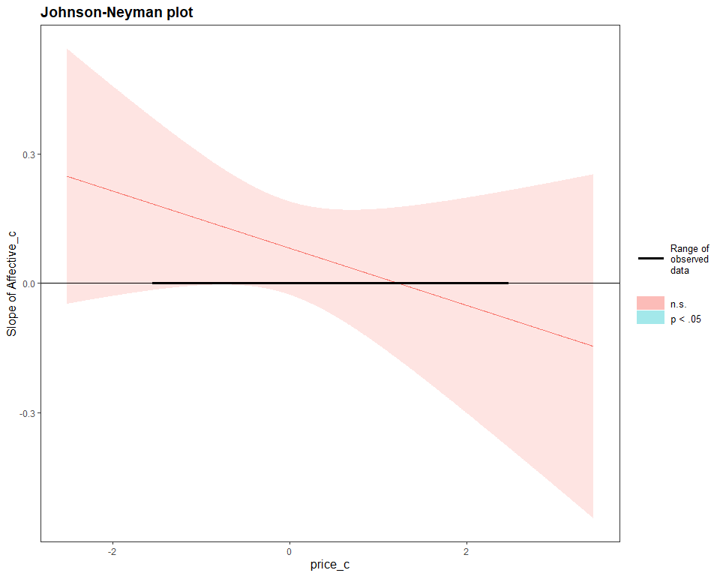
# ── 8.8 Plot ─────────────────────────────────────────────────────────────────
# interactions::interact_plot(
# ha3_3way,
# pred = Affective,
# modx = price_perception_num,
# mod2 = employment_n,
# modx.values = c(-1, 0, 1),
# x.label = "Affective Emotions (mean-centred)",
# y.label = "Purchase Intention (F1)",
# legend.main = "Price Barrier\n(±1 SD)",
# main.title = "Ha3: Affective × Price × Employment → Purchase Intention") +
# theme_study()
# ggsave("Ha3_price_moderation.png", p_ha3, width = 11, height = 6, dpi = 300)

Hypothesis of Country-Specific Demographic Drivers
Alternative (H₁): In both nations, socioeconomic position has a favorable impact on cognitive beliefs and purchase frequency, but it does so through distinct mechanisms—directly in Zimbabwe and indirectly through education and urban residency in Poland.
Null (H₀): Neither country’s cognitive views nor purchase frequency are significantly impacted by socioeconomic position.
# 9. Ha4: COUNTRY-SPECIFIC DEMOGRAPHIC DRIVERS
#
# Hypothesis:
# Zimbabwe — SES affects Cognitive Beliefs and Purchase Frequency DIRECTLY
# Poland — SES operates INDIRECTLY via Education & Urban residency → Cognitive
#
# SEP composite = mean(household_econ_n, education_n, employment_n)
# ── 9.1 Country subsets ──────────────────────────────────────────────────────
ha4_data <- df |>
select(country, SEP, household_econ_n, education_n, employment_n,
Cognitive, purchase_freq_n) |>
drop_na()
df_pol <- filter(ha4_data, country == "Poland")
df_zim <- filter(ha4_data, country == "Zimbabwe")
cat(sprintf("\nHa4: n(Poland) = %d | n(Zimbabwe) = %d\n",
nrow(df_pol), nrow(df_zim)))
Ha4: n(Poland) = 90 | n(Zimbabwe) = 82
# ── 9.2 OLS by country (baseline robustness check) ──────────────────────────
ols_pol <- lm(purchase_freq_n ~ SEP + education_n + Cognitive, data = df_pol)
ols_zim <- lm(purchase_freq_n ~ SEP + education_n + Cognitive, data = df_zim)
rob_test(ols_pol,
"Ha4 OLS — Poland: SEP + Education + Cognitive → Purchase_Freq")
--- Ha4 OLS — Poland: SEP + Education + Cognitive → Purchase_Freq ---
t test of coefficients:
Estimate Std. Error t value Pr(>|t|)
(Intercept) 2.881287 1.030488 2.7960 0.00638 **
SEP 0.563432 0.283226 1.9893 0.04984 *
education_n -0.105529 0.177436 -0.5947 0.55358
Cognitive 0.052528 0.131530 0.3994 0.69062
---
Signif. codes: 0 '***' 0.001 '**' 0.01 '*' 0.05 '.' 0.1 ' ' 1
rob_test(ols_zim,
"Ha4 OLS — Zimbabwe: SEP + Education + Cognitive → Purchase_Freq")
--- Ha4 OLS — Zimbabwe: SEP + Education + Cognitive → Purchase_Freq ---
t test of coefficients:
Estimate Std. Error t value Pr(>|t|)
(Intercept) 4.547940 1.034165 4.3977 3.421e-05 ***
SEP -0.053920 0.381699 -0.1413 0.8880
education_n 0.032054 0.328921 0.0975 0.9226
Cognitive -0.052874 0.156825 -0.3372 0.7369
---
Signif. codes: 0 '***' 0.001 '**' 0.01 '*' 0.05 '.' 0.1 ' ' 1
# ── 9.3 Chow structural-break test ──────────────────────────────────────────
ols_pool <- lm(purchase_freq_n ~ SEP + education_n + Cognitive, data = ha4_data)
rss_pool <- sum(resid(ols_pool)^2)
rss_split <- sum(resid(ols_pol)^2) + sum(resid(ols_zim)^2)
k <- length(coef(ols_pool))
n_total <- nrow(ha4_data)
chow_F <- ((rss_pool - rss_split) / k) / (rss_split / (n_total - 2 * k))
chow_p <- pf(chow_F, df1 = k, df2 = n_total - 2 * k, lower.tail = FALSE)
cat(sprintf("\n--- Chow Test: F(%d, %d) = %.4f p = %.6f ---\n",
k, n_total - 2 * k, chow_F, chow_p))
--- Chow Test: F(4, 164) = 1.5537 p = 0.189154 ---
# ── 9.4 Multi-group SEM (free vs constrained) ────────────────────────────────
# The model encodes both country pathways simultaneously.
# Poland pathway: SEP → Education → Cognitive → Purchase (indirect)
# Zimbabwe pathway: SEP → Cognitive & Purchase directly
ha4_sem_spec <- '
# Poland mechanism: SEP flows through education to cognitive beliefs
education_n ~ m_edu * SEP
# Cognitive beliefs: driven by SEP and (for Poland) education
Cognitive ~ a_sep * SEP + a_edu * education_n
# Purchase frequency: direct SEP effect + through cognition
purchase_freq_n ~ b_cog * Cognitive + d_sep * SEP
# Defined indirect effects
indirect_sep_cog := a_sep * b_cog
indirect_edu_path := m_edu * a_edu * b_cog
total_indirect := indirect_sep_cog + indirect_edu_path
total_sep_effect := d_sep + total_indirect
'
# Free model: all paths estimated separately per country
ha4_free <- sem(ha4_sem_spec, data = ha4_data,
group = "country",
estimator = "ML",
se = "bootstrap", bootstrap = 1000,
missing = "ml")
Warning: lavaan->lavParTable():
using a single label per parameter in a multiple group setting implies
imposing equality constraints across all the groups; If this is not
intended, either remove the label(s), or use a vector of labels (one for
each group); See the Multiple groups section in the man page of
model.syntax.
# Constrained model: regression paths forced equal across countries (null model)
ha4_const <- sem(ha4_sem_spec, data = ha4_data, group = "country",
group.equal = "regressions",
estimator = "ML", se = "bootstrap", bootstrap = 1000,
missing = "ml")
sem_fit_summary(ha4_free, "Ha4 Free (unconstrained) Model")
--- Ha4 Free (unconstrained) Model ---
Fit indices:
cfi tli rmsea srmr aic bic
0.991 0.984 0.038 0.064 1409.005 1462.512
cat("\n--- Ha4: Δχ² test — free vs constrained ---\n")
--- Ha4: Δχ² test — free vs constrained ---
print(lavTestLRT(ha4_free, ha4_const))
Warning: lavaan->lavTestLRT():
some models have the same degrees of freedom
Chi-Squared Difference Test
Df AIC BIC Chisq Chisq diff Df diff Pr(>Chisq)
ha4_free 7 1409 1462.5 7.8771
ha4_const 7 1409 1462.5 7.8771 0 0
# Per-country structural path estimates
pe_free <- parameterEstimates(ha4_free, boot.ci.type = "bca.simple", ci = TRUE) |>
filter(op %in% c("~", ":=")) |>
select(lhs, op, rhs, group, est, se, pvalue, ci.lower, ci.upper)
cat("\n--- Ha4: Poland paths (group = 1) ---\n")
--- Ha4: Poland paths (group = 1) ---
print(filter(pe_free, group == 1))
lhs op rhs group est se pvalue ci.lower ci.upper
1 education_n ~ SEP 1 0.908 0.076 0.000 0.748 1.048
2 Cognitive ~ SEP 1 0.015 0.174 0.929 -0.299 0.405
3 Cognitive ~ education_n 1 0.151 0.130 0.247 -0.104 0.403
4 purchase_freq_n ~ Cognitive 1 0.000 0.096 1.000 -0.192 0.184
5 purchase_freq_n ~ SEP 1 0.287 0.192 0.134 -0.125 0.625
cat("\n--- Ha4: Zimbabwe paths (group = 2) ---\n")
--- Ha4: Zimbabwe paths (group = 2) ---
print(filter(pe_free, group == 2))
lhs op rhs group est se pvalue ci.lower ci.upper
1 education_n ~ SEP 2 0.908 0.076 0.000 0.748 1.048
2 Cognitive ~ SEP 2 0.015 0.174 0.929 -0.299 0.405
3 Cognitive ~ education_n 2 0.151 0.130 0.247 -0.104 0.403
4 purchase_freq_n ~ Cognitive 2 0.000 0.096 1.000 -0.192 0.184
5 purchase_freq_n ~ SEP 2 0.287 0.192 0.134 -0.125 0.625
# ── 9.5 Country-specific mediation confirmatory tests ────────────────────────
# Poland: SEP → Education (mediator) → Cognitive → Purchase
cat("\n--- Ha4 Poland: SES → Education → Cognitive (mediation) ---\n")
--- Ha4 Poland: SES → Education → Cognitive (mediation) ---
pol_m <- lm(education_n ~ SEP, data = df_pol)
pol_y <- lm(Cognitive ~ SEP + education_n, data = df_pol)
ha4_med_pol <- run_mediation(pol_m, pol_y, treat = "SEP", mediator = "education_n",
sims = 1000)
Running nonparametric bootstrap
Causal Mediation Analysis
Nonparametric Bootstrap Confidence Intervals with the BCa Method
Estimate 95% CI Lower 95% CI Upper p-value
ACME 0.060229 -0.269756 0.369809 0.742
ADE 0.058371 -0.412672 0.524374 0.820
Total Effect 0.118600 -0.312377 0.477827 0.622
Prop. Mediated 0.507836 -3.121160 32.953989 0.800
Sample Size Used: 90
Simulations: 1000
# Zimbabwe: SEP → Cognitive (mediator) → Purchase
cat("\n--- Ha4 Zimbabwe: SES → Cognitive → Purchase (mediation) ---\n")
--- Ha4 Zimbabwe: SES → Cognitive → Purchase (mediation) ---
zim_m <- lm(Cognitive ~ SEP, data = df_zim)
zim_y <- lm(purchase_freq_n ~ SEP + Cognitive, data = df_zim)
ha4_med_zim <- run_mediation(zim_m, zim_y, treat = "SEP", mediator = "Cognitive",
sims = 1000)
Running nonparametric bootstrap
Causal Mediation Analysis
Nonparametric Bootstrap Confidence Intervals with the BCa Method
Estimate 95% CI Lower 95% CI Upper p-value
ACME -1.1360e-02 -1.8548e-01 4.3549e-02 0.746
ADE -3.0218e-02 -5.4049e-01 4.5832e-01 0.830
Total Effect -4.1578e-02 -5.4842e-01 4.6192e-01 0.802
Prop. Mediated 2.7323e-01 9.5178e+13 9.7771e+13 0.908
Sample Size Used: 82
Simulations: 1000
# ── 9.6 Decision ─────────────────────────────────────────────────────────────
lrt_result <- lavTestLRT(ha4_free, ha4_const)
Warning: lavaan->lavTestLRT():
some models have the same degrees of freedom
delta_p <- lrt_result[["Pr(>Chisq)"]][2]
cat("\n>>> Ha4 Decision:\n")
>>> Ha4 Decision:
cat(sprintf(" Chow test: F = %.4f p = %.4f → %s\n",
chow_F, chow_p,
if (chow_p < 0.05) "REJECT H\u2080 (structural break confirmed)"
else "FAIL TO REJECT H\u2080"))
Chow test: F = 1.5537 p = 0.1892 → FAIL TO REJECT H₀
# ── 9.7 Coefficient plot (Poland vs Zimbabwe) ────────────────────────────────
coef_tbl <- bind_rows(
tidy(ols_pol, conf.int = TRUE) |> mutate(Country = "Poland"),
tidy(ols_zim, conf.int = TRUE) |> mutate(Country = "Zimbabwe")
) |>
filter(term != "(Intercept)") |>
mutate(term = recode(term,
"SEP" = "SEP (composite)",
"education_n" = "Education",
"Cognitive" = "Cognitive Beliefs"
))
ggplot(coef_tbl,
aes(x = estimate, y = term, colour = Country,
xmin = conf.low, xmax = conf.high)) +
geom_vline(xintercept = 0, linetype = "dashed", colour = "grey60") +
geom_pointrange(position = position_dodge(width = 0.6),
linewidth = 0.8, size = 0.9) +
scale_colour_manual(values = COL_COUNTRY) +
labs(
title = "Ha4: Demographic Drivers of Purchase Frequency by Country",
subtitle = "OLS coefficients ± 95% CI (HC3 robust)",
x = "Coefficient estimate", y = NULL
) +
theme_study()
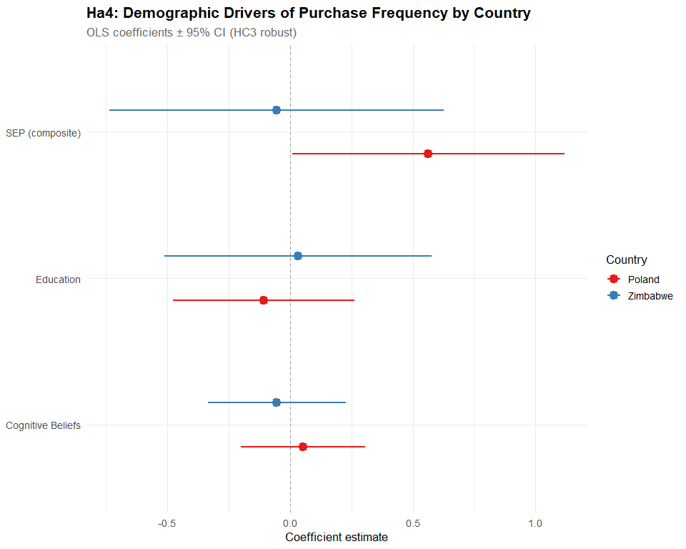
# ggsave("Ha4_country_demographic_drivers.png", p_ha4,
# width = 9, height = 5, dpi = 300)

Consolidated Models
modelsummary(
list(
# Ha1
"Aff ~ Cog" = bk2,
"PF ~ Cog + Aff" = bk3,
# Ha2
"PF ~ Cert" = bk2_ha2,
"D2 ~ Cert + PF" = bk3_ha2,
# Ha3
"Ha3 Base" = ha3_base,
"Ha3 3-Way" = ha3_3way,
# Ha4
"Ha4 Poland" = ols_pol,
"Ha4 Zimbabwe" = ols_zim
),
statistic = "({std.error}) [{conf.low}, {conf.high}]",
stars = c("*" = .10, "**" = .05, "***" = .01),
vcov = "HC3",
notes = "HC3 heteroskedasticity-robust standard errors in parentheses; 95% CIs in brackets.",
output = "Hypothesis_Results_Table.docx"
)

