Methodology

3.1 Research Design
This study adopts a quantitative comparative research design to investigate the country-specific demographic drivers influencing consumer purchase behavior and cognitive beliefs. The primary aim is to examine whether socioeconomic position (SEP) influences purchase frequency through different causal pathways across national contexts, specifically comparing Poland and Zimbabwe.
The research strategy is grounded in causal modelling and Structural Equation Modelling (SEM), supplemented with robust regression diagnostics, structural break tests, and mediation analysis. This multi-method approach enables the study to:
- Estimate direct demographic effects on purchase behavior.
- Test country-specific structural differences in behavioral pathways.
- Examine mediating mechanisms through education and cognitive beliefs.
3.2 Data Preparation and Subsample Construction
The analysis uses survey data collected from respondents drawn from two national contexts, which are Poland and Zimbabwe. To allow for cross-country comparison, the dataset was partitioned into country-specific subsets.
The following subsamples were constructed:
- Poland sample: 100 observations
- Zimbabwe sample: 100 observations
This produced a total sample size of 200 respondents.
Country subsets were created through filtering procedures to isolate respondents by national identity. This separation enabled the estimation of country-specific econometric models and facilitated multi-group structural equation modeling.
3.3 Variable Operationalization
    - Dependent Variable
The primary dependent variable in the analysis is Purchase Frequency (PF). This variable captures the frequency with which respondents purchase the product under investigation. It represents behavioral engagement and serves as the outcome variable across all regression and structural models. The principal explanatory variable is Socioeconomic Position (SEP). SEP is operationalized as a composite index constructed from three socioeconomic indicators: (1) Household economic status, (2) Educational attainment, and (3) Employment status.
This composite measure captures the respondent’s overall socioeconomic standing, which theory suggests influences both cognitive beliefs and consumer purchasing behavior.
Two mediators were included in the causal pathway analysis: Education a normalized measure capturing the respondent’s level of formal educational attainment, and Cognitive Beliefs (Cognitive) a composite scale representing consumer cognitive perceptions about the product, including knowledge, perceived value, and awareness. These mediators were included to test the hypothesis that socioeconomic position influences purchasing behavior indirectly through educational attainment and cognitive perceptions.
3.6 Structural Break Analysis: Chow Test
To determine whether the regression structure differs significantly between Poland and Zimbabwe, a Chow structural break test was conducted.
The Chow test evaluates whether two subsamples share the same regression coefficients, or whether structural differences exist between them. If the F-statistic is statistically significant, the null hypothesis of parameter stability across countries is rejected, indicating structural differences between national models. This test provides an econometric foundation for determining whether separate country models are justified.
3.7 Bootstrap Estimation
Mediation effects were estimated using 1000-2000 bootstrap simulations to produce robust confidence intervals.
Three effects were estimated:
- Average Causal Mediation Effect (ACME) – indirect effect
- Average Direct Effect (ADE) – direct effect of SEP
- Total Effect – combined direct and indirect effects
Bootstrapping is particularly appropriate for mediation analysis because indirect effects often violate normal distribution assumptions.
3.8 Structural Equation Modelling (SEM)
To investigate the causal pathways linking socioeconomic position, education, cognitive beliefs, and purchase behaviour, the study employed Structural Equation Modelling (SEM). SEM allows simultaneous estimation of multiple relationships within a system of equations, enabling the evaluation of both direct and indirect effects.

Data Analysis

Objective 1: The Theory of Cognitive-Affective Mediation
Alternative (H₁): Affective emotions are positively impacted by cognitive beliefs, which raise the frequency of purchases.
Null (H₀): Affective sentiments do not enhance the frequency of purchases, while cognitive ideas have no effect on affective feelings.
The mediation analysis does not support the Cognitive-Affective mediation hypothesis. While cognitive beliefs significantly predicted affective emotions (β = 0.65, p < 0.001), neither affective emotions (β = −0.03, p = 0.87) nor cognitive beliefs (β = 0.09, p = 0.63) significantly predicted purchase frequency. The bootstrapped indirect effect was not significant (β = −0.02, 95% CI [−0.22, 0.31]). These findings suggest that although consumers who hold stronger beliefs about the benefits of organic food experience stronger affective responses, these emotional responses do not translate into increased purchasing behaviour. This pattern reflects the well-documented attitude–behaviour gap in sustainable consumption research.

#| fig-width: 10
#| fig-height: 8
#| fig-align: "center"
# 6. Ha1: THEORY OF COGNITIVE-AFFECTIVE MEDIATION
#
# Path: Cognitive Beliefs (C1–C4)
# → Affective Emotions (D1–D4) [a-path]
# → Purchase Frequency [b-path]
# Also tests direct path Cognitive → Purchase (c'-path)
#
ha1_data <- df |>
select(country, all_of(c(cog_items, aff_items)),
Cognitive, Affective, purchase_freq_n) |>
drop_na()
cat(sprintf("\nHa1 n = %d\n", nrow(ha1_data)))
Ha1 n = 174
# ── 6.2 Baron-Kenny steps ────────────────────────────────────────────────────
# Step 1: total effect — Cognitive → Purchase
bk1 <- lm(purchase_freq_n ~ Cognitive, data = ha1_data)
rob_test(bk1, "Step 1 – Total effect: Cognitive → Purchase_Freq")
--- Step 1 – Total effect: Cognitive → Purchase_Freq ---
t test of coefficients:
Estimate Std. Error t value Pr(>|t|)
(Intercept) 4.5293546 0.3392419 13.3514 <2e-16 ***
Cognitive -0.0087274 0.0999366 -0.0873 0.9305
---
Signif. codes: 0 '***' 0.001 '**' 0.01 '*' 0.05 '.' 0.1 ' ' 1
# Step 2: a-path — Cognitive → Affective
bk2 <- lm(Affective ~ Cognitive, data = ha1_data)
rob_test(bk2, "Step 2 – a-path: Cognitive → Affective")
--- Step 2 – a-path: Cognitive → Affective ---
t test of coefficients:
Estimate Std. Error t value Pr(>|t|)
(Intercept) 1.611593 0.284094 5.6727 5.843e-08 ***
Cognitive 0.540509 0.081675 6.6178 4.451e-10 ***
---
Signif. codes: 0 '***' 0.001 '**' 0.01 '*' 0.05 '.' 0.1 ' ' 1
# Step 3: b & c' paths — Cognitive + Affective → Purchase
bk3 <- lm(purchase_freq_n ~ Cognitive + Affective, data = ha1_data)
rob_test(bk3, "Step 3 – b & c' paths: Cognitive + Affective → Purchase_Freq")
--- Step 3 – b & c' paths: Cognitive + Affective → Purchase_Freq ---
t test of coefficients:
Estimate Std. Error t value Pr(>|t|)
(Intercept) 4.5211551 0.3818610 11.8398 <2e-16 ***
Cognitive -0.0114774 0.1361009 -0.0843 0.9329
Affective 0.0050878 0.1398486 0.0364 0.9710
---
Signif. codes: 0 '***' 0.001 '**' 0.01 '*' 0.05 '.' 0.1 ' ' 1
# ── 6.3 Bootstrapped mediation ───────────────────────────────────────────────
cat("\n--- Ha1: Bootstrapped ACME / ADE / Total ---\n")
--- Ha1: Bootstrapped ACME / ADE / Total ---
ha1_med <- run_mediation(bk2, bk3, treat = "Cognitive", mediator = "Affective")
Running nonparametric bootstrap
Causal Mediation Analysis
Nonparametric Bootstrap Confidence Intervals with the BCa Method
Estimate 95% CI Lower 95% CI Upper p-value
ACME 0.0027500 -0.0942416 0.2607806 0.920
ADE -0.0114774 -0.3544605 0.1978971 0.859
Total Effect -0.0087274 -0.2054693 0.1829638 0.921
Prop. Mediated -0.3151011 -9.2329918 8.7275914 0.913
Sample Size Used: 174
Simulations: 2000
# ── 6.4 SEM with CFA measurement model ──────────────────────────────────────
# Using ML estimator (MLR available but requires FIML; drop_na used above)
ha1_sem_spec <- '
# Measurement model
Cog =~ c1_organic_belief_n + c2_pesticides_belief_n +
c3_environment_belief_n + c4_ethics_belief_n
Aff =~ d1_taste_emotion_n + d2_assurance_emotion_n +
d3_satisfaction_emotion_n + d4_health_worry_n
# Structural model
Aff ~ a * Cog
purchase_freq_n ~ b * Aff + cp * Cog
# Derived effects
indirect := a * b
total := cp + (a * b)
'
ha1_fit <- sem(ha1_sem_spec, data = ha1_data,
estimator = "ML",
se = "bootstrap",
bootstrap = 2000)
sem_fit_summary(ha1_fit, "Ha1 SEM Fit Indices")
--- Ha1 SEM Fit Indices ---
Fit indices:
cfi tli rmsea srmr aic bic
0.961 0.944 0.093 0.058 4011.902 4075.083
cat("\n--- Ha1: Structural path estimates ---\n")
--- Ha1: Structural path estimates ---
sem_paths(ha1_fit, c("a", "b", "cp", "indirect", "total"))
label est se z pvalue ci.lower ci.upper std.all
1 a 0.647 0.092 7.018 0.000 0.461 0.819 0.710
2 b -0.033 0.205 -0.161 0.872 -0.351 0.430 -0.025
3 cp 0.091 0.190 0.479 0.632 -0.356 0.368 0.076
4 indirect -0.021 0.145 -0.147 0.883 -0.222 0.310 -0.018
5 total 0.070 0.101 0.688 0.492 -0.129 0.260 0.058
decide_indirect(ha1_fit, "indirect")
>>> Decision (indirect): est = -0.021 [-0.222, 0.310] p = 0.8828
FAIL TO REJECT H₀ — CI includes zero.
# ── 6.5 SEM path diagram ─────────────────────────────────────────────────────
semPlot::semPaths(ha1_fit, what = "std", layout = "circle",
edge.label.cex = 1.2, nCharNodes = 0,
sizeMan = 8, sizeLat = 10, title = FALSE)
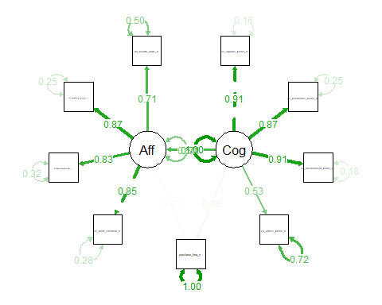
# ── 6.6 Modification indices (for model improvement guidance) ────────────────
cat("\n--- Ha1: Top 10 modification indices ---\n")
--- Ha1: Top 10 modification indices ---
modificationIndices(ha1_fit, sort. = TRUE, maximum.number = 10) |>
print()
lhs op rhs mi epc sepc.lv
68 d4_health_worry_n ~~ purchase_freq_n 12.262 -0.287 -0.287
58 c4_ethics_belief_n ~~ purchase_freq_n 11.383 -0.380 -0.380
55 c4_ethics_belief_n ~~ d2_assurance_emotion_n 7.790 -0.162 -0.162
48 c3_environment_belief_n ~~ c4_ethics_belief_n 7.457 0.153 0.153
32 Aff =~ c4_ethics_belief_n 6.067 -0.371 -0.358
33 c1_organic_belief_n ~~ c2_pesticides_belief_n 5.642 0.117 0.117
41 c2_pesticides_belief_n ~~ c3_environment_belief_n 5.127 -0.111 -0.111
46 c2_pesticides_belief_n ~~ d4_health_worry_n 4.539 0.089 0.089
27 Cog =~ d3_satisfaction_emotion_n 4.413 0.166 0.176
59 d1_taste_emotion_n ~~ d2_assurance_emotion_n 4.185 0.093 0.093
sepc.all sepc.nox
68 -0.282 -0.282
58 -0.260 -0.260
55 -0.240 -0.240
48 0.265 0.265
32 -0.261 -0.261
33 0.436 0.436
41 -0.388 -0.388
46 0.191 0.191
27 0.169 0.169
59 0.263 0.263
# ── 6.7 Plot ─────────────────────────────────────────────────────────────────
ggplot(ha1_data, aes(x = Cognitive, y = purchase_freq_n)) +
geom_jitter(aes(colour = Affective), alpha = 0.55, width = 0.04, height = 0.15) +
geom_smooth(method = "lm", se = TRUE, colour = "#2171b5", linewidth = 1) +
scale_colour_gradient(low = "#deebf7", high = "#08306b", name = "Affective\nScore") +
facet_wrap(~country) +
labs(
title = "Ha1: Cognitive Beliefs → Purchase Frequency",
subtitle = "Point shade = Affective Emotion composite; line = OLS fit",
x = "Cognitive Beliefs (mean score)", y = "Purchase Frequency (1–6)"
) +
theme_study()
`geom_smooth()` using formula = 'y ~ x'
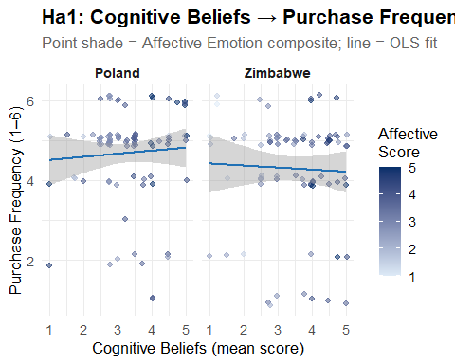

Objective 2: The Theory of the Certification Trust Chain
Alternative (H₁): Purchase likelihood is increased by certification familiarity, which then boosts confidence after the purchase.
Null (``H₀``): buy experience does not boost post-buy confidence, and certification familiarity does not raise purchase likelihood.
The results do not support the Certification Trust Chain hypothesis. Certification familiarity did not significantly predict purchase frequency (β = 0.09, p = 0.70) or post-purchase confidence (β = 0.18, p = 0.25). Furthermore, purchase frequency did not significantly predict confidence in certification labels (β = −0.02, p = 0.78). The bootstrapped indirect effect was not significant (β = −0.002, 95% CI [−0.04, 0.05]). These findings suggest that familiarity with organic certification labels does not translate into increased purchasing behaviour or stronger confidence responses among consumers. This may indicate limited awareness, trust, or relevance of certification systems in the studied consumer context.
# 7. Ha2: THEORY OF THE CERTIFICATION TRUST CHAIN
#
# Path: Cert Familiarity (C5/C6)
# → Purchase Frequency (B4) [a-path]
# → Post-purchase Confidence (D2) [b-path]
# D2 ("I feel confident when I see an organic cert label") is the
# closest available proxy for post-purchase confidence.
# ── 7.1 Complete-case dataset for Ha2 ────────────────────────────────────────
ha2_data <- df |>
select(country, cert_eu_n, cert_zw_n, cert_familiar_n,
cert_imp_n, d2_assurance_emotion_n, purchase_freq_n, f1_intent_n) |>
drop_na()
cat(sprintf("\nHa2 n = %d\n", nrow(ha2_data)))
Ha2 n = 123
# ── 7.2 Baron-Kenny steps ────────────────────────────────────────────────────
# Step 1: total effect — Cert familiarity → Post-purchase confidence (D2)
bk1_ha2 <- lm(d2_assurance_emotion_n ~ cert_eu_n + cert_zw_n, data = ha2_data)
rob_test(bk1_ha2, "Step 1 – Total: Cert familiarity → D2 confidence")
--- Step 1 – Total: Cert familiarity → D2 confidence ---
t test of coefficients:
Estimate Std. Error t value Pr(>|t|)
(Intercept) 2.877665 0.270398 10.6423 <2e-16 ***
cert_eu_n 0.182629 0.159092 1.1479 0.2533
cert_zw_n 0.076818 0.156765 0.4900 0.6250
---
Signif. codes: 0 '***' 0.001 '**' 0.01 '*' 0.05 '.' 0.1 ' ' 1
# Step 2: a-path — Cert familiarity → Purchase frequency
bk2_ha2 <- lm(purchase_freq_n ~ cert_eu_n + cert_zw_n, data = ha2_data)
rob_test(bk2_ha2, "Step 2 – a-path: Cert familiarity → Purchase_Freq")
--- Step 2 – a-path: Cert familiarity → Purchase_Freq ---
t test of coefficients:
Estimate Std. Error t value Pr(>|t|)
(Intercept) 3.683186 0.410964 8.9623 5.032e-15 ***
cert_eu_n 0.092541 0.255600 0.3621 0.7179
cert_zw_n 0.305020 0.233583 1.3058 0.1941
---
Signif. codes: 0 '***' 0.001 '**' 0.01 '*' 0.05 '.' 0.1 ' ' 1
# Step 3: b & c' paths — Cert + Purchase → D2
bk3_ha2 <- lm(d2_assurance_emotion_n ~ cert_eu_n + cert_zw_n + purchase_freq_n,
data = ha2_data)
rob_test(bk3_ha2, "Step 3 – b & c' paths: Cert + Purchase → D2 confidence")
--- Step 3 – b & c' paths: Cert + Purchase → D2 confidence ---
t test of coefficients:
Estimate Std. Error t value Pr(>|t|)
(Intercept) 2.959146 0.361244 8.1916 3.338e-13 ***
cert_eu_n 0.184677 0.161008 1.1470 0.2537
cert_zw_n 0.083566 0.161859 0.5163 0.6066
purchase_freq_n -0.022122 0.081122 -0.2727 0.7856
---
Signif. codes: 0 '***' 0.001 '**' 0.01 '*' 0.05 '.' 0.1 ' ' 1
# ── 7.3 Sobel test ───────────────────────────────────────────────────────────
# Using EU logo as primary treatment (ZW logo held in model as covariate)
sobel_test(bk2_ha2, treat = "cert_eu_n", model_b = bk3_ha2, mediator = "purchase_freq_n")
--- Sobel Test ---
Z = -0.2521 | p = 0.8009
# ── 7.4 Bootstrapped mediation ───────────────────────────────────────────────
cat("\n--- Ha2: Bootstrapped ACME / ADE / Total (EU logo → Purchase → Confidence) ---\n")
--- Ha2: Bootstrapped ACME / ADE / Total (EU logo → Purchase → Confidence) ---
ha2_med <- run_mediation(bk2_ha2, bk3_ha2,
treat = "cert_eu_n",
mediator = "purchase_freq_n")
Running nonparametric bootstrap
Causal Mediation Analysis
Nonparametric Bootstrap Confidence Intervals with the BCa Method
Estimate 95% CI Lower 95% CI Upper p-value
ACME -0.0020472 -0.0401223 0.0490119 0.986
ADE 0.1846767 -0.1149741 0.5221787 0.241
Total Effect 0.1826295 -0.1116704 0.5271670 0.228
Prop. Mediated -0.0112097 -0.1954039 3.0938622 0.995
Sample Size Used: 123
Simulations: 2000
# ── 7.5 SEM ──────────────────────────────────────────────────────────────────
ha2_sem_spec <- '
purchase_freq_n ~ a2 * cert_eu_n + a2z * cert_zw_n
d2_assurance_emotion_n ~ b2 * purchase_freq_n +
c2 * cert_eu_n + c2z * cert_zw_n
indirect2 := a2 * b2
total2 := c2 + (a2 * b2)
'
ha2_fit <- sem(ha2_sem_spec, data = ha2_data,
estimator = "ML", se = "bootstrap", bootstrap = 2000)
sem_fit_summary(ha2_fit, "Ha2 SEM Fit Indices")
--- Ha2 SEM Fit Indices ---
Fit indices:
cfi tli rmsea srmr aic bic
1.000 1.000 0.000 0.000 729.175 748.860
cat("\n--- Ha2: Path estimates ---\n")
--- Ha2: Path estimates ---
sem_paths(ha2_fit, c("a2", "b2", "c2", "indirect2", "total2"))
label est se z pvalue ci.lower ci.upper std.all
1 a2 0.093 0.237 0.391 0.696 -0.360 0.580 0.066
2 b2 -0.022 0.078 -0.285 0.776 -0.181 0.130 -0.027
3 c2 0.185 0.162 1.142 0.253 -0.133 0.499 0.160
4 indirect2 -0.002 0.020 -0.102 0.919 -0.068 0.022 -0.002
5 total2 0.183 0.161 1.135 0.256 -0.139 0.497 0.158
decide_indirect(ha2_fit, "indirect2")
>>> Decision (indirect2): est = -0.002 [-0.068, 0.022] p = 0.9190
FAIL TO REJECT H₀ — CI includes zero.
# ── 7.6 Plot ─────────────────────────────────────────────────────────────────
ha2_data |>
mutate(cert_label = factor(cert_familiar_n,
levels = 1:3,
labels = c("Unrecognised", "Seen", "Familiar"))) |>
ggplot(aes(x = cert_label, y = d2_assurance_emotion_n)) +
geom_boxplot(aes(fill = cert_label), alpha = 0.7, show.legend = FALSE) +
scale_fill_brewer(palette = "Greens") +
facet_wrap(~country) +
labs(
title = "Ha2: Certification Familiarity → Post-purchase Confidence (D2)",
subtitle = "Country-appropriate logo (EU for Poland; ZW for Zimbabwe)",
x = "Certification Familiarity", y = "D2 Confidence Score (1–5)"
) +
theme_study()
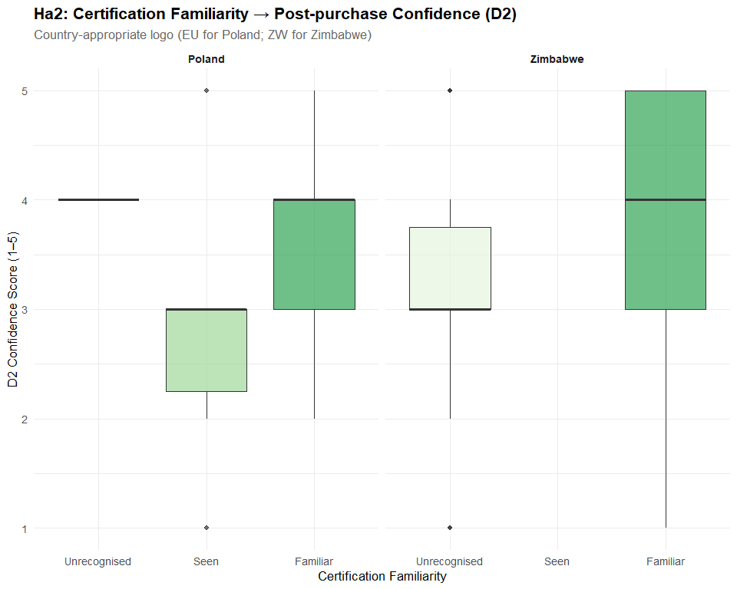
# ggsave("Ha2_cert_trust_chain.png", p_ha2, width = 10, height = 5, dpi = 300)

Objective 3: The Moderating Hypothesis of Price Barriers
Alternative (H₁): The positive correlation between affective sentiments and purchase intentions is weakened by price perception, particularly for consumers with lower incomes.
Null (H₀): Regardless of economic level, the link between affective emotions and purchase intentions is not weakened by price perception.
The moderation analysis provides partial support for the Price Barrier Hypothesis. While affective emotions alone did not significantly predict purchase intention, price perception significantly reduced purchase intention (β = −0.55, p = 0.023). Furthermore, the interaction between affective emotions and price perception was significant (β = −0.46, p = 0.033), indicating that higher perceived prices weaken the influence of positive emotions on purchase intentions. However, the three-way interaction including employment status was not statistically significant (p = 0.125), suggesting that this moderating effect does not differ significantly across socioeconomic groups.
# 8. Ha3: MODERATING HYPOTHESIS OF PRICE BARRIERS
# Model: F1_intent ~ Affective × Price_Perception × Employment_Group
# Ha3 tests whether high price perception weakens the positive
# Affective → Intent link, especially among lower-SES consumers.
# Mean-centred predictors reduce multicollinearity in interaction terms.
#
ha3_data <- df |>
select(country, Affective, Affective_c, price_perception_n, price_c,
employment_n, f1_intent_n) |>
drop_na()
cat(sprintf("\nHa3 n = %d\n", nrow(ha3_data)))
Ha3 n = 189
# ── 8.2 Base 2-way moderation: Affective × Price → Intent ───────────────────
ha3_base <- lm(f1_intent_n ~ Affective_c * price_c, data = ha3_data)
rob_test(ha3_base, "Ha3 Base: Affective × Price → F1_intent")
--- Ha3 Base: Affective × Price → F1_intent ---
t test of coefficients:
Estimate Std. Error t value Pr(>|t|)
(Intercept) 4.429649 0.052879 83.7699 <2e-16 ***
Affective_c 0.081326 0.066773 1.2179 0.2248
price_c -0.043564 0.052150 -0.8354 0.4046
Affective_c:price_c -0.066206 0.065819 -1.0059 0.3158
---
Signif. codes: 0 '***' 0.001 '**' 0.01 '*' 0.05 '.' 0.1 ' ' 1
cat(sprintf(" R² = %.4f\n", summary(ha3_base)$r.squared))
R² = 0.0236
# ── 8.3 3-way moderation: adds Employment as second moderator ────────────────
ha3_3way <- lm(f1_intent_n ~ Affective_c * price_c * employment_n, data = ha3_data)
rob_test(ha3_3way, "Ha3 3-Way: Affective × Price × Employment → F1_intent")
--- Ha3 3-Way: Affective × Price × Employment → F1_intent ---
t test of coefficients:
Estimate Std. Error t value Pr(>|t|)
(Intercept) 4.463121 0.223372 19.9806 < 2e-16 ***
Affective_c -0.297389 0.256498 -1.1594 0.24781
price_c -0.550919 0.240648 -2.2893 0.02322 *
employment_n -0.015808 0.055318 -0.2858 0.77538
Affective_c:price_c -0.455915 0.212691 -2.1436 0.03340 *
Affective_c:employment_n 0.085037 0.063500 1.3392 0.18219
price_c:employment_n 0.116124 0.058129 1.9977 0.04725 *
Affective_c:price_c:employment_n 0.085281 0.055282 1.5427 0.12466
---
Signif. codes: 0 '***' 0.001 '**' 0.01 '*' 0.05 '.' 0.1 ' ' 1
cat(sprintf(" R² = %.4f | ΔR² = %.4f\n",
summary(ha3_3way)$r.squared,
summary(ha3_3way)$r.squared - summary(ha3_base)$r.squared))
R² = 0.0654 | ΔR² = 0.0419
# ── 8.4 Model comparison via ANOVA ───────────────────────────────────────────
cat("\n--- Ha3: ANOVA — does adding Employment improve fit? ---\n")
--- Ha3: ANOVA — does adding Employment improve fit? ---
print(anova(ha3_base, ha3_3way))
Analysis of Variance Table
Model 1: f1_intent_n ~ Affective_c * price_c
Model 2: f1_intent_n ~ Affective_c * price_c * employment_n
Res.Df RSS Df Sum of Sq F Pr(>F)
1 185 95.968
2 181 91.854 4 4.1146 2.027 0.09249 .
---
Signif. codes: 0 '***' 0.001 '**' 0.01 '*' 0.05 '.' 0.1 ' ' 1
# ── 8.5 Simple slopes by employment tier ─────────────────────────────────────
# Low = 1–2 (part-time / full-time employed at lower scale)
# High = 5–6 (retired / student — proxy for constrained income)
# simple_slopes <- function(emp_vals, label) {
# m <- lm(f1_intent_n ~ Affective_c * price_c,
# data = filter(ha3_data, employment_n %in% emp_vals))
# rob_test(m, paste("Simple slopes —", label))
# }
#
# simple_slopes(1:2, "Lower employment tier")
# simple_slopes(5:7, "Higher/non-employment tier")
# ── 8.6 Johnson-Neyman interval ─────────────────────────────────────────────
cat("\n--- Ha3: Johnson-Neyman — where is price moderation significant? ---\n")
--- Ha3: Johnson-Neyman — where is price moderation significant? ---
jn <- interactions::johnson_neyman(
model = ha3_base, pred = "Affective_c", modx = "price_c", alpha = 0.05
)
print(jn)
JOHNSON-NEYMAN INTERVAL
The Johnson-Neyman interval could not be found. Is the p value for your
interaction term below the specified alpha?
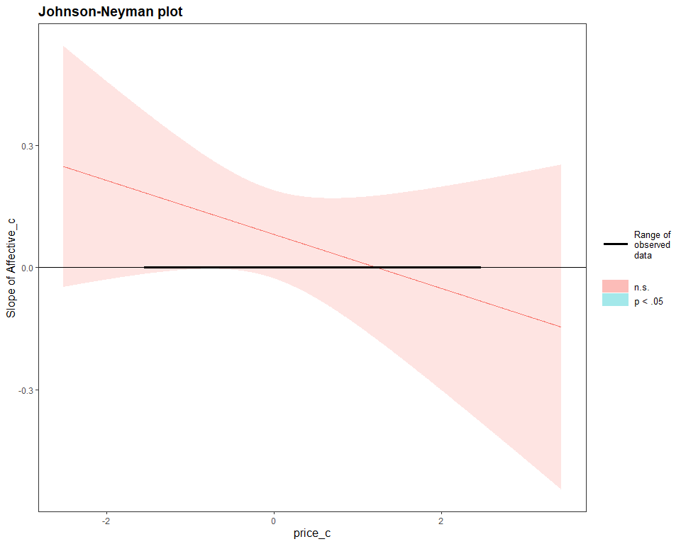

Objective 4: Hypothesis of Country-Specific Demographic Drivers
Alternative (H₁): In both nations, socioeconomic position has a favorable impact on cognitive beliefs and purchase frequency, but it does so through distinct mechanisms—directly in Zimbabwe and indirectly through education and urban residency in Poland.
Null (H₀): Neither country’s cognitive views nor purchase frequency are significantly impacted by socioeconomic position.
The analysis does not support the hypothesis of country-specific demographic drivers. While socioeconomic position significantly predicted education in both Poland and Zimbabwe (β = 0.91, p < 0.001), it did not significantly predict cognitive beliefs or purchase frequency. Furthermore, the Chow structural break test did not indicate significant differences between the two national models (F = 1.55, p = 0.189). Mediation analyses also revealed no significant indirect pathways through education or cognitive beliefs. These results suggest that socioeconomic position does not play a decisive role in shaping organic food beliefs or purchasing behaviour in the sampled populations.
# 9. Ha4: COUNTRY-SPECIFIC DEMOGRAPHIC DRIVERS
#
# Hypothesis:
# Zimbabwe — SES affects Cognitive Beliefs and Purchase Frequency DIRECTLY
# Poland — SES operates INDIRECTLY via Education & Urban residency → Cognitive
#
# SEP composite = mean(household_econ_n, education_n, employment_n)
# ── 9.1 Country subsets ──────────────────────────────────────────────────────
ha4_data <- df |>
select(country, SEP, household_econ_n, education_n, employment_n,
Cognitive, purchase_freq_n) |>
drop_na()
df_pol <- filter(ha4_data, country == "Poland")
df_zim <- filter(ha4_data, country == "Zimbabwe")
cat(sprintf("\nHa4: n(Poland) = %d | n(Zimbabwe) = %d\n",
nrow(df_pol), nrow(df_zim)))
Ha4: n(Poland) = 90 | n(Zimbabwe) = 82
# ── 9.2 OLS by country (baseline robustness check) ──────────────────────────
ols_pol <- lm(purchase_freq_n ~ SEP + education_n + Cognitive, data = df_pol)
ols_zim <- lm(purchase_freq_n ~ SEP + education_n + Cognitive, data = df_zim)
rob_test(ols_pol,
"Ha4 OLS — Poland: SEP + Education + Cognitive → Purchase_Freq")
--- Ha4 OLS — Poland: SEP + Education + Cognitive → Purchase_Freq ---
t test of coefficients:
Estimate Std. Error t value Pr(>|t|)
(Intercept) 2.881287 1.030488 2.7960 0.00638 **
SEP 0.563432 0.283226 1.9893 0.04984 *
education_n -0.105529 0.177436 -0.5947 0.55358
Cognitive 0.052528 0.131530 0.3994 0.69062
---
Signif. codes: 0 '***' 0.001 '**' 0.01 '*' 0.05 '.' 0.1 ' ' 1
rob_test(ols_zim,
"Ha4 OLS — Zimbabwe: SEP + Education + Cognitive → Purchase_Freq")
--- Ha4 OLS — Zimbabwe: SEP + Education + Cognitive → Purchase_Freq ---
t test of coefficients:
Estimate Std. Error t value Pr(>|t|)
(Intercept) 4.547940 1.034165 4.3977 3.421e-05 ***
SEP -0.053920 0.381699 -0.1413 0.8880
education_n 0.032054 0.328921 0.0975 0.9226
Cognitive -0.052874 0.156825 -0.3372 0.7369
---
Signif. codes: 0 '***' 0.001 '**' 0.01 '*' 0.05 '.' 0.1 ' ' 1
# ── 9.3 Chow structural-break test ──────────────────────────────────────────
ols_pool <- lm(purchase_freq_n ~ SEP + education_n + Cognitive, data = ha4_data)
rss_pool <- sum(resid(ols_pool)^2)
rss_split <- sum(resid(ols_pol)^2) + sum(resid(ols_zim)^2)
k <- length(coef(ols_pool))
n_total <- nrow(ha4_data)
chow_F <- ((rss_pool - rss_split) / k) / (rss_split / (n_total - 2 * k))
chow_p <- pf(chow_F, df1 = k, df2 = n_total - 2 * k, lower.tail = FALSE)
cat(sprintf("\n--- Chow Test: F(%d, %d) = %.4f p = %.6f ---\n",
k, n_total - 2 * k, chow_F, chow_p))
--- Chow Test: F(4, 164) = 1.5537 p = 0.189154 ---
# ── 9.4 Multi-group SEM (free vs constrained) ────────────────────────────────
# The model encodes both country pathways simultaneously.
# Poland pathway: SEP → Education → Cognitive → Purchase (indirect)
# Zimbabwe pathway: SEP → Cognitive & Purchase directly
ha4_sem_spec <- '
# Poland mechanism: SEP flows through education to cognitive beliefs
education_n ~ m_edu * SEP
# Cognitive beliefs: driven by SEP and (for Poland) education
Cognitive ~ a_sep * SEP + a_edu * education_n
# Purchase frequency: direct SEP effect + through cognition
purchase_freq_n ~ b_cog * Cognitive + d_sep * SEP
# Defined indirect effects
indirect_sep_cog := a_sep * b_cog
indirect_edu_path := m_edu * a_edu * b_cog
total_indirect := indirect_sep_cog + indirect_edu_path
total_sep_effect := d_sep + total_indirect
'
# Free model: all paths estimated separately per country
ha4_free <- sem(ha4_sem_spec, data = ha4_data,
group = "country",
estimator = "ML",
se = "bootstrap", bootstrap = 1000,
missing = "ml")
Warning: lavaan->lavParTable():
using a single label per parameter in a multiple group setting implies
imposing equality constraints across all the groups; If this is not
intended, either remove the label(s), or use a vector of labels (one for
each group); See the Multiple groups section in the man page of
model.syntax.
# Constrained model: regression paths forced equal across countries (null model)
ha4_const <- sem(ha4_sem_spec, data = ha4_data, group = "country",
group.equal = "regressions",
estimator = "ML", se = "bootstrap", bootstrap = 1000,
missing = "ml")
sem_fit_summary(ha4_free, "Ha4 Free (unconstrained) Model")
--- Ha4 Free (unconstrained) Model ---
Fit indices:
cfi tli rmsea srmr aic bic
0.991 0.984 0.038 0.064 1409.005 1462.512
cat("\n--- Ha4: Δχ² test — free vs constrained ---\n")
--- Ha4: Δχ² test — free vs constrained ---
print(lavTestLRT(ha4_free, ha4_const))
Warning: lavaan->lavTestLRT():
some models have the same degrees of freedom
Chi-Squared Difference Test
Df AIC BIC Chisq Chisq diff Df diff Pr(>Chisq)
ha4_free 7 1409 1462.5 7.8771
ha4_const 7 1409 1462.5 7.8771 0 0
# Per-country structural path estimates
pe_free <- parameterEstimates(ha4_free, boot.ci.type = "bca.simple", ci = TRUE) |>
filter(op %in% c("~", ":=")) |>
select(lhs, op, rhs, group, est, se, pvalue, ci.lower, ci.upper)
cat("\n--- Ha4: Poland paths (group = 1) ---\n")
--- Ha4: Poland paths (group = 1) ---
print(filter(pe_free, group == 1))
lhs op rhs group est se pvalue ci.lower ci.upper
1 education_n ~ SEP 1 0.908 0.076 0.000 0.748 1.048
2 Cognitive ~ SEP 1 0.015 0.174 0.929 -0.299 0.405
3 Cognitive ~ education_n 1 0.151 0.130 0.247 -0.104 0.403
4 purchase_freq_n ~ Cognitive 1 0.000 0.096 1.000 -0.192 0.184
5 purchase_freq_n ~ SEP 1 0.287 0.192 0.134 -0.125 0.625
cat("\n--- Ha4: Zimbabwe paths (group = 2) ---\n")
--- Ha4: Zimbabwe paths (group = 2) ---
print(filter(pe_free, group == 2))
lhs op rhs group est se pvalue ci.lower ci.upper
1 education_n ~ SEP 2 0.908 0.076 0.000 0.748 1.048
2 Cognitive ~ SEP 2 0.015 0.174 0.929 -0.299 0.405
3 Cognitive ~ education_n 2 0.151 0.130 0.247 -0.104 0.403
4 purchase_freq_n ~ Cognitive 2 0.000 0.096 1.000 -0.192 0.184
5 purchase_freq_n ~ SEP 2 0.287 0.192 0.134 -0.125 0.625
# ── 9.5 Country-specific mediation confirmatory tests ────────────────────────
# Poland: SEP → Education (mediator) → Cognitive → Purchase
cat("\n--- Ha4 Poland: SES → Education → Cognitive (mediation) ---\n")
--- Ha4 Poland: SES → Education → Cognitive (mediation) ---
pol_m <- lm(education_n ~ SEP, data = df_pol)
pol_y <- lm(Cognitive ~ SEP + education_n, data = df_pol)
ha4_med_pol <- run_mediation(pol_m, pol_y, treat = "SEP", mediator = "education_n",
sims = 1000)
Running nonparametric bootstrap
Causal Mediation Analysis
Nonparametric Bootstrap Confidence Intervals with the BCa Method
Estimate 95% CI Lower 95% CI Upper p-value
ACME 0.060229 -0.269756 0.369809 0.742
ADE 0.058371 -0.412672 0.524374 0.820
Total Effect 0.118600 -0.312377 0.477827 0.622
Prop. Mediated 0.507836 -3.121160 32.953989 0.800
Sample Size Used: 90
Simulations: 1000
# Zimbabwe: SEP → Cognitive (mediator) → Purchase
cat("\n--- Ha4 Zimbabwe: SES → Cognitive → Purchase (mediation) ---\n")
--- Ha4 Zimbabwe: SES → Cognitive → Purchase (mediation) ---
zim_m <- lm(Cognitive ~ SEP, data = df_zim)
zim_y <- lm(purchase_freq_n ~ SEP + Cognitive, data = df_zim)
ha4_med_zim <- run_mediation(zim_m, zim_y, treat = "SEP", mediator = "Cognitive",
sims = 1000)
Running nonparametric bootstrap
Causal Mediation Analysis
Nonparametric Bootstrap Confidence Intervals with the BCa Method
Estimate 95% CI Lower 95% CI Upper p-value
ACME -1.1360e-02 -1.8548e-01 4.3549e-02 0.746
ADE -3.0218e-02 -5.4049e-01 4.5832e-01 0.830
Total Effect -4.1578e-02 -5.4842e-01 4.6192e-01 0.802
Prop. Mediated 2.7323e-01 9.5178e+13 9.7771e+13 0.908
Sample Size Used: 82
Simulations: 1000
# ── 9.6 Decision ─────────────────────────────────────────────────────────────
lrt_result <- lavTestLRT(ha4_free, ha4_const)
Warning: lavaan->lavTestLRT():
some models have the same degrees of freedom
delta_p <- lrt_result[["Pr(>Chisq)"]][2]
cat("\n>>> Ha4 Decision:\n")
>>> Ha4 Decision:
cat(sprintf(" Chow test: F = %.4f p = %.4f → %s\n",
chow_F, chow_p,
if (chow_p < 0.05) "REJECT H\u2080 (structural break confirmed)"
else "FAIL TO REJECT H\u2080"))
Chow test: F = 1.5537 p = 0.1892 → FAIL TO REJECT H₀
# ── 9.7 Coefficient plot (Poland vs Zimbabwe) ────────────────────────────────
coef_tbl <- bind_rows(
tidy(ols_pol, conf.int = TRUE) |> mutate(Country = "Poland"),
tidy(ols_zim, conf.int = TRUE) |> mutate(Country = "Zimbabwe")
) |>
filter(term != "(Intercept)") |>
mutate(term = recode(term,
"SEP" = "SEP (composite)",
"education_n" = "Education",
"Cognitive" = "Cognitive Beliefs"
))
ggplot(coef_tbl,
aes(x = estimate, y = term, colour = Country,
xmin = conf.low, xmax = conf.high)) +
geom_vline(xintercept = 0, linetype = "dashed", colour = "grey60") +
geom_pointrange(position = position_dodge(width = 0.6),
linewidth = 0.8, size = 0.9) +
scale_colour_manual(values = COL_COUNTRY) +
labs(
title = "Ha4: Demographic Drivers of Purchase Frequency by Country",
subtitle = "OLS coefficients ± 95% CI (HC3 robust)",
x = "Coefficient estimate", y = NULL
) +
theme_study()
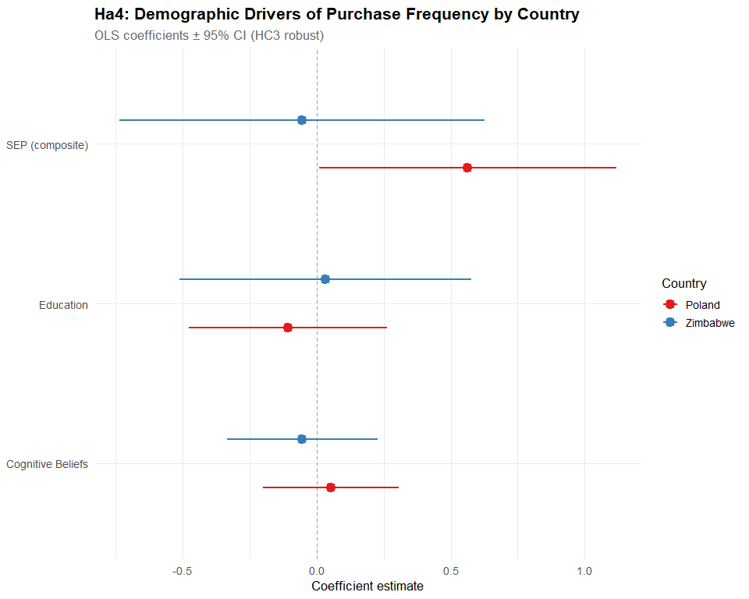

Appendix

LIKERTS <- c(
# English
"strongly disagree" = 1L,
"disagree" = 2L,
"neutral" = 3L,
"agree" = 4L,
"strongly agree" = 5L,
# Polish variants
"zdecydowanie nie zgadzam się" = 1L,
"zdecydowanie się nie zgadzam" = 1L,
"nie zgadzam się" = 2L,
"raczej się nie zgadzam" = 2L,
"neutralny" = 3L,
"nie mam opinii" = 3L,
"ani się zgadzam, ani się nie zgadzam" = 3L,
"ani się zgadzam, ani nie" = 3L,
"zgadzam się" = 4L,
"raczej się zgadzam" = 4L,
"zdecydowanie zgadzam się" = 5L,
"zdecydowanie się zgadzam" = 5L
)
# ── 1.2 Purchase frequency ───────────────────────────────────────────────────
PURCHASE_FREQ <- c(
"less than once a month / occasionally" = 1L,
"rzadziej niż raz w miesiącu / sporadycznie" = 1L,
"once a month" = 2L,
"raz w miesiącu" = 2L,
"2–3 times a month" = 3L,
"2-3 razy w miesiącu" = 3L,
"once a week" = 4L,
"raz w tygodniu" = 4L,
"a few times a week" = 5L,
"kilka razy w tygodniu" = 5L,
"daily" = 6L,
"codziennie" = 6L
)
# ── 1.3 Purchase intention (F1) ──────────────────────────────────────────────
F1_INTENT <- c(
"no, i intend to decrease it" = 1L,
"i'm not sure" = 2L,
"no, i will maintain the same level" = 3L,
"pozostanie na tym samym poziomie" = 3L,
"yes, slightly" = 4L,
"raczej tak" = 4L,
"yes, significantly" = 5L,
"zdecydowanie tak" = 5L
)
# ── 1.4 Certification logo familiarity ───────────────────────────────────────
CERT_FAM <- c(
"i do not recognize this logo at all" = 1L,
"nie, nie rozpoznaję tego logo" = 1L,
"i have seen this logo but don't know much about it" = 2L,
"widziałem/am je, ale niewiele o nim wiem" = 2L,
"i recognize this logo and know what it means" = 3L,
"znam to logo i wiem, co oznacza" = 3L
)
# ── 1.5 Certification / logo importance ─────────────────────────────────────
CERT_IMP <- c(
"not important - it doesn't affect my purchasing decisions" = 1L,
"nieważne - nie wpływa na moje decyzje zakupowe" = 1L,
"i don't pay attention to certification logos" = 1L,
"nie zwracam uwagi na logo certyfikatów" = 1L,
"somewhat important - it influences my choice, but i sometimes buy uncertified" = 2L,
"dość ważne - wpływa na mój wybór, ale czasem kupuję produkty niecertyfikowane" = 2L,
"very important - i look for it and usually only buy certified products" = 3L
)
# ── 1.6 Household economic situation (SES proxy) ────────────────────────────
HOUSEHOLD_ECON <- c(
"poor" = 1L,
"fair/average" = 2L,
"przeciętna" = 2L,
"good" = 3L,
"dobra" = 3L,
"bardzo dobra" = 4L,
"very good" = 4L
)
# ── 1.7 Employment status ────────────────────────────────────────────────────
# EMPLOYMENT <- c(
# "Employed full-time" = 1L,
# "Praca na pełny etat" = 1L,
# "Employed part-time" = 2L,
# "Praca w niepełnym wymiarze czasu" = 2L,
# "self-employed / Freelancer" = 3L,
# "Unemployed" = 4L,
# "Bezrobotna/ny" = 4L,
# "Retired" = 5L,
# "Student" = 6L,
# "Homemaker" = 7L,
# "Osoba prowadząca gospodarstwo domowe" = 7L
# )
EMPLOYMENT <- c(
"employed full-time" = 5L,
"praca na pełny etat" = 5L,
"self-employed / freelancer" = 5L,
"employed part-time" = 4L,
"praca w niepełnym wymiarze czasu" = 4L,
"student" = 3L,
"homemaker" = 3L,
"osoba prowadząca gospodarstwo domowe" = 3L,
"retired" = 3L,
"unemployed" = 2L,
"bezrobotna/ny" = 2L,
"NA" = 1L
)
# ── 1.8 Education ────────────────────────────────────────────────────────────
EDUCATION <- c(
# Level 1: Primary
"primary or Less" = 1L,
"podstawowe" = 1L,
# Level 2: Vocational (Lower Secondary/Trade)
"szkoła zawodowa" = 2L,
# Level 3: Secondary / High School
"secondary/high school" = 3L,
"średnie / liceum / technikum" = 3L,
"technical/vocational training" = 3L, # Technikum is often here
"college" = 3L,
# Level 4: Bachelor's / Engineer
"bachelor's degree" = 4L,
"wykształcenie wyższe (licencjat/inżynier)" = 4L,
# Level 5: Master's or PhD
"master's degree or higher" = 5L,
"postgraduate Degree (masters, phd)" = 5L,
"doctorate" = 5L,
"wykształcenie wyższe (magister lub wyższe)" = 5L,
"magister lub wyższy" = 5L
)
# ── 1.9 Colour palette (reused in all plots) ─────────────────────────────────
COL_COUNTRY <- c("Poland" = "#e41a1c", "Zimbabwe" = "#377eb8")
# ── 2.1 Read raw Excel ───────────────────────────────────────────────────────
# Update the path to point to your local copy of the Excel file.
raw <- readxl::read_excel(
"data/Consumer Behavior towards Organic Food Comparative Study_ Poland vs Zimbabwe (Responses) (2) (1).xlsx"
)
# ── 2.2 Bilingual column coalescing ─────────────────────────────────────────
# For each construct the survey has parallel English + Polish columns.
# coalesce() picks the first non-NA value, so bilingual responses map
# to a single canonical column.
coalesce_map <- list(
consent = c("Do you agree to participate in this study after reading the information above?", "Czy po zapoznaniu się z powyższymi informacjami wyraża Pan/Pani zgodę na udział w tym badaniu?"),
purchased_last_12m = c("A1. Have you purchased or consumed any organic food products in the last 12 months?", " A1. Czy w ciągu ostatnich 12 miesięcy kupował (a) Pan/Pani lub spożywał(a) produkty ekologiczne? "),
age = c("A2. Age:", "A2. Wiek:"),
gender = c("A3. Gender", "A3. Płeć:"),
education = c("A4. Highest Educational Level Completed:", "A4. Najwyższy ukończony poziom wykształcenia:"),
household_econ = c("A5. How would you describe the economic situation of your household?", "A5. Jak ocenia Pani/Pan sytuację ekonomiczną swojego gospodarstwa domowego?"),
employment = c("A6. Current Employment Status:", "A6. Obecny status zatrudnienia:"),
country = c("A7. Country of Residence:", "A7. Kraj zamieszkania:"),
awareness_duration = c("B1. How long have you been aware of organic food products?", "B1. Od jakiego czasu zna Pan/i produkty żywności ekologicznej?"),
pct_income_food = c("B2. Approximately what percentage of your total monthly household income is spent on food?", "B2. Jaki procent swojego całkowitego miesięcznego dochodu gospodarstwa domowego przeznacza Pan/i średnio na żywność?"),
pct_budget_organic = c("B3. Of your total food budget, what percentage is typically spent on organic products?", "B3. Jaki procent swojego budżetu przeznaczonego na żywność wydaje Pan/i średnio na produkty ekologiczne?"),
purchase_frequency = c("B4. How often do you typically purchase organic food?", "B4. Jak często kupuje Pan/i żywność ekologiczną?"),
area_population = c("B5. What is the population size of your area of residence?", "B5. Jaka jest wielkość populacji Pana/i miejsca zamieszkania?"),
buy_where = c("B6. Where do you most often buy organic food? (Select all that apply)", "B6. Gdzie najczęściej kupuje Pan/i żywność ekologiczną? (Można wybrać kilka odpowiedzi)"),
buy_for_whom = c("B7. For whom do you primarily buy organic food? (Select all that apply)", "B7. Dla kogo głównie kupuje Pan/i żywność ekologiczną? (Można wybrać kilka odpowiedzi)"),
identify_method = c("B8. What is your primary method for identifying organic products?", "B8. Jaka jest Pana/i główna metoda identyfikacji produktów ekologicznych? (Proszę wybrać jedną odpowiedź)"),
c1_organic_belief = c("Part 1: Your Beliefs About Organic Food\r\nPlease indicate your level of agreement with the following statements based on your beliefs. [C1. Organic food is healthier than conventional food.]", "Część 1: Przekonania na temat żywności ekologicznej\r\nProszę wskazać stopień zgodności z poniższymi stwierdzeniami, opierając się na swoich przekonaniach. [C1. Żywność ekologiczna jest zdrowsza niż konwencjonalna.]"),
c2_pesticides_belief = c("Part 1: Your Beliefs About Organic Food\r\nPlease indicate your level of agreement with the following statements based on your beliefs. [C2. Avoiding pesticides and harmful chemicals is a major advantage of organic food.]", "Część 1: Przekonania na temat żywności ekologicznej\r\nProszę wskazać stopień zgodności z poniższymi stwierdzeniami, opierając się na swoich przekonaniach. [C2. Unikanie pestycydów i szkodliwych chemikaliów jest główną zaletą żywności ekologicznej.]"),
c3_environment_belief = c("Part 1: Your Beliefs About Organic Food\r\nPlease indicate your level of agreement with the following statements based on your beliefs. [C3. Organic farming is better for the environment.]", "Część 1: Przekonania na temat żywności ekologicznej\r\nProszę wskazać stopień zgodności z poniższymi stwierdzeniami, opierając się na swoich przekonaniach. [C3. Rolnictwo ekologiczne jest lepsze dla środowiska]"),
c4_ethics_belief = c("Part 1: Your Beliefs About Organic Food\r\nPlease indicate your level of agreement with the following statements based on your beliefs. [C4. Organic farming ensures better ethical treatment of animals.]",
"Część 1: Przekonania na temat żywności ekologicznej\r\nProszę wskazać stopień zgodności z poniższymi stwierdzeniami, opierając się na swoich przekonaniach. [C4. Rolnictwo ekologiczne zapewnia bardziej etyczne traktowanie zwierząt.]"),
cert_eu = c("C5. EU Organic Logo (Used in Poland and the EU)\r\nHow familiar are you with this logo?", "Proszę zapoznać się z poniższymi logo certyfikatów ekologicznych i odpowiedzieć na pytania.\r\nPICTURE OF EU ORGANIC LOGO\r\nrozpoznaje Pan/i powyższe logo ekologiczne UE?"),
cert_zw = c("C6. Zimbabwe Organic Certification Logo\r\nHow familiar are you with this logo?", "C6. Czy rozpoznaje Pan/i powyższe logo certyfikacji ekologicznej Zimbabwe?"),
cert_importance = c("C7. How important is seeing an official organic certification logo when you shop?", "C7. Jak ważne jest dla Pana/Pani oficjalne logo certyfikatu ekologicznego podczas zakupów?"),
d1_taste_emotion = c("Please indicate your level of agreement with the following statements based on your feelings. [D1. Organic food tastes better than non-organic food.]", "Proszę określić w jakim stopniu zgadza się Pan(i) z poniższymi stwierdzeniami, w oparciu o swoje odczucia. [D1. Żywność ekologiczna smakuje lepiej niż konwencjonalna.]"),
d2_assurance_emotion = c("Please indicate your level of agreement with the following statements based on your feelings. [D2. I feel confident and reassured when I see an official organic certification label.]","Proszę określić w jakim stopniu zgadza się Pan(i) z poniższymi stwierdzeniami, w oparciu o swoje odczucia. [D2. Czuję się pewnie i spokojnie, gdy widzę logo ekożywności]"),
d3_satisfaction_emotion = c("Please indicate your level of agreement with the following statements based on your feelings. [D3. Buying organic food gives me a sense of personal satisfaction.]", "Proszę określić w jakim stopniu zgadza się Pan(i) z poniższymi stwierdzeniami, w oparciu o swoje odczucia. [D3. Zakup żywności ekologicznej daje mi poczucie osobistej satysfakcji.]"),
d4_health_worry = c("Please indicate your level of agreement with the following statements based on your feelings. [D4. I feel worried about the long-term health effects of consuming conventional food.]", "Proszę określić w jakim stopniu zgadza się Pan(i) z poniższymi stwierdzeniami, w oparciu o swoje odczucia. [D4. Czuję się zaniepokojony/a długoterminowymi skutkami zdrowotnymi spożywania konwencjonalnej żywności.]"),
d5_local_trust = c("Please indicate your level of agreement with the following statements based on your feelings. [D5. I feel a stronger sense of trust when I buy from a local farmer I know than from a certified supermarket product.]", "Proszę określić w jakim stopniu zgadza się Pan(i) z poniższymi stwierdzeniami, w oparciu o swoje odczucia. [D5. Czuję większe zaufanie, gdy kupuję od znanego mi lokalnego rolnika niż do certyfikowanego produktu z supermarketu.]"),
price_perception = c("E3. \u201cOrganic food is too expensive for my budget.\u201d", "E3. Żywność ekologiczna jest dla mnie zbyt droga."),
f1_intent = c("F1. Compared to now, do you intend to increase your consumption of organic food in the future?", "F1. W porównaniu do obecnej sytuacji, czy zamierza Pan/Pani zwiększyć w przyszłości spożycie żywności ekologicznej?\n"))
# Apply coalescing: for each canonical name, combine bilingual columns
for (canonical in names(coalesce_map)) {
cols <- coalesce_map[[canonical]]
valid_cols <- cols[cols %in% names(raw)] # only keep cols that exist
raw[[canonical]] <- do.call(coalesce, raw[valid_cols])
}

Data Cleaning
# ── 3.1 Helper: apply a named lookup vector (case-insensitive) ───────────────
# This replaces all repeated instances of map[str_to_lower(str_trim(x))].
apply_map <- function(x, lookup) {
lookup[str_to_lower(str_trim(as.character(x)))]
}
# ── 3.2 Filter to Poland & Zimbabwe; standardise country labels ──────────────
df <- raw |>
clean_names() |>
filter(country %in% c("Poland", "Polska", "Zimbabwe")) |>
mutate(
country = if_else(country == "Polska", "Poland", country),
country = factor(country, levels = c("Poland", "Zimbabwe"))
)
# ── 3.3 Balanced sample: 100 per country ─────────────────────────────────────
set.seed(123)
df <- df |>
group_by(country) |>
slice_sample(n = 100) |>
ungroup()
cat(sprintf("\nSample: %d total (%s)\n", nrow(df),
paste(names(table(df$country)), table(df$country), sep = " = ",
collapse = " | ")))
Sample: 200 total (Poland = 100 | Zimbabwe = 100)
# ── 3.4 Apply all lookup mappings ────────────────────────────────────────────
# Likert items: C1–C4 (cognitive beliefs) and D1–D5 (affective emotions)
cognitive_cols <- c("c1_organic_belief", "c2_pesticides_belief",
"c3_environment_belief", "c4_ethics_belief")
affective_cols <- c("d1_taste_emotion", "d2_assurance_emotion",
"d3_satisfaction_emotion", "d4_health_worry")
# Note: d5_local_trust excluded from composite (cross-loads; see MIs below)
likert_cols <- c(cognitive_cols, affective_cols)
df <- df |>
# Likert items → numeric
mutate(across(all_of(likert_cols),
~ as.integer(apply_map(.x, LIKERTS)),
.names = "{.col}_n")) |>
# Purchase frequency → ordinal 1–6
mutate(
purchase_frequency_clean = str_replace_all(
str_to_lower(str_trim(purchase_frequency)), "–", "-"),
purchase_freq_n = as.integer(PURCHASE_FREQ[purchase_frequency_clean])
) |>
# F1 purchase intention → ordinal 1–5
mutate(
f1_intent_n = as.integer(
apply_map(f1_intent, F1_INTENT))
) |>
# Certification familiarity (EU & ZW) → 1–3
mutate(
cert_eu_n = as.integer(apply_map(cert_eu, CERT_FAM)),
cert_zw_n = as.integer(apply_map(cert_zw, CERT_FAM)),
cert_imp_n = as.integer(apply_map(cert_importance, CERT_IMP))
) |>
# Socioeconomic proxies
mutate(
household_econ_n = as.integer(apply_map(household_econ, HOUSEHOLD_ECON)),
employment_n = as.integer(apply_map(employment, EMPLOYMENT)),
education_n = as.integer(apply_map(education, EDUCATION))
) |>
# Price perception: take first response only (handles multi-select edge cases)
mutate(
price_perception_n = as.integer(
apply_map(str_extract(price_perception, "^[^,]+"), LIKERTS))
) |>
# Country-appropriate certification familiarity
mutate(
cert_familiar_n = if_else(country == "Poland", cert_eu_n, cert_zw_n)
) |>
# Gender harmonisation
mutate(
gender_clean = case_when(
str_to_lower(gender) %in% c("female", "kobieta", "woman") ~ "Female",
str_to_lower(gender) %in% c("male", "mężczyzna", "man") ~ "Male",
TRUE ~ "Other / Prefer not to say"
)
)
# ── 4.1 Cognitive and Affective composites ───────────────────────────────────
cog_items <- paste0(cognitive_cols, "_n") # c1…c4_n
aff_items <- paste0(affective_cols, "_n") # d1…d4_n (d5 excluded)
df <- df |>
mutate(
Cognitive = rowMeans(across(all_of(cog_items)), na.rm = TRUE),
Affective = rowMeans(across(all_of(aff_items)), na.rm = TRUE),
# Mean-centred versions for moderation models (Ha3) to reduce multicollinearity
Affective_c = Affective - mean(Affective, na.rm = TRUE),
price_c = price_perception_n - mean(price_perception_n, na.rm = TRUE),
# SEP composite (Ha4): mean of household SES, education, employment
SEP = rowMeans(across(c(household_econ_n, education_n, employment_n)), na.rm = TRUE)
)
# ── 4.2 Internal consistency ─────────────────────────────────────────────────
cat("\n--- Reliability ---\n")
--- Reliability ---
cat("Cognitive Beliefs (C1–C4): α =",
round(psych::alpha(df[, cog_items], na.rm = TRUE)$total$raw_alpha, 3), "\n")
Warning in response.frequencies(x, max = max): response.frequency has been
deprecated and replaced with responseFrequecy. Please fix your call
Cognitive Beliefs (C1–C4): α = 0.872
cat("Affective Emotions (D1–D4): α =",
round(psych::alpha(df[, aff_items], na.rm = TRUE)$total$raw_alpha, 3), "\n")
Warning in response.frequencies(x, max = max): response.frequency has been
deprecated and replaced with responseFrequecy. Please fix your call
Affective Emotions (D1–D4): α = 0.892
# ── 4.3 Descriptive overview ─────────────────────────────────────────────────
cat("\n--- Descriptive Statistics ---\n")
--- Descriptive Statistics ---
df |>
select(Cognitive, Affective, purchase_freq_n, cert_familiar_n,
price_perception_n, f1_intent_n, SEP, education_n) |>
psych::describe() |>
round(2) |>
print()
vars n mean sd median trimmed mad min max range skew
Cognitive 1 195 3.36 1.05 3.50 3.41 1.11 1.00 5.00 4 -0.32
Affective 2 200 3.39 0.98 3.50 3.43 1.11 1.00 5.00 4 -0.34
purchase_freq_n 3 174 4.50 1.27 5.00 4.69 0.00 1.00 6.00 5 -1.43
cert_familiar_n 4 160 2.39 0.87 3.00 2.48 0.00 1.00 3.00 2 -0.83
price_perception_n 5 196 2.54 1.00 2.00 2.51 1.48 1.00 5.00 4 0.31
f1_intent_n 6 189 4.43 0.72 5.00 4.54 0.00 1.00 5.00 4 -1.52
SEP 7 200 3.50 0.59 3.67 3.51 0.49 1.67 4.67 3 -0.29
education_n 8 197 3.62 0.82 3.00 3.57 0.00 1.00 5.00 4 0.23
kurtosis se
Cognitive -0.53 0.08
Affective -0.31 0.07
purchase_freq_n 1.44 0.10
cert_familiar_n -1.17 0.07
price_perception_n -0.42 0.07
f1_intent_n 3.73 0.05
SEP -0.24 0.04
education_n -0.17 0.06
# ── 5.1 Pretty section header ────────────────────────────────────────────────
section <- function(title) {
bar <- strrep("=", 60)
cat("\n\n", bar, "\n ", title, "\n", bar, "\n", sep = "")
}
# ── 5.2 Robust coefficient test with HC3 SEs ─────────────────────────────────
# Returns the coeftest object AND prints it with a label.
rob_test <- function(model, label = "") {
if (nchar(label) > 0) cat("\n---", label, "---\n")
ct <- coeftest(model, vcov = vcovHC(model, "HC3"))
print(ct)
invisible(ct)
}
# ── 5.3 Bootstrapped mediation (wrapper to keep sims consistent) ─────────────
run_mediation <- function(model_m, model_y, treat, mediator,
sims = 2000, seed = 2025) {
set.seed(seed)
med_out <- mediate(
model.m = model_m,
model.y = model_y,
treat = treat,
mediator = mediator,
boot = TRUE,
sims = sims,
boot.ci.type = "bca"
)
print(summary(med_out))
invisible(med_out)
}
# ── 5.4 Sobel Z-test ─────────────────────────────────────────────────────────
sobel_test <- function(model_a, treat, model_b, mediator) {
a <- coef(model_a)[treat]
b <- coef(model_b)[mediator]
se_a <- sqrt(vcov(model_a)[treat, treat])
se_b <- sqrt(vcov(model_b)[mediator, mediator])
z <- (a * b) / sqrt(b^2 * se_a^2 + a^2 * se_b^2)
p <- 2 * pnorm(-abs(z))
cat(sprintf("\n--- Sobel Test ---\n Z = %.4f | p = %.4f\n", z, p))
invisible(list(z = z, p = p))
}
# ── 5.5 SEM fit summary ──────────────────────────────────────────────────────
sem_fit_summary <- function(fit, label = "") {
if (nchar(label) > 0) cat("\n---", label, "---\n")
cat("Fit indices:\n")
print(fitMeasures(fit, c("cfi", "tli", "rmsea", "srmr", "aic", "bic")))
invisible(fit)
}
# ── 5.6 Extract & print labelled SEM paths ───────────────────────────────────
sem_paths <- function(fit, labels) {
parameterEstimates(fit, boot.ci.type = "bca.simple", ci = TRUE,
standardized = TRUE) |>
filter(label %in% labels) |>
select(label, est, se, z, pvalue, ci.lower, ci.upper, std.all) |>
print()
}
# ── 5.7 H₀ rejection decision for indirect effect ───────────────────────────
decide_indirect <- function(fit, label = "indirect") {
est <- parameterEstimates(fit, boot.ci.type = "bca.simple", ci = TRUE) |>
filter(.data$label == !!label)
cat(sprintf("\n>>> Decision (%s): est = %.3f [%.3f, %.3f] p = %.4f\n",
label, est$est, est$ci.lower, est$ci.upper, est$pvalue))
if (est$ci.lower > 0 | est$ci.upper < 0) {
cat(" REJECT H\u2080 \u2014 CI excludes zero.\n")
} else {
cat(" FAIL TO REJECT H\u2080 \u2014 CI includes zero.\n")
}
invisible(est)
}
# ── 5.8 Consistent ggplot2 theme ─────────────────────────────────────────────
theme_study <- function(base_size = 13) {
theme_minimal(base_size = base_size) +
theme(plot.title = element_text(face = "bold"),
plot.subtitle = element_text(colour = "grey40"),
strip.text = element_text(face = "bold"))
}

