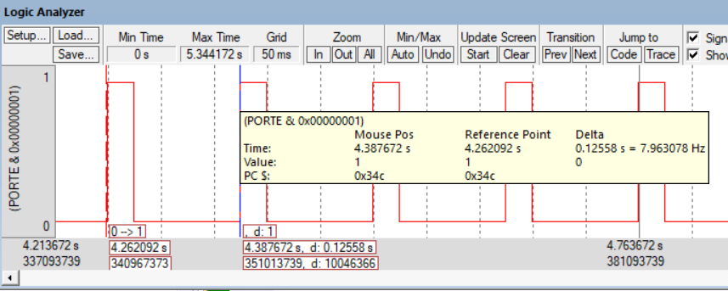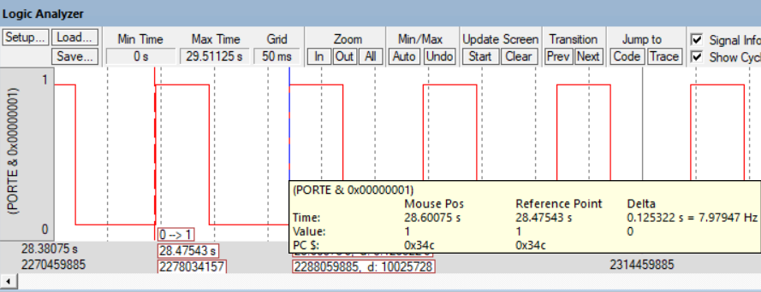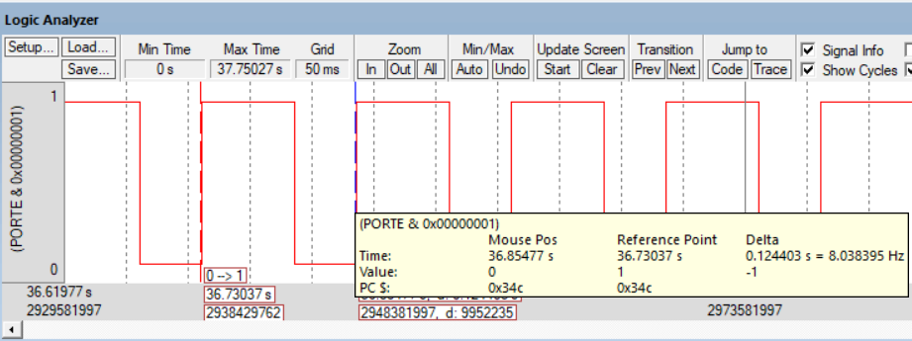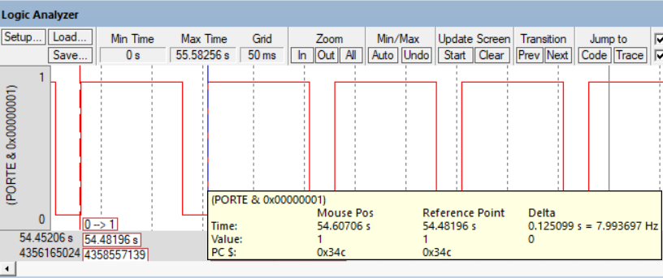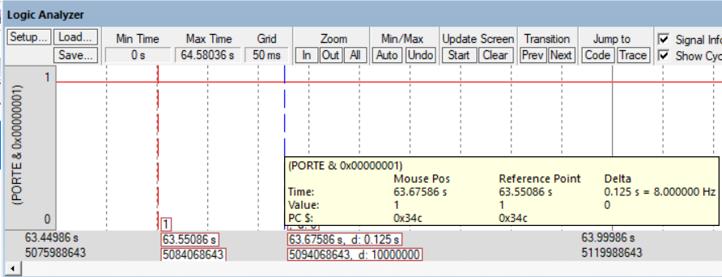

|  |  |  |  |
| --- | --- | --- | --- |
| Parameter | Value | Units | Conditions |
| Resistance of the    10kΩ resistor, R1 | 9.79k | ohms | with power off and    disconnected from circuit  (measured with ohmmeter) |
| Supply Voltage, V+3.3 | 3.29 | volts | Powered  (measured with voltmeter) |
| Input Voltage, VPE1 | 0 | volts | Powered, but  with switch not pressed  (measured with voltmeter) |
| Resistor current | 0 | mA | Powered, but switch not pressed      I=VPE1/R1 (calculated and  measured with an ammeter) |
| Input Voltage, VPE1 | 3.28 | volts | Powered and  with switch pressed  (measured with voltmeter) |
| Resistor current | .329 | mA | Powered and switch pressed      I=VPE1/R1 (calculated and  measured with an ammeter) |

*Table 3.1. Switch measurements.*

|  |  |  |  |  |
| --- | --- | --- | --- | --- |
| Row | Parameter | Value | Units | Conditions |
| 1 | Resistance of the    220Ω resistor, R19 | 215 | ohms | with power off and    disconnected from circuit  (measured with ohmmeter) |
| 2 | +5 V power supply  *V+5* | 5.01 | volts | (measured with voltmeter relative to ground, *notice that the +5V power is not exactly +5 volts*) |
| 3 | TM4C123 Output, *VPE0*    input to 7406 | .09 | volts | with **PE0** = 0  (measured with voltmeter relative to ground) |
| 4 | 7406 Output, *Vk-*    LED k- | 3.37 | volts | with **PE0** = 0  (measured with voltmeter relative to ground) |
| 5 | LED a+, *Va+*  Bottom side of R19 (anode side of LED) | 4.98 | volts | with **PE0** = 0  (measured with voltmeter relative to ground) |
| 6 | LED voltage | 1.61 | volts | calculated as *Va+*- *Vk-* |
| 7 | LED current | -7.3 | mA | calculated as (*V+5*- *Va+*)/R19  and  measured with an ammeter |
| 8 | TM4C123 Output, *VPE0*    input to 7406 | 3.29 | volts | with **PE0** = 1  (measured with voltmeter relative to ground) |
| 9 | 7406 Output, *Vk-*    LED k- | .13 | volts | with **PE0** = 1  (measured with voltmeter relative to ground) |
| 10 | LED a+, *Va+*  Bottom side of R19 (anode side of LED) | 2.25 | volts | with **PE0** = 1  (measured with voltmeter relative to ground) |
| 11 | LED voltage | 1.61 | volts | calculated as *Va+*- *Vk-* |
| 12 | LED current | -7.3 | mA | calculated as (*V+5*- *Va+*)/R19  and  measured with an ammeter |
| -11 |