CS-3120

Dr. Feng Jiang

Xiaosong Wang

May, 14, 2020

Final Project Report

For my final project, I decided to use the Convolutional Neural Network (CNN) which we learnt recently to solve the same problem for Homework 3. The homework 3 is about to distinguish different pictures between cats, dogs, and pandas.

The main reason that I decided to do this topic is I want to know how well or bad the CNN performance compares to the K Nearest Neighbor. I get part of code from the previous homework which is the function to read csv file. And I also got code from the demo code introduced in class. Before starting the project, I watched all the online course videos with Liang Chen, and we studied and did research about CNN. I chose the topic and he did the main part of the program. I also modified the code, such as tried different hyper parameters to see how they can affect the result.

The library and packages that we used are sklearn, opencv, keras, matplotlib, numpy.

After reading the file, I first separated the input file into 70% of training dataset, and 30 % of testing dataset. Compares with the demo code sharing in class, we are treating the colorful picture for this project.



Then I passed in the data to the CNN model by 64 filters with 5\*5 matrix.

First, I tried 5 epochs.

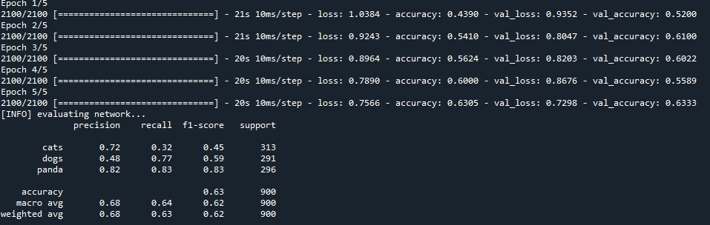

The accuracy for cats is about 70%, dogs is about 50%, panda is about 80%

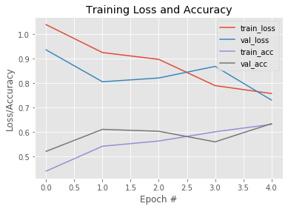

Then, I tried 30 epochs to see if there are any difference.

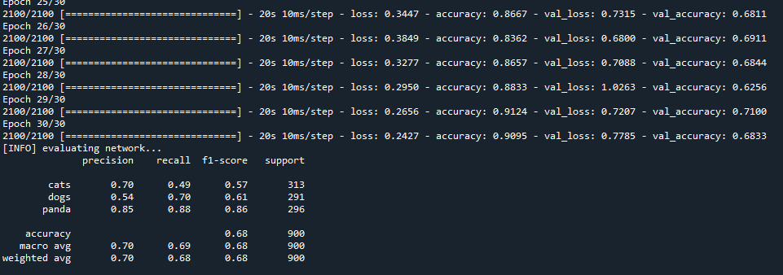

The accuracy for cats is about 70%, dogs is about 55%, panda is about 85%

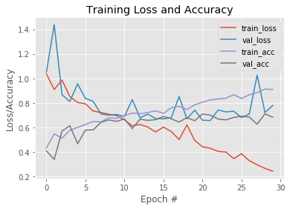

We can see from the comparison that increase the number of epoch do improve the performance, but not a lot. One interesting thing is we can find out that the accuracy of panda is obviously higher than the accuracy of cats and dogs. I guess it might cause by the color of different animals. Cats and Dogs have a lot of breed which have different colors and looks, but panda looks all similar and unique.

What the same is between 5 epochs and 30 epochs is since the epochs goes up, the loss is decrease and the accuracy is getting higher.

Finally, I went back to homework 3 and run the program with the same input again.

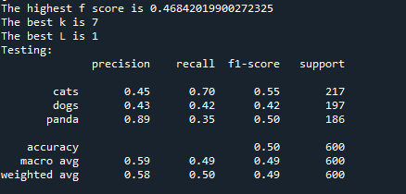

Compare with the result of CNN, whether it is 5 epochs or 30 epochs, CNN performed much better than the KNN.