CS-3120

Dr. Feng Jiang

Xiaosong Wang

Mar 3, 2020

HW2 Report

Testing the model

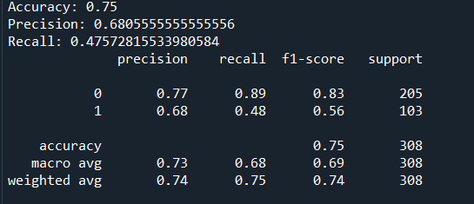

Confusion Matrix

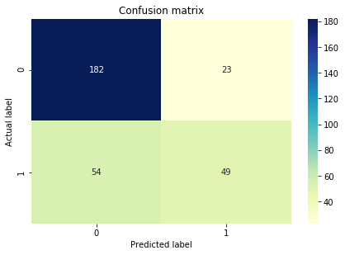

ROC Curve

