Assignment-5 Report

Xiaosong Wang

The Dimension of Weight Matrix 1 and Weight Matrix 2

The Dimension of Weight Matrix 1 is 3 by 6

Because the input matrix is 4 by 3. We have 6 nodes in the hidden layer, so the dimension of hidden layer matrix is 4 by 6. Thus, the weight matrix 1 has to be 3 by 6.

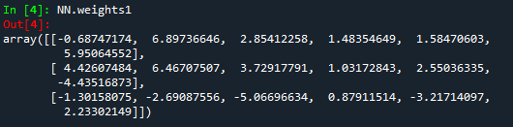

The Dimension of Weight Matrix 2 is 6 by 2

The dimension of hidden layer matrix is 4 by 6, and the output layer matrix is 4 by 2. Thus the weight matrix 2 is 6 by 2.

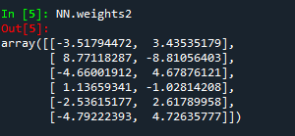

Testing

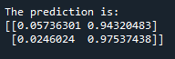

The prediction for X1 = [0, 0, 0] is the first row y1 = [0.05736301, 0.94320483] approximately [0, 1]

The prediction for X1 = [1, 1, 1] is the first row y1 = [0.0246024, 0.97537438] approximately [0, 1]