CAB330
Assessment 1 Report
Group Report: Tasks 1–4
Individual Reports: Task 5

Group Number | Student ID | Full Name
Group 52 | 11761776 | Yuta Matsuzaki
 | [Insert] | [Insert]
 | [Insert] | [Insert]

Around 21 pages for the group part
Task 1 – Data Selection and Distribution

1.1 Distribution of the Target Variable
The original hotel booking dataset contained 16611 observations. The target variable is_canceled indicates whether a booking was cancelled (Y) or not cancelled (N). The distribution of the target variable is shown in Table 1.
Is_canceled | Observations | Proportion
Y | 6931 | 41.7%
N | 9680 | 58.3%
The dataset contained 16611 observations. 41.7% were cancelled, and 58.3% were not cancelled

1.2 Variable Selection, Roles and Data Types
booking_id was removed because it is a unique identifier and does not describe booking characteristics. company was removed because approximately 95.5% of its data was missing, making reliable imputation difficult. total_guests was also removed because EDA confirmed it represents the same value as adults + children + babies; thus, we kept adults, children, and babies and removed total_guests. The individual guest variables were retained because they provide additional information about each booking's composition. The remaining variables were retained because they describe booking characteristics, including arrival date, duration of stay, guest composition, booking history, room type, price, and special requests. These variables could represent useful information for predicting cancellations.

1.3 Data Quality and Preprocessing
The dataset was first examined by describing it (Figure 1). It revealed that negative values exist in lead_time and zero values in total_guests. These values are erroneous because lead_time represents the number of days from the booking to the arrival, and total_guests should be more than 1 for a valid stay.
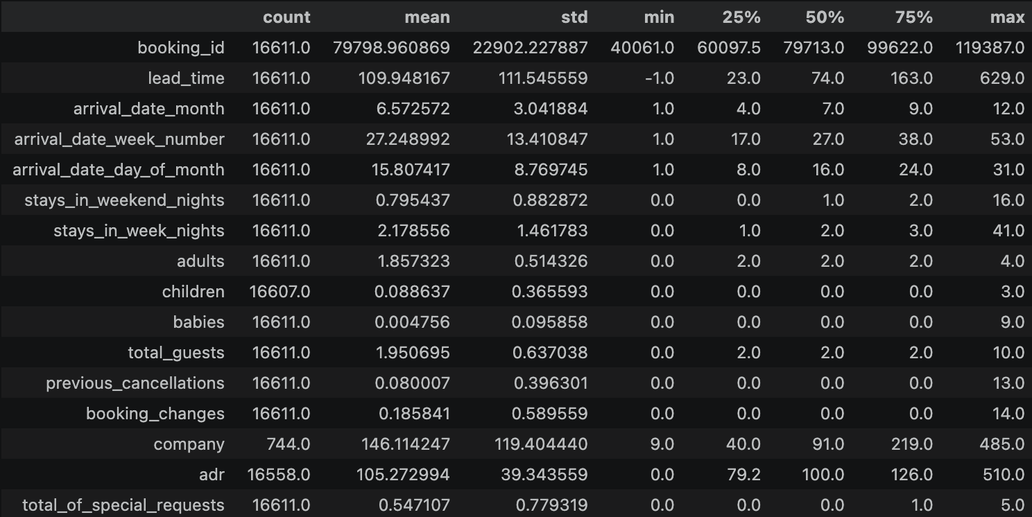
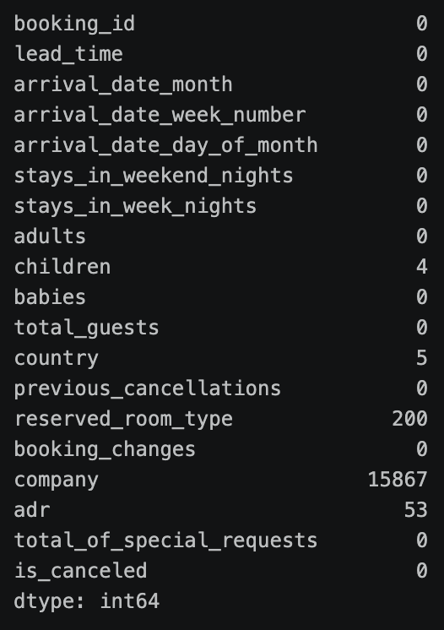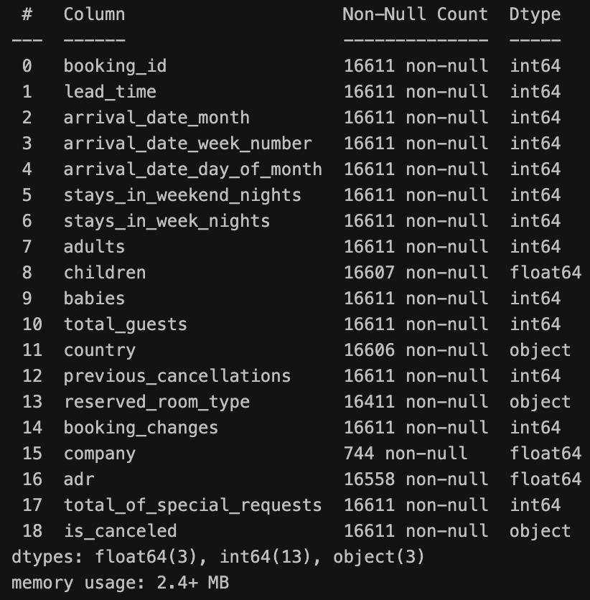

Lead_time
EDA identified 32 data points with lead_time = -1. A negative value is invalid for this feature, as lead_time represents the number of days between booking and scheduled arrival. The lead_time distribution was right-skewed, with several relatively large values. Therefore, it was first treated as missing and then filled with the median lead time. Median imputation was selected because it is less affected by extreme values than the mean.
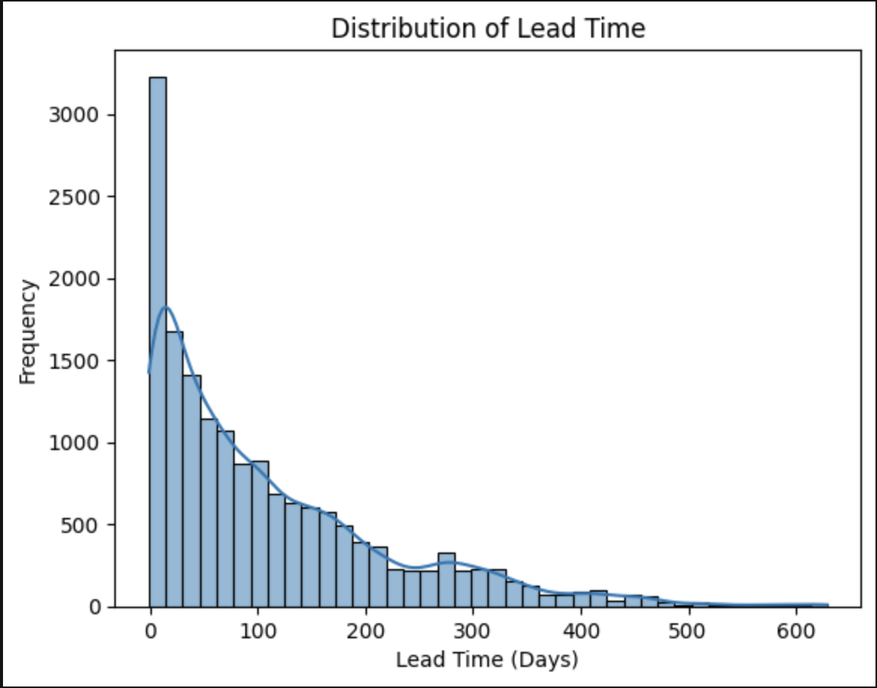

Guest information(adults, children, babies, total_guests)
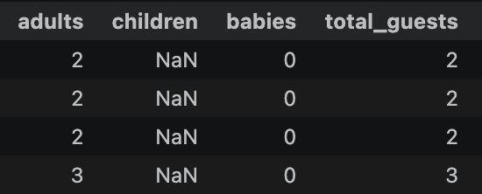
4 missing values for children was identified. Examination of these records showed that total_guests−adults−babies=0 for all four observations.

This indicated that the missing child count was 0. Therefore, the four missing children values were replaced with 0, and the variable was converted to integer type. EDA also identified 32 bookings with total_guests == 0. These data points were considered invalid because they represented bookings with no guests. The actual number of guests could not be reliably determined, and these rows only represent about 0.19% of the original dataset; thus, these records were removed rather than imputed.
Furthermore, total_guests was removed because it equals the sum of the adults, children, and babies variables. Retaining the individual variables preserves more detailed information about guest composition while avoiding redundant information.

Categorical missing values(country, reserved_room_type)
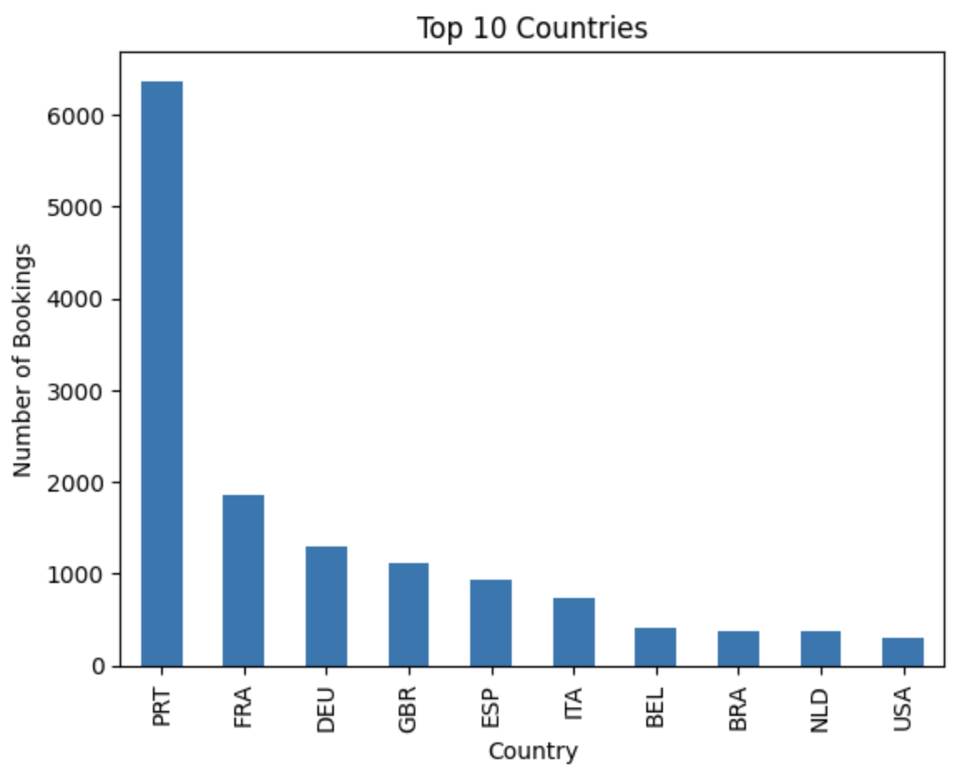
5 missing data points were identified in country. Although Portugal (PRT) was the most common country in the dataset, assigning missing observations to the most frequent category would make an unsupported assumption about their actual country. Therefore, missing data points were flagged as the Unknown category
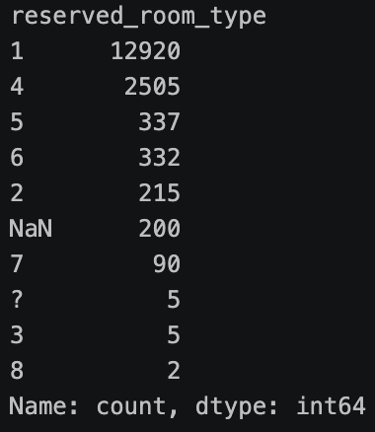
reserved_room_type included 200 missing values, and 5 observations were represented by "?" which were considered to be an alternative representation of unknown room information. Because of this, both missing values and the values in the "?" category were combined into an Unknown category. This allowed the observations to be retained without assuming that they belonged to the most common room type.

ADR
The adr variable contained 53 missing observations. Median imputation was used because ADR contained relatively high values and the median is less sensitive to extreme observations than the mean.

Company
The company variable includes 15,867 missing observations, and because of this extremely high proportion of missing information, meaningful imputation was not considered reliable. Therefore, the variable was removed.

1.4 Group and Individual Data Partitioning
After saving clean_data.csv and running the supplied data_partition.ipynb, report the size and target distribution of each generated dataset.
Dataset | Observations | Cancelled (%) | Not cancelled (%)
clean_group_data | 15086 | 41.77 | 58.23
clean_test_A | 497 | 41.85 | 58.15
clean_test_B | 498 | 41.77 | 58.23
clean_test_C | 498 | 41.77 | 58.23
Briefly comment on whether the target proportions are similar across the partitions.

1.5 Training and Test Partition
Dataset | Observations | Cancelled (%) | Not cancelled (%)
X_train, y_train | 12068 | 41.77 | 58.23
X_test, y_test | 3018 | 41.78 | 58.22
The group dataset was split into 80% training data and 20% test data. Stratified sampling was applied to maintain approximately the same proportion of cancelled and non-cancelled bookings in both sets and a fixed random state of 42 was used to ensure reproducibility.

Task 2 – Decision Trees

2.1 Default Decision Tree
Report training/test accuracy, ROC curve and classification report.
[Insert relevant performance table / ROC figure]

2.2 Overfitting Assessment
State whether the default tree overfits. Support the conclusion with training/test performance and tree characteristics such as depth and number of nodes/leaves.

2.3 Variable Importance and First Splits
Identify the variables used in the first and second splits and explain what these indicate. Report the five most important variables.
Rank | Variable | Importance | Interpretation
[Insert] | [Insert] | [Insert] | [Insert]
[Insert] | [Insert] | [Insert] | [Insert]
[Insert] | [Insert] | [Insert] | [Insert]
[Insert] | [Insert] | [Insert] | [Insert]
[Insert] | [Insert] | [Insert] | [Insert]

2.4 Hyperparameter Tuning
Describe the tuning approach, parameter search space, validation method and selected parameters.
Hyperparameter | Values searched | Selected value
[Insert] | [Insert] | [Insert]
[Insert] | [Insert] | [Insert]
[Insert] | [Insert] | [Insert]
[Insert] | [Insert] | [Insert]

2.5 Tuned Decision Tree Evaluation
Evaluate the tuned tree using the same metrics as the default tree and discuss whether overfitting improved.

Task 3 – Regression

3.1 Data Preparation for Regression
Describe any processing required for the regression model, including treatment of categorical variables and whether standardisation was used.

3.2 Default Logistic Regression
Report training/test accuracy, ROC curve and classification report.
[Insert relevant performance table / ROC figure]

3.3 Overfitting Assessment
Discuss whether the default model overfits and support the conclusion with results.

3.4 Variable Importance
Identify and interpret the five most important variables.
Rank | Variable | Coefficient / importance | Interpretation
[Insert] | [Insert] | [Insert] | [Insert]
[Insert] | [Insert] | [Insert] | [Insert]
[Insert] | [Insert] | [Insert] | [Insert]
[Insert] | [Insert] | [Insert] | [Insert]
[Insert] | [Insert] | [Insert] | [Insert]

3.5 Hyperparameter Tuning
Describe the tuning method, parameter search space, validation method and selected parameters.
Hyperparameter | Values searched | Selected value
[Insert] | [Insert] | [Insert]
[Insert] | [Insert] | [Insert]
[Insert] | [Insert] | [Insert]
[Insert] | [Insert] | [Insert]

3.6 Tuned Regression Evaluation
Evaluate the tuned model and compare it with the default model, including overfitting.

Task 4 – Neural Networks

4.1 Data Preparation for Neural Networks
Describe any additional processing required before fitting the neural network.

4.2 Default Neural Network
Describe the architecture, activation functions and training settings. Report training/test accuracy, ROC curve and classification report.
Component | Configuration
[Insert] | [Insert]
[Insert] | [Insert]
[Insert] | [Insert]
[Insert] | [Insert]
[Insert] | [Insert]
[Insert] | [Insert]

4.3 Overfitting Assessment
Discuss whether the default network overfits and provide evidence.

4.4 Hyperparameter Tuning
Describe the tuning approach, search space, validation method and selected parameters.
Hyperparameter | Values searched | Selected value
[Insert] | [Insert] | [Insert]
[Insert] | [Insert] | [Insert]
[Insert] | [Insert] | [Insert]
[Insert] | [Insert] | [Insert]
[Insert] | [Insert] | [Insert]

4.5 Tuned Neural Network Evaluation
Evaluate the tuned network using the same metrics and discuss whether overfitting improved.

4.6 Comparison of Tuned Group Models
Compare the tuned Decision Tree, Regression and Neural Network models using test performance and justify which model(s) are preferred.
Model | Test accuracy | ROC-AUC | Other key metric | Comments
[Insert] | [Insert] | [Insert] | [Insert] | [Insert]
[Insert] | [Insert] | [Insert] | [Insert] | [Insert]
[Insert] | [Insert] | [Insert] | [Insert] | [Insert]

Task 5 – Individual Evaluation (3 pages each)

Student A
Name: [Insert] Student ID: [Insert] Assigned dataset: [Insert]

5.1 Evaluation Results
Model | Accuracy | Precision / Recall / F1 summary | ROC-AUC
[Insert] | [Insert] | [Insert] | [Insert]
[Insert] | [Insert] | [Insert] | [Insert]
[Insert] | [Insert] | [Insert] | [Insert]
[Insert ROC chart(s) and any concise supporting figure/table.]

5.2 Comparison with Group Test Performance
Compare individual-test performance with the group test results and discuss any important differences.

5.3 Model Recommendation
Recommend which model(s) should be used for future unseen hotel-booking data and justify the recommendation.

Student B
Name: [Insert] Student ID: [Insert] Assigned dataset: [Insert]

5.1 Evaluation Results
Model | Accuracy | Precision / Recall / F1 summary | ROC-AUC
[Insert] | [Insert] | [Insert] | [Insert]
[Insert] | [Insert] | [Insert] | [Insert]
[Insert] | [Insert] | [Insert] | [Insert]
[Insert ROC chart(s) and any concise supporting figure/table.]

5.2 Comparison with Group Test Performance
Compare individual-test performance with the group test results and discuss any important differences.

5.3 Model Recommendation
Recommend which model(s) should be used for future unseen hotel-booking data and justify the recommendation.

Student C
Name: [Insert] Student ID: [Insert] Assigned dataset: [Insert]

5.1 Evaluation Results
Model | Accuracy | Precision / Recall / F1 summary | ROC-AUC
[Insert] | [Insert] | [Insert] | [Insert]
[Insert] | [Insert] | [Insert] | [Insert]
[Insert] | [Insert] | [Insert] | [Insert]
[Insert ROC chart(s) and any concise supporting figure/table.]

5.2 Comparison with Group Test Performance
Compare individual-test performance with the group test results and discuss any important differences.

5.3 Model Recommendation
Recommend which model(s) should be used for future unseen hotel-booking data and justify the recommendation.

Submission Checklist
- Cover page includes group number, full names and Student IDs.
- Group report contains responses to Tasks 1–4.
- Each group member's Task 5 report is included.
- Reports are self-explanatory and do not rely on the Jupyter notebook.
- Relevant figures/tables/screenshots are included without excessive detail.
- Completed Team Agreement is included.
- Jupyter notebook containing all code is included separately in the ZIP.
- Final report is named assessment1-report.docx or assessment1-report.pdf.
- All required documents are compressed into assessment1.zip.

