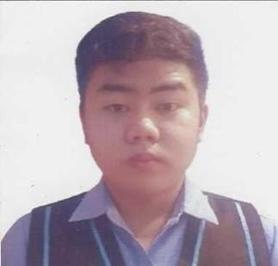

**PERSONAL DETAIL**

1808 R5 Receiver St. CAA Las Piñas City, Philippines

Birthday:

May 08, 2002

Contact No: 09275503758

Email Address: [Christian.ugay08@gmail.com](mailto:Christian.ugay08@gmail.com)

**PERSONAL OBJECTIVE**

To obtain a Experience and meaningful challenging position, that would enable me to learn more about business by applying all my skills and abilities that I’ve learned through life experiences and a position that would also allow me for advancement for the indefinite future.

CHRISTIAN ORTEGA UGAY

I am brave, ambitious person who is eager to achieve and contribute knowledge, who is responsible with good communication skills that been developed by practices via indoor and outdoor activities, as well as determined and not easy to give up for the things that I wanted. I am Excellent to give fully to help working to others to achieve a certain goal in time.

# SKILLS

* Proficient in Microsoft Applications (Word, PowerPoint, etc.)
* Video Editing
* Ability to verbally communicate with persons inside and outside the organization.
* Basic troubleshooting in Computer
* Smart, willing to work on time and flexible as well.
* Skilled in use of Computer , Preferably in PC
* Able to Adjust in any work Environment and willing to Trained
* Can work as Independent and as a Team Member

# ACCOMPLISHMENTS

* Participated in seminars about Computer
* Participated in online games tournament
* Has been Part of truck and field competition.
* Basic troubleshooting in Computer

# EDUCATIONAL BACKGROUND

* **TECHNOLOGICAL UNIVERSITY OF THE PHILIPPINES**

Ayala Boulevard, Ermita, Manila

Bachelor of Information Technology(September-2021-Present)

* **Holy Rosary Academy of Las Piñas City (Senior High School)**

St. Joseph Ave. corner Naga Road, Pulanglupa Dos, Las Piñas City, 1740

* **Captain Albert Aguilar National High School**

CAA Road Corner Balikatan St. Bf Int'l Village, 1740 Las Piñas, Philippines.

* **CAA ELEMENTARY SCHOOLS**

PATOLA ST, CAA LAS PIÑAS CITY

**WORK EXPERIENCE**

HELP DESK **/** CHATTER **|** ELECTRIC AVENUE ONLINE CASINO July 2023 – May 2024 | Philippines

Jn trading Comp / US based

* Help them To Create Account and Install on their Devices
* Provide 24/7 Contact Service regarding To their Problem and Account Issue
* Coordinating With Team Member Relevant to System Issues and problem
* Making Documentation for monitoring and tracking of withdraw Money
* Responsible For checking and Loading their Account Via REMOTE Using VPN
* Communicating to the Customer about their Account, History Game, Deposits and Withdraw
* Checking the Maintaining Balance And Pending Account

**REFERENCE**

* **Christian Benedict Santos (**Workmate**)**

09682394346

* Leah Anne Arandil (Manager)

09061066364