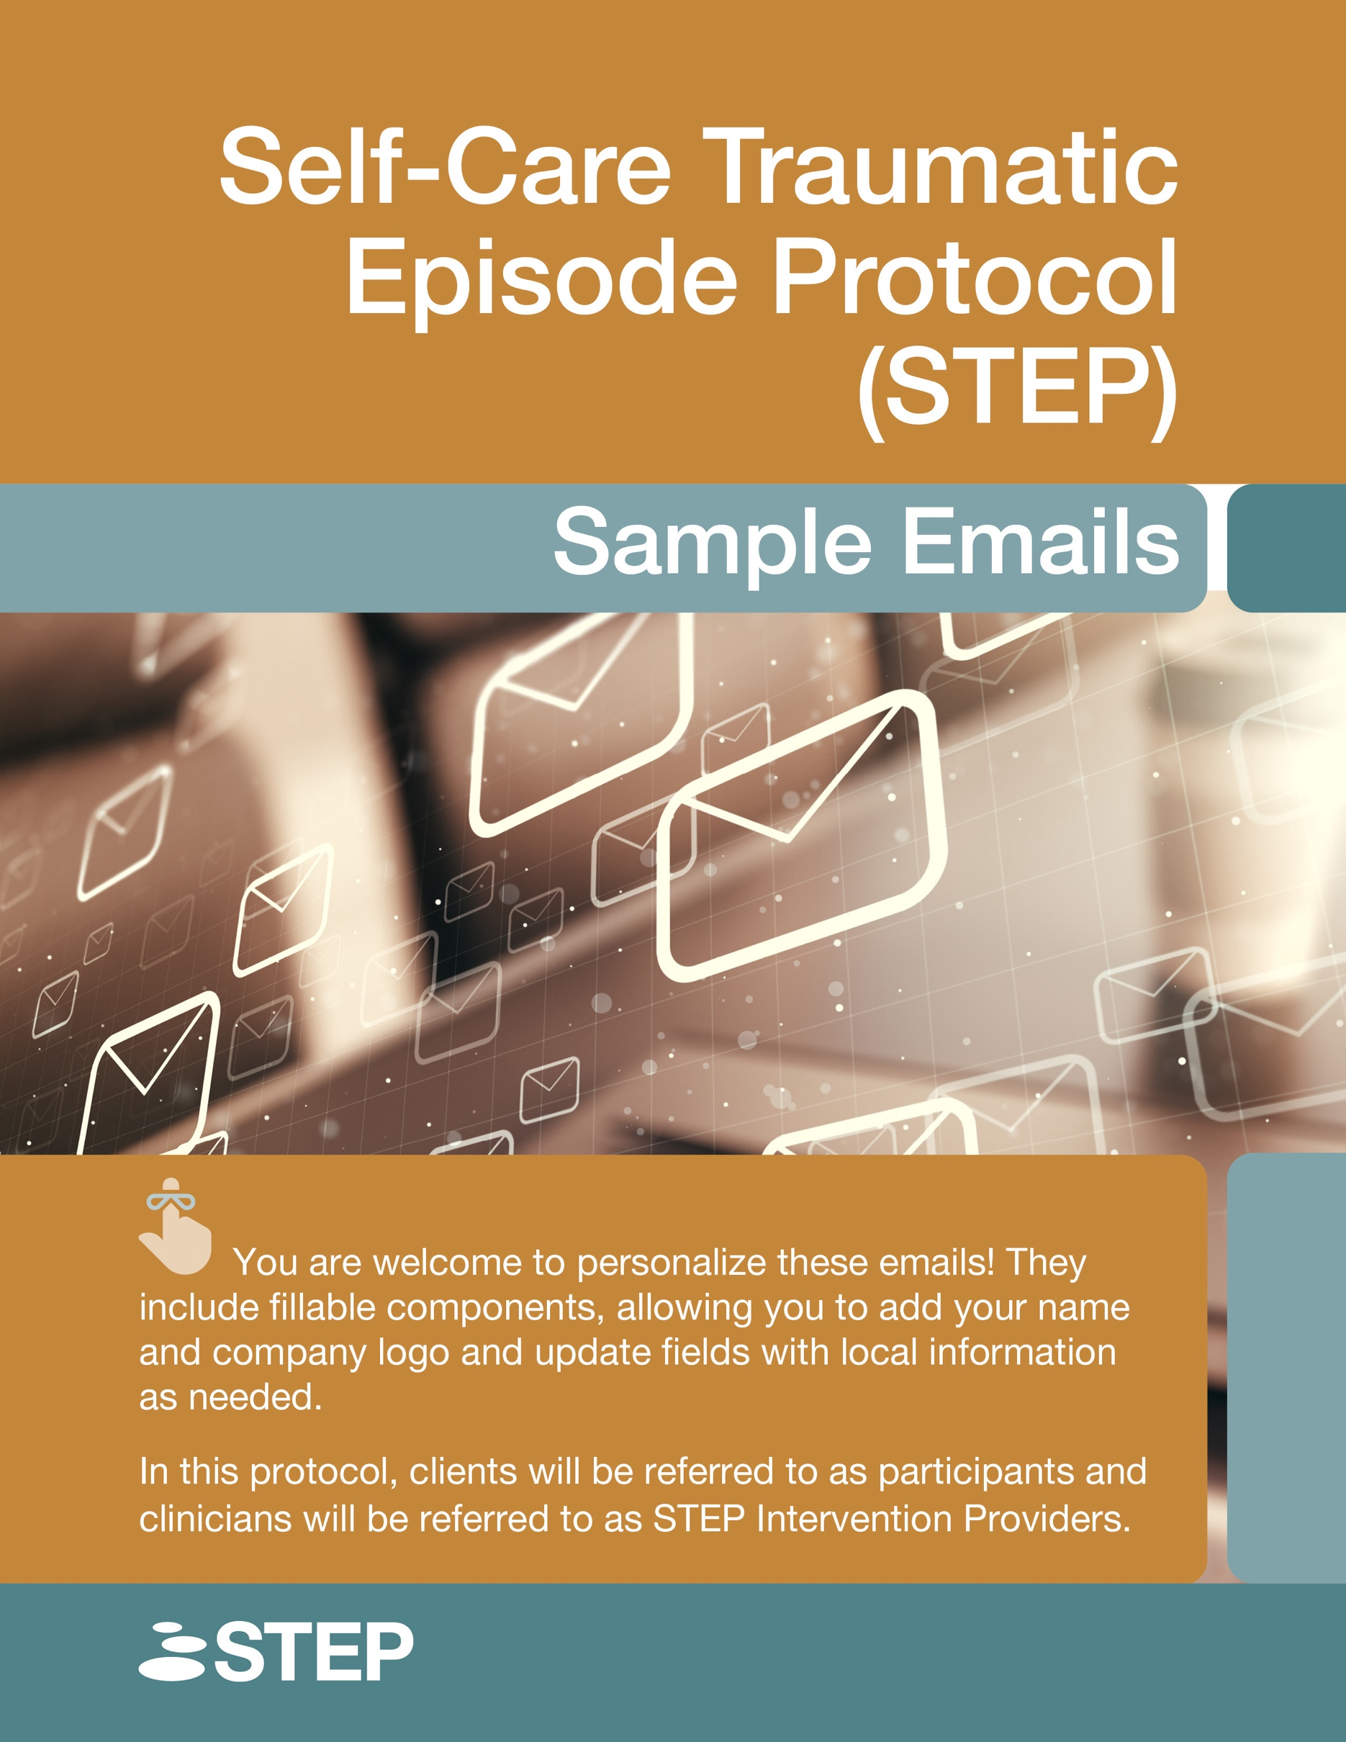

Contents
A Human Connection: Enhancing Support 4
General Email Guide: Determining Whether to Use STEP Solo or STEP Together 4
Sequence of Sample Emails for the STEP Intervention 5
List of General Emails to Determine Which Protocol to Use (STEP Solo, STEP Together, or Alternative Interventions) 7
STEP-1: Invite to Participate (with Consent and Information) 8
STEP-2: Screening Measures 10
STEP-3: Discussing Intervention Options 11
STEP-3: Proceeding to STEP Solo 12
STEP-3: Proceeding to STEP Together 12
Emails for STEP Solo 14
List of Emails 14
STEP Solo Sequence 15
SOLO-1: Invite to Participate (with Consent and Information) 16
SOLO-2: Screening Measures 18
SOLO-3: Access to STEP Solo 19
SOLO-4: Follow-Up After Completing STEP Solo 21
SOLO-5: Post-Intervention Data 22
SOLO-6: Sending Pre-Intervention Measures Again 23
SOLO-7: Password Change 24
Emails for STEP Together 26
List of Emails 26
STEP Together Sequence 27
TOGETHER-1: Invite to Participate (with Consent and Information) 28
TOGETHER-2: Screening Measures 30
TOGETHER-3: Scheduling the Group 31
TOGETHER-4: Pre-Intervention Measures 32
TOGETHER-5: Introductory meeting (with protocol sheets + 4 Elements + Link) 34
TOGETHER-6: Processing meeting (with protocol sheets + 4 Elements + Link + Feedback form) 36
TOGETHER-7: Follow-Up 38
TOGETHER-8: Post-Group Data 39

A Human Connection: Enhancing Support

Integrating a human connection into the STEP intervention enhances trust, engagement, and personalization, making it a more effective tool. Regular human check-ins support service providers, reducing burnout and fostering a positive workplace. An in-house STEP Intervention Provider can serve as a trusted resource if confidentiality is maintained, while an external provider offers added neutrality. A human handoff helps those screened out of the protocol receive guidance and clinical judgment should be used if participants wish to continue. Offering multiple providers gives staff choice, and using STEP as a maintenance tool can proactively support well-being. Sample emails serve as guides and should be personalized to align with each provider’s voice and goals.

For further information on integrating a human connection into the STEP Intervention, refer to page 23 of the manual.

General Email Guide: Determining Whether to Use STEP Solo or STEP Together

If you want to utilize the STEP intervention with participants but are uncertain whether they will be referred to STEP Solo, STEP Together, or STEP Supported (one-to-one intervention), you can use the following sequence of emails to explain and start the STEP process. The STEP intervention is designed to collect important information that will assist in developing an effective treatment plan tailored to their needs.

If you know you want to use STEP Solo with participants, proceed with the email sequence outlined in the emails for STEP Solo section.

If you know you want to use STEP Together with participants, proceed with the email sequence outlined in the emails for STEP Together section.

Sequence of Sample Emails for the STEP Intervention
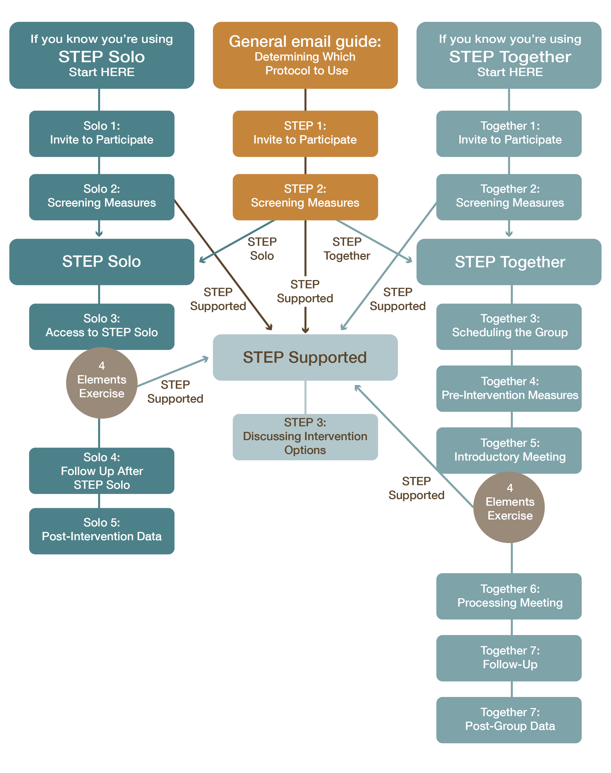

List of General Emails to Determine Which Protocol to Use (STEP Solo, STEP Together, or Alternative Interventions)

- STEP-1: Invite to Participate (with Consent and Information)
- STEP-2: Screening Measures
- STEP-3: Discussing Intervention Options
  - or SOLO-3: Access to STEP Solo
  - or TOGETHER-3: Scheduling the Group

After you receive the screening and pre-intervention data from email STEP-2, use the results to determine whether clients will continue with STEP Solo, STEP Together, or one-to-one interventions.

Based on these results, you will send one of the following emails:

- Proceeding with STEP Solo: email SOLO-3 – Access to STEP Solo, and then continue with the STEP Solo email sequence.
- Proceeding with STEP Together: email TOGETHER-3 – Scheduling the Group, and then continue with the STEP Together email sequence.
- Proceeding with one-to-one intervention: email STEP-3 – Discussing Intervention Options.

STEP-1: Invite to Participate (with Consent and Information)

Subject: Invitation to Participate in STEP

 Two Attachments: Consent & Terms of Use for STEP Interventions and Information Letter for STEP Interventions (see pages 25 and 26 of the manual)

Hello [Insert Participant Name],

We would like to invite you to participate in the STEP intervention, which combines psychoeducation, stabilization techniques, processing, and containment strategies. The intervention aims to help you stay grounded, process overwhelming emotions, and continue functioning effectively in your daily life.

Please find attached two important documents:
- Information Letter: This outlines the intervention approach, including the protocol, your well-being priorities, and details on data collection.
- Consent Form: This explains what participation involves and confirms agreement to take part.

What to Expect:

- Consent Form: Please read and complete the attached consent form. It includes important details on:
  - Confidentiality and privacy guidelines
  - Your rights and responsibilities as a participant
- Pre-Session Forms: After we receive your consent form, you will be asked to complete some online forms and measures to track your progress and assess your readiness for the intervention. Your data will be collected online and shared with [Insert STEP Intervention Provider Name] to help monitor your participation. Your information will be kept confidential. The data may be used for protocol improvements, research, or teaching, and all personal information will be kept anonymous. You can opt out of the research by contacting your STEP Intervention Provider.
- Screening and Evaluation: After we receive your consent form, we will ask you to complete some online forms and measures to track your progress and assess which version of STEP may be a good fit for you.
- Screening Review: After we receive all completed screening documents from you, we will review the information to ensure that STEP is an appropriate intervention for you. Then, we will discuss the next steps in your care.
- Accessing the Intervention: If STEP is appropriate, we will send you information about how we will proceed with the intervention.
- Follow-Up: Shortly after completing STEP, we will check in to see how the process went and discuss the next steps. Additionally, we will send you some post-intervention measures to evaluate the effectiveness of the intervention.
To Participate, please read and complete the attached consent form. Once we receive your signed consent, we will follow up with the screening measures. If you have any questions or need further clarification, feel free to contact us; we will be happy to assist you.

Kind regards,
[Insert Your Name]
[Insert Your Role]
[Insert Organization Name]

STEP-2: Screening Measures

When to Send: Send this email when you receive the signed consent form.

Subject: STEP: Measures to Complete and Unique ID

Hello [Insert Participant Name],

Thank you for taking the time to read the information letter and complete the consent form.

To continue, we’ve attached some pre-screening measures for you to complete. These measures are designed to track your progress and assess which intervention may best meet your needs. Your data will be collected online and shared with us via email.

When completing the measures, please use the unique identifier provided below instead of your name. This ensures confidentiality and helps us securely match your responses to your record:

- Your Unique Identifier: [Insert Unique ID]

You will also be asked for your STEP Intervention Provider’s name. This ensures the data is sent to the correct provider. Your provider is:

- STEP Intervention Provider: [Insert Name]

Please rest assured that your data will be handled with the utmost care. Only your unique identifier and scores will be sent to the STEP Intervention Provider via email. This approach maintains your privacy and ensures that your personal information remains protected.

Please complete the following screening measures:
- Initial Screening
- Pre-and-Post-Test Data

Please complete these screening measures before [Insert Date].

If you have any questions or encounter any issues while completing the measures, please don’t hesitate to reach out. You can reply to this email or call us at [Insert Contact Number].

Kind regards,
[Insert Your Name]
[Insert Your Role]
[Insert Organization Name]

STEP-3: Discussing Intervention Options
Please note: This email is only for individuals who will not be proceeding with STEP Solo or STEP Together because scores on the screening/pre-intervention data/4 Elements or your clinical judgement have determined it is not an appropriate intervention at this time.

When to Send: When you send this email will depend on your timeline; however, we recommend responding as soon as possible after you receive the screening results.
Subject: STEP: Next Steps

Hello [Insert Participant Name],

Thank you for completing the screening measures. Based on the results, we’d like to discuss some interventions that may suit your needs. We would like to book a time to meet [in person/on the phone/virtually]. I am available [Insert Date and time options or your online booking system link]; please let me know what works for you.

Looking forward to connecting soon.

Best regards,
[Insert Your Name]
[Insert Your Position]
[Insert Your Contact Information]

STEP-3: Proceeding to STEP Solo

If your client is ready to move forward with STEP Solo, please send the SOLO-3: Access to STEP Solo email (see STEP Solo sample email list on the Prepped 4 Learning website).

STEP-3: Proceeding to STEP Together

If your client is ready to participate in STEP Together, please send the TOGETHER-3: Scheduling the Group email (see STEP Together sample email list on Kajabi).

You may select to use the STEP Together protocol in a one-to-one format if appropriate. If STEP is not an appropriate intervention, please discuss alternative interventions.

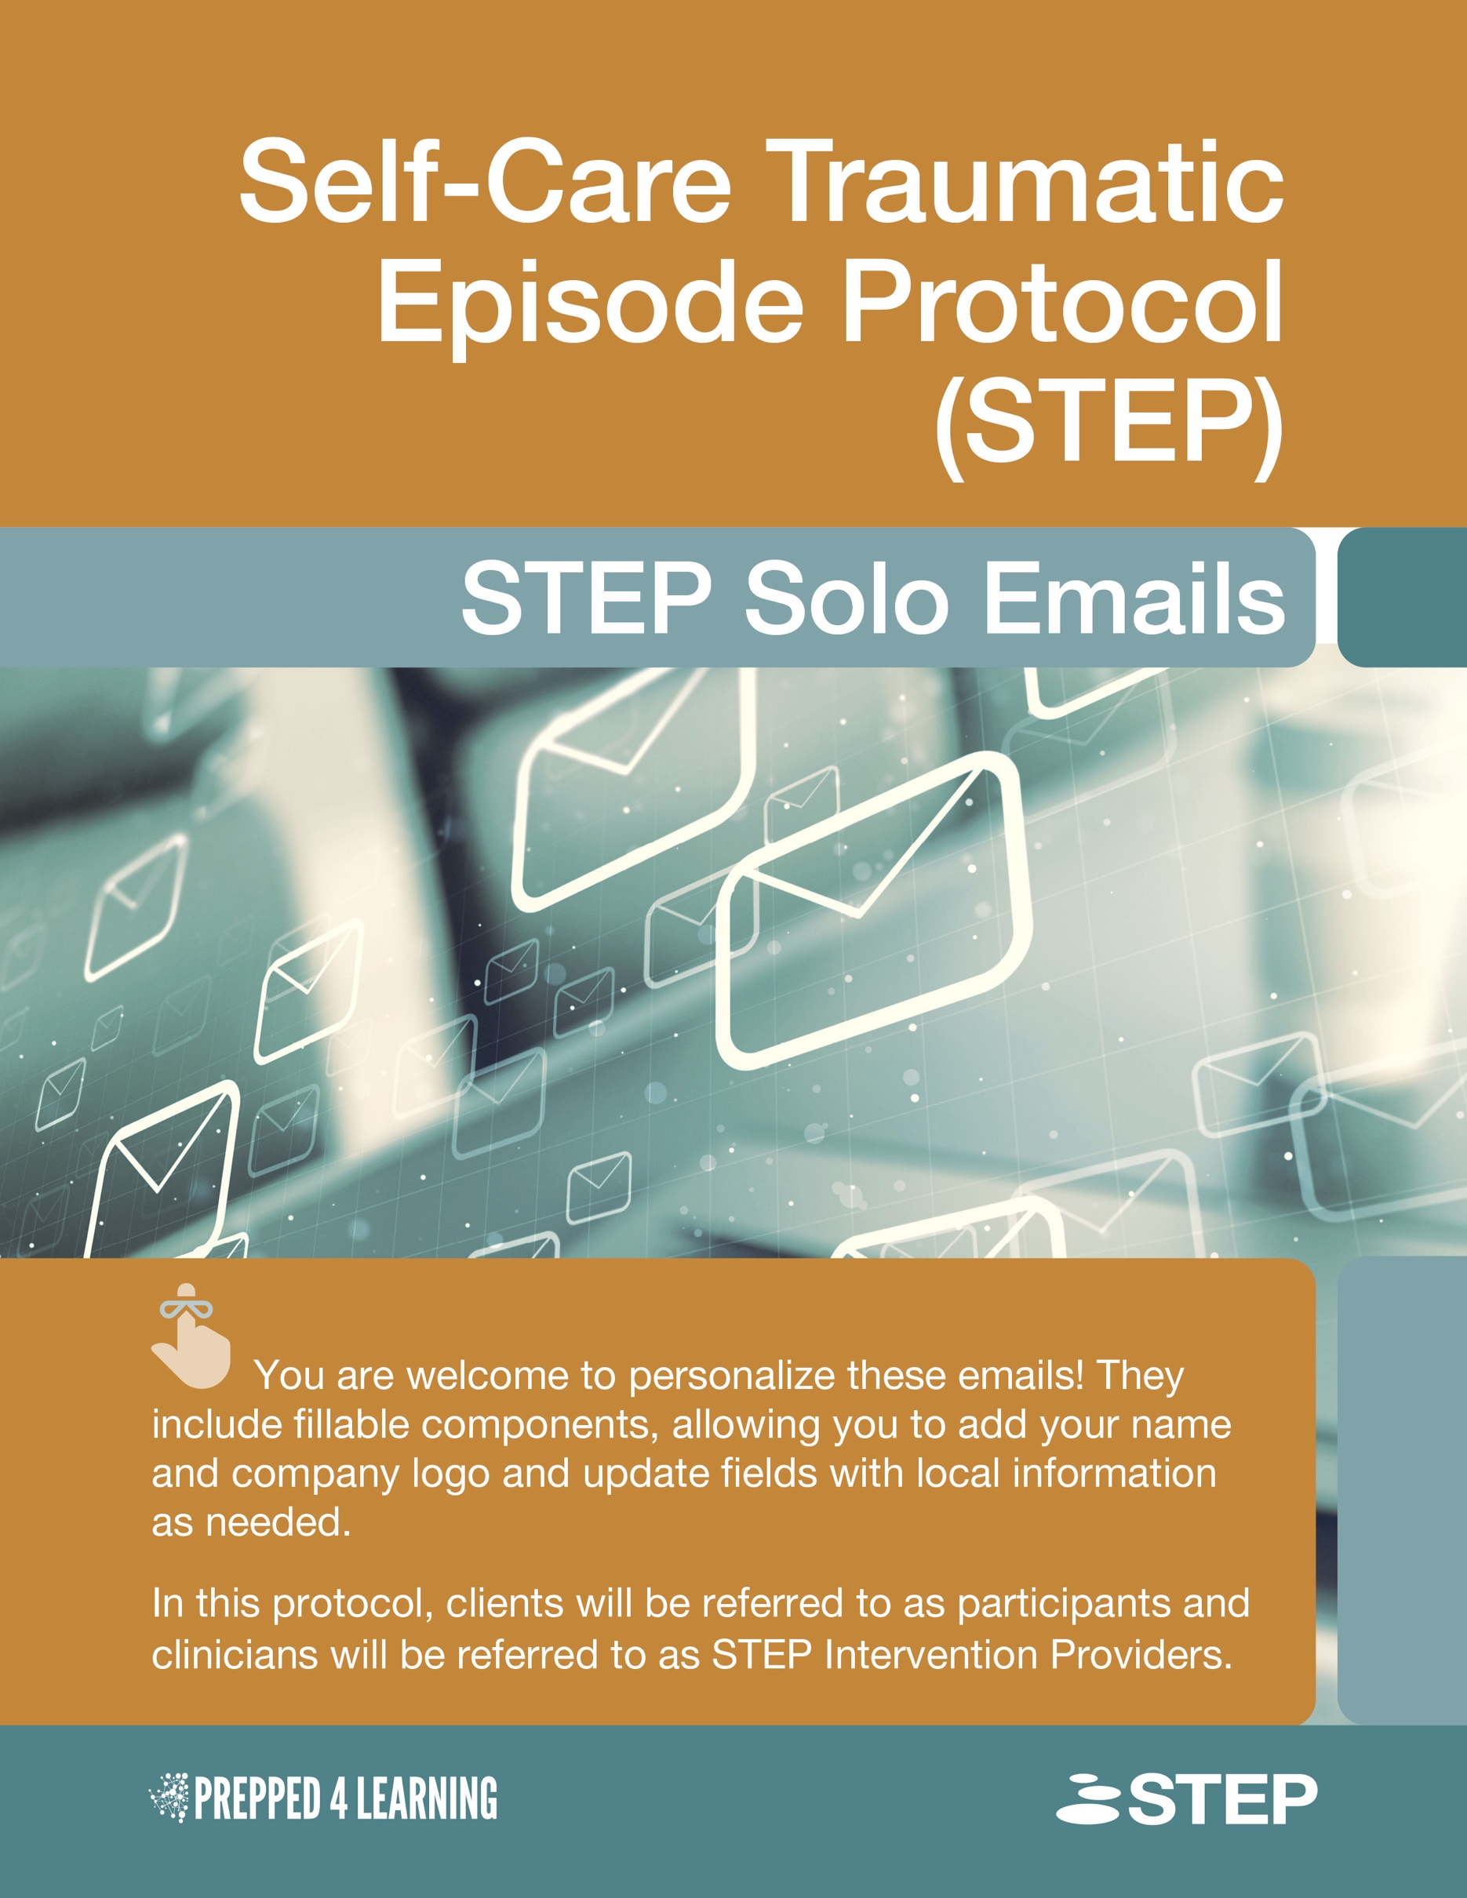

Emails for STEP Solo

If you know your client will be using STEP Solo, follow the STEP Solo-specific sequence of emails outlined below. In this case, you will not use the General Email Guide to determine which protocol to use. You will begin with SOLO-1: Invite to Participate (with Consent and Information).

List of Emails
- SOLO-1: Invite to Participate (with Consent and Information)
- SOLO-2: Screening Measures
Start here if you have sent the information letter and received the signed consent and screening measures.
- SOLO-3: Access to STEP Solo
- SOLO-4: Follow-Up After Completing STEP Solo
- SOLO-5: Post-Intervention Data
- SOLO-6: Sending Pre-Intervention Measures Again
- SOLO-7: Password Change
  If your client has been directed to self-regulation resources after completing the 4 Elements exercise, rather than proceeding to the processing portion of the protocol, send the email STEP-3: Discussing Intervention Options (See page 9 of this document) to explore intervention options that may better meet their needs.

STEP Solo Sequence
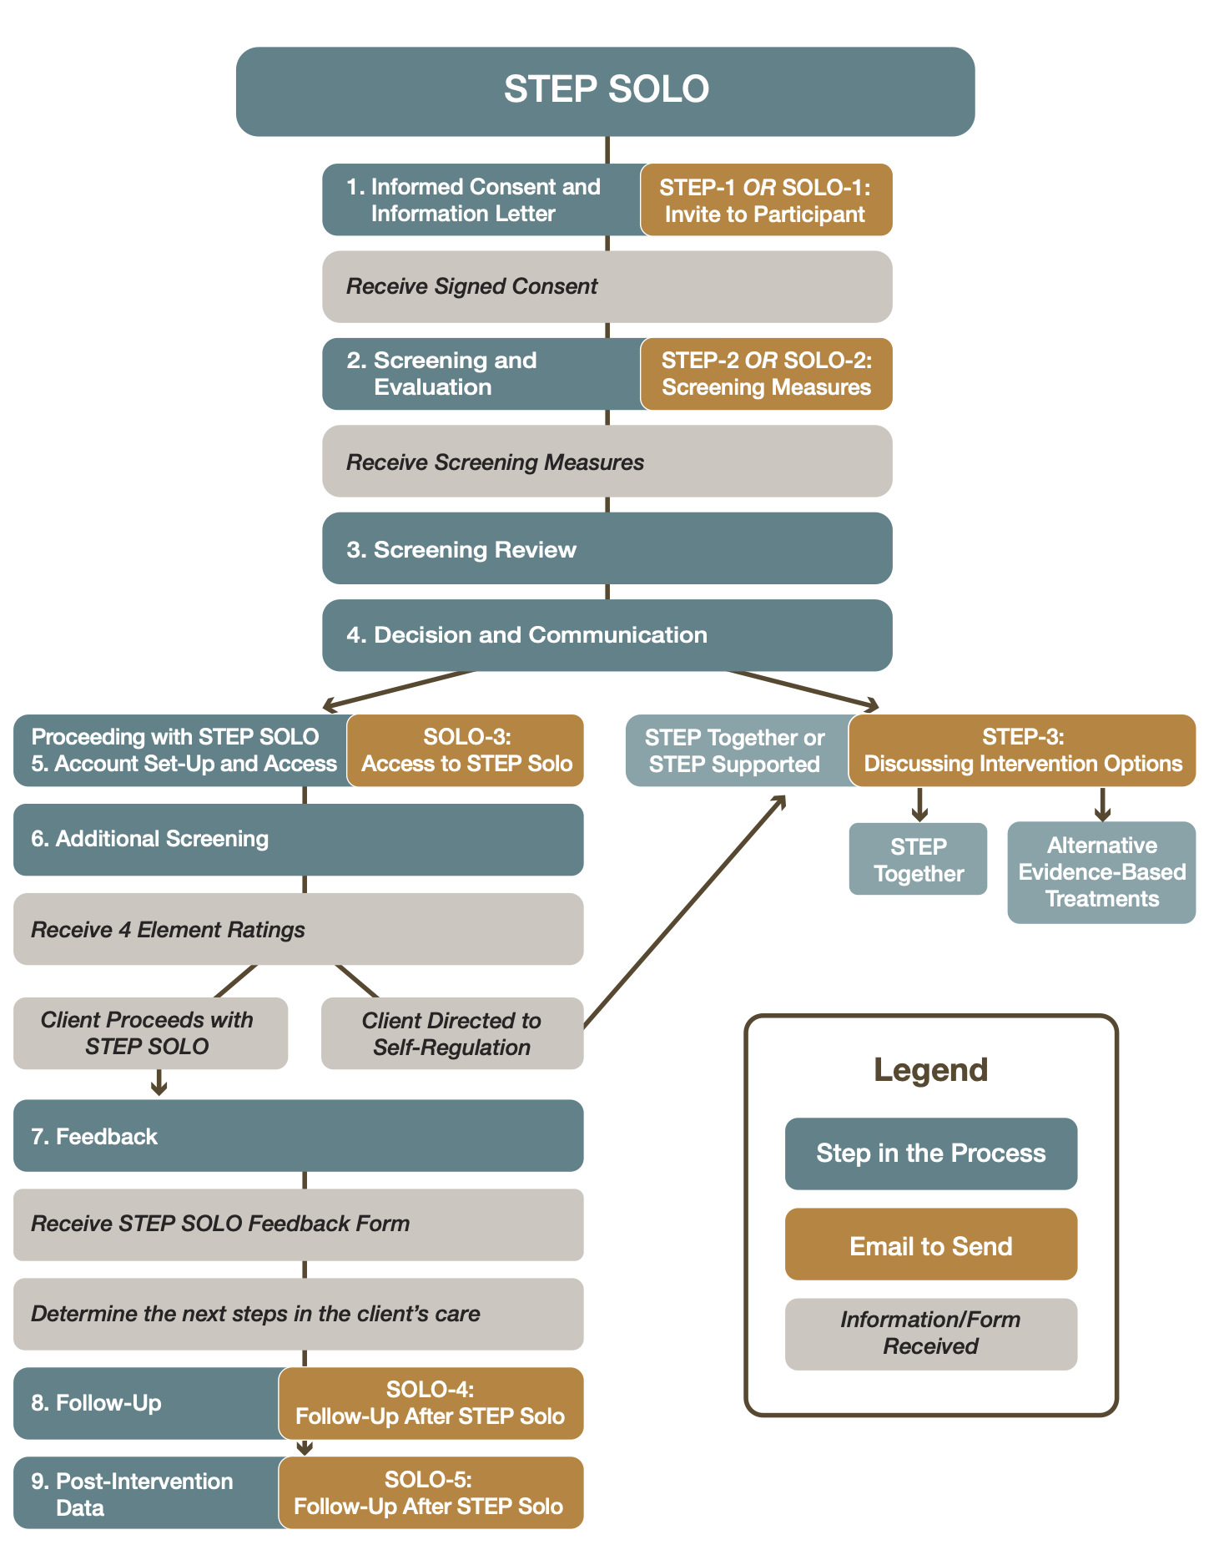

SOLO-1: Invite to Participate (with Consent and Information)

Subject: Invitation to Participate in STEP Solo
 Attachments: Consent Form and Information (see Prepped 4 Learning website or pages 25 and 26 of the manual)

Hello [Insert Participant Name],

As we discussed, we would like to invite you to use the STEP Solo intervention for self-care, to process aspects of a distressing experience, or as a tool for maintenance.

Please find attached two important documents:
- Information Letter: This outlines the intervention approach, including the protocol, your well-being priorities, and details on data collection.
- Consent Form: This explains what participation involves and confirms agreement to take part.

What to Expect:
- Consent Form: Please read and complete the attached consent form. It includes important details on:
  - Confidentiality and privacy guidelines
  - Your rights and responsibilities as a participant
- Pre-Session Forms: After we receive your consent form, you will be asked to complete some online forms and measures to track your progress and assess your readiness for the intervention. Your data will be collected online and shared with [Insert STEP Intervention Provider Name] to help monitor your participation. Your information will be kept confidential. The data may be used for protocol improvements, research, or teaching, and all personal information will be kept anonymous. You can opt out of the research by contacting your STEP Intervention Provider.
- Screening and Evaluation: After we receive your consent form, we will ask you to complete some online forms and measures to track your progress and assess whether STEP Solo may be a good fit for you.
- Screening Review: After we receive all completed screening documents from you, we will review the information to ensure that STEP Solo is an appropriate intervention for you. Then, we will discuss the next steps in your care.
- Account Setup and Access: If STEP Solo is appropriate, we will send you login information to access the platform.
- Follow-Up: Shortly after completing STEP Solo, we will check in to see how the process went and discuss the next steps. Additionally, we will send you some post-intervention measures to evaluate the effectiveness of the intervention.
To Participate, please read and complete the attached consent form. Once we receive your signed consent, we will follow up with the screening measures. If you have any questions or need further clarification, feel free to contact us; we will be happy to assist you.

Kind regards,
[Insert Your Name]
[Insert Your Position]
[Insert Your Contact Information]

SOLO-2: Screening Measures

When to Send: Send this email when you receive the signed consent form.

Subject: STEP Solo: Measures to Complete and Unique ID

Hello [Insert Participant Name],

Thank you for taking the time to read the information letter and complete the consent form.

To continue, we’ve attached some pre-screening measures for you to complete. These measures are designed to track your progress and assess your readiness for the intervention. Your data will be collected online and shared with us via email.

When completing the measures, please use the unique identifier provided below instead of your name. This ensures confidentiality and helps us securely match your responses to your record:

- Your Unique Identifier: [Insert Unique ID]

You will also be asked for your STEP Intervention Provider’s name. This ensures the data is sent to the correct clinician. Your STEP Intervention Provider is:

- STEP Intervention Provider: [Insert Name]

Please rest assured that your data will be handled with the utmost care. Only your unique identifier and scores will be sent to the clinician via email. This approach maintains your privacy and ensures that your personal information remains protected.

Please complete the following screening measures:
- Initial Screening
- Pre-and-Post-Test Data

Please complete these screening measures before [Insert Date].

If you have any questions or encounter any issues while completing the measures, please don’t hesitate to reach out. You can reply to this email or call us at [Insert Contact Number].

Kind regards,
[Insert Your Name]
[Insert Your Position]
[Insert Your Contact Information]

SOLO-3: Access to STEP Solo
Please note: This email is only for individuals who will be proceeding with STEP Solo. If your client will not be proceeding with STEP Solo, please send STEP-3: Discussing Intervention Options.

When to Send: After you receive the screening measures and confirm that STEP Solo is likely an appropriate intervention for the client.

Customizing the Email: Add any resources you typically send to your clients. For example, there is a spot for emergency services contact information and crisis helplines. Please update these fields with local information.

Subject: STEP Solo Access

Hello [Insert Participant Name],

Thank you for completing the screening measures. After reviewing your responses, we believe the STEP Solo intervention may be a good fit for you.

As a reminder, as you complete the STEP Solo intervention, your results will be sent via email to your STEP Intervention Provider, [Insert STEP Intervention Provider Name]. Throughout the process, there may be times when you are directed to self-regulation strategies. If this occurs, please reach out to [Insert STEP Intervention Provider Name] for support and to discuss the next steps in your care. They will assist you in finding an intervention that can best meet your needs.

Please be aware that the results of the STEP Solo intervention may not be monitored continuously. While the videos will guide you through the process, there may be instances when support is not immediately available. If you are experiencing distress or feel overwhelmed at any time, please use the self-regulation strategies provided to assist in calming your mind and body. If you find this is not enough, please reach out to the following resources for immediate support:

Emergency Services Contact Information: [Insert Local Information]
Crisis Helpline: [Insert Local Information]

After you complete the protocol, we will check in to see how the process went and discuss the next steps. We will also send you some post-intervention measures to evaluate the effectiveness of the intervention.

Accessing STEP Solo:
- Link: Access STEP Solo
- Username: [Insert Username]
- Password: [Insert Password]

As a reminder, this password is provided for personal use only. Please do not share the login information with anyone else.
If you have any questions or concerns, feel free to contact us at [Insert Contact Information].

Best regards,
[Insert Your Name]
[Insert Your Position]
[Insert Your Contact Information]

SOLO-4: Follow-Up After Completing STEP Solo
When to Send: As soon as possible after they complete STEP Solo.
Subject: Checking In After STEP Solo

Hello [Insert Participant Name],
I wanted to take a moment to check in and see how you’re feeling after completing STEP Solo. We appreciate any feedback you’re willing to share. Your insights help us better understand and meet your needs.

How was your experience?
- Did you find it helpful?
- Did any part of the intervention leave you with questions or thoughts you’d like to explore further?
- How are you feeling about the work we’ve done so far?

If anything came up during or after the intervention that you’d like to discuss, please don’t hesitate to let me know. I’m here to support you as you process the work we’re doing together. I look forward to hearing your thoughts!

Warm regards,
[Insert Your Name]
[Insert Your Position]
[Insert Your Contact Information]

SOLO-5: Post-Intervention Data
When to Send: One week after they complete STEP Solo.

Subject: Follow-Up: Complete Your Post-STEP Measures

Hello [Insert Participant Name],

Thank you for completing STEP Solo. As part of the process, we kindly ask you to complete the post-intervention measures to help us track progress and outcomes related to the intervention.

To maintain confidentiality, please use your unique ID when completing the measures. Feel free to reach out if you are unsure of your unique ID, and we’ll provide it again. As a reminder, your STEP Intervention Provider was [Insert STEP Intervention Provider Name].

Here’s how to complete the measures:
- Pre-and-Post-Test Data

Please complete the measures before [Insert Date].

If you have any questions about the measures or the process, please don’t hesitate to contact us. Thank you for taking the time to complete these measures; we greatly appreciate your participation.

Warm regards,
[Insert Your Name]
[Insert Your Position]
[Insert Your Contact Information]

SOLO-6: Sending Pre-Intervention Measures Again

When to Send: When rechecking current symptom levels for individuals using STEP Solo to assess if the intervention is still suitable.

Subject: Checking In: Please Complete the Next Set of Measures for STEP Solo

Hello [Insert Participant Name],

We’d like to check in on how you’re doing and ensure that STEP Solo is still a good fit for you and your needs at this time. To help us assess and adjust as needed, please complete the following measures at your earliest convenience.
To maintain confidentiality, please use your unique ID when completing the measures. If you are unsure of your unique ID, feel free to reach out, and we’ll provide it again. As a reminder, your STEP Intervention Provider was [Insert STEP Intervention Provider Name].

Here’s how to complete the measures:
- Pre-and-Post-Test Data

Please complete the measures before [Insert Date].

If you have any questions about the measures or the process, please don’t hesitate to contact us. Thank you for taking the time to complete these measures; we greatly appreciate your participation.

Best regards,
[Insert Your Name]
[Insert Your Position]
[Insert Your Contact Information]

SOLO-7: Password Change
Subject: STEP Solo: New Password for Protocol Access

Hello [Insert Participant Name],

Please be advised that the password to access the protocol has been changed.

Here is your new password:
- Link: Access STEP Solo
- Username: [Insert Username]
- Password: [Insert Password]

As a reminder, this password is provided for personal use only. Please do not share the login information with anyone else.

If you have any questions or concerns, feel free to contact us at [Insert Contact Information].
Best regards,
[Insert Your Name]
[Insert Your Position]
[Insert Your Contact Information]

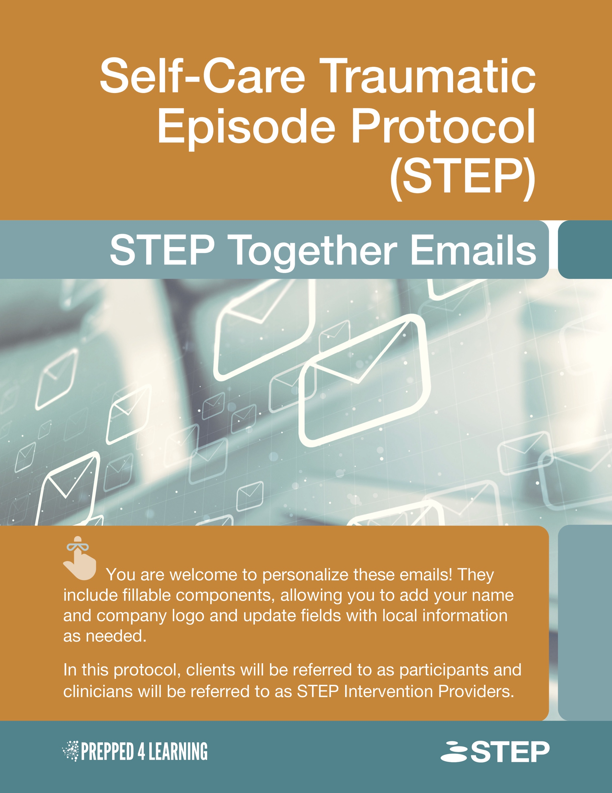

Emails for STEP Together

If you know your client will be using STEP Together, follow the STEP Together-specific sequence of emails outlined below. In this case, you will not use the General Email Guide to determine which protocol to use. You will begin with TOGETHER-1: Invite to Participate (with Consent and Information).

List of Emails
- TOGETHER-1: Invite to Participate (with Consent and Information)
- TOGETHER-2: Screening Measures
Start here if you have sent the information letter and received the signed consent and screening measures.
- TOGETHER-3: Scheduling the Group
- TOGETHER-4: Pre-Intervention Measures
- TOGETHER-5: Introductory Meeting (with Protocol Sheets + 4 Elements + Link)
- TOGETHER-6: Processing Meeting (with Protocol Sheets + 4 Elements + Link + Feedback Form)
- TOGETHER-7: Follow-Up
- TOGETHER-8: Post-Group Data

STEP Together Sequence
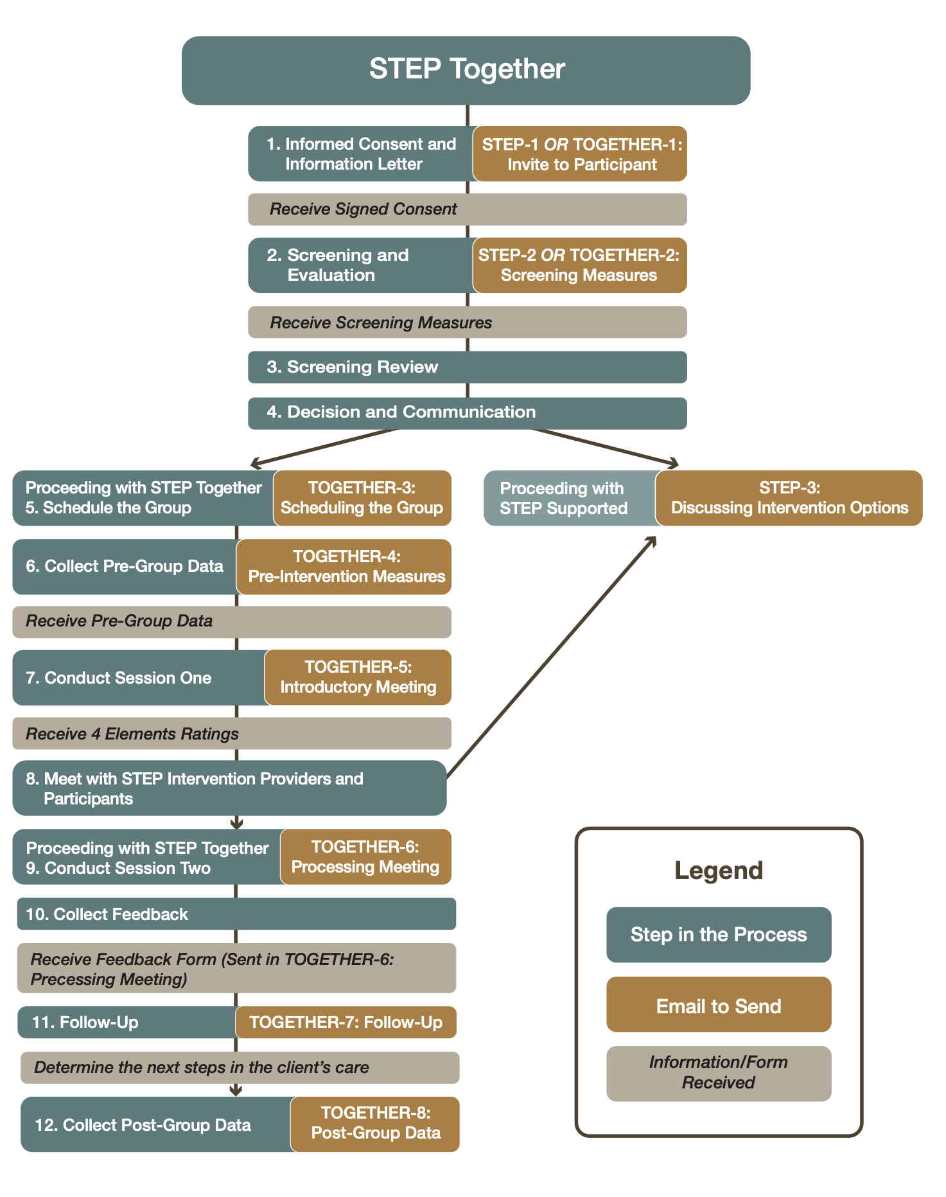

TOGETHER-1: Invite to Participate (with Consent and Information)

Subject: Invitation to Participate in STEP Together Sessions

 Attachments: Consent Form and Information (See pages 25 and 26 in the manual)

Hello [Insert Participant Name],

I’d like to invite you to participate in a series of sessions designed to support your coping and alleviate psychological distress caused by an overwhelming event.

We’ll be using a video protocol called STEP Together, which combines psychoeducation, stabilization techniques, processing, and containment strategies. The aim of STEP Together is to help you stay grounded, process overwhelming emotions, and continue functioning effectively in your daily life.

About STEP Together:
- STEP Together is based on Eye Movement Desensitization and Reprocessing (EMDR) Therapy and the Group Traumatic Episode Protocol (G-TEP). G-TEP was developed for in-person groups, STEP Together is a remote version of this evidence-based protocol, meaning it is conducted online or in a hybrid manner.
- What is EMDR Therapy? You can learn more about it here: EMDR Therapy

What to Expect:
- Consent Form: Please read and complete the attached consent form. It includes important details on:
  - Confidentiality and privacy guidelines
  - Group expectations and participation
  - Your rights and responsibilities as a participant
- Pre-Session Forms: After we receive your consent form, you will be asked to complete some online forms and measures to track your progress and assess your readiness for the intervention. Your data will be collected online and shared with [Insert STEP Intervention Provider Name] to help monitor your participation. Your information will be kept confidential. The data may be used for protocol improvements, research, or teaching, and all personal information will be kept anonymous. You can opt out of the research by contacting your STEP Intervention Provider.
- Introductory Online Meeting: We’ll start with an online meeting that will introduce the STEP Together intervention through a presentation and video. In this session, we will have an introduction to the processing intervention, discuss self-care and relaxation strategies.
- The STEP Together Process (2nd meeting):
  - You will then follow the intervention at your own pace, with remote guidance from the STEP Intervention Provider(s). Please note that during the protocol, you won’t be required to share personal experiences or emotions with the group.
  - As with any processing work, it’s possible that your emotional stress may temporarily increase. This is a normal part of the process, as STEP Together aims to reduce distress related to the recent traumatic experience.
  - If you continue to experience high levels of distress after completing the protocol, we’ll discuss the next steps together. Should you need additional support, your STEP Intervention Provider is available for one-on-one guidance.
  - If STEP Together is not the best fit for you, we may refer you to alternative interventions tailored to your needs.

To Participate: Please read and complete the attached consent form. Once we receive your signed consent, we will follow up with the pre-session measures. If you have any questions or need further clarification, feel free to reach out to your STEP Intervention Provider; they will be happy to assist you.

Kind regards,
[Insert Your Name]
[Insert Your Position]
[Insert Your Contact Information]

TOGETHER-2: Screening Measures

When to Send: Send this email as you begin to gather participants for your group. It is likely best to send it three weeks before the scheduled group to allow for enough time to complete the screening and the pre-post measures that will be sent in email three.

Subject: STEP Together: Measures to Complete and Unique ID

Hello [Insert Participant Name],

Thank you for taking the time to complete the consent form. We greatly appreciate your prompt response, as it helps us prepare for the STEP Together group.

To continue, we’ve attached some pre-screening measures for you to complete. These measures are designed to track your progress and assess your readiness for the intervention. Your data will be collected online and shared with the STEP Intervention Providers via email.

When completing the measures, please use the unique identifier provided below instead of your name. This ensures confidentiality and helps us securely match your responses to your record:

- Your Unique Identifier: [Insert Unique ID]

You will also be asked for your STEP Intervention Provider’s name. This ensures the data is sent to the correct clinician. Your STEP Intervention Provider is:

- STEP Intervention Provider: [Insert Name]

Please rest assured that your data will be handled with the utmost care. Only your unique identifier and scores will be sent to the STEP Intervention Provider via email. This approach maintains your privacy and ensures that your personal information remains protected.

- Measures: Initial Screening

If you have any questions or encounter any issues while completing the measures, please don’t hesitate to reach out. You can reply to this email or call us at [Insert Contact Number].

Thank you again, and we look forward to working with you soon.

Kind regards,
[Insert Your Name]
[Insert Your Position]
[Insert Your Contact Information]

TOGETHER-3: Scheduling the Group

When to Send: After you have received the screening measures and confirmed STEP Together is likely an appropriate intervention for the client.

Subject: STEP Together Session Dates

Hello [Insert Participant Name],
Thank you for completing the screening measures. After reviewing your responses, we believe the STEP Together intervention may be a good fit for you.
We are pleased to inform you that the upcoming STEP Together sessions have been scheduled. These sessions are designed to support your coping and alleviate psychological distress caused by an overwhelming event. The STEP Together sessions will take place over two days.

Session Details:
- Dates: [Insert specific dates, e.g., February 5th and 8th]
  - We recommend meeting twice within a short period of time (e.g. a week, if possible)
- Time: [Insert Time, e.g., 6:00 PM – 8:00 PM]
  - We recommend allowing two hours for each session. You may not require that much time for the first session.
- Location: [Insert location or virtual link]
- STEP Intervention Provider: [Insert STEP Intervention Provider Name].

Please confirm your attendance by [Insert final date for confirmation, e.g., February 1st], as this helps us ensure the sessions are tailored to meet everyone's needs.

If you have any questions or concerns, feel free to contact us at [Insert Contact Information].
We look forward to seeing you at the sessions and working together towards feeling calmer, stronger, and more balanced.

Best regards,
[Insert Your Name]
[Insert Your Position]
[Insert Your Contact Information]

TOGETHER-4: Pre-Intervention Measures

When to Send: Send two weeks before the first group. The measures will need to be submitted one week before the first scheduled session.

Subject: STEP Together: Additional Measures to Complete

Hello [Insert Participant Name],

Please complete the attached pre-group measures. These measures are different from the initial screening forms and are designed to evaluate changes before and after your participation in the group.

Please complete these measures no later than one week before the first group session on [Insert Date] to ensure we have the necessary information to support your journey.

- Measures: Pre-and-Post-Test Data

When completing the measures, please use your unique identifier to maintain confidentiality:

Your Unique Identifier: [Insert Unique ID]

As a reminder, your STEP Intervention Provider for this program will be [STEP Intervention Provider’s Name], who will guide and support you throughout the process.

As a reminder, the first group session is scheduled for:
- Date: [Insert Date]
- Time: [Insert Time]
- Location/Virtual Link: [Insert Location/Link]

If you have any questions about the pre-intervention measures or need assistance, feel free to reply to this email or contact us at [Insert Contact Information].

Thank you for your time and effort. We’re looking forward to seeing you at the first session!

Kind regards,
[Insert Your Name]
[Insert Your Position]
[Insert Your Contact Information]

TOGETHER-5: Introductory Meeting (with protocol sheets + 4 Elements + Link)

Subject: Next Steps for Your Upcoming STEP Together Session

 Attachment: Protocol Sheets (See Module “Before the Group” on Kajabi)

Hello [Insert Participant Name],

Thank you for completing the necessary measures! We appreciate your effort in preparing for the upcoming STEP Together Group.

As we move closer to the session, please find below the next steps and important details:

1. Protocol Sheets: Attached are the protocol sheets you will need for the session. Please print these sheets (in colour, if possible) and have them ready for our time together. If you do not have access to a printer, feel free to draw the necessary information directly onto a sheet of paper. Please print these sheets single-sided so you have three separate pages.

2. Disconnection Instructions: If you are disconnected from the group during the intervention, try some deep breathing and attempt to log back into the platform. If you are having trouble rejoining, one of our facilitators will reach out to help you reconnect.
- You can use the 4 Elements exercise or this breathing exercise to regulate while you wait to reconnect.

3. Tech Tips for Joining Online Groups:
- Strong Internet Connection: Ensure you have a strong internet connection. If possible, plug into your internet using an Ethernet cable or sit closer to your Wi-Fi router to avoid disruptions.
- Quiet and Private Space: Choose a quiet, private space to participate in the group. This will help you stay focused during the session.
- Headphones: If you have a pair of headphones, please use them. They will improve audio quality and reduce background noise, making it easier for you to hear and engage in the session.
- Test Your Equipment: Before the session, test your camera, microphone, and speakers to make sure everything is working properly.

4. Session Details:
- Date: [Insert Date]
- Time: [Insert Time]
- Link to Join: [Insert Link to the Session]

Please make sure to log in a few minutes early to ensure everything is working smoothly.
If you have any questions before the session, don't hesitate to reach out. We look forward to seeing you soon!

Best regards,
[Insert Your Name]
[Insert Your Position]
[Insert Your Contact Information]

TOGETHER-6: Processing Meeting (with protocol sheets + 4 Elements + Link + Feedback form)

Subject: Preparing for Our Second STEP Together Session

 Attachment: Protocol Sheets (See module “Before the Group” on Kajabi)

Hello [Insert Participant Name],

We’re looking forward to our second group intervention session, and I wanted to send a quick reminder with some helpful information to ensure a smooth experience.

1. Protocol Sheets: Attached are the protocol sheets you will need for the session. These sheets are the same as those used in the first session. Please print these sheets (in colour, if possible) and have them ready for our time together. If you do not have access to a printer, feel free to draw the necessary information directly onto a sheet of paper. Please print these sheets single-sided so you have three separate pages.

2. Disconnection Instructions: In case you are disconnected, please try some deep breathing and attempt to rejoin the platform. If you are having difficulty reconnecting, a facilitator will reach out to help you.
- You can use the 4 Elements exercise or this breathing exercise to regulate while you wait to reconnect.

3. Tech Tips for Online Group Sessions: To ensure the best possible experience during our virtual session, consider the following tips
- Strong Internet Connection: Make sure your internet connection is stable. Plugging directly into your router or sitting closer to it can improve your connection.
- Quiet and Private Space: Find a quiet, private space where you can participate without distractions. This will help you stay focused during the session.
- Headphones: If you have a pair of headphones, please use them to reduce background noise and improve audio clarity.
- Test Your Equipment: Please check your microphone, camera, and speakers before joining to make sure everything is working smoothly.

5. Session Details:
- Date: [Insert Date]
- Time: [Insert Time]
- Link to Join: [Insert Link to the Session]

6. After the Group: Please complete the feedback form after the group.

Finally, please make sure to log in a few minutes before the session begins to ensure you’re set up and ready to go!

If you have any questions or need anything in the meantime, feel free to reach out. We’re excited to continue the work we’ve started and look forward to seeing you soon.

Best regards,
[Insert Your Name]
[Insert Your Position]
[Insert Your Contact Information]

TOGETHER-7: Follow-Up

Subject: Checking In After Our STEP Together Session

You might select to do another processing session with some clients as needed or to see them individually so they can further process the distressing event guided by the videos.

Hello [Insert Participant Name],

I wanted to take a moment to check in and see how you’re feeling after our recent STEP Together session. Your feedback and reflections are valuable as we continue this process together.

How was your experience?
- Did you find the session helpful?
- Did any part of the session leave you with questions or thoughts you’d like to explore further?
- How are you feeling about the work we’ve done so far?

If anything came up for you during or after the session that you’d like to discuss, please don’t hesitate to reach out. We are here to support you as you process the work we’re doing together.

Thank you again for your openness and participation in the group. I look forward to hearing your thoughts!

Warm regards,
[Insert Your Name]
[Insert Your Position]
[Insert Your Contact Information]

TOGETHER-8: Post-Group Data

Subject: Follow-Up: Complete Your Post-Group Measures

Hello [Insert Participant Name],

Thank you for participating in our group session. As part of the process, we kindly ask you to complete the post-group measures to help us track progress and outcomes related to the session.

To maintain confidentiality, please use your unique ID when completing the measures. If you are unsure of your unique ID, feel free to reach out, and we’ll provide it again. As a reminder, your STEP Intervention Provider was [Insert STEP Intervention Provider Name].

Here’s how to complete the measures:
- Pre-and-Post-Test Data

Please complete the measures before [Insert Date].

If you have any questions about the measures or the process, please don’t hesitate to contact us.

Thank you for taking the time to complete these measures. Your participation is greatly appreciated.

Warm regards,
[Insert Your Name]
[Insert Your Position]
[Insert Your Contact Information]

