1. Executive Summary
This report presents the findings of the routine structural and surface inspection conducted on the Northfield Bridge (Structure ID: NB-204) and the adjacent arterial roadway corridor on April 18, 2026. The inspection was carried out by a certified team in accordance with AASHTO and local DOT guidelines. Overall structural integrity was assessed as satisfactory, with minor remediation recommended for two identified zones.
Immediate safety concerns were not identified during the inspection. However, a scheduled maintenance intervention is recommended within the next 90 days to address surface cracking and joint seal deterioration observed at the eastern expansion joint.

2. Inspection Summary Data
The table below summarizes key inspection metrics recorded during the site visit:
Inspection Zone | Component | Condition Rating | Action Required
Zone A – West Span | Deck Surface | Good (8/10) | None
Zone B – East Span | Expansion Joint | Fair (5/10) | Seal Replacement
Zone C – Piers | Concrete Pillars | Good (7/10) | Monitor
Zone D – Approach | Road Surface | Good (7/10) | None
Zone E – Drainage | Drainage Channel | Fair (6/10) | Clear Debris

3. Site Photograph
Figure 1 depicts the primary inspection site, Northfield Bridge Corridor, captured during the field assessment. Key structural zones are visible and align with data recorded in Section 2.
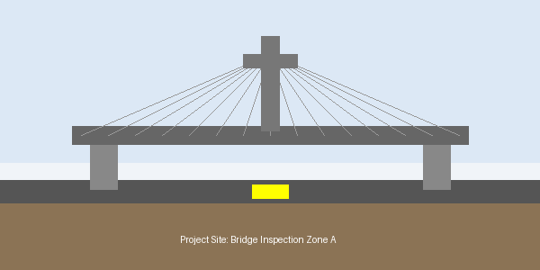
Figure 1: Northfield Bridge — Inspection Zone Overview (April 18, 2026)

4. Findings & Recommendations

4.1 Structural Integrity
No critical structural deficiencies were identified. Load-bearing elements including main girders, cross-beams, and pier caps show no signs of significant corrosion, spalling, or deformation. Visual inspection of the concrete deck surface on the west span revealed hairline cracking consistent with normal thermal cycling — no intervention required at this time.

4.2 Surface & Joint Conditions
The eastern expansion joint (Zone B) exhibits accelerated seal degradation, likely attributable to increased heavy vehicle traffic over the past 18 months. Seal replacement is recommended prior to the onset of the wet season to prevent moisture infiltration and sub-deck damage.

4.3 Drainage Systems
Drainage channels in Zone E showed partial blockage from accumulated debris. A maintenance crew should be dispatched within 30 days to clear the channel and restore full drainage capacity. No structural damage to the channel walls was observed.

5. Next Steps & Schedule
Based on the findings outlined above, the following action schedule is recommended for the Metro Civil Engineering Division:
• Within 30 days: Clear drainage debris in Zone E
• Within 90 days: Replace expansion joint seal in Zone B
• Within 6 months: Follow-up inspection of Zone C pier caps
• Annual: Full structural re-inspection per standard protocol
Report prepared and reviewed by:
Lead Inspector: J. Harmon, P.Eng. | Reviewed by: S. Patel, Sr. Civil Engineer
Metro Civil Engineering Division — Infrastructure Assessment Unit

