**Databases: Normalisation Exercise**

**Schema 1:**

1) Identify the candidate key(s)

The candidate key is a combination of ‘stuID’ and ‘unit’, because both these attributes are required together to specify a row.

2) Identify the key and non-key attributes in every table.

Key attributes: stuID, unit

Non-key attributes: name, gender, grade

3) Determine which normal forms from (1NF, 2NF, 3NF, BCNF) the schema does or does not satisfy. Give evidence to support your answer.

1NF: Yes, because all cells contain a single value and there are no duplicate rows/columns

2NF: No, because 2NF requires no partial functional dependencies. Since the primary key is {‘stuID’, ‘unit’}, the column ‘name’ doesn’t comply with this because it is only dependent on ‘stuID’, not on ‘unit’, and therefore is a partial functional dependency (likewise with ‘gender’ and ‘grade’).

3NF + BCNF: These are not satisfied because 2NF is not satisfied

4) 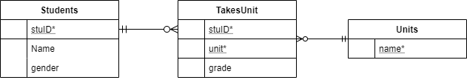

**Schema 2:**

1) Identify the candidate key(s)

The candidate key here is ‘city’ because it is the only attribute which can identify a unique row in the table.

2) Identify the key and non-key attributes in every table.

Key attributes: city

Non-key attributes: country, pop, co_pop, capital

3) Determine which normal forms from (1NF, 2NF, 3NF, BCNF) the schema does or does not satisfy. Give evidence to support your answer.

1NF: Yes, because each cell contains a single piece of information with no duplicate rows

2NF: Yes, because the primary key isn’t a compound key as it only has a single attribute, therefore there can be no partial functional dependencies meaning 2NF is satisfied.

3NF: No, because there are transitive functional dependencies in the table: city -> country -> co_pop (country population depends on country, which depends on the primary key of city).

BCNF: No because 3NF is not satisfied

4)

