Meal Planning Sample Week Report
Generated: 2026-04-30 16:17:29 UTC

Recent Plan Runs
Plan Run ID | Run Time | Solver | Seconds | Slack | Total kcal/fiber
4 | 2026-04-30 16:14:47.008592+00:00 | optimal | 0.05 | 25872.00 | 0 / 0.0
3 | 2026-04-30 16:14:46.841052+00:00 | optimal | 0.06 | 25872.00 | 0 / 0.0
2 | 2026-04-30 16:14:39.601688+00:00 | optimal | 0.06 | 25872.00 | 0 / 0.0

Latest Plan (Week)
Day | Breakfast | Lunch | Dinner | Snack
1 | Super Seedy Breakfast Porridge | One-Pot Chipotle Pasta with Smoky Seedy Topping | 4-Bean Chilli | Simply Perfect Beef Spag Bol
2 | Mango and Kale Smoothie Bowl | Tomato Risotto with Saffron | 4-Bean Chilli | Butternut Squash and Quinoa Chilli
3 | Mango and Kale Smoothie Bowl | Butternut Squash and Quinoa Chilli | All-in-one kale & borlotti minestrone with ditalini, chilli oil & pine nuts | Simply Perfect Beef Spag Bol
4 | Gluten-Free Pancakes | Lemon Chicken Orzo | All-in-one kale & borlotti minestrone with ditalini, chilli oil & pine nuts | Tomato Risotto with Saffron
5 | Gluten-Free Pancakes | Lemon Chicken Orzo | Chickpea & Cauliflower Curry | Lentil Stew With Sausages, Crispy Walnuts And Lemon
6 | Simple Overnight Oats | Lentil Stew With Sausages, Crispy Walnuts And Lemon | Chicken And Mushroom Risotto | One-Pot Chipotle Pasta with Smoky Seedy Topping
7 | Simple Overnight Oats | Papardelle with Fennel Sausage Ragu | Chicken And Mushroom Risotto | Papardelle with Fennel Sausage Ragu

Nutrition Overview
Average daily calories: 0 kcal
Average daily fiber: 0.0 g
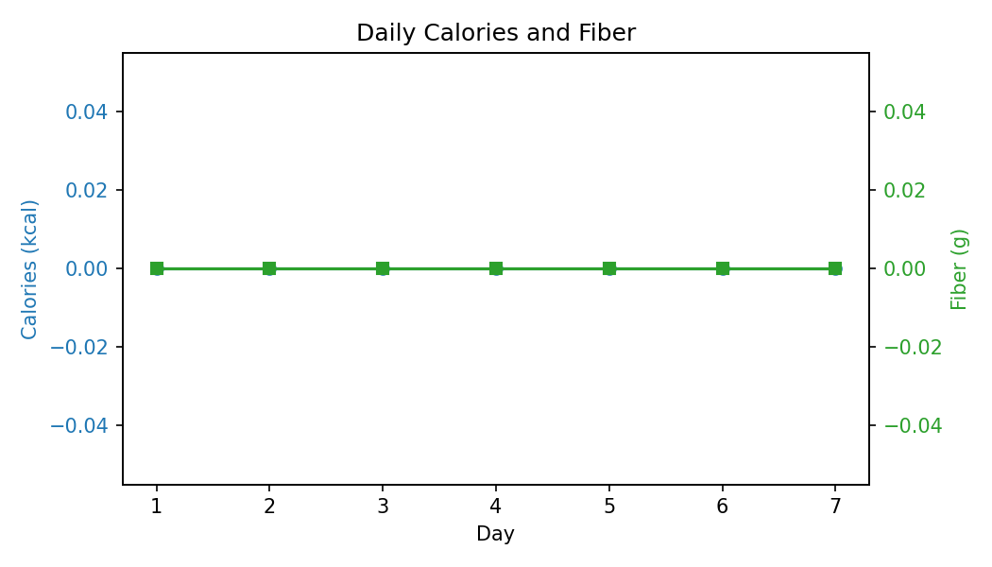

Daily Dozen Coverage
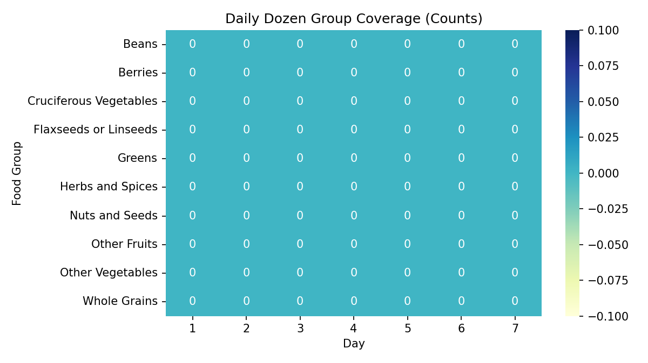

Top Ingredients
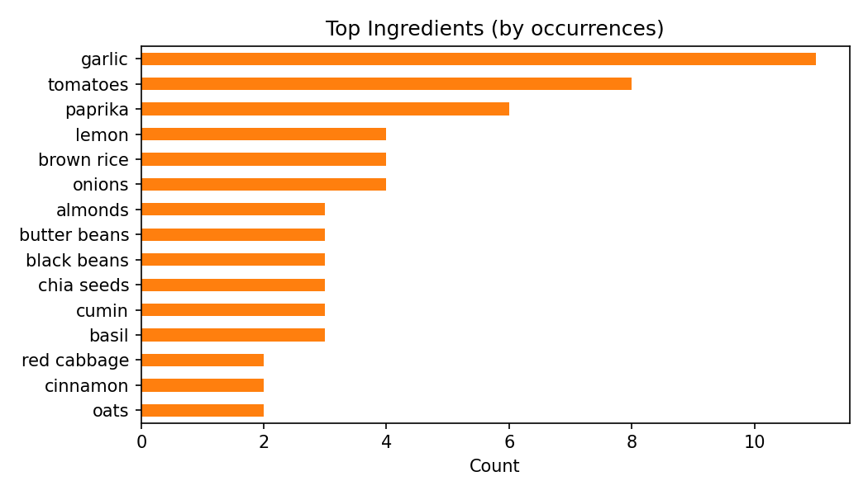

Recipe Repetition
