Modeling and Diagnostics of Reservoir Release Policies Using LSTM
Matthew Chen¹, Jonathan D. Herman²
¹ Department of Civil & Environmental Engineering, University of California, Davis
² Department of Civil & Environmental Engineering, University of California, Davis

Abstract

Introduction

Methods

Introduction to Long Short-Term Memory
Here we give a brief introduction to the Long Short-Term Memory (LSTM) architecture. The LSTM model addresses the problem of unstable gradients in training recurrent neural networks by conserving long term information using memory cells managed by several gating mechanisms. This allows the model to learn dynamic temporal relationships and long-term dependencies (Hochreiter & Urgen Schmidhuber, 1997). In a LSTM, every timestep $t$ has a hidden state $h^{\left(t\right)}$ and a memory cell state $c^{\left(t\right)}.$ The cell states store and maintain long term information, and information from the cell state can be released into the hidden state where it can be used for prediction. This flow of information is managed by the output gate. As new inputs arrive, the model can also save and remove information from the cell state, which are managed by the input gate and forget gate, respectively. The gates control the flow of information through element-wise matrix multiplication, with gate values ranging from 0 and 1.
The gate values at each timestep depend on the previous hidden state $h^{\left(t-1\right)}$ and the new input $x^{\left(t\right)}$ while the sigmoid function $σ$ enforces that the gates values are between 0 and 1. The forget gate, $f^{\left(t\right)}$, parameterized by the weight matrices $W_{f}$, $U_{f}$, and $b_{f}$, controls what information is perpetuated versus forgotten from the previous cell state (Eq. 1).
$$\begin{aligned}f^{\left(t\right)}=σ\left(W_{f}h^{\left(t-1\right)}+U_{f}x^{\left(t\right)}+b_{f}\right)\#\left(1\right)\end{aligned}$$
Meanwhile, the input gate, $i^{\left(t\right)}$, controls the information flow from the new input into the cell state. This gate is parameterized by the weight matrices $W_{i}$, $U_{i}$, and $b_{i}$ (Eq. 2).
$$\begin{aligned}i^{\left(t\right)}=σ\left(W_{i}h^{\left(t-1\right)}+U_{i}x^{\left(t\right)}+b_{i}\right)\#\left(2\right)\end{aligned}$$
Finally, the output gate, $o^{\left(t\right)},$ controls information flow from the cell state to the hidden state to make a prediction at the current timestep. This gate is parameterized by the weight matrices $W_{o}$, $U_{o}$, and $b_{o}$ (Eq. 3).
$$\begin{aligned}o^{\left(t\right)}=σ\left(W_{o}h^{\left(t-1\right)}+U_{o}x^{\left(t\right)}+b_{o}\right)\#\left(3\right)\end{aligned}$$
After the gate values are computed, a candidate cell state update ${\tilde{c}}^{\left(t\right)}$is computed from the previous hidden state and data input from the current timestep using a tanh activation function (Eq. 4).
$$\begin{aligned}{\tilde{c}}^{\left(t\right)}=tanh\left(W_{c}h^{\left(t-1\right)}+U_{c}x^{\left(t\right)}+b_{c}\right)\#\left(4\right)\end{aligned}$$
The cell state is then updated based on the values of the forget and input gates (Eq. 5).
$$\begin{aligned}c^{\left(t\right)}=f^{\left(t\right)}⊙c^{\left(t-1\right)}+i^{\left(t\right)}⊙{\tilde{c}}^{\left(t\right)}\#\left(5\right)\end{aligned}$$
Finally, the hidden state is computed based on the value of the output gate, which is used to derive the final prediction (Eq. 6).
$$\begin{aligned}h^{\left(t\right)}=o^{\left(t\right)}⊙tanh\left(c^{\left(t\right)}\right)\#\left(6\right)\end{aligned}$$
In Figure 1, the operations from Equations 1-6 are presented as a computational graph.
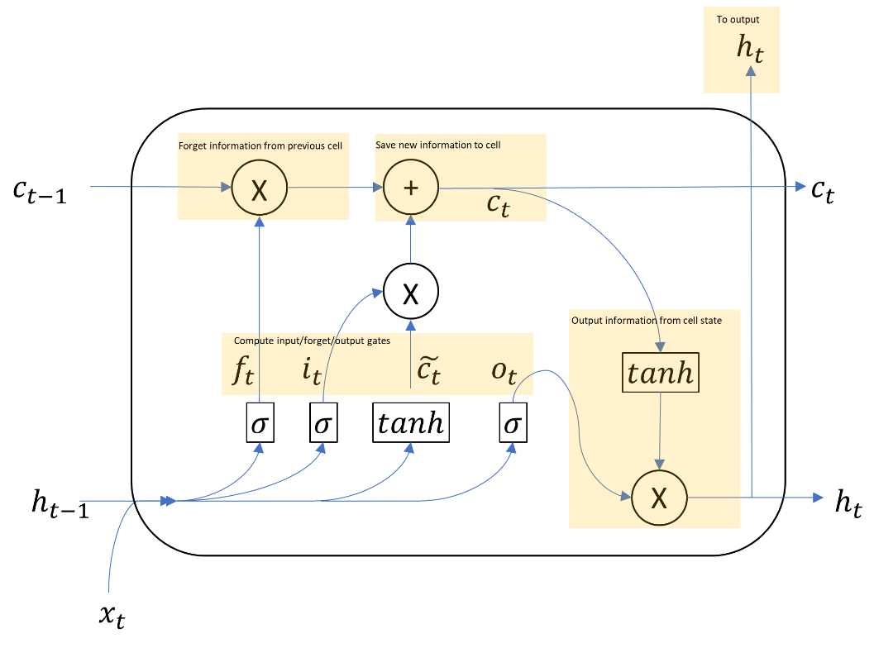
Figure 1. The LSTM architecture represented as a computational graph.

Data Processing
In general, the reservoir data record including inflow and release timeseries are split into training, validation, and testing portions. The training portion, representing the first 60% of the available timeseries, is used directly for model training, i.e. optimizing model parameters to improve fit. The validation portion, representing the next 20% of the available record, is used for hyperparameter tuning, model selection, and early stopping. Early stopping is a technique that prevents overfitting by interrupting the training process based on the validation data as a proxy for out-of-sample performance. The validation set provides some measure of out-of-sample performance especially if the validation set is not over utilized in the modeling process (i.e. overfitting to validation or “data leaking”). Finally, the testing portion, representing the last 20% of the available data record, is used solely for the estimation of out-of-sample performance. The testing data is untouched throughout the model building process; however, it is also the furthest away from the training set in time. This may be a challenge if the reservoir operating policy has shifted in the meantime.
Prior to modeling, the data is linearly transformed to be zero mean and unit standard deviation, based on statistics from the training set. In early experiments, data normalization or the scaling of the data to be in between 0 and 1 was also tested but provided little benefit over standardization. Additionally, while the majority of records are verified to be complete, missing values are imputed using the training mean. We also split the data into batches of 3 years each to stabilize the training of the LSTM models. Using longer sequences may result in vanishing or exploding gradients in the training process, while shorter sequences will stunt the model’s ability to capture longer term dependencies, such as carryover storage.

Model Selection and Hyperparameter Tuning
In the first section of this study, we conduct experiments on an individual reservoir (Shasta Reservoir) to compare model architectures, select optimal hyperparameters, and compare LSTM performance against other machine learning benchmarks. Out of concern for computational cost, the hyperparameters selected here are generally used throughout the study; while we recognize that optimal hyperparameters for Shasta reservoir may not be optimal for a different reservoir, tuning to a specific reservoir will provide a general idea for the size of model necessary to capture reservoir operations.
We consider three main LSTM architectures (see Figure 2). We are interested in the ability of the LSTM to learn to conserve mass and learn reservoir storages implicitly in its cell states; as such the modeling task is to predict reservoir releases based only on inflow and the day of the year inputs. Model 1 is a standard LSTM model where data is first processed by an LSTM and then headed by a single layer feed-forward neural network to provide additional non-linear flexibility in learning the operating policy. Model 2 is similar to Model 1 but adopts an autoregressive structure. That is, the previous output is concatenated as an additional input for the current prediction. Finally, Model 3 externally models the mass balance for implied storages and concatenates them as an additional input. All three models are trained using the square error loss function.
For hyperparameter tuning, we tune the model architecture details using exhaustive search. Specifically, we select the model with the optimal validation loss over a predefined grid of hyperparameters, averaging over 5 different random seeds to account for stochasticity in the optimization algorithm. In this study, we tune the number of LSTM layers (1 or 2), the size of the LSTM hidden layer (between 5 and 50), the hidden size of the feed-forward net (between 5 and 50), and the dropout regularization probability (0.3, 0.5, or 0.7).
The LSTM experiments were conducted in the Pytorch deep learning library (Paszke et al., 2019). In training, model parameters were optimized using the Adam algorithm, a first-order stochastic gradient descent algorithm with momentum, and strong performance demonstrated in practice (Kingma & Ba, 2015).
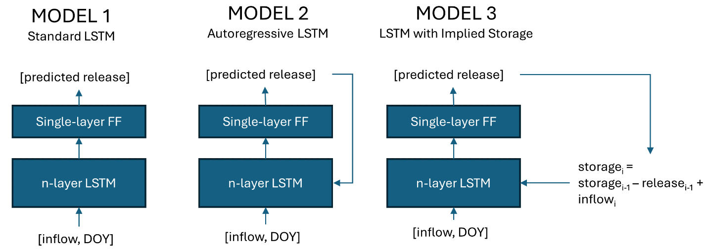
Figure 2. LSTM model architectures. “FF” is short for feed-forward neural network; “DOY” is short for day of the year.

Machine Learning Benchmarks
As benchmarks for the LSTM model, we consider autoregressive linear and random forest models with 5 lags. Specifically, we model reservoir releases as a function of the current day of the year and inflow, as well as the previous 5 inflow values. We also consider benchmarks where the current observed storage is another data input since the linear and random forest models cannot learn to preserve information over time unlike the LSTM architecture (these are denoted linear* and random forest*, respectively). This modeling problem is represented by Equation 7, where ${\hat{y}}^{\left(t\right)}$ is the predicted target release at time $t$, and $x_{in},x_{sto},x_{DOY}$ are the inflow, storage, and day of year features, respectively.
$$\begin{aligned}{\hat{y}}^{\left(t\right)}=f\left(x_{in}^{\left(t\right)},x_{in}^{\left(t-1\right)},x_{in}^{\left(t-2\right)},x_{in}^{\left(t-3\right)},x_{in}^{\left(t-4\right)},x_{in}^{\left(t-5\right)},x_{sto}^{\left(t\right)},x_{DOY}^{\left(t\right)}\right)\#\left(7\right)\end{aligned}$$
These benchmark models, trained with square-error loss, are implemented in the open-source scikit-learn library (Pedregosa et al., 2011).
Since we are interested in the LSTM learning storage information implicitly, it is useful to also add a benchmark where observed storage is explicitly provided to the LSTM model. As such we also compare a version of Model 1 (denoted as Model 1*) that is provided inflow, storage and the day of the year rather only inflow and day of the year. We also consider the mass-conserving LSTM (MC-LSTM), which is a modified LSTM architecture where its memory states are true mass accumulators (Hoedt et al., 2021).

Inspection of Cell States and Observed Storage
One of the main questions of this study is to test if a LSTM model applied to the reservoir operations problem is capable of learning storage representations in its memory cell states on its own without being given storage data explicitly, with a larger goal to determine if such a model is physically interpretable. This is inspired by the success of LSTM in capturing hydrologic states such as snowpack in its memory cells without requiring snowpack data (Kratzert et al., 2019). Similar to Kratzert et al., (2019), we study the correlation coefficients between the memory cell states compared to observed storage, as well as visualizing the timeseries of memory states with stronger relationships. The purpose of such an analysis is to uncover if the LSTM manages to learn storage information (therefore conserving mass) in an interpretable way; the ideal would be a model that aligns with physical understanding.

Large Sample Individual Training
Next, we ask the question of how well the LSTM model and the benchmarks perform when trained individually to a large sample of reservoirs across the continental United States. Here we use inflow and release records from the ResOps dataset (Steyaert et al., 2022), and filter for reservoirs where the record is at least 80% complete. For each reservoir selected, we conduct data processing as before, selecting 60% of the available record for training, 20% for validation, and the last 20% for testing.

Large Sample Pooled Training
We additionally test a top-down modeling approach, that is, learning a general model by training on all available data. In rainfall-runoff modeling, studies suggest that training on more than one basin outperforms training on individual basins, i.e. (Kratzert et al., 2024). However, hydrological models capture physical processes that are likely to be generalizable across basins, even if they are out-of-sample. Reservoirs, in contrast, may be operated uniquely, i.e., differing operating functions, and thus a large sample of reservoirs may not form independently and identically distributed samples where generalizable operating behavior can be learned. To access the ability of a simultaneously trained LSTM reservoir policy to generalize, we randomly select 80% of ResOps reservoirs (where at least 80% of the data record is complete), pool and train on them simultaneously, and test out-of-sample performance using the remaining 20% of reservoirs.
We also compare the test performance after fine-tuning the pooled model with various amounts fine-tuning data. Finetuning in this context refers to calibrating a pre-trained model to a specific reservoir by running additional training iterations from data unique to the reservoir of interest. This is related to the concept of transfer learning in the machine learning literature in which a pre-trained model trained on a large dataset can be adapted to improve performance for a potentially different task on a smaller dataset (Tan et al., 2018). The idea of “knowledge transfer” has shown to be successful in a variety of domains including image recognition (Iorga & Neagoe, 2019) and natural language processing (Ruder et al., 2019). In this case, we can train and validate (on a 75% training and 25% validation split, respectively) using 5-30 year subsets of the complete data record for the held-out reservoirs as the finetuning data, and finally test using the last 20% of the complete record so that results between finetuning, individual training, and the pooled training model are comparable. Note that validation scores here are not directly comparable since they vary in length depending on the amount of finetuning data used.

Model Performance vs. Degree of Regulation
Research has shown that LSTM rainfall-runoff models perform worse on managed basins (reference). Consequently, we hypothesize that the degree of regulation in a reservoir adversely affects performance. Specifically, we compare performance from the large sample of individually trained reservoirs against the mean inflow to max storage (surrogate for capacity) ratio as a measure of degree of regulation, and compute Pearson’s correlation coefficient between the LSTM $R^{2}$ performance and the degree of regulation. Statistical inference is done using randomization testing and Monte Carlo resampling, i.e. via permutation test, to determine the p-value against the null hypothesis of no correlation.

Model Performance Over Time
Finally, we study the trend of model performance over time to gain a more robust understanding of out-of-sample performance. While overfitting can lead to a downward shift between training set and out-of-sample performance, reservoir policies themselves may also change over time. Any difference between the out-of-sample and test distributions may cause a declining trend in performance. To understand this problem, we first train a new “initial” LSTM model for several example reservoirs with different degrees of regulation reservoirs based on the first 30 years and validate on the next 10 years, and then analyze $R^{2}$ performance on rolling and sliding 20-year windows to capture how performance changes over time. Notably, this experiment is challenged by limited record lengths: the length of the initial training window is chosen so that the model can learn a reasonable representation of the operating policy while the moving window size is chosen to balance signal and noise.
We also analyze the entire prediction timeseries for the select example reservoirs with different degrees of regulation and plot predicted releases against observed releases for the entire record length. The goal is to further understand the influence of the degree of regulation, as well as to gain insight into the prediction behavior of the LSTM model.

Results

Model Selection and Comparison to Benchmarks
Table 1 summarizes $R^{2}$ performance results for Models 1-3 trained on Shasta Reservoir, as well as its linear and random forest benchmarks, and models where storage is explicitly provided.
Table 1. Train, validation, and test $R^{2}$ scores for LSTM Models 1-3 and benchmark ML models. Models with observed storage as input are denoted with *.
From a model selection perspective, we are interested in comparing validation scores so that the test data is withheld from the model building process; the test data can later be used for further analysis of model behavior (such as the behavior of cell states) and provide a final estimate for out-of-sample performance. Between Models 1-3, Model 1 (validation $R^{2}=0.69$) and Model 2 (validation $R^{2}=0.70$) both perform reasonably well and are essentially the identical, however, we select Model 1 as the main LSTM architecture of interest going forward since Model 1 is more parsimonious and efficient to train. After running the hyperparameter tuning process with exhaustive grid search, we find that 1 LSTM layer, 30 LSTM hidden units, 15 feed-forward hidden units, and a dropout probability of 0.3 is optimal for Model 1. The optimal hyperparameters for Models 2 and 3 are similar, each selecting 1 LSTM layer, 35 LSTM hidden units, and 15-20 feed-forward hidden units. This suggests that the optimal hyperparameters are not sensitive to these different choices of architecture.
Model 1 out-performs the linear* (validation $R^{2}=0.43$) and random forest* (validation $R^{2}=0.64$) machine learning benchmarks even when observed storage is provided, but underperforms itself when observed storage is provided in Model 1* (validation $R^{2}=0.82$). These results highlight the advantage of LSTM to learn non-stationarities, long-term dependencies and non-linear temporal relationships compared to other architectures such as the linear or random forest models. However, while Model 1 may have learned to maintain some internal information about storage over time, the gap in performance compared to Model 1* suggests that even if storage is learned, it may be used sup-optimally. For example, we can use Model 3 which accumulates implied storages explicitly for illustration; the implied storages for Model 3 (validation $R^{2}=0.60$) match observed storages reasonably well and are directly inputted into the model, yet performance is lower than Model 1 or Model 1* (see Figure S1 in the Supplementary Materials).
Performance of MC-LSTM is low with a validation $R^{2}$ of 0.44, which is similar to the linear benchmarks. Since the MC-LSTM enforces mass conservation, we expected it to be a good candidate to learn storage accumulation internally. However, after plotting predicted releases against observed releases, the model is unable to learn reasonable seasonal releases and tends to under or overshoot peak releases (see Figure S2 in the Supplementary Materials).

Comparison of Cell States and Observed Storage
In this section, we compare the memory cell states of Model 1 trained on Shasta reservoir with observed storages to see if the model learns physically interpretable states internally. In the test data, six different cell states have correlation coefficients with observed storage that is greater than or equal to in absolute value to 0.40, with values of 0.52, 0.50, 0.48, 0.46, 0.43, and -0.45, respectively. These states are scaled and plotted against observed storage for the testing dataset in Figure 3. We observe that in many cases, the analysis reveals memory cell states contain information about the seasonality of storages, but not the values of storages themselves. It is possible that the storage values are represented through complex interactions of multiple different states, though unfortunately such a situation would not be directly interpretable. Overall, these results are consistent with the previous finding that performance is lower when storage is withheld from the LSTM.
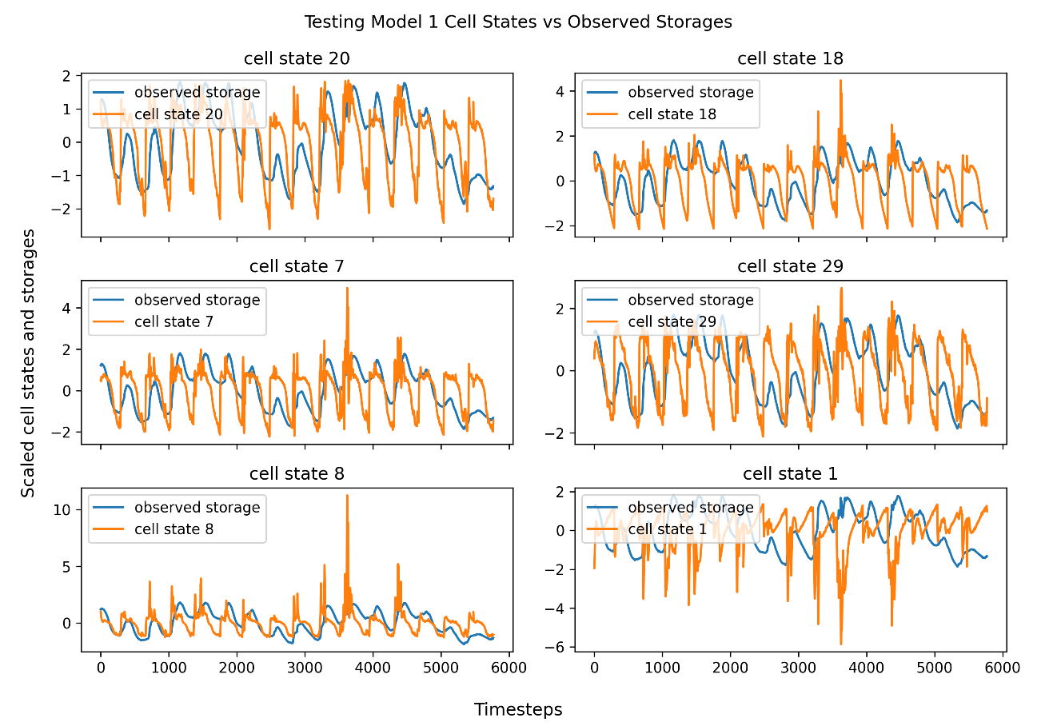
Figure 3. Comparison of cell states with high correlation to storage and observed storage.

Performance for Many Reservoirs
Next, we extend our results to evaluate Model 1 performance when fitted individually to large sample of ResOps reservoirs (n=116). Figure 4 shows the distribution of $R^{2}$ scores across the training, validation, and test sets. We find that in both validation and testing, Model 1 (validation median = 0.618) performs similarly to a random forest with observed storage (validation median = 0.612), while both significantly outperform the linear models (validation median = 0.376). Model 1*, with observed storage inputs, has the highest performance (validation median = 0.712). These results are consistent with the model selection findings for Shasta reservoir.
We also observe large spreads of $R^{2}$ scores for each model, with high and low extreme values. For example, the interquartile range for Model 1 in validation is 0.357 with a maximum score of 0.978 and a minimum score of -1.656.
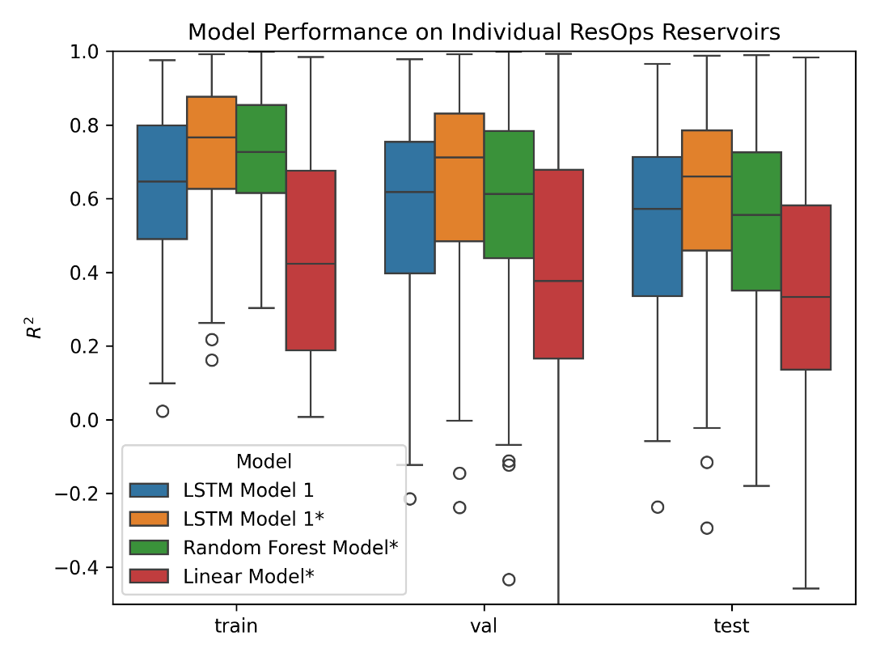
Figure 4. Distribution of $R^{2}$ scores for Model 1 and selected benchmarks for n=116 reservoirs. Models with observed storage as input are denoted with *.

Pooled Training and Finetuning
After training models to reservoirs individually, we answer the question of whether stronger results can be achieved by training on a pool of reservoirs simultaneously, and if transfer learning or finetuning can be leveraged to further improve performance. Figure 5 compares $R^{2}$ scores on the last 20% of record for out-of-sample (OOS) reservoirs, comparing individually trained models, the pooled model, as well as finetuning the pooled model with 5-30 years of data. We find that the pooled model (median score of 0.343) performs significantly worse than training individually (median score of 0.567). This result confirms that given the feature space, we are unable to find a strong reservoir policy that generalizes across reservoirs. Introducing finetuning improves performance, although not exceeding training models individually. This suggests that finetuning on the pooled model provides little additional knowledge compared to individual training.
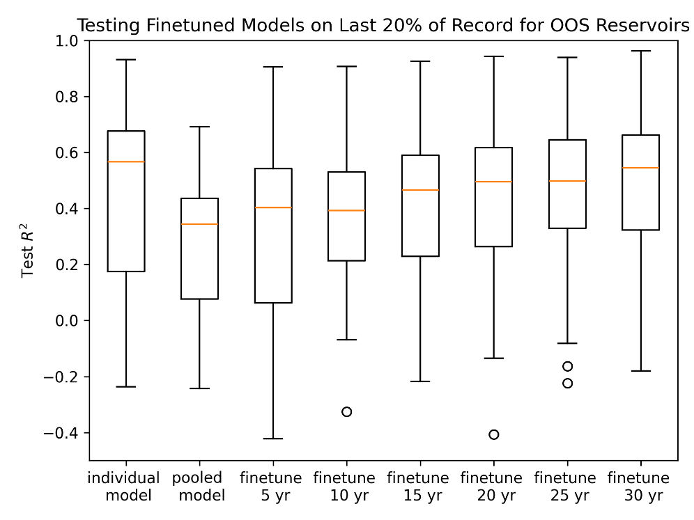
Figure 5. $R^{2}$ performance scores on the last 20% of available record for out-of-sample (OOS) reservoirs for individual and pooled Model 1 and finetuning on 5-30 years data

Degree of Regulation and Model Performance
Previously, we found large variances in performance across a large sample of reservoirs (Figure 4). In this section, we find that the degree of regulation as a key metric that adversely affects model performance. A lower degree of regulation may indicate shorter lag times between inflow and release, i.e., release predictions are more directly sensitive to inflow and therefore more accurate. Figure 6 confirms these results, plotting $R^{2}$ performances against the log ratio between mean inflow and max storage (higher indicates lower degree of regulation). We find that the Pearson’s correlation between $R^{2}$scores and the log mean-inflow-max-storage ratio to be high, 0.6, 0.59, and 0.49 for the training, validation, and test scores, respectively. Randomization testing reveals that the correlation coefficients are significant at the 0.05 level, that is, rejecting the null hypothesis of no correlation. These results provide strong evidence that model performance is adversely associated with increased degree of regulation.
We also find no clear connection between geographic location and model performance. Figure 7 shows $R^{2}$ with respect to geographic location, and we find no apparent spatial patterns; location alone does not appear to be a strong indicator of model performance unlike the degree of regulation.
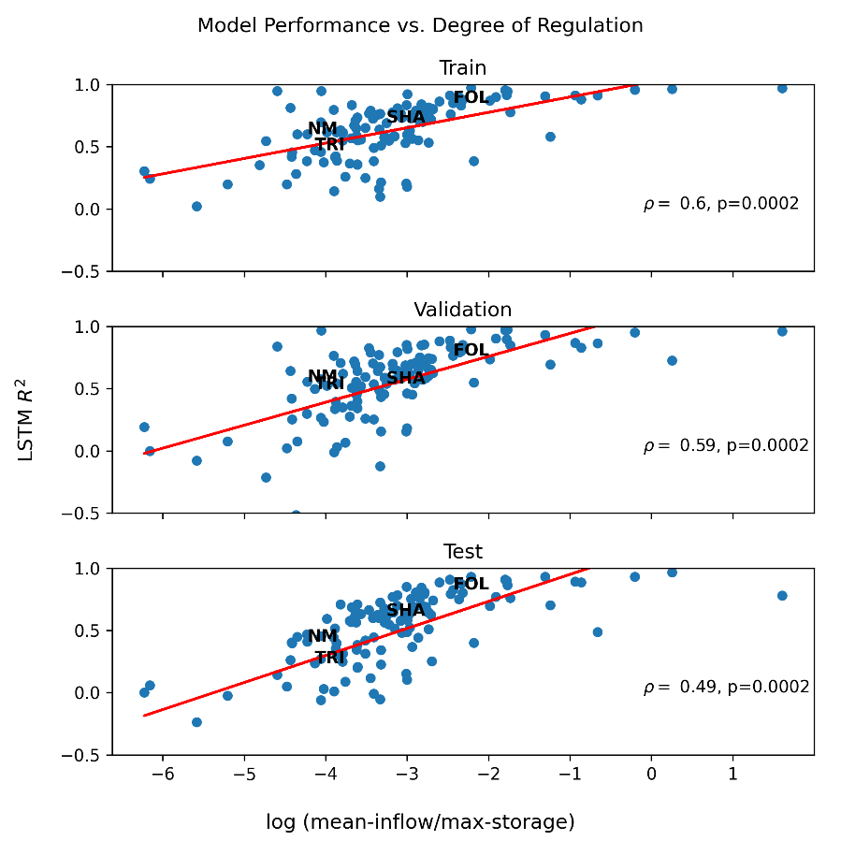
Figure 6. Train, validation, and test $R^{2}$ plotted against the log mean-inflow-max-storage ratio for individually trained LSTMs
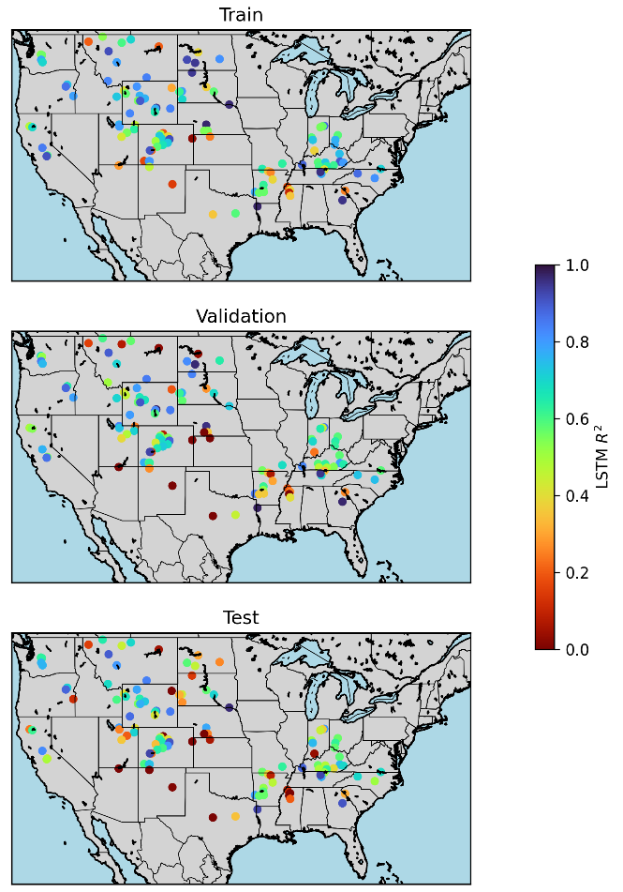
Figure 7. Map of train, validation, and test $R^{2}$scores for individually trained LSTMs

Analysis of Release Timeseries
Four specific sites, Folsom (FOL), Shasta (SHA), Trinity (TRI), and New Melones (NM), are selected from the data cloud in Figure 6 to represent different degrees of regulation, as measured by the log mean-inflow-max-storage ratio. Folsom represents the lowest degree of regulation, while Trinity and New Melones have higher degrees of regulation. Shasta reservoir is in between. Figure 8 plots the predicted and observed releases for these four selected reservoirs using LSTM Model 1.
Both Shasta and Folsom capture peak releases reasonably well, however, Shasta is more prone to false-positive peaks, which can be resolved by inputting observed storage (see Supplementary Materials Figure S3 for Model 1* timeseries). This suggests that adding observed storage facilities the Shasta model to learn better thresholding behavior and improve performance when predicting larger lags between inflow and release, and that the model was unable to learn this optimally on its own. Meanwhile, Folsom has a lower degree of regulation making it more sensitive to inflow patterns directly, which corresponds to higher performance. In contrast, New Melones and Trinity reservoirs have much lower performance scores corresponding to their high degree of regulation. While both learn reasonable seasonal releases, the models have largely ignored peak releases especially for Trinity reservoir. Adding observed storage to the model does not alleviate this behavior, which highlights peak releases that are heavily regulated. In all, these results complement the finding that the degree of regulation adversely affects model performance.
Sharp declines in validation and test performance are also observed for Shasta, New Melones, and Trinity, but not for Folsom. While some degree of overfitting is possible, it is also likely that the drop in performance is due to the reservoir release policy itself changing in between the training and testing periods. Shasta, New Melones, and Trinity have higher degrees of regulation and may be more sensitive to changes in policy, while Folsom releases are more sensitive to inflows directly which make them less affected by changes to the operating policy. This conjecture is supported by a weak negative correlation ($ρ=-0.24$) between the difference in train and test $R^{2}$ and the log mean-inflow-max-storage ratio (Figure 9). The result is statistically significant ($p=0.014)$. That is, there is statistically significant evidence that a higher degree of regulation corresponds to larger declines in train and test performance.
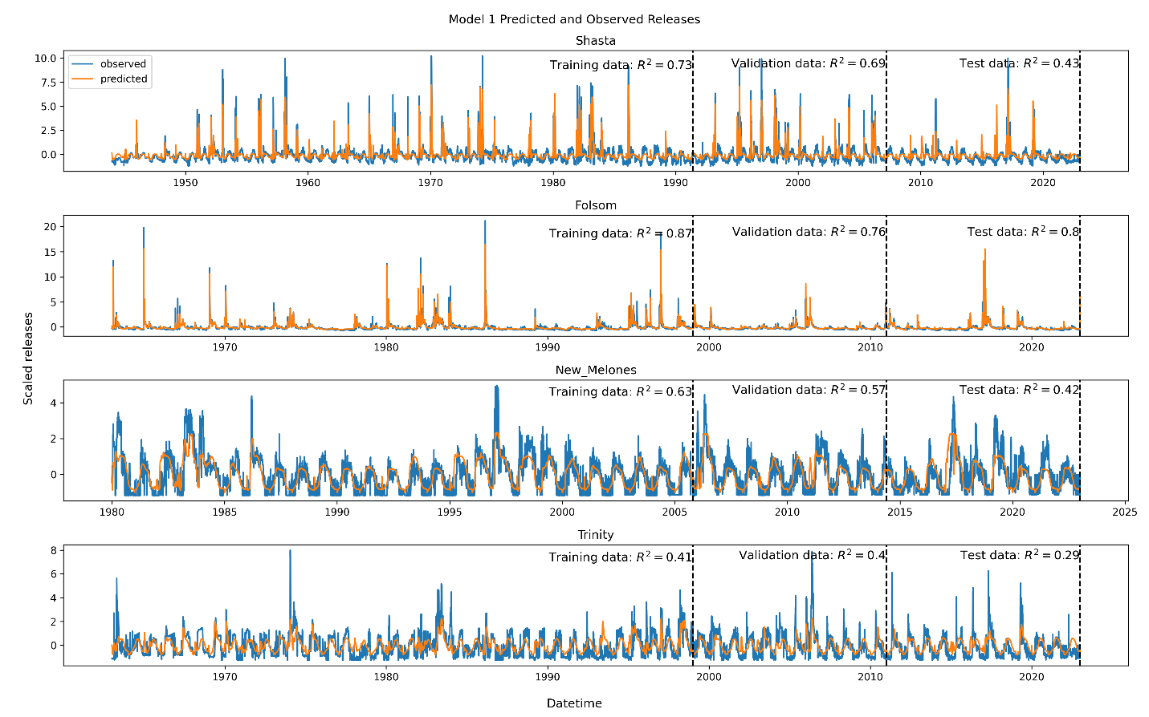
Figure 8. Timeseries plots for predicted and observed releases for Shasta, Folsom, New Melones, and Trinity using Model 1
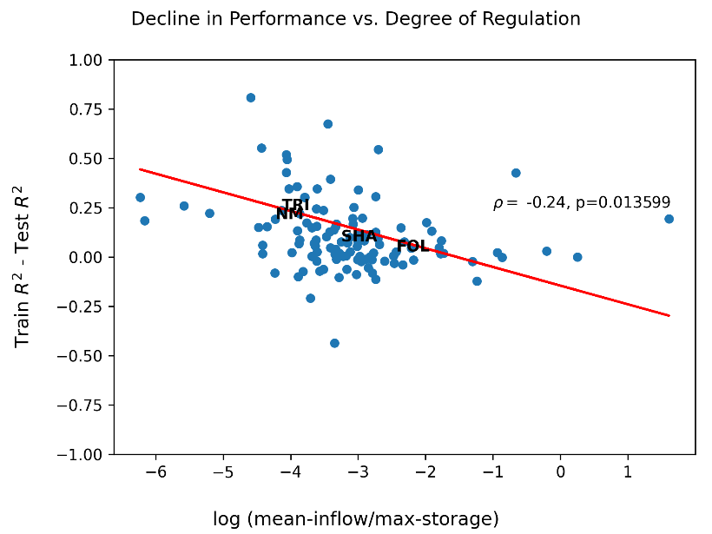
Figure 9. Decline in $R^{2}$ in training and test versus log mean-inflow-max-storage ratio.

Performance Over Time
We continue to explore the question of declining performance using an “initial model” trained on the first 30 years of record and validated on the next 10 years for Folsom, Shasta, New Melones, and Trinity. Figure 10 shows performance in 20-year rolling and sliding windows for these selected reservoirs. The initial model for Folsom shows an initial drop in performance apparent in the rolling windows, but then stabilizes. This behavior is expected with some degree of overfitting; although note that the full Folsom model is not prone to overfitting from Figure 8. In contrast, performance for Shasta continues to decline and does not stabilize. This is also consistent with declining train, validation, and test $R^{2}$ for the full Shasta model in Figure 8. In the sliding window plots, there is a clear decrease in slope in the out-of-sample region. This behavior is consistent with changing distributions between testing windows and the initial training window – supporting the hypothesis that changing operating policies are resulting in declining performance. The trends for New Melones and Trinity are more difficult to interpret. New Melones has a much shorter record length, so it is difficult to distinguish between overfitting and shifting operating policy. The initial model for Trinity appears to be underfit, with very poor training performance but higher out-of-sample performance.

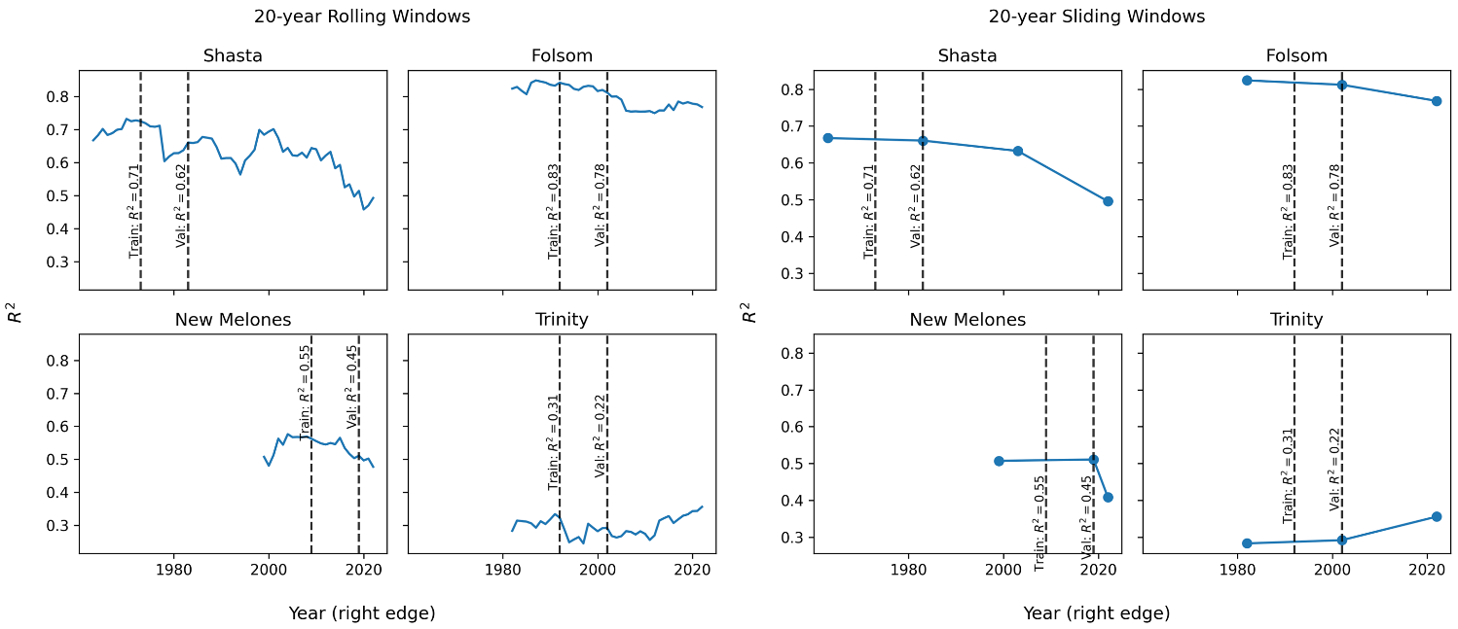
Figure 10. 20-year rolling and sliding $R^{2}$ performance for initial models trained for Shasta, Folsom, New Melones, and Trinity

Discussion and Conclusion

Data Availability Statement
All code corresponding to methods and figure generation can be found in the repository: https://github.com/Matt2371/DL-reservoir-modeling.

Acknowledgments

References
Hochreiter, S., & Urgen Schmidhuber, J. (1997). Long Short-Term Memory. Neural Computation, 9(8), 1735–1780. https://doi.org/https://doi.org/10.1162/neco.1997.9.8.1735
Hoedt, P.-J., Kratzert, F., Klotz, D., Halmich, C., Holzleitner, M., Nearing, G., et al. (2021). MC-LSTM: Mass-Conserving LSTM. Proceedings of the 38th International Conference on Machine Learning, 139, 4275–4286. Retrieved from http://arxiv.org/abs/2101.05186
Iorga, C., & Neagoe, V.-E. (2019). A Deep CNN Approach with Transfer Learning for Image Recognition. In 2019 11th International Conference on Electronics, Computers and Artificial Intelligence (ECAI) (pp. 1–6). IEEE. https://doi.org/10.1109/ECAI46879.2019.9042173
Kingma, D. P., & Ba, J. (2015). Adam: A Method for Stochastic Optimization. In Proceedings of the 3rd International Conference on Learning Representations (ICLR 2015) (pp. 1–15). Retrieved from http://arxiv.org/abs/1412.6980
Kratzert, F., Herrnegger, M., Klotz, D., Hochreiter, S., & Klambauer, G. (2019). NeuralHydrology – Interpreting LSTMs in Hydrology. In Explainable AI: Interpreting, Explaining and Visualizing Deep Learning (Vol. 11700, pp. 347–362). https://doi.org/10.1007/978-3-030-28954-6_19
Kratzert, F., Gauch, M., Klotz, D., & Nearing, G. (2024). HESS Opinions: Never train an LSTM on a single basin. Hydrol. Earth Syst. Sci. Discuss. [Preprint], 1–19. https://doi.org/10.5194/hess-2023-275
Paszke, A., Gross, S., Massa, F., Lerer, A., Bradbury, J., Chanan, G., et al. (2019). PyTorch: An Imperative Style, High-Performance Deep Learning Library. In 33rd Conference on Neural Information Processing Systems (NeurIPS 2019) (pp. 1–12). Retrieved from http://arxiv.org/abs/1912.01703
Pedregosa, F., Michel, V., Grisel, O., Blondel, M., Prettenhofer, P., Weiss, R., et al. (2011). Scikit-learn: Machine Learning in Python. Journal of Machine Learning Research (Vol. 12). Retrieved from http://scikit-learn.sourceforge.net.
Ruder, S., Peters, M. E., Swayamdipta, S., & Wolf, T. (2019). Transfer Learning in Natural Language Processing. In Proceedings of the 2019 Conference of the North (pp. 15–18). Stroudsburg, PA, USA: Association for Computational Linguistics. https://doi.org/10.18653/v1/N19-5004
Steyaert, J. C., Condon, L. E., W.D. Turner, S., & Voisin, N. (2022). ResOpsUS, a dataset of historical reservoir operations in the contiguous United States. Scientific Data, 9(1), 34. https://doi.org/10.1038/s41597-022-01134-7
Tan, C., Sun, F., Kong, T., Zhang, W., Yang, C., & Liu, C. (2018). A survey on deep transfer learning. In Lecture Notes in Computer Science (including subseries Lecture Notes in Artificial Intelligence and Lecture Notes in Bioinformatics) (Vol. 11141 LNCS, pp. 270–279). Springer Verlag. https://doi.org/10.1007/978-3-030-01424-7_27

Supplementary Materials
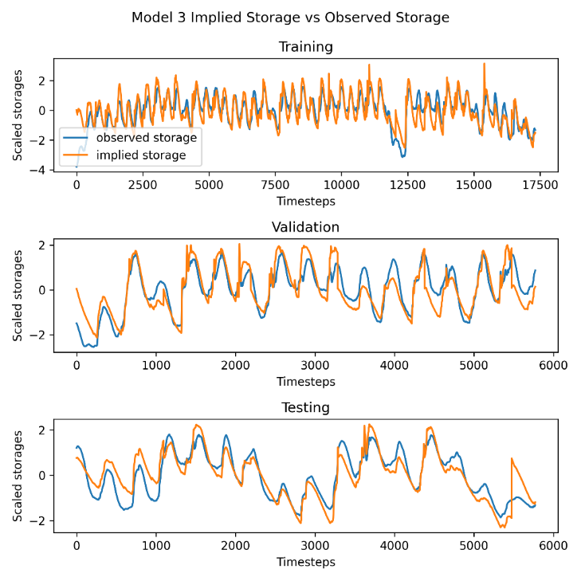
Figure S1. Comparison between Model 3 implied storage and observed storage for Shasta Reservoir

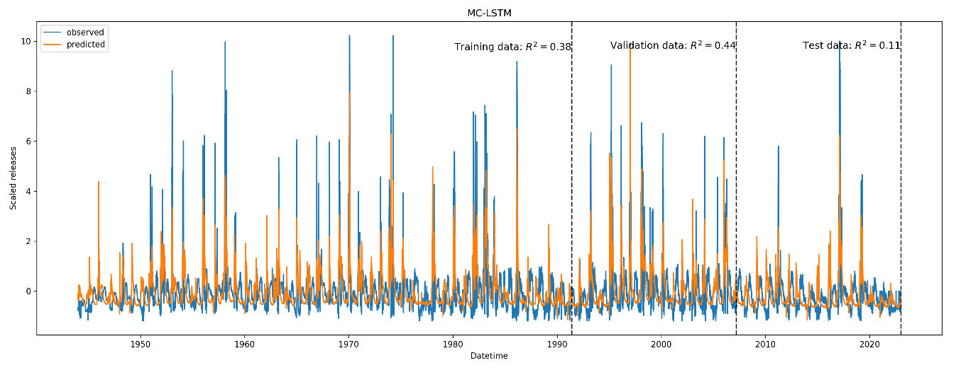
Figure S2. MC-LSTM predicted and observed releases.
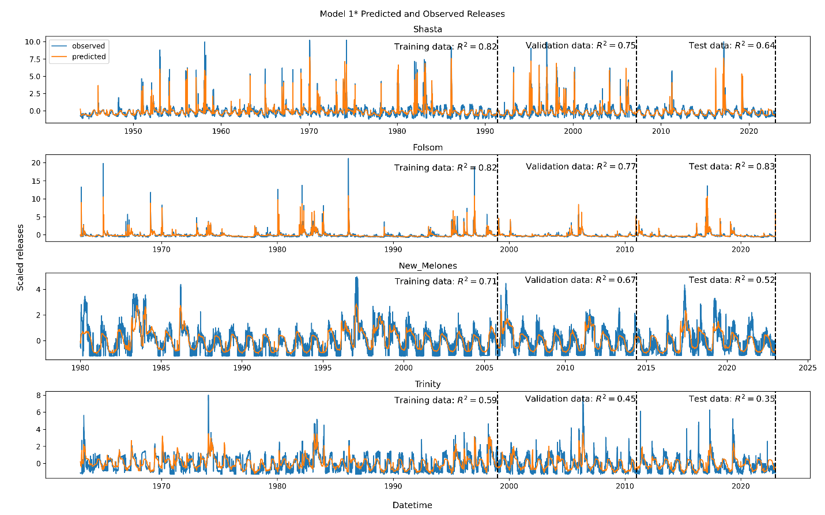
Figure S3. Timeseries plots for predicted and observed releases for Shasta, Folsom, New Melones, and Trinity using Model 1*

