**Results**

**Model Projections**

Figure 1 below plots the projected system objectives for all scenarios. For reliability, it is apparent that the mean of all scenarios is decreasing, from about 0.9 at the start of the projection to 0.7 at the end, though variability is also increasing with time. For flood volume, the mean of all scenarios remains relatively constant, though variability is also increasing with time as with reliability. It is difficult to discern whether flood volume is predicted to increase or decrease.

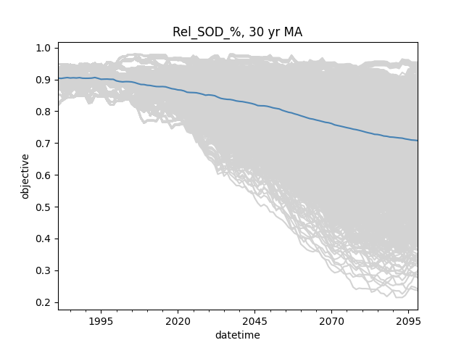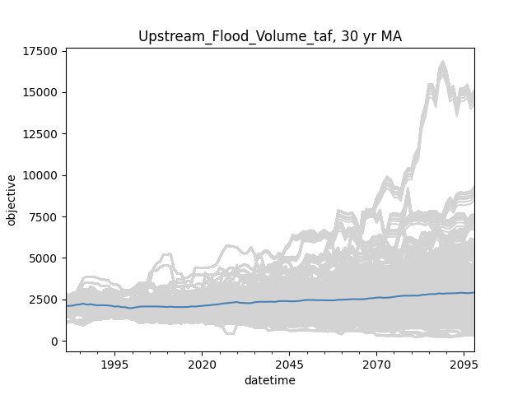

Figure . 30-year moving averages of ensemble projections of water supply reliability (left) and cumulative flood volume (right) for 3492 GCM/RCP/LULC scenarios. The blue line represents the mean of all scenarios.

**Single Scenario Analysis**

For reliability, the distribution of first detection years includes 110 or 0.3% no detects out of the sample size of 3492 scenarios, which are not plotted in Figure 2. The distribution is also heavily right skewed, with many detections occurring earlier in the century. In all, most scenarios show a significant detection, and detections are more likely to happen earlier. For flood volume, the distribution includes 2274 or 65% no detects out of the sample size of 3492. The distribution is also right skewed, though there is also a jump in detections at the end of the century. In all, the majority of scenarios did not detect a significant change in the projection period, and the ones that did are more likely to detect at either early or late extremes.

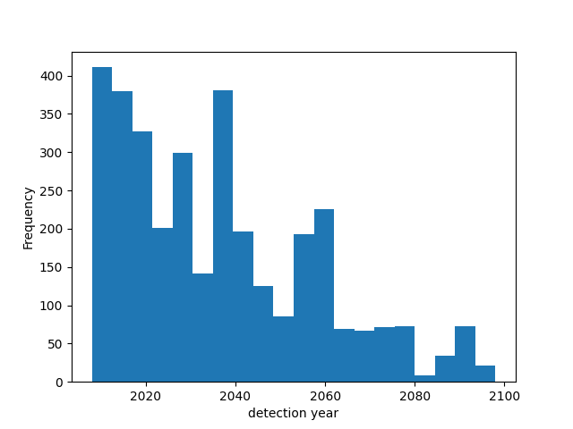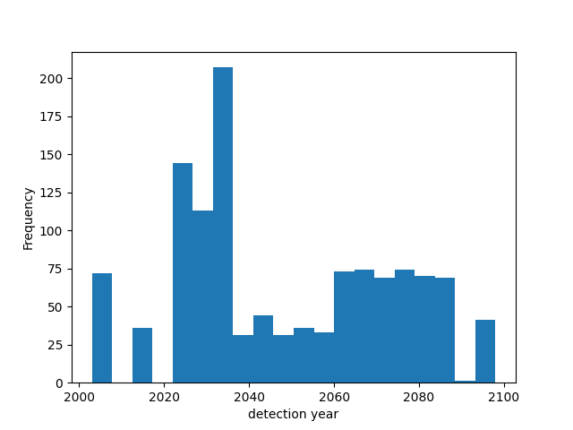

Figure 2. Distributions of first detection years for reliability (left) and flood volume (right) for all scenarios. No-detect scenarios are not shown.

When first detection years are sorted by GCM’s, RCP’s, and LULC’s respectively for reliability (Table 1), it is apparent that GCM’s are the most variable in both the median as first detections occur all over the century and the standard deviation. For LULC, though standard deviations are somewhat larger than from the GCM sorting, the median exhibits a much smaller range centered on about the year 2033. Interestingly, RCP’s, which represents the varying effects of climate change, show increasing medians as the RCP number increases.

Table . Distributions of first detection years sorted by choice of GCM’s, LULC’s and RCP’s for reliability.



Sorting as above was also conducted for flood volume (Table 2). 15 out of 31 GCM’s did not detect a significant change in the projection period, and the variability of the median first dection year for those with detections is high. Results for standard deviations is similar, with a range of 0.2 to 30.3 years despite relatively high sample sizes. In contrast, LULC again shows little effect on median, centered on 2042, and standard deviations are high but consistent. RCP’s exhibit a similar pattern as with reliability, although the 2.6 pathway detected much later in the projection.

The above results show that the choice in GCM contributes the most to objective uncertainty, which can be further confirmed and demonstrated with a more formalized sensitivity analysis.

Table . Distributions of first detection years sorted by choice of GCM’s, LULC’s and RCP’s for cumulative flood volume. Categories with no detections are highlighted.

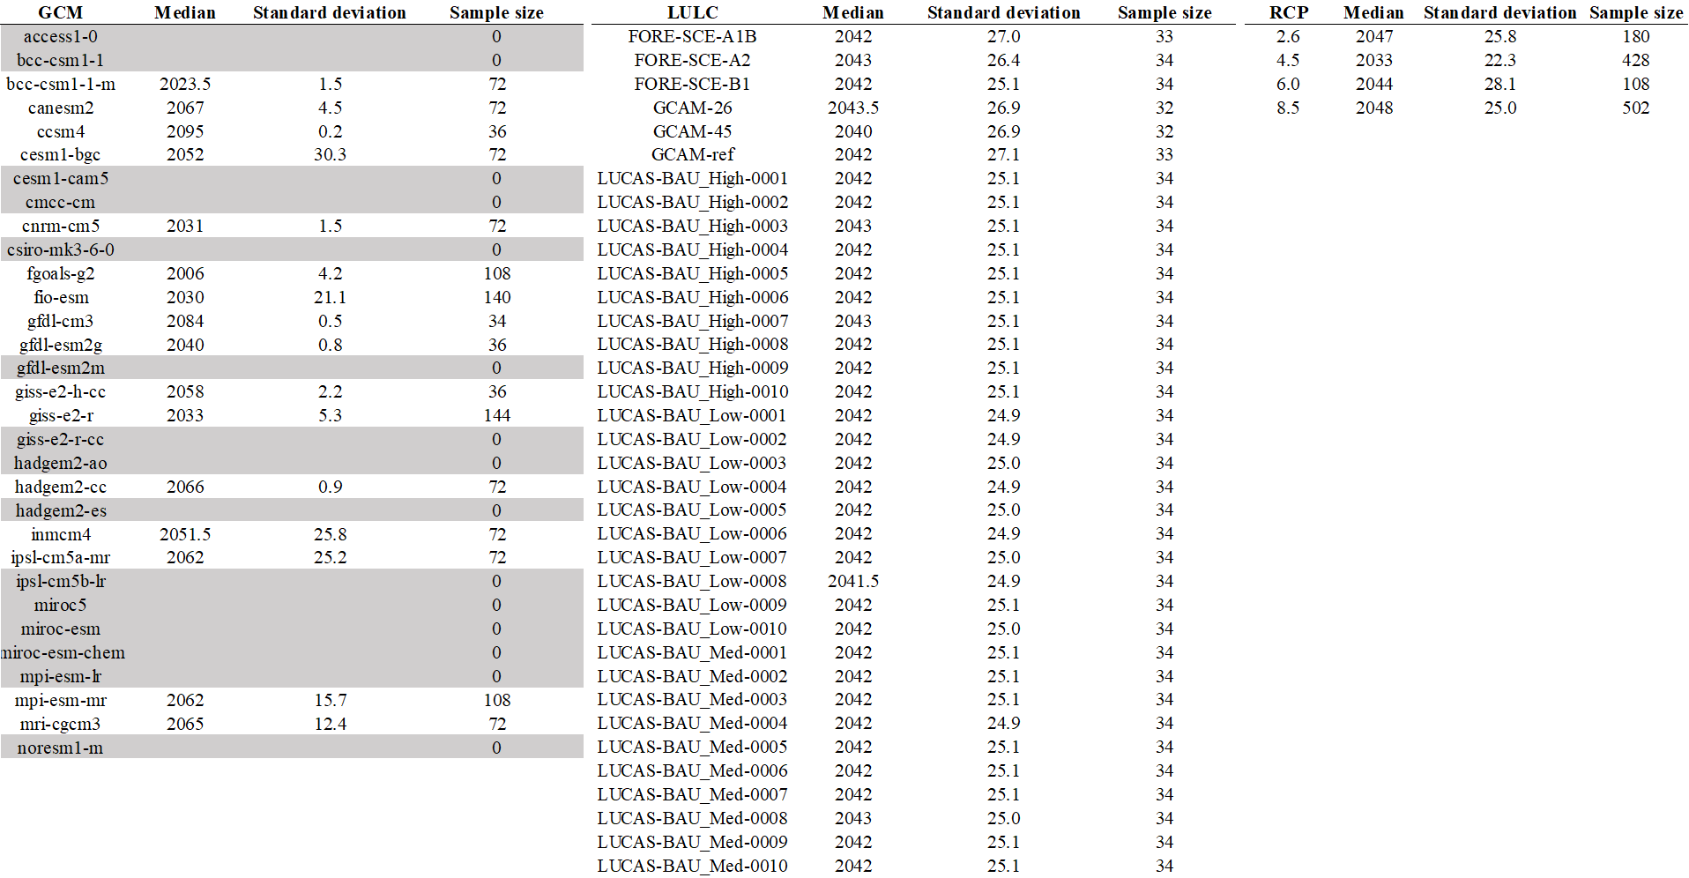

**Multiple Scenario Analysis**

The multiple scenario analysis was presented as relative counts between scenarios with detection and the total number of relevant scenarios. Considering the entire ensemble (Figure 3), it is abundantly clear that the reliability objective showed far greater detection rates compared with flood volume. For reliability, 89.8% of scenarios showed a detection at the end of the projection period whereas only 13.3% scenarios for flood volume show significant change. Additionally, detections climb steadily throughout the projection for both scenarios, although relative counts for reliability show year-to-year less variability.

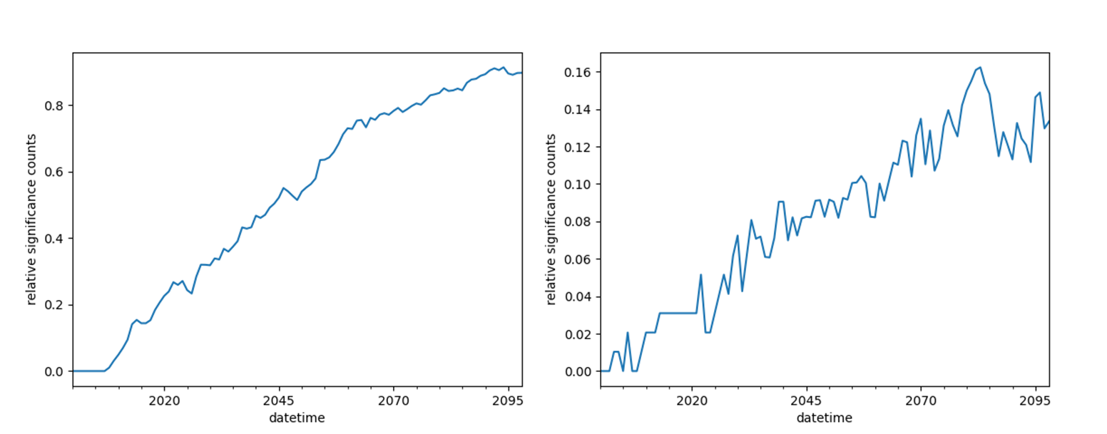

Figure . Annual relative counts of significant detections for the entire ensemble, with the reliability objective shown on the right and flood volume shown on the left

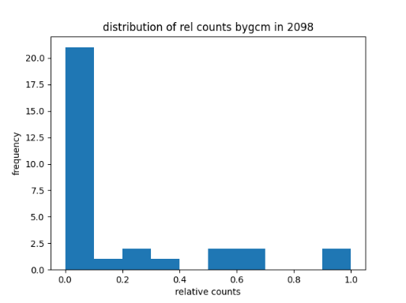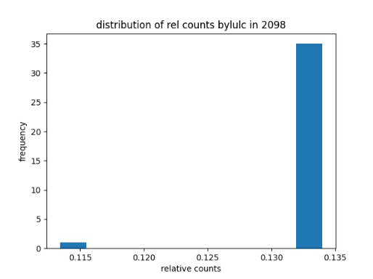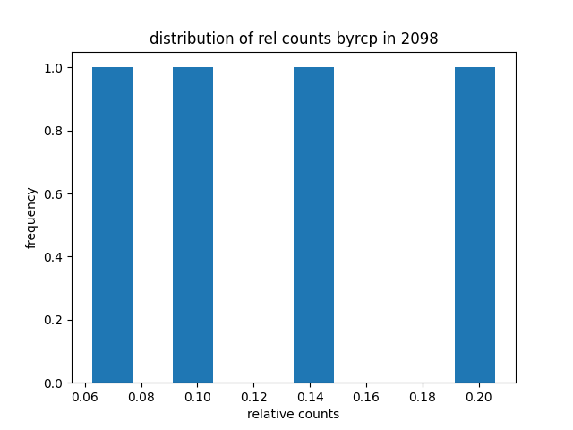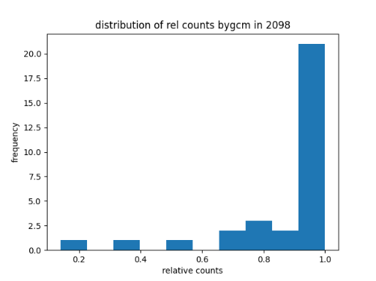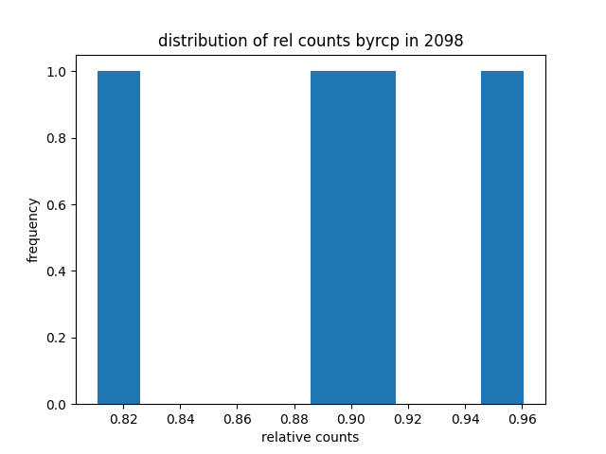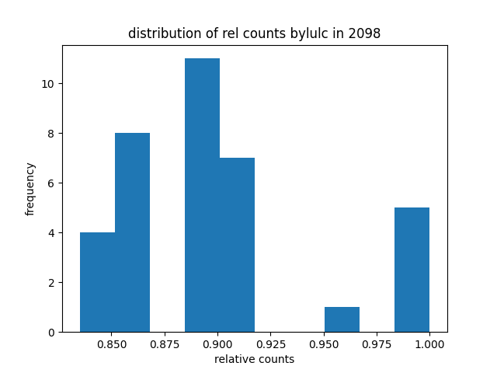

Figure . Distribution of relative detection counts at the end of the projection period (2098) sorted by GCM/RCP/LULC for reliability (top) and flood volume (bottom)