**GAME IDEA 1:** Game Design Brief

**Concept:**  
A top-down dungeon crawler which will have the player moving through a dungeon to defeat the final boss.

**Gameplay:**

The dungeon will be designed as a ‘gothic fantasy’ setting, with obstacles scattered in the level.  
Enemies will periodically spawn and approach the player, who must use their weapons:  
1. A sword that has a short range but higher damage, and  
2. A bow that does ranged attacks but is limited in damage and ammunition.  
 NOTE: There will be pickups available to increase the skills of the weapons and player

There will be 3 levels of the dungeon:  
1. Getting used to controls, pickups, fighting.  
2. Larger and harder level focused on building your equipment and skills.  
3. Boss level.

The game ends when the boss is defeated.

**Core Mechanics:**  
2-Dimensional Movement – By WASD/Arrow Keys  
Basic Interactions – ‘E’ to Interact, ‘I’ for Inventory, ‘LeftShift’ for stats, etc.  
Health, Stamina and Ammunition tracking  
Attack/Defense stat tracking  
Raycast for interaction, attacking, etc.

**Minor Mechanics/Logic:**

UI showing Health, Stamina and Ammunition on screen  
UI showing Inventory, Stats, etc. when a button is pressed  
Pause Menu  
Upon boss defeat, allow the player to play again or exit the game

**Out of scope mechanics:**

Multiplayer Functionality:  
 - Harder Enemies  
Puzzle aspect (Pull levers in a specific order, etc)  
Another Stage  
Magic

**Inspirations/similar works:**

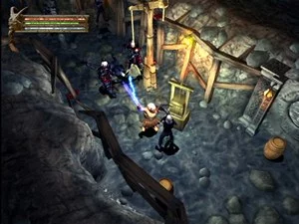- Baldur’s Gate: Dark Alliance

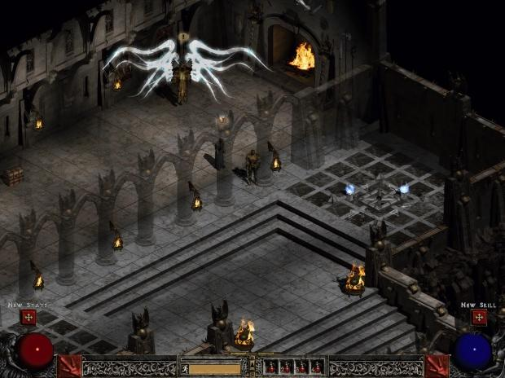 - Diablo 2

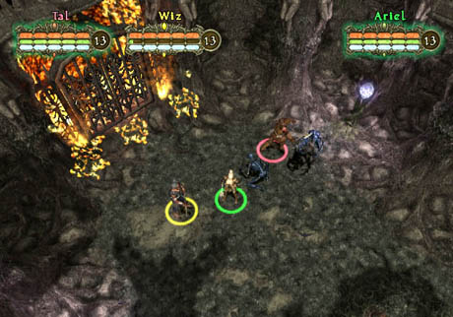 - Champions of Norrath

**Development challenges:**

Making the UI so it will exit the game or restart when the button is pressed  
Adding Textures to the game to fit the style  
Size of the game, will need dedication and appropriate time management.  
Animations