**GAME IDEA 2:** Game Design Brief

**Concept:**  
A side-scroller zerg-rush game where the player will need to survive as long as they can while killing enemies.

**Gameplay:**

The stage is multiple layers, so the player and enemies can jump onto platforms.  
The stage will have modular platforms that move up and down or left to right that the player can utilize to escape from enemies.

There will be periodically stronger enemies that spawn, so the player must utilize the pickups to increase damage, restore health and ammunition.

Players are scored in 3 ways:  
1. Time Survived  
2. No. of enemies killed  
3. No. of pickups used

**Core Mechanics:**  
1-Dimensional Movement – By AD/Arrow Keys, ‘w’ to jump, ‘S’ to crouch  
Interactions – ‘E’ to pickup, ‘Space’ to shoot  
Health and Ammunition tracking  
Raycast attacking  
Score and Time UI

**Minor Mechanics/Logic:**

UI showing Health and Ammunition on screen  
Pause Menu  
Upon defeat, show the final score and allow the player to play again or exit the game

**Out of scope mechanics:**

Multiplayer Functionality – Score challenge  
Different Levels  
Main menu for level selector  
“Mini-Boss” for extra points

**Inspirations/similar works:**

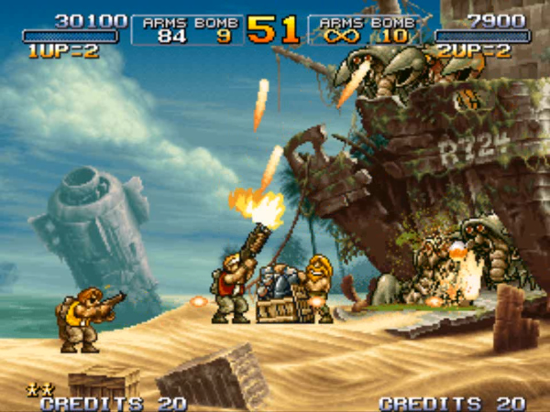- Metal Slug 3

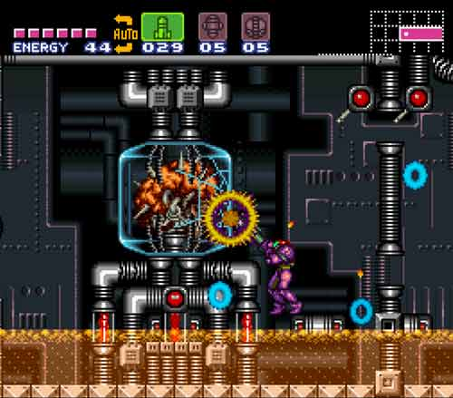 - Super Metroid

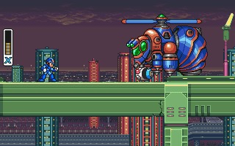 -- Mega Man X

**Development challenges:**

Side Scrolling Aspect  
Moving Platforms  
Random Spawning  
AI tracking and jumping  
Animations