**GAME IDEA 3:** Game Design Brief

**Concept:**  
A 2-player split screen racing game where the goal is to get the shortest time.

**Gameplay:**

There will be 3 different levels to race upon:  
1. Normal Racing Track  
2. Desert Racing Track  
3. Night Racing Track

Each level will have varying level of difficulties including hazards, jumps, off-tracks and possible shortcuts.

The game will end when both players complete 3 laps.  
Upon completion, players will be asked to play again, choose another level or exit the game.

**Core Mechanics:**  
2-Dimensional Movement – By WASD/Arrow Keys   
Time + Position UI

**Minor Mechanics/Logic:**

Pickups to temporarily increase speed.  
Upon completion, show the final score and which player has won, and allow the player to play again, choose another level or exit the game

**Out of scope mechanics:**

Battle Items  
Harder level types – Edges to fall off  
Negative Pickups – Slow Speed of opponent/self, inverse controls.

**Inspirations/similar works:**

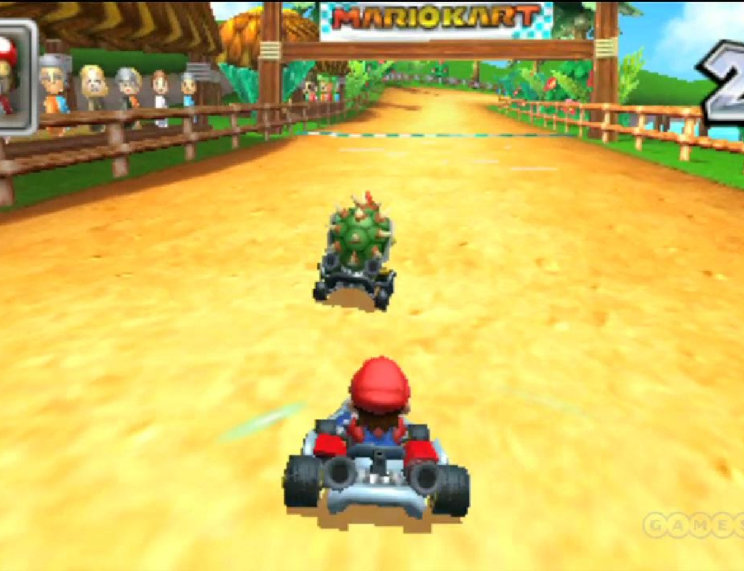 - Mario Cart 7

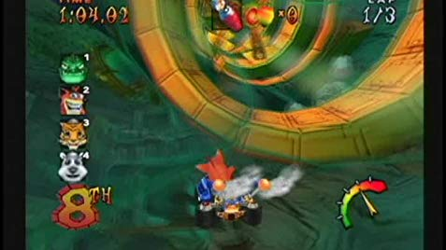 - Crash Nitro Cart

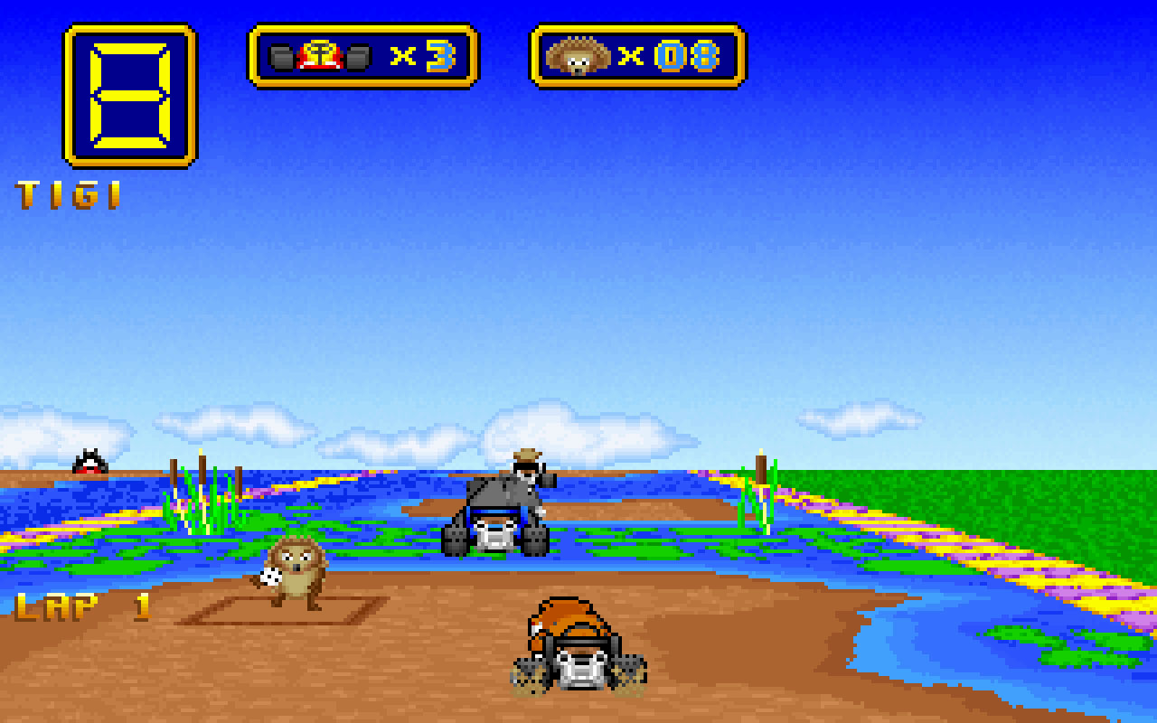 - Wacky Wheels

**Development challenges:**

Temporary Adjustments  
Registering Lap Time and Final Time as separate scoring  
Level Selector  
Animations