Matt Anderson U00628270 <https://github.com/MattAndersonCEG3900>

Laptop: Lenovo ThinkPad T400, 4 GB RAM, Intel Core 2 Duo

Phone: Samsung Galaxy S5 running Android 6.0.1

Task 1:

Screenshots: Page 2

Status report/Summary: Page 3

Documentation: Pilot dropbox

Task 2:

Status report/Summary: Page 5

Task 3:

Screenshots: Page 5-7

Status report/Summary: Page 8

Task 4:

Screenshots: Page 9

Status report/Summary: Page 10

Source: Unchanged

Task 5:

Screenshots: Page 10

Status report/Summary: Page 11

Definition/Help: Page 11

Source/Documentation: Pilot dropbox

### Task 1: Program comprehension: “Uniting Twist” (1.5 hours)

### C:\Users\steinybear\AppData\Local\Microsoft\Windows\INetCache\Content.Word\Screenshot_2017-03-20-13-59-24.png

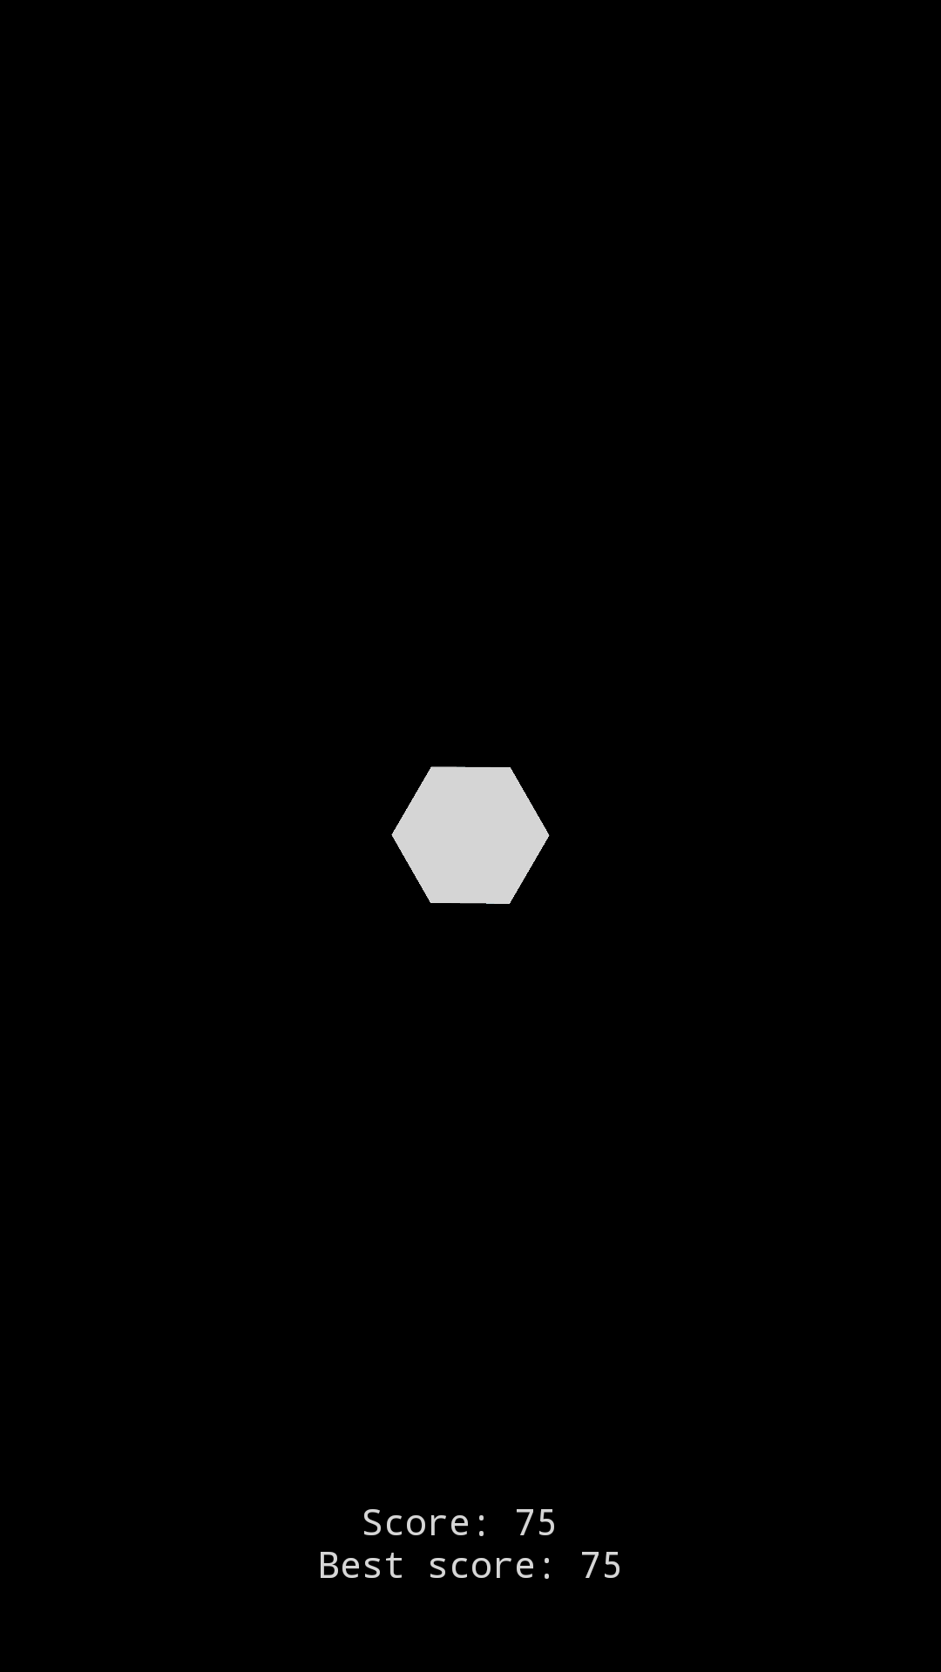

### 

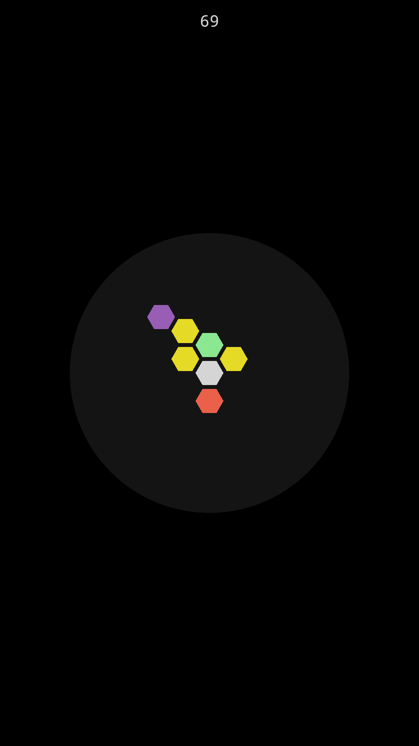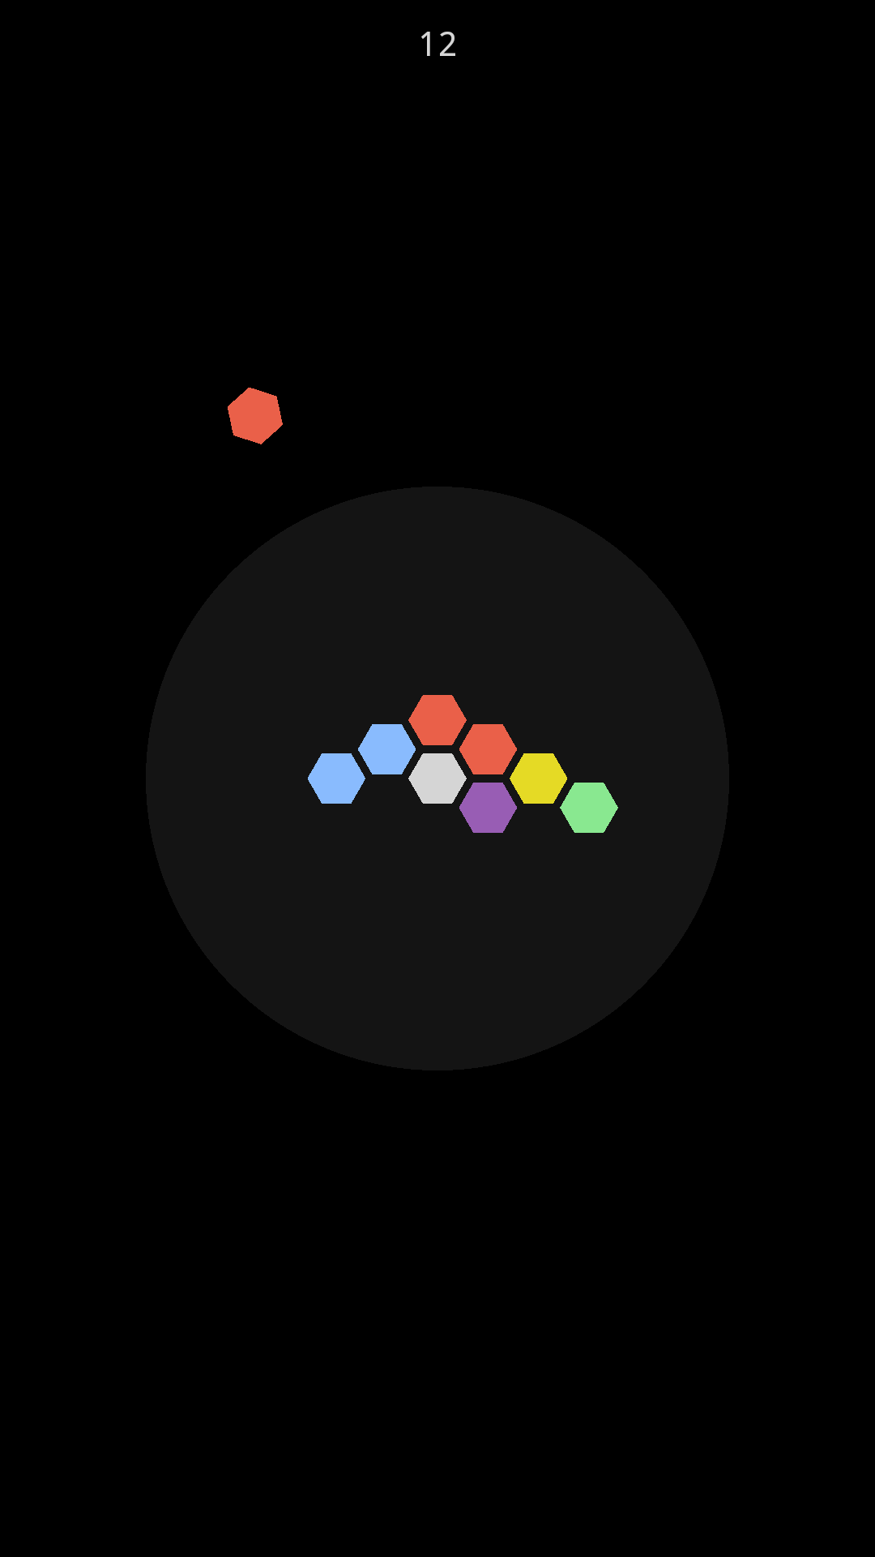

**Status**:

This program is working fine. I have not experienced any hangs, bugs, or crashes with it in its current state.

**Summary**:

This is one of the few programs that compiled and ran flawlessly and without hours of troubleshooting. It was also relatively easy to play it and figure out what the goal was and what the rules were. I would definitely keep this part of the project in future sections of the course.

### Task 2: MS Azure: Photo Uploader (1 hour)

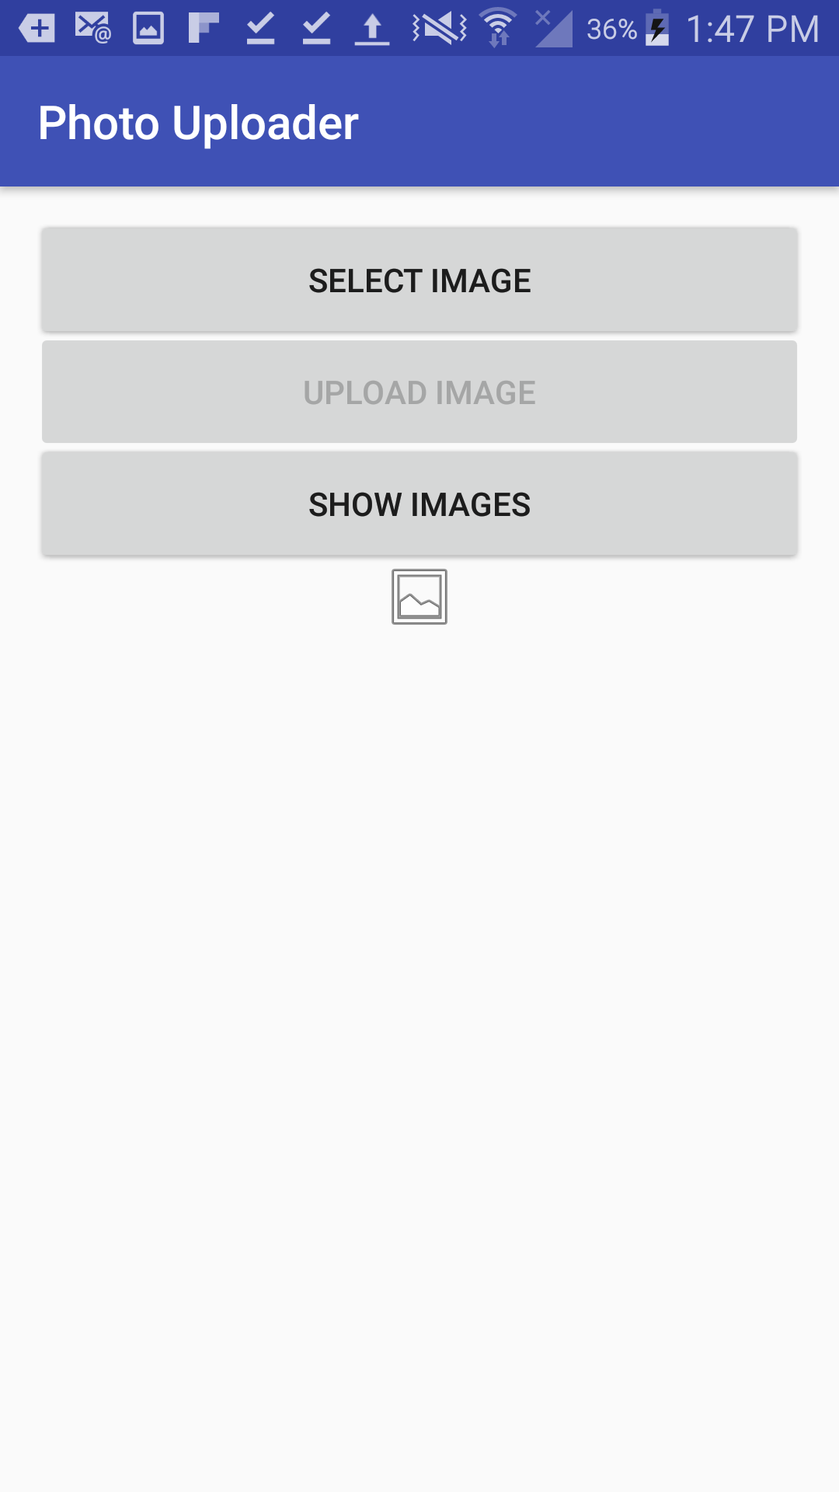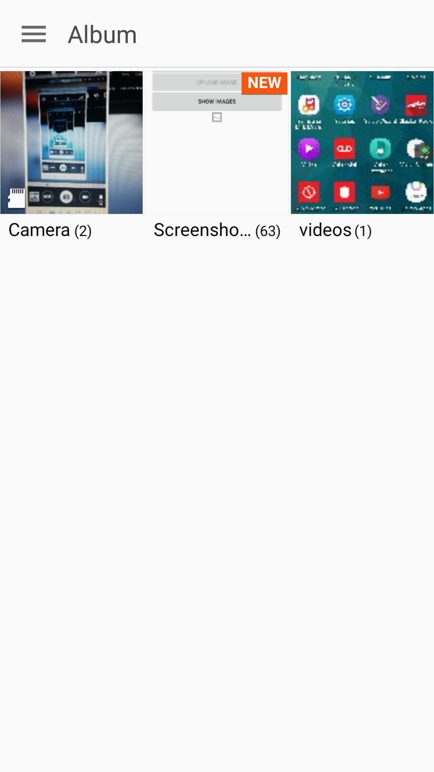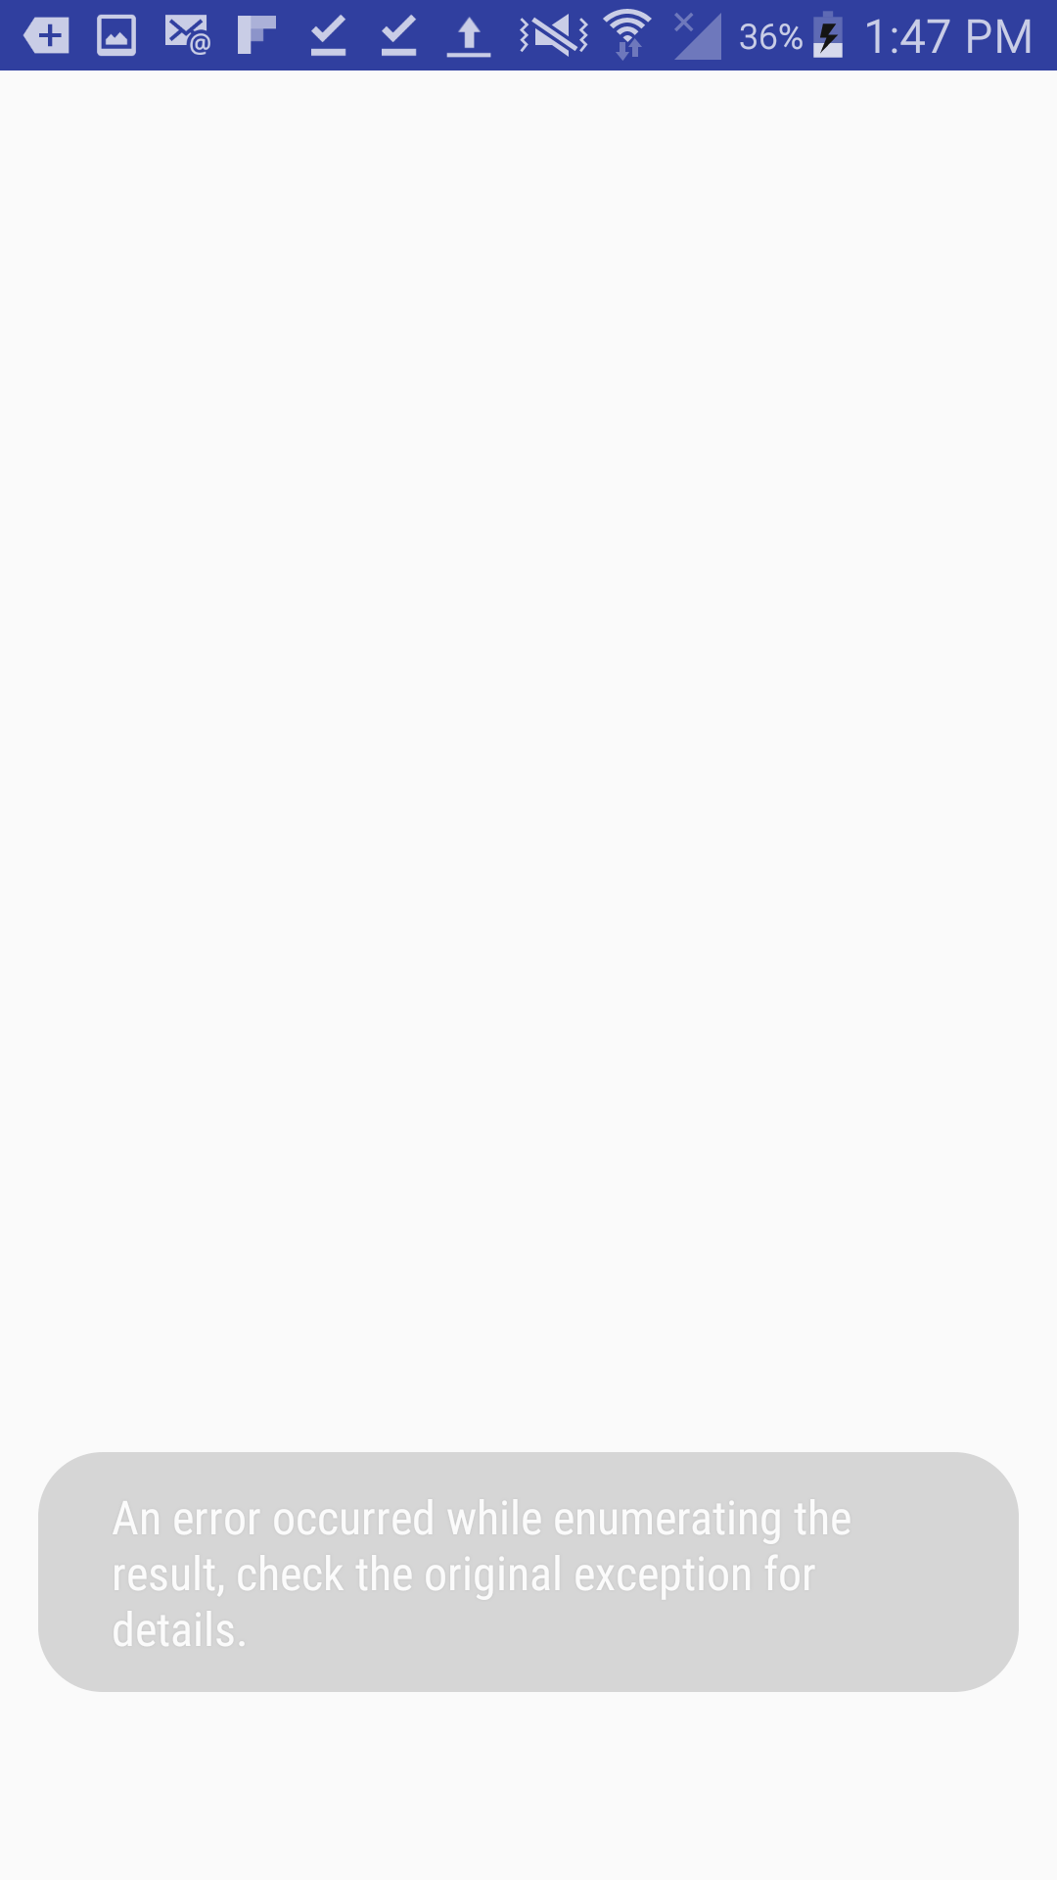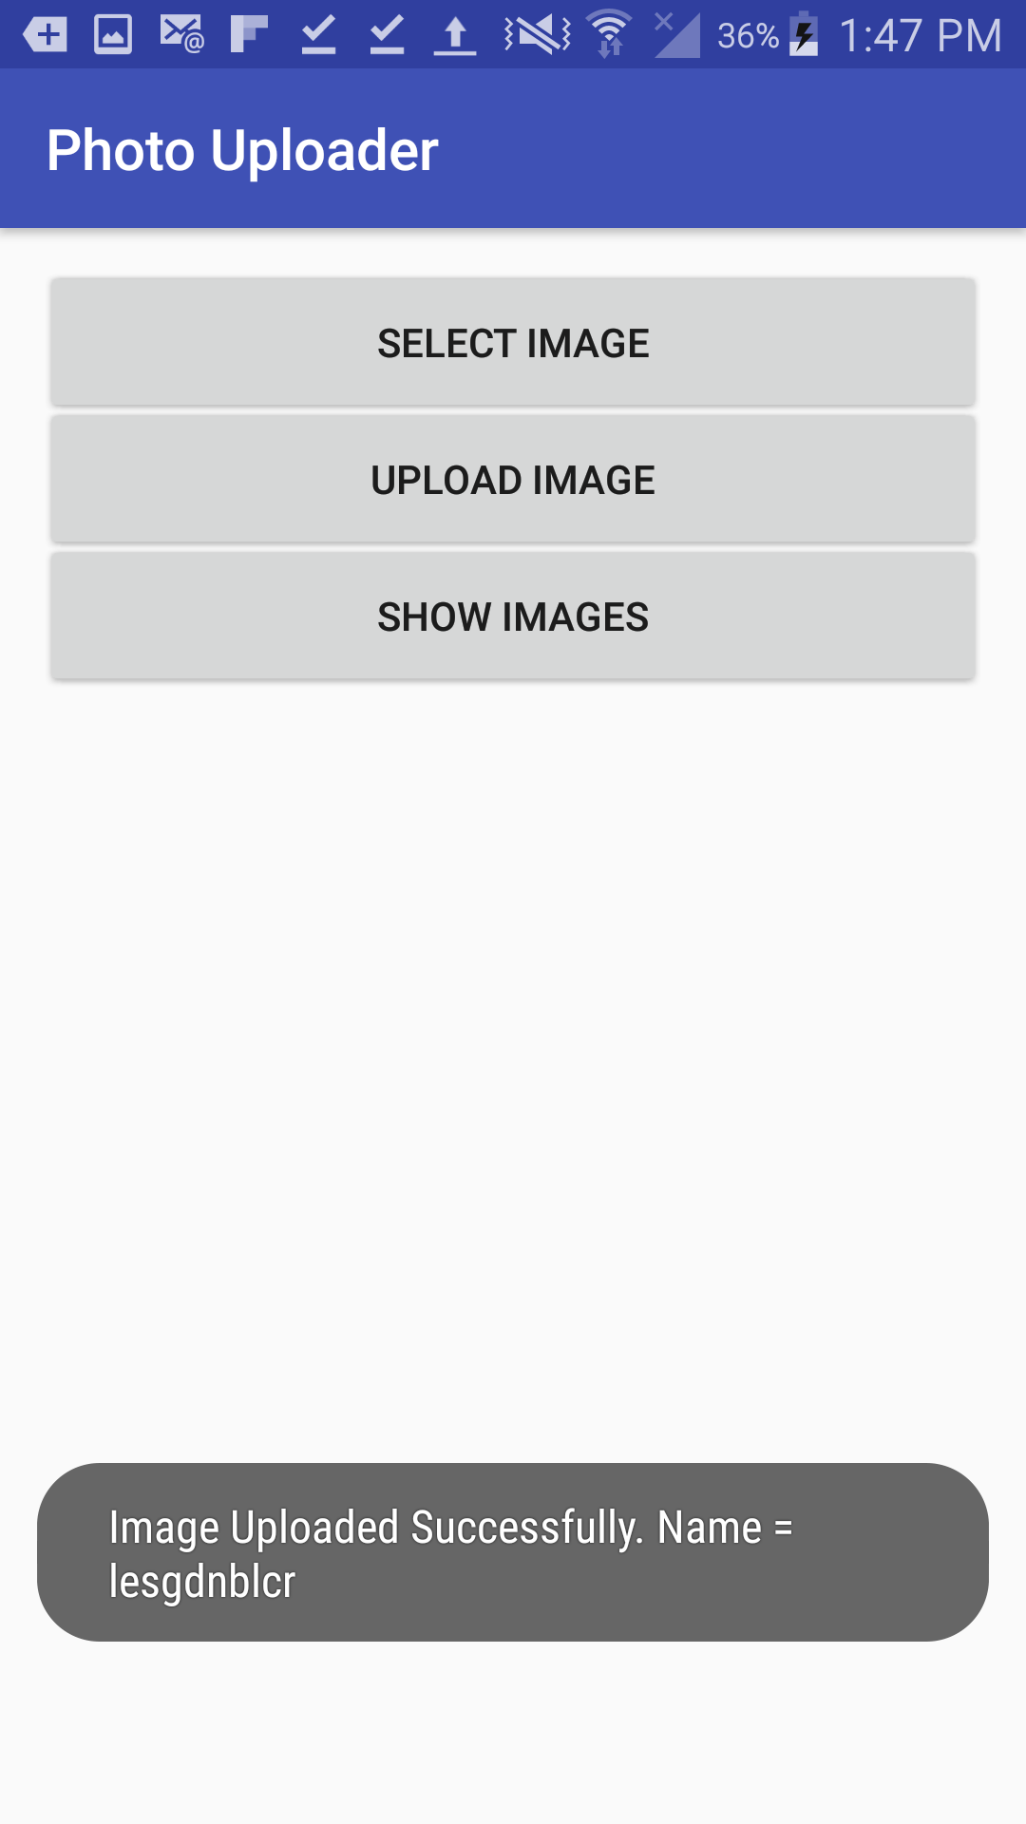

### Status report:

### The program started with a strange enumeration error but it never occurred again and this program also ran flawlessly. There are currently no crashes, bugs, or hangs.

### Summary:

### This is another good small task to use in future classes. Setting up the Azure storage was quick and easy and doesn’t take hours of troubleshooting.

### Task 3: Google Cloud Platform: Bookshelf App for Java (6 hours)

**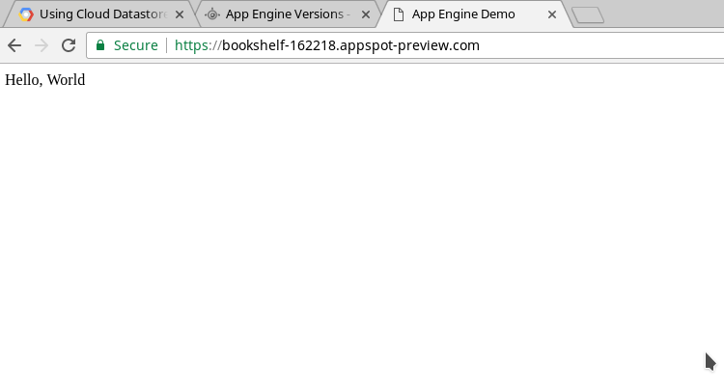**

**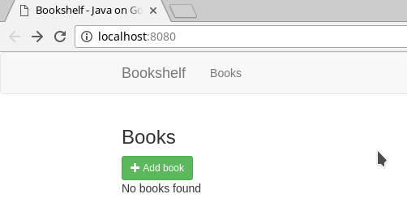**

**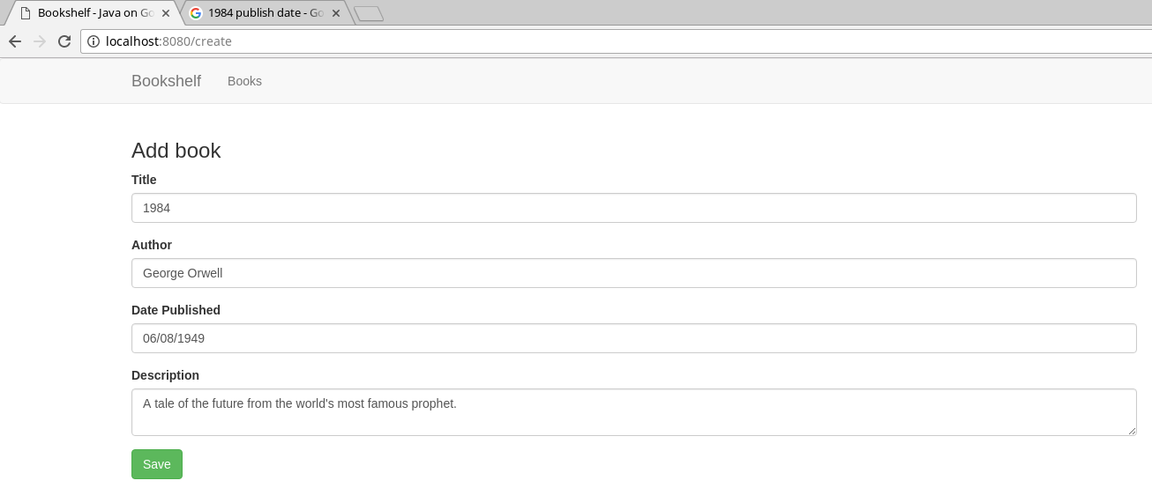**

**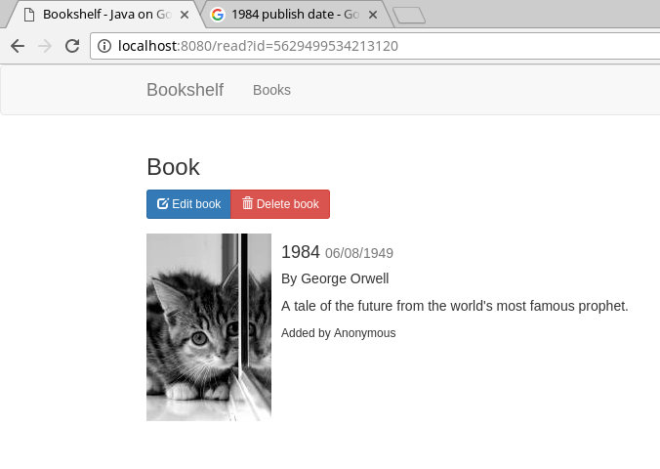**

### Status report:

### The program was working flawlessly at a point. Then it randomly stopped working and told me I was using Java 8 when I needed Java 7. I installed Java 7 and then it gave me an error saying that it was attempting to still use Java 8. I spent a lot of time trouble shooting this and nothing worked. I ran out of time and moved on to other tasks.

### Summary:

### This was the beginning of the frustrations with this project. I spent hours going through different solutions to 503 “unavailable” errors when I tried to connect to localhost:8080. I finally resolved the problem by following the tutorial for the standard version instead of the flexible environment and it worked immediately. Then it stopped working (after no changes) and hasn’t worked since.

### Task 4: Collaborative Tagging of XKCD Cartoons (5 hours)

### 

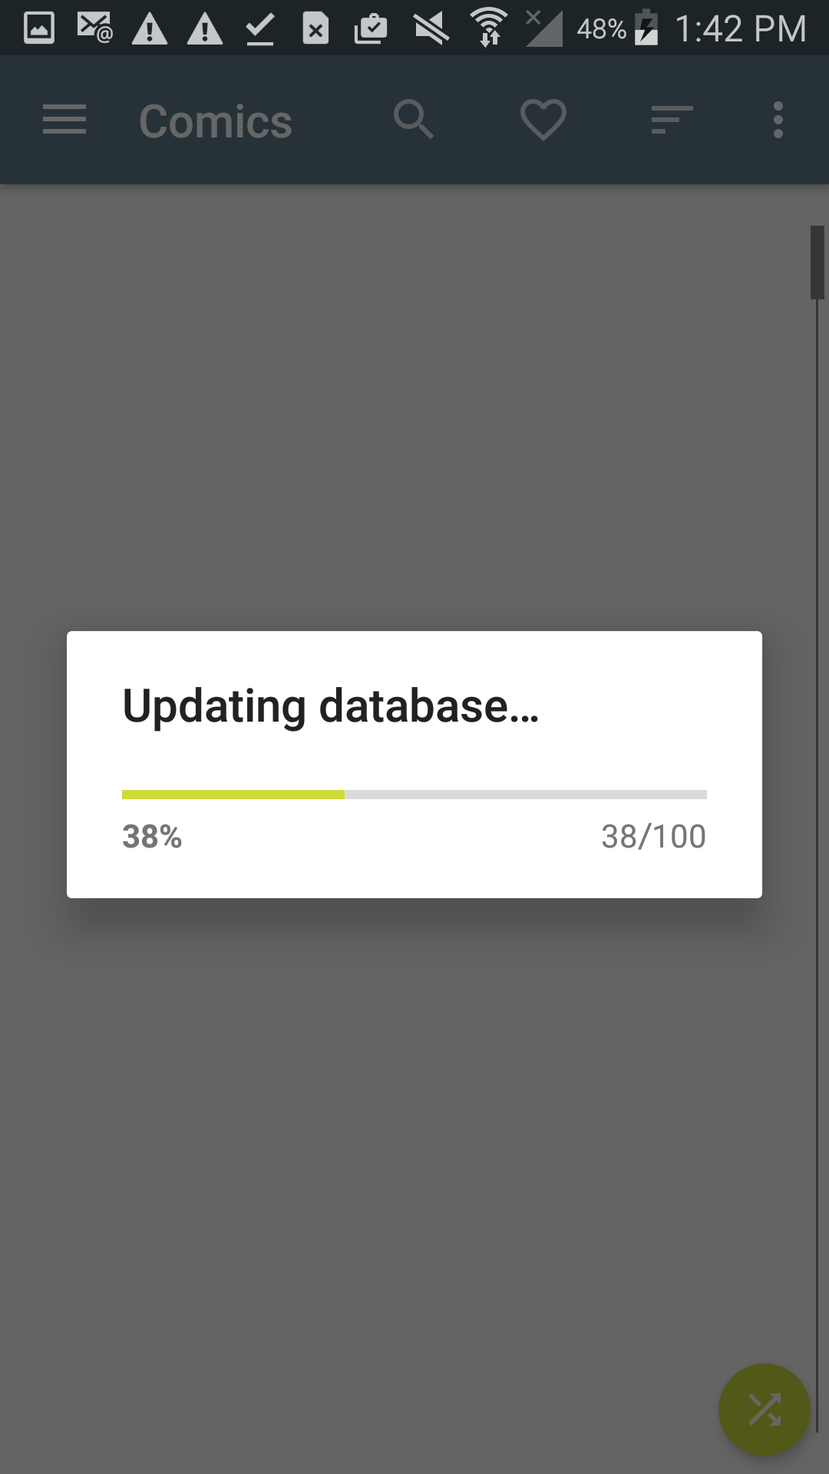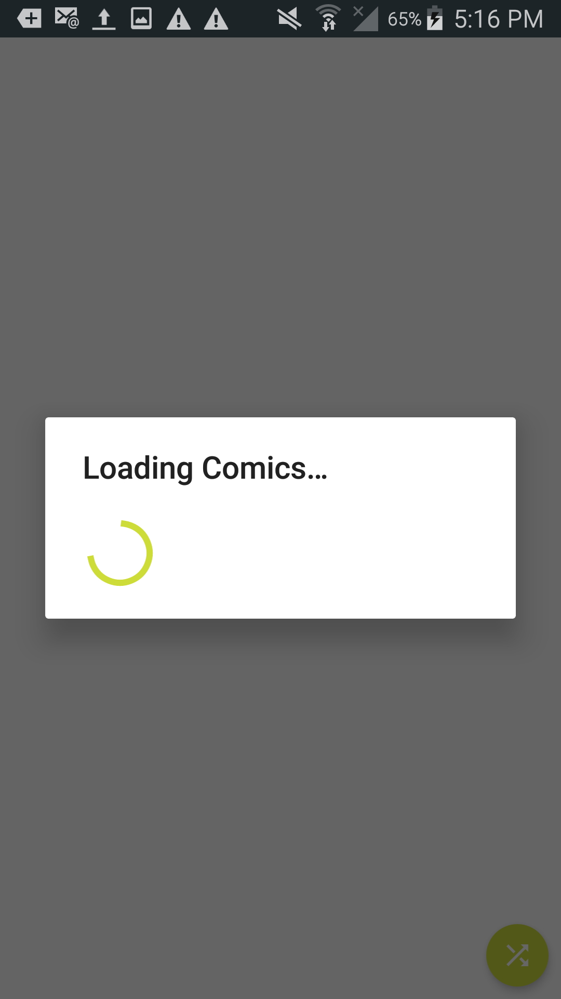

### 

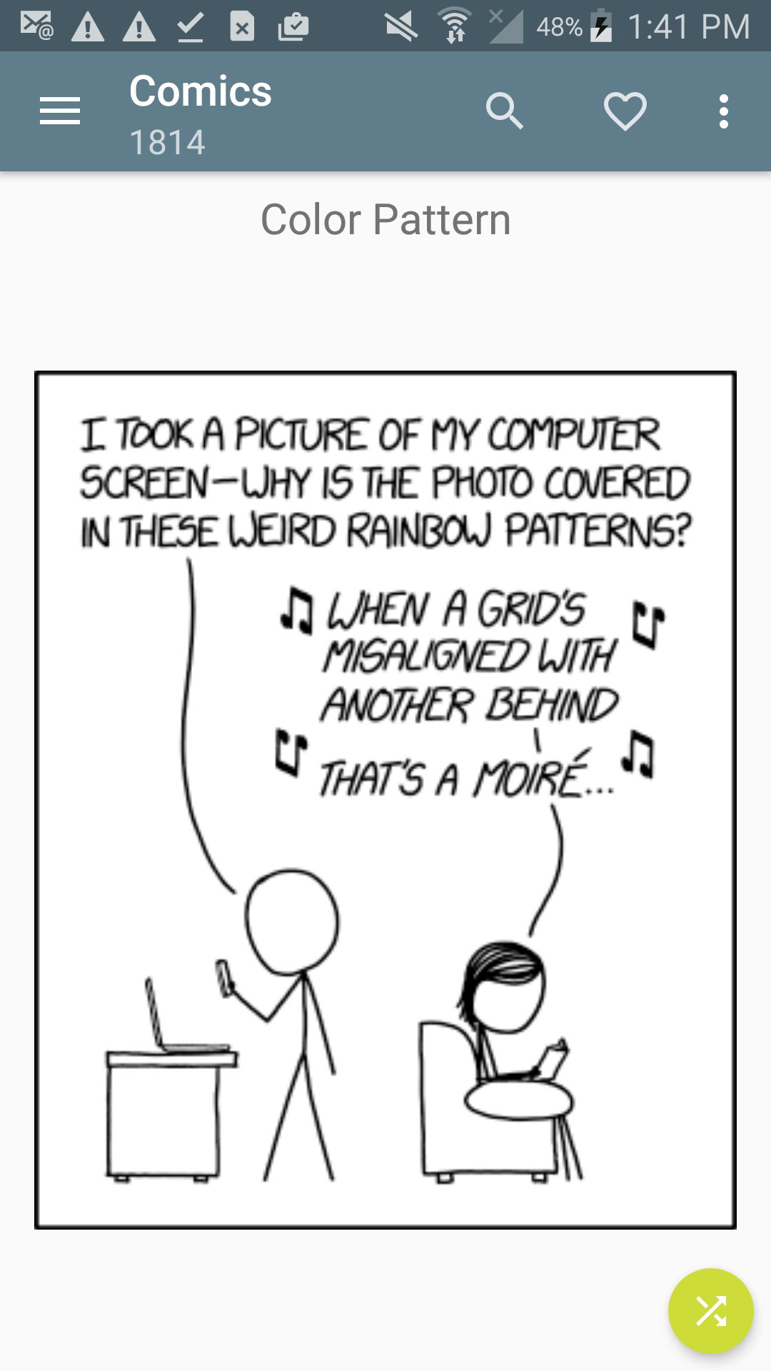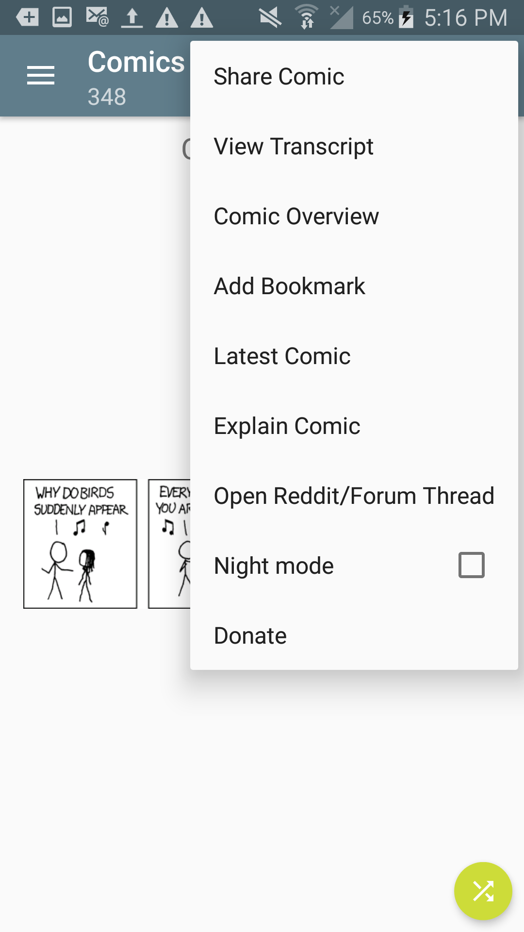

### Status report:

### This app was another simple and flawless compile and run. However, I was not able to come anywhere close to deciphering this code. I managed to find the exact spot where comics are displayed, but I was able to gain almost no understanding of what was happening without documentation. When I ended this task, I was still debugging and stepping through the code to try to understand.

### Summary:

### Very difficult. Some questions I was asking myself were “How are these images fetched from the internet and how is the database used? How can I add tag values to this database or access both databases separately to get the information for each comic? How can I do any of this without breaking it?” This task could have been an entire project in and of itself.

### Task 5: Analyses of Password Dumps (5 hours)

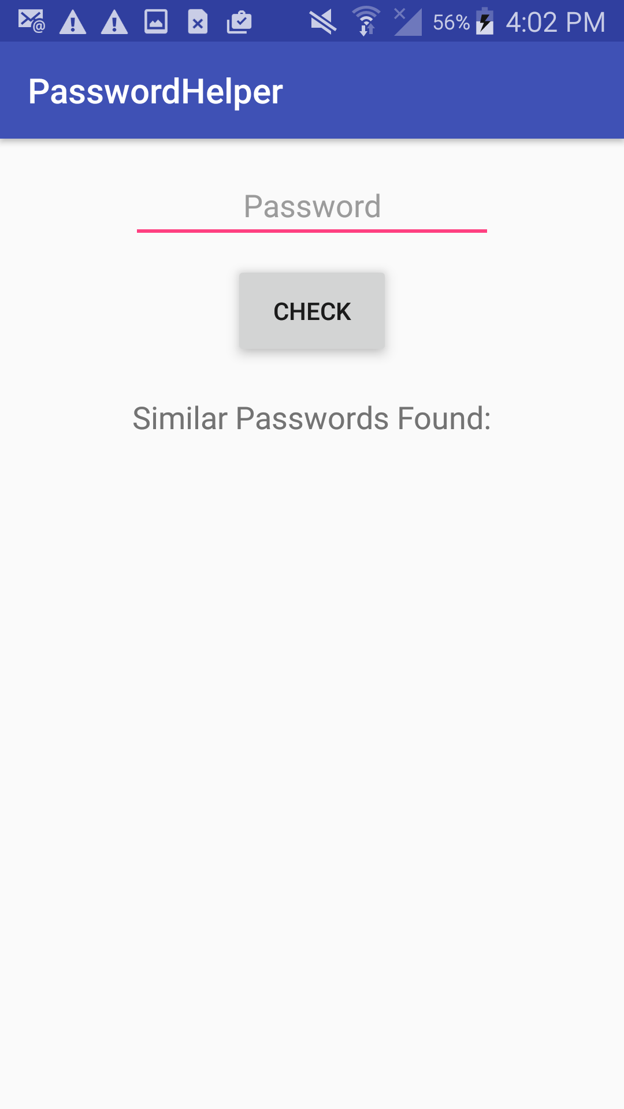

### Status report:

### Broken. I have tried dozens of slightly different methods to read files in Java and not a single one has worked. I just keep getting null readers regardless of where I put the input file. I also was not able to gain an understanding of Cloud Dataflow to implement that as a mapreduce.

### Summary:

### Very difficult. Speaking of mapreduce, I can’t find any examples of it and Android. Everyone seems to be saying that they use Dataflow instead, which is not something that can be just picked up and used. This is another task that could have been an entire project by itself. I’m also unsure of how to get multiple screenshots of the app when it has one screen and one function.

### Definition:

### Any password that contains a password in the word lists (case ignored). Given more time, this could be improved to consider whether lowercase, uppercase, numbers, symbols, and minimum password lengths were used.

### Help:

### This would help a future CEG 3900 project by utilizing cloud processing, as well as practice using password lists.

### Total Time: About 8 hours (16.5 including making the report)

### P5 Notes:

### The projects could use more mid-range time/difficulty tasks. Some of the tasks in this project were download and run, while the time to study and implement aspects didn’t exist for other tasks.