# Group 4 – Communications System

Software Requirements Specification

Revision History

|  |  |  |  |
| --- | --- | --- | --- |
| **Date** | **Revision** | **Description** | **Author** |
| 02/19/2022 | 1.0 | Initial Version | Owen Casebeer |
| 02/20/2022 | 1.1 | Added Requirements | Anthony Lopez |
| 02/20/2022 | 1.1.2 | Updated Overall Description | Matthew Baron |
| 02/21/2022 | 1.1.3 | Updated non-functional requirements | Owen Casebeer |
| 02/21/2022 | 1.1.4 | Added Sequential Diagrams | Anthony Lopez |
| 2/25/2022 | 1.1.5 | Added internal/external reqs | Owen Casebeer |
| 2/25/2022 | 1.1.6 | Added Class Diagrams | Matthew Baron |
| 3/1/2022 | 1.1.7 | Updated requirements | Owen Casebeer |
|  |  |  |  |
|  |  |  |  |
|  |  |  |  |
|  |  |  |  |
|  |  |  |  |
|  |  |  |  |
|  |  |  |  |
|  |  |  |  |
|  |  |  |  |
|  |  |  |  |

Table of Contents

1. Purpose 4

1.1. Scope 4

1.2. Definitions, Acronyms, Abbreviations 4

1.3. References 4

1.4. Overview 4

2. Overall Description 5

2.1. Product Perspective 5

2.2. Product Architecture 5

2.3. Product Functionality/Features 5

2.4. Constraints 5

2.5. Assumptions and Dependencies 5

3. Specific Requirements 6

3.1. Functional Requirements 6

3.2. External Interface Requirements 6

3.3. Internal Interface Requirements 7

4. Non-Functional Requirements 8

4.1. Security and Privacy Requirements 8

4.2. Environmental Requirements 8

4.3. Performance Requirements 8

# Purpose

## Scope

This document will catalog the user, system, and hardware requirements for the Communications System. It will not however, document how these requirements will be implemented.

## Definitions, Acronyms, Abbreviations

CS – Communications System

## References

Use Case ID: 1000U

Use Case Name: Create a chat

Relevant Requirements: 3.1.2

Primary Actor: User

Pre-conditions: User is logged in.

Post-conditions: Chat is created.

Basic Flow or Main Scenario:

1. The user selects participants from the user directory to create a chat.
2. The system responds by creating a chatroom on the server.

Extensions or Alternate Flows:

1. The user creates an empty chatroom.
2. The user invites users from the user directory to join the room.

Exceptions: None.

Related Use Cases: 2000U

Use Case ID: 2000U

Use Case Name: Send a message

Relevant Requirements: 3.1.2

Primary Actor: User

Pre-conditions: User is logged in.

Post-conditions: The message is delivered to the chat.

Basic Flow or Main Scenario:

1. The user opens an existing chatroom.
2. The user inputs the desired message and sends it.
3. The server receives the message and delivers it to the chat’s participants.

Extensions or Alternate Flows: None.

Exceptions: The message fails to send.

Related Use Cases: 1000U

Use Case ID: 3000U

Use Case Name: Access chat history

Relevant Requirements: 3.1.1

Primary Actor: Supervisor

Pre-conditions: Supervisor is logged in.

Post-conditions: The supervisor is granted access to all chat logs.

Basic Flow or Main Scenario:

1. The supervisor attempts to access user chat logs.
2. The system responds by granting a directory of logs.

Extensions or Alternate Flows: None.

Exceptions: None.

Related Use Cases: None.

**Use Case Diagram**

**Class Diagrams**

**Sequential Diagrams**

**Sequential Diagram Use Case #1000**

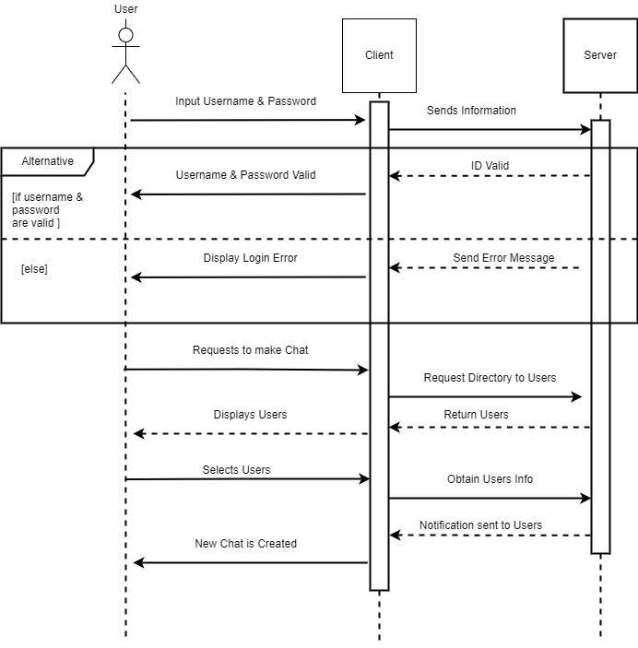

**Sequential Diagram Use Case #2000**

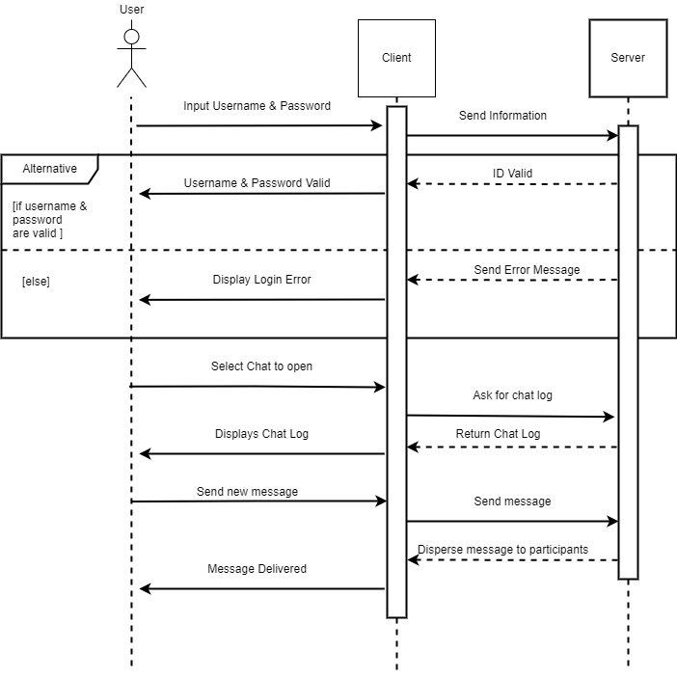

**Sequential Diagram Use Case #3000**

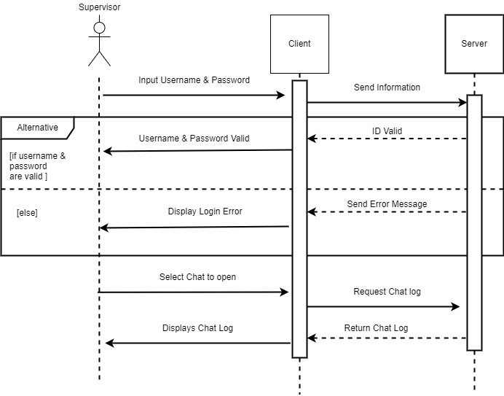

## Overview

The Communications System (CS) is designed to interconnect corporate communications nationwide through a text-based messaging system.

# Overall Description

## Product Perspective

## Product Architecture

The system will be organized into 2 major modules: the client module and the server module.

## Product Functionality/Features

The high-level features of the system are as follows:

* All employees have a unique login
* Chat rooms consisting of 2 or more users
* Strictly text-based
* Asynchronous messaging
* All chatrooms are logged
* Delivery/Read receipts

## Constraints

2.4.1 The project must be completed by 5/4/2022.

## Assumptions and Dependencies

No current assumptions.

# Specific Requirements

## Functional Requirements

### Common Requirements:

3.1.1.1 All chats are recorded and stored in a database.SR9 QA

### Client Module Requirements:

3.1.2.1 SR9 Users should be allowed to log in using their issued ID and password.

3.1.2.2 Users should be allowed to create chats/chatrooms.

3.1.2.3 Users should be allowed enter and leave chatrooms as they please.

3.1.2.4 Chatrooms should have a participants list and security settings to limit who can join the chat.

3.1.2.5 Users should be able to set how long messages are stored before they are automatically deleted from their personal chat history.

3.1.2.6 New messages will be labeled as read if the chat is opened.

3.1.2.7 Users should have access to a directory of users.

### Server Module Requirements:

3.1.3.1 Messages are asynchronous.

3.1.3.2 Messages will be labeled as delivered if successfully sent.

## External Interface Requirements

3.2.1 The system must provide an GUI to allow users to access communications features.

## Internal Interface Requirements

3.3.1 The system must process outgoing messages from the client to ensure messages are delivered to all applicable parties.

3.3.2 The system must process requests for past chat logs from users with the appropriate access level.

# Non-Functional Requirements

## Security and Privacy Requirements

4.1.1 The CS may only be accessed with a successful log in with a username and password.

4.1.2 The CS will be stored on a private corporate server.

4.1.3 Only supervisors and IT accounts may access the chat logs.

4.1.4 Only IT accounts may change user account passwords.

4.1.5 Encryption is not to be used within the system.

## Environmental Requirements

4.2.1 The CS will be built with the Java programming language.

## Performance Requirements

4.3.1 Message logging must not reduce the performance of the chat system.

4.3.2 Chat rooms must support an unlimited number of participants.