Intro Markdown

Matt Bixley

August 27, 2020

Table of Contents

# R Markdown

This is an R Markdown document. Markdown is a simple formatting syntax for authoring HTML, PDF, and MS Word documents. For more details on using *R Markdown* see <http://rmarkdown.rstudio.com>. (Xie *et al.* 2018)

When you click the **Knit** button a document will be generated that includes both content as well as the output of any embedded R code chunks within the document. You can embed an R code chunk like this: Ctrl + Shft + I

# Palmer Penguins

We are going to use the Palmer Penguins dataset curated by [Allison Horst](https://github.com/allisonhorst/palmerpenguins) and can be installed from Cran with the code install.packages("palmerpenguins") There are 3 different species of penguins in this dataset, collected from 3 islands in the Palmer Archipelago, Antarctica.

head(penguins)

## # A tibble: 6 x 8  
## species island bill_length_mm bill_depth_mm flipper_length_… body_mass_g sex   
## <fct> <fct> <dbl> <dbl> <int> <int> <fct>  
## 1 Adelie Torge… 39.1 18.7 181 3750 male   
## 2 Adelie Torge… 39.5 17.4 186 3800 fema…  
## 3 Adelie Torge… 40.3 18 195 3250 fema…  
## 4 Adelie Torge… NA NA NA NA <NA>   
## 5 Adelie Torge… 36.7 19.3 193 3450 fema…  
## 6 Adelie Torge… 39.3 20.6 190 3650 male   
## # … with 1 more variable: year <int>

## Tables

penguins %>%   
 count(species) %>%   
 kable(caption = "Species Counts")

Species Counts

|  |  |
| --- | --- |
| species | n |
| Adelie | 152 |
| Chinstrap | 68 |
| Gentoo | 124 |

we can generate more elegent tables with [kableExtra](https://haozhu233.github.io/kableExtra/awesome_table_in_html.html#overview)

penguins %>%   
 group_by(species) %>%   
 summarize(across(where(is.numeric), mean, na.rm = TRUE)) %>%   
 kable(caption = "Summarized Data", format = "html") %>%   
 kableExtra::kable_styling(bootstrap_options = c("striped", "hover", "condensed", "responsive"), full_width = F, position = "left")

Summarized Data

species

bill_length_mm

bill_depth_mm

flipper_length_mm

body_mass_g

year

Adelie

38.79139

18.34636

189.9536

3700.662

2008.013

Chinstrap

48.83382

18.42059

195.8235

3733.088

2007.971

Gentoo

47.50488

14.98211

217.1870

5076.016

2008.081

text_tbl <- data.frame(  
 Items = c("Item 1", "Item 2", "Item 3"),  
 Features = c(  
 "Lorem ipsum dolor sit amet, consectetur adipiscing elit. Proin vehicula tempor ex. Morbi malesuada sagittis turpis, at venenatis nisl luctus a. ",  
 "In eu urna at magna luctus rhoncus quis in nisl. Fusce in velit varius, posuere risus et, cursus augue. Duis eleifend aliquam ante, a aliquet ex tincidunt in. ",   
 "Vivamus venenatis egestas eros ut tempus. Vivamus id est nisi. Aliquam molestie erat et sollicitudin venenatis. In ac lacus at velit scelerisque mattis. "  
 )  
)  
kable(text_tbl) %>%  
 kableExtra::kable_styling(full_width = F) %>%  
 kableExtra::column_spec(1, bold = T, border_right = T) %>%  
 kableExtra::column_spec(2, width = "30em", background = "yellow")

Items

Features

Item 1

Lorem ipsum dolor sit amet, consectetur adipiscing elit. Proin vehicula tempor ex. Morbi malesuada sagittis turpis, at venenatis nisl luctus a.

Item 2

In eu urna at magna luctus rhoncus quis in nisl. Fusce in velit varius, posuere risus et, cursus augue. Duis eleifend aliquam ante, a aliquet ex tincidunt in.

Item 3

Vivamus venenatis egestas eros ut tempus. Vivamus id est nisi. Aliquam molestie erat et sollicitudin venenatis. In ac lacus at velit scelerisque mattis.

## Plots

You can also embed plots, for example:

mass_flipper2 <- ggplot(data = penguins,   
 aes(x = flipper_length_mm,  
 y = body_mass_g)) +  
 geom_point(aes(color = species,   
 shape = species),  
 size = 3,  
 alpha = 0.8) +  
 theme_minimal() +  
 scale_color_manual(values = c("darkorange","purple","cyan4")) +  
 labs(title = "Penguin size, Palmer Station LTER",  
 subtitle = "Flipper length and body mass for Adelie, Chinstrap and Gentoo Penguins",  
 x = "Flipper length (mm)",  
 y = "Body mass (g)",  
 color = "Penguin species",  
 shape = "Penguin species") +  
 theme(legend.position = c(0.2, 0.7),  
 legend.background = element_rect(fill = "white", color = NA),  
 plot.title.position = "plot",  
 plot.caption = element_text(hjust = 0, face= "italic"),  
 plot.caption.position = "plot")  
mass_flipper2

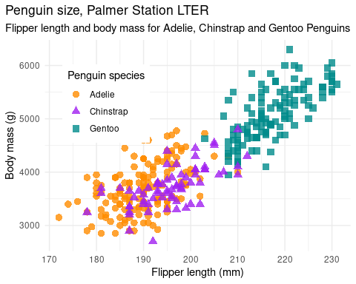

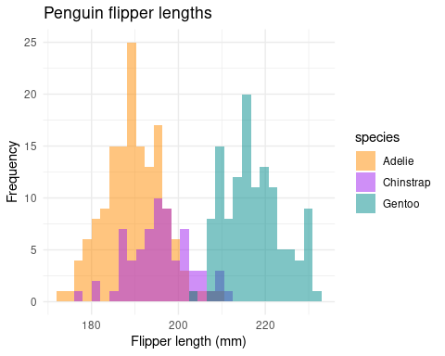

Caption for the plot created

Note that the echo = FALSE parameter was added to the code chunk to prevent printing of the R code that generated the plot.

## Equations

equation $z=x+y$ can be written in line or equations can be centered

$$a^{2}+b^{2}=c^{2}$$

$$∣\begin{matrix}a & b \\ c & d\end{matrix}∣=ad−bc$$

# Other Options

## Images

If we have images or plots already stored that we wish to add we can write the following with or without an image caption.



PalmerPenguins

include_graphics("data/pp_logo.png")



## Engines

Python, Shell, SQL, Rcpp, Stan, JavaScript, Julia, C and Fortran are all options

echo "Hello from Bash!"

## Hello from Bash!

## Citations

How do we cite things?

citation("palmerpenguins")

##   
## To cite palmerpenguins in publications use:  
##   
## Horst AM, Hill AP, Gorman KB (2020). palmerpenguins: Palmer  
## Archipelago (Antarctica) penguin data. R package version 0.1.0.  
## https://allisonhorst.github.io/palmerpenguins/  
##   
## A BibTeX entry for LaTeX users is  
##   
## @Manual{,  
## title = {palmerpenguins: Palmer Archipelago (Antarctica) penguin data},  
## author = {Allison Marie Horst and Alison Presmanes Hill and Kristen B Gorman},  
## year = {2020},  
## note = {R package version 0.1.0},  
## url = {https://allisonhorst.github.io/palmerpenguins/},  
## }

inline citations using a .bib file we can cite PalmerPenguins (Horst *et al.* 2020) and at the same time lets give the citation for R created by Robert Gentleman and Ross Ihaka (R Core Team 2020) or inline like this R Core Team (2020)

And we can change all the stlyes of citation to suit. [Here](https://citationstyles.org/) or here at [Zotero](https://www.zotero.org/styles)

# References

**Horst AM**, **Hill AP**, **Gorman KB**. Palmerpenguins: Palmer archipelago (antarctica) penguin data. <https://allisonhorst.github.io/palmerpenguins/> 2020

**R Core Team**. R: A language and environment for statistical computing. <https://www.R-project.org/> R Foundation for Statistical Computing, Vienna, Austria, 2020

**Xie Y**, **Allaire J**, **Grolemund G**. R markdown: The definitive guide. <https://bookdown.org/yihui/rmarkdown> Chapman; Hall/CRC, Boca Raton, Florida, 2018