biscoe island report

Matt Bixley

27 August, 2020

# Objectives

* parameters
* report template
* output

## Read Data

Read in our parameterized data, this uses the glue package and we also use here to help find our data within our project. Again we are using the Palmer Penguins dataset (Horst *et al.* 2020)

data <- read_csv(here::here('data', glue::glue(params$island, '.csv'))) %>%   
 clean_names()

### Header 3 - Table

Summarized Data

|  |  |  |  |  |
| --- | --- | --- | --- | --- |
| species | culmen_length_mm | flipper_length_mm | culmen_depth_mm | body_mass_g |
| Adelie Penguin (Pygoscelis adeliae) | 38.98 | 188.80 | 18.37 | 3709.66 |
| Gentoo penguin (Pygoscelis papua) | 47.50 | 217.19 | 14.98 | 5076.02 |

#### Header 4 - Plot

data %>%   
 ggplot(aes(x = flipper_length_mm, y = body_mass_g)) +  
 geom_point(aes(colour = species, shape = species), size = 3) +  
 labs(title = params$island)

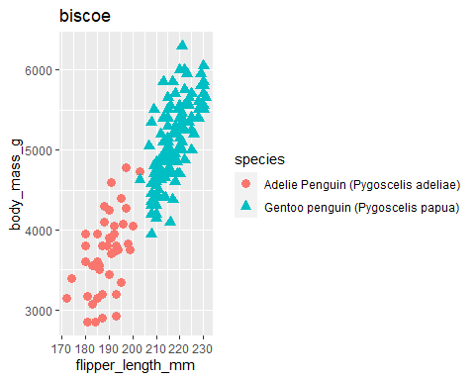

# References

**Horst AM**, **Hill AP**, **Gorman KB**. Palmerpenguins: Palmer archipelago (antarctica) penguin data. <https://allisonhorst.github.io/palmerpenguins/> 2020