Matt Boote   
51272089

Brief Description of Scene:  
This scene involves Star wars characters on a ship. There are two robots who are walking down a ship hallway when they come to a door. They stop there and outcomes a Stormtrooper telling them to get out of here. They turn around and run the other way. The scene loops. The lights are the two yellow cubes on the roofs.

ScreenShots

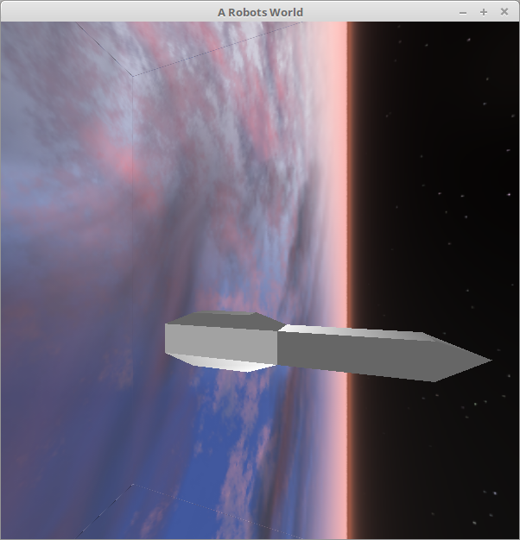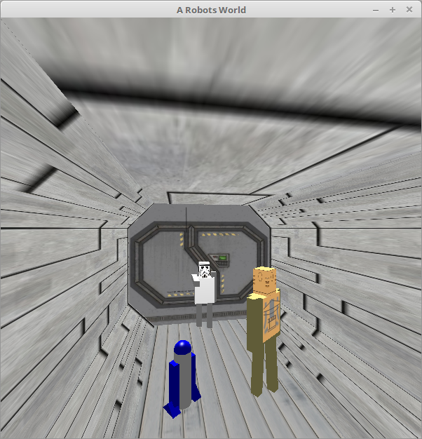

Extra Features:

* Multiple Camera Modes. I actually have 4 views. One for R2D2 view, CP30 view, the default view and a view from outside the ship. The default view and the ship view are free to move around however the robots’ views are not. To change a view click F1
* Skybox: From the ship view you can see the skybox that is used. Fittingly they are in outer space.

Models Generated:

R2D2. The blue and white robot was constructed using a quad strip for its cylinder body, a solid sphere for his head and cubes for his legs.

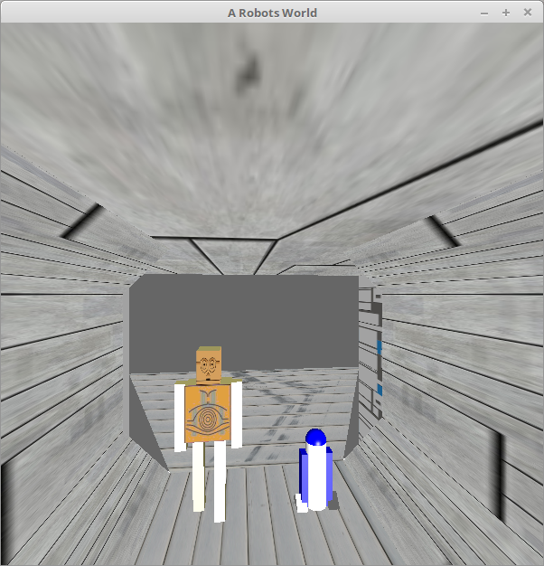

CP30. He was built using quads for his head and torso. The arms and legs are cubes. He has been textured to have his head and torso. He has a walking animation which moves his legs. Both he and R2 rotate once they are spotted.

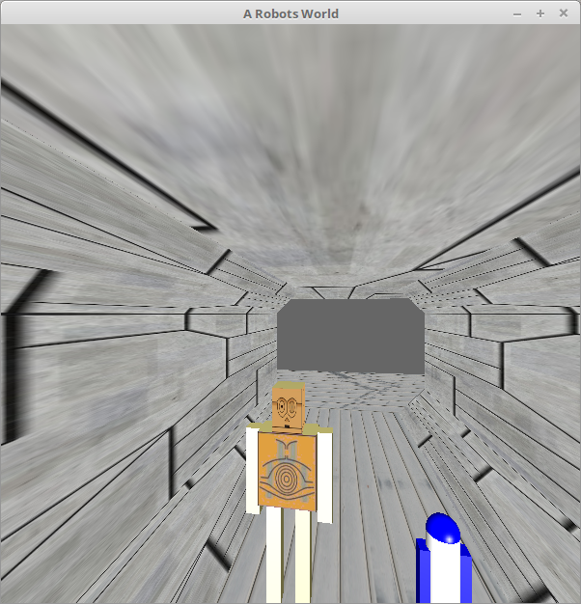

Stormtrooper. This was built using the same model as CP30 however I made him a little shorter and gave him a white colour and Stormtrooper textures. His arm is rotated as if he pointing at them.

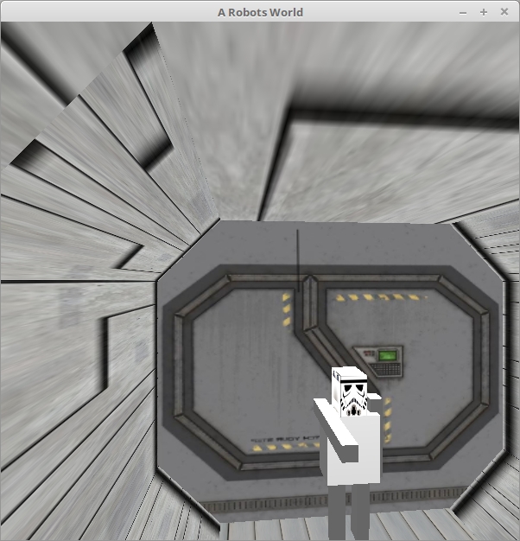

Ship. This ship base was made by Quads, allowing for it to be textured, however I ran out of time. The front of ship is a big cube and the tip is three GLTRIANGLE’s.



Problems Faced:

* I struggled with the lighting aspect of the assignment. I spent a lot of time fiddling around with surface normal which in the end couldn’t be fixed.
* Texturing, I had a lot of problems with some of my texture files as they would display all messed up. Also, I used to get the odd segmentation fault. However, I fixed this by converting correctly to BMP and TGA files.
* Camera Views. These took a long time to implement. As there was a bit of logic behind changing the views and if we need to update the ‘eye’ values. Eventually, I got a tutor help and looked at lab examples and it worked out.

Controls

* To change View click F1.
* To move forward use up arrow and backward is the back arrow. To rotate the view use the left and right arrow.

References:

COSC363 Labs. Used for navigation.

Skybox Texture from <http://www.geocities.com/petes-oasis/>

Stormtrooper and Cp30 texture from [www.cubecraft.com](http://www.cubecraft.com)

Other textures referenced from [www.textures.com](http://www.textures.com)