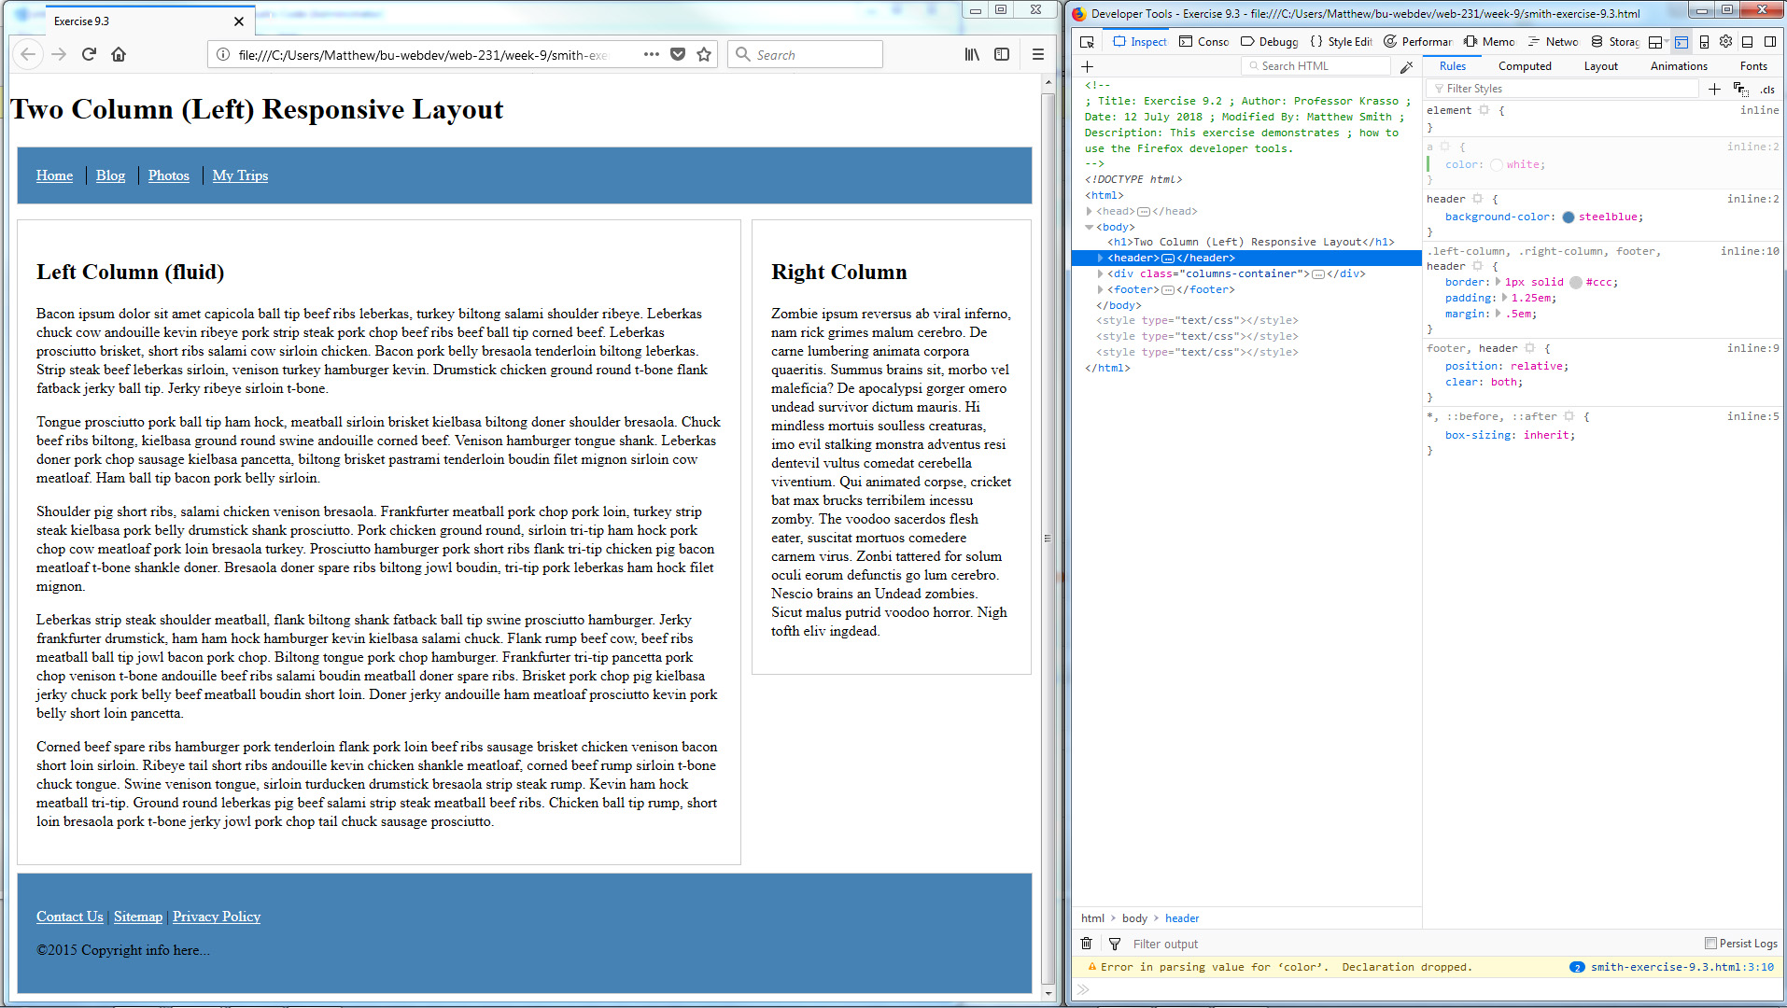

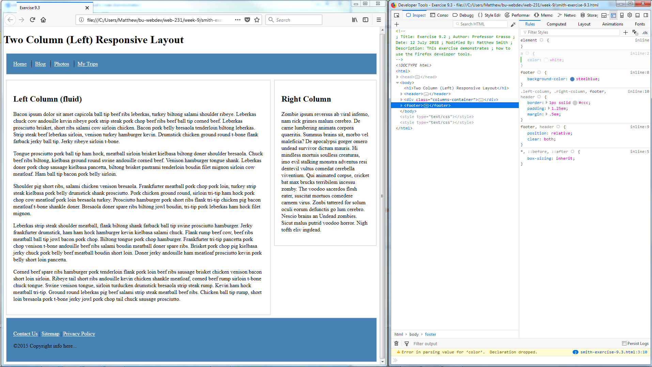

Instructions:

- I opened up the in Firefox.
- I pressed F12 to open the developer tools.
- I clicked on "Inspector" in the top menu to open up the code.
- I clicked on the <header> element in the left window.
- Then I click on the "+" at the top of the right window to add a new style rule for "header".
- I added a "background-color" style and set it to "steelblue".
- Then I click on the "+" at the top of the right window to add a new style rule for "a".
- I added a "color" style and set it to "white".
- Then I selected the <footer> element in the left window.
- I repeated steps 5 through 8 on the footer element.

